`

Olivia Gray

Allestree Woodlands School

Candidate number: 9080

Centre number: 23358

A-Level Computing Project H446-03

Contents

**Analysis** 3

Design Brief 3

Project Outline 3

Computational Methods 4

Thinking Abstractly and Visualisation 4

Thinking Ahead 4

Thinking Procedurally 5

Thinking Logically 6

Thinking Concurrently 7

Target Market 8

Stakeholders 8

Questionnaire 9

Target Platform 10

Researching Existing Products 10

Essential Features 12

Hardware and Software Requirements 14

Recommended Software Requirements 15

Limitations 16

Measurable Success Criteria 16

**Design** 19

Graphical User Interface (GUI) 19

Structure Diagram 22

Variables Table 24

Algorithms 30

Sequence of Algorithms 39

Planning Test Data for Development 40

Game State 1: Main Menu 40

Game State 2: Levels 41

Game State 3: Pause Menu 43

Testing Strategies in relation to the project 43

Input Validation 44

Post-development tests 45

Final checks for post-development 47

**Development Story** 51

Iterative Development Cycle 1 51

1.1 – Rotating the maze 51

1.2 – Moving the ball 54

1.3 – Moving the ball around the maze 55

Prototype 1 – The maze and ball 56

Iterative Development Cycle 2 58

2.1 – Entrance, exit, and loading to a new scene 58

2.2 – Diamonds and diamond counter 61

2.3 – Barriers and buttons 64

Prototype 2 – Objects in the maze 66

Iterative Development Cycle 3 69

3.1 – Enemies 69

3.15 – Refurbished enemies 70

3.2 – Player-enemy collision 73

3.3 – Player-wall collision 76

Prototype 3 – Enemies and collisions 79

Iterative Development Cycle 4 81

4.1 – Highlighting walls 81

4.2 – Placing mines 86

4.3 – Picking up mines and mine UI counter 92

Prototype 4 – Mines 94

Iterative Development Cycle 5 96

5.1 – Timer 96

5.2 – UI maze rotation indicators 99

Prototype 5 – UI elements 100

Iterative Development Cycle 6 103

Prototype 6 – Graphics 103

Iterative Development Cycle 7 107

7.1 -Main menu 107

7.125 – Level select menu 108

7.15 – Tutorial menu 111

7.175 – Settings menu 113

7.2 – Pause menu 117

7.3 – Sound system 121

7.4 – High score system 123

Prototype 7 – Polishing Up 127

Iterative Development Cycle 8 131

8.1 – Level 1 131

8.2 – Level 2 135

8.3 – Level 3 139

8.4 – Level 4 143

8.5 – Level 5 147

8.6 – Level 6 151

8.7 – Level 7 155

8.8 – Level 8 159

Prototype 8 – Levels 162

**Evaluation** 163

Post-Development Testing 163

Final Checks 169

Usability Testing 175

Evaluating the Solution 185

**Appendix A – Bibliography** 187

**Appendix B – Code Listings** 187

# **Analysis**

## **Design Brief**

My client, the chief strategy officer of an education firm, has presented the task of creating a 3D game that will fit into a larger website focused on introducing many different career paths to teenagers between the ages of twelve and fifteen years old. The game will have a focus on education, whilst also having unique features that make the game (and the career path of archaeology) stand out. For example, this game will be a physics-based puzzle game because of the unpredictable nature of physics, which can lend to an exciting and dynamic experience for the audience. The purpose of the game is to open the user’s eyes to a career in archaeology, whilst being both realistic and slightly fantastical about it, in order to interest the audience in the given career.

The client has specified that they would like puzzle elements in the game, to improve the user’s logical skills, such as problem-solving and pathfinding, which will be achieved in the maze layout of each level of the game.

## **Project Outline**

This game will be called ‘History is a Maze’ and will be a physics-based puzzle game. The base mechanic of the game will be tilting a maze to control a ball and get it to the exit within a time limit. The game will support both keyboard and gamepad controls, using the WASD keys and the joysticks on the controllers to rotate the maze along the x- and z-axis. There will also be a high score system implemented into the game in order to make it more competitive, therefore more attractive to replay. The high scores will be calculated using time remaining and the amount of diamonds collected in the maze by the ball. The graphics of the game will be quite abstract, using bright colours to represent important landmarks, such as the ball, entrance, exit, and diamonds, but soft lighting to illuminate the walls of the maze. This is to mirror the somewhat fantastical nature of archaeology, but also to make every object in the maze easy to see and identify. The game will also have a mine collection and deployment system, making use of highlighting walls to accurately place mines, which detonate to destroy some of the walls in the maze. This is where the biggest aspect of the puzzle game lies, as it encourages the user to think logically in order to get out of the maze with the resources they are given (they will be limited to three mines on every level) However, to introduce the simple mechanics of the game (the movement of the maze) mines will be excluded from initial levels so the user has a chance to adapt and get used to the controls laid out for them.

## **Computational Methods**

### **Thinking Abstractly and Visualisation**

My client requires a game that presents the user with a semi-realistic account of archaeology, to add to their LearnFuture website. To fulfil their criteria, I have elected to create a physics-based puzzle game that requires the user to tilt a maze to guide the ball through it to the exit. This is like the 2000s board game ‘Screwball Scramble’ where the player had to control obstacles in the level to direct a ball bearing through the obstacle course. Examples of the obstacles included in this game are a maze, a rotating platform, a tilting walkway, and parallel wires the ball must roll along without falling in between. There are some elements from this real-life alternative that I need to include within my own product, like the maze and using rotation to control the movement of the ball. This is essential because the solution should encourage the user to think logically and explore the puzzle for themselves to understand how to complete them. By abstracting features from the real-life alternative, I can better tailor the solution to the client’s specification. Another use of abstraction in the game relates directly to archaeology itself, as it will not be necessary to use hyper-realistic 3D graphics which is essential as the game will be web-based so high quality graphics will have a highly negative impact on performance (not just for the game, but the whole network). Another feature that will be abstracted from archaeology is the movement; as it is a physics-based game, the ball will be affected by Unity physics (gravity, friction, bounciness, etc…) so the lack of accurate movement will add to the experience of playing the game, encouraging critical and logical thinking to understand how the ball moves around the maze.

### **Thinking Ahead**

The inputs that need to be taken from the user will be from both a keyboard and a gamepad. The controls that operate the rotation of the maze will be W, A, S, D on keyboard and the left and right joystick on the gamepad, where each joystick controls one axis of rotation. This will be processed by the program to output the movement of the maze to the screen for the user to see. Another input that will need to be taken should control highlighting walls in the maze and placing mines to unlock sections of the maze. These inputs will not be used until the user progresses through the game and unlocks this mechanic. The outputs from these inputs will be highlighting walls in the maze by changing their materials to a bright, emissive colour, placing an object that represents a mine, then triggering an explosion sound effect after a certain amount of time Mouse clicks should be able to be processed on the menu screens so that the user can access different levels and settings in the game. The outputs from these inputs will include loading different menus or levels. If these inputs and outputs were omitted from the game, the user would be unable to interact with it, effectively making it not a game at all, meaning it would not fulfil its purpose as laid out by the client. Lastly, an output will come from the speakers of the device. This will include backing music and various sound effects, such as an explosion noise when a wall is blown up by a mine, and thuds when the ball hits the walls of the maze (this specific sound effect’s volume could be affected by the velocity that the ball hits the wall at to increase realism). The user will also be able to control the master volume with a slider in the settings menu.

### **Thinking Procedurally**

Procedural thinking will help generate the solution to the client’s problem, as the product will be complex and include many scenes, all with many sub-procedures. This means that thinking procedurally will help break down the problem into more manageable parts, and determine a suitable order that these game states and sub-procedures should occur in.

The user will first be presented with the main menu. In this game state, sub-procedures will include checking for mouse clicks or gamepad buttons as input. Each button will have a corresponding sub-procedure which will load a new panel on the main menu UI (for example, the settings, tutorials, or level select menu. This will be achieved by disabling the current panel and enabling the wanted panel. The ‘Quit’ button will use Unity’s ‘application.Quit()’ function to exit the program.

When the player is in-game, many sub-procedures will be used to ensure the smooth running of the game. For example, there will be a sub-procedure that manages the rotation of the maze floor, a sub-procedure that is called when the ball hits a wall, and a sub-procedure that controls the placing and detonation of the mine, among others. These sub-procedures may be interdependent on each other and the result of previous sub-procedures, such as: there will be a sub-procedure calculating the closest wall segment to the ball, then, when the player gives the necessary input, another sub-procedure will be called that causes a mine to be instantiated on the closest wall (that has just been calculated), or, when the user gives the input to place a mine in one sub-procedure, another sub-procedure will be started that begins a countdown timer to give the player time to get away from the mine before it detonates. Then, when it detonates, another sub-procedure will be called to instantiate an explosion sound effect, a particle effect, destroy the mine object, and calculate what objects are close enough to be destroyed.

During the game, the player can pause it at any point. Several sub-procedures will be used, on top of the functions linked to the buttons that the player can press. When the pause menu is activated, one sub-procedure will deal with literally pausing the game by setting the timescale to zero, another will manage a short animation that dims the background, so that the menu is clearer, and a final sub-procedure will be necessary to activate the menu panel on the User Interface.

There will also be two sub-procedures that are necessary for transferring persistent data across two game states. These sub-procedures will control the high-scores and completion Booleans of each level. In-game, these variables will initially be set when the ball reaches the exit, and the variables will be accessed again when the player runs the game and the main menu is shown. These variables will be stored in player preferences as not much data needs to be stored persistently so it will not have a huge negative impact on the processing time of the product.

These sub-procedures will be necessary to reduce the complexity of the program and keep the scripting neat and orderly. Confining sub-procedures to their different game-states keeps the program organised and means that testing the game-states will be much easier as every module is self-contained. This problem can be solved using procedural thinking because it can be decomposed into separate, self-contained game states, which is an abstraction of the real-life alternative, Screwball Scramble. This means that the computational solution is useful because it speeds up the process of controlling and using the available data to navigate through the maze. If the solution was not solved computationally, the product would not be as efficient, therefore, it would not be as high quality as it could be.

### **Thinking Logically**

### **Thinking Concurrently**

There will be processes in the game which will need to executed concurrently to make the game function as efficiently and seamlessly as possible. Concurrency will be used in many areas of the game including sound channels, checking user input against constantly changing data, enemy pathfinding, and the timer display. In reality, some of these functions would happen much slower, although this would take away from the nature of the product as a mini-game, which is meant to be fast-paced and quick to complete. If this product was not solved using computational methods, it would feel clunky and unpolished, and would not be particularly interesting to the user, causing them to turn the game off prematurely.

For example, the master volume channel will constantly play the backing track for the game, but it will also be necessary for sound effects, such as an explosion and thud, to play at the relevant events in the game. This will be solved concurrently because the sound effects will be played on top of the background music (therefore simultaneously). Without this element of concurrency, the solution would not be as atmospheric, meaning that the game would not feel eerie, causing the user to lose interest.

In the update function, the program will also be constantly checking for user input (so it can take the corresponding action to make the game function as intended) This will be happening every frame, meaning that, in some cases, some functions will be executed alongside the update function. An example of this would be when the user is telling the program to highlight the closest wall segment. This needs to be processed concurrently because it will improve ease of use, as, without this feature, the player would have to re-press the highlight button every time they want to select a new block, which will be annoying and somewhat time-consuming. However, if it processed concurrently, the player only needs to hold the highlight button and the closest block (which is highlighted) will be updated.

Enemy pathfinding can also be processed concurrently, as there will be many enemies per level, and each one will be following a set route. This means it can be processed concurrently as each enemy object will be checking for when it reaches the next route marker, then updating its marker array and travelling to the next indexed marker. If this was not processed concurrently, it would be marginally slower, but if the game was to be expanded, and huge levels were added with tens of enemies, the time difference would be noticeable to the user. Since the game is being played on a web browser, it is imperative that the game is as efficient as possible, therefore concurrency is necessary here.

The sub-procedures relating to the timer can be processed in quick succession, giving the impression of concurrency. The timer will be controlled by an integer variable in a script, but it will be converted to a string to be displayed on the UI. This will happen quickly so there is no delay in the variable updating and the display updating, as if there was, this would be irritating to the user because it would appear as though their time limit on each level was cut short prematurely. This would cause users to stop playing the game, because it would appear unfair.

Furthermore, all of these functions (and more) will have to be processed in concurrency with each other to make the game run efficiently and smoothly. For example, the timer will be updating, whilst the closest wall will be being calculated, whilst the enemies are being managed. If these were not processed concurrently, the game would feel disjointed as there would be a delay between each event in the game happening. This would cause the user to turn the game off as it would not feel polished or well-made or well-designed, which defeat the client’s purpose for the game – it should go without saying that the solution is of high quality to entice the intended audience towards the game.

## **Target Market**

The intended audience of this game is teenagers of any gender between the ages of twelve and fifteen years old. This is because the game is designed to encourage teenagers to consider many career paths, and this is the age range when teenagers are encouraged to consider their future, and, in many countries, this is before they have picked their GCSE subjects or equivalent. This game will include the use of mines which destroy ancient ruins. This could be perceived as violence, therefore this game will have a PEGI rating of PEGI 7.

## **Stakeholders**

|  |  |  |  |  |
| --- | --- | --- | --- | --- |
| Name of Stakeholder | Role within Project | Need for the game | Testing the game | Use of final game |
| Teresa Greenwood | CSO of LearnFuture | To use on the LearnFuture website that is aimed at exposing teenagers to new and unusual career paths. | They will play it to ensure that it is meets the educational elements specified in the requirements. | They will use it on the LearnFuture website. |
| Richard Smith | Prospective user | Exploring potential career paths. | By playing it, they can decide whether the game completes its purpose as promoting archaeology as interesting. | They will use it, amongst other games, on the LearnFuture website to help them decide what careers interest them. |
| Patricia Smith | Parent of prospective user | To help their teenager decide on potential career paths, and create easy, relaxed discussion around a stressful decision. | After playing it, they can see whether it makes discussions surrounding careers with their child easier. | They can play the game on the LearnFuture website with their child to open discussions with them about careers. |

**Teresa Greenwood** is a 41-year old female and Chief Strategy Officer of the educational start-up company – LearnFuture. She has a lot of experience working with teenagers, having been a secondary school teacher before making a career change, however, she does not have a lot of experience playing games. This means that she is able to analyse how the game fits its intended audience, although the quality of the experience of playing the game will be left to prospective users. She will, therefore, by more likely to interact with users of the game and ask them about their experience of it, and how helpful it has been in helping them making a crucial decision. The project will meet Greenwood’s needs by supplying LearnFuture with a game to advertise a career in archaeology.

**Richard Smith** is a 13-year old male who is a potential user of LearnFuture. He has had plenty experience playing games and is perhaps in the best position to understand how the game has influenced his decision in career. Therefore, his feedback will be crucial to the game, so he will be feeding back to the myself and Teresa Greenwood on his thoughts about the game and how it has helped him, in relation to the other games on the LearnFuture website. This game will fit his needs as it provides an easily-accessible opportunity to explore a career relating to archaeology.

**Patricia Smith** is the 46-year old mother of Richard Smith. She has a small amount of experience playing games with her son, and also understands her son aspirations. This means that she can play the game with Richard Smith to understand how the game could influence the audience, by presenting an interesting insight into archaeology. This game will fit Patricia’s needs as it should allow her to openly discuss careers with her son, which is important for all parents of teenagers playing games on the LearnFuture website.

## **Questionnaire**

I have chosen to use a questionnaire to collect specific information about the client’s expectations of the game. This will include some multiple-choice questions and will ask for some comments from the client as well. This should help me further understand what features and mechanics is needed in the game so that it is suitable for the LearnFuture website. This is the questionnaire that I gave to the client:

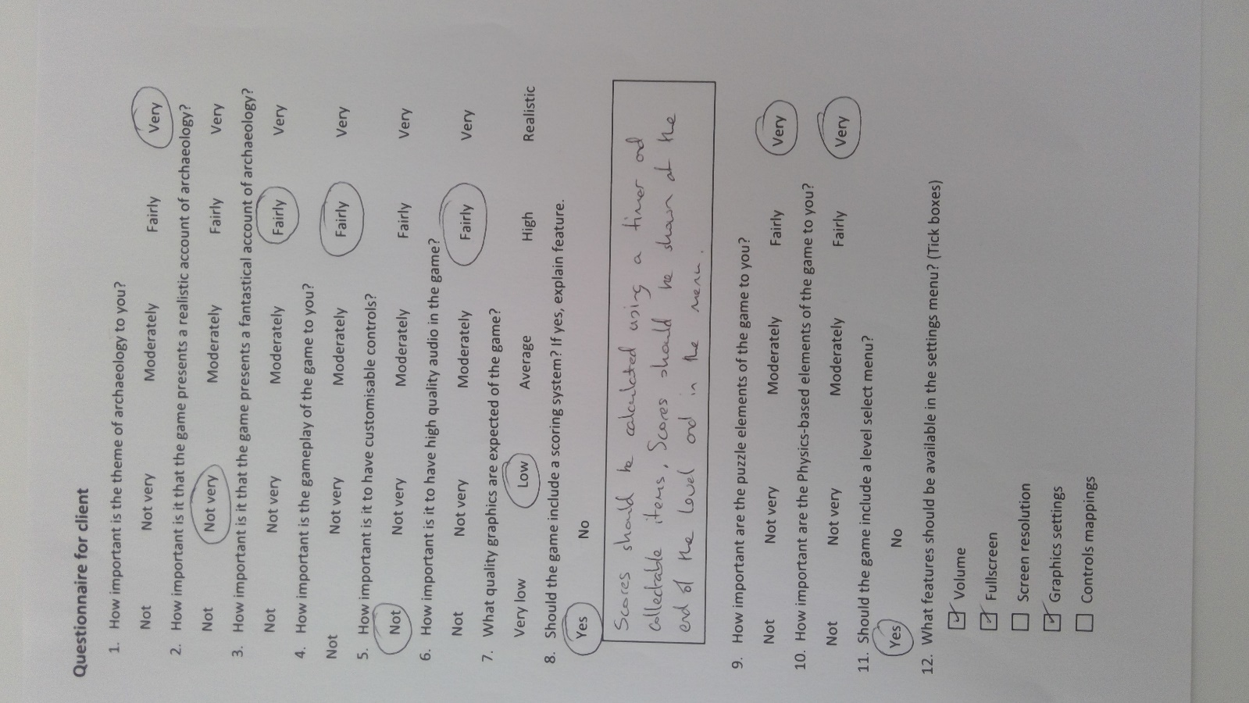From the feedback I received from the above questionnaire, I have discovered that the client is very interested in the game having a large focus on the problem-solving elements, also making use of physics systems to build up the core mechanic of the game. Furthermore, it is very important that the focus of the game lies in the archaeology theme, although the client would like a mix of realism and fantasy within the game to make it more interesting to young, developing minds. The client is not expecting high quality graphics and audio but would be interested in seeing some sort of soundtrack playing in the background. With regards to the menus, the client would like some but not all of the proposed features in the settings menu – so there should definitely be volume settings, full screen options, and changeable graphic quality settings. They would also like to see a scoring system and a level select menu, so it could be possible to show users’ high scores for each level from the level select menu.

## **Target Platform**

I have elected to create this game for PC because it will be a web-based software on the LearnFuture website. As a result, the inputs will be primarily from the keyboard, however, there will also be an option for the user to control the game using a gamepad. Furthermore, there will be no need to create the game for a specific operating system as the game will be run in Google Chrome, which can support Windows, Linux, and MacOS – the most commonly used operating systems. This is important because the game needs to be accessible to the audience, as it is part of the LearnFuture.

## **Researching Existing Products**

|  |  |  |
| --- | --- | --- |
| **Existing Game** | **Features**(green represents features that will be implemented into the game) | **Justification of features** |
| **Super Rub ‘a’ Dub** | * Control the level, not the duck * Must reach exit point * Enemies * Collect ‘children’ to make longer chain * Obstacles * Collect ducklings in bubbles * Gamepad controls | Implementing the player’s controls so that they only directly affect the level adds a uniqueness to the game, which could attract the audience to the game on the LearnFuture website. This would beneficial because it could lead long-term support that expands the game, adding new levels and mechanics over time. This would lead to a broader experience for the audience that would better equip them with the knowledge to make an informed decision of whether archaeology is the career for them. Without this feature, the game may feel boring and unoriginal which may turn the audience away from exploring an unusual career in archaeology, effectively defeating the point of having this game on the LearnFuture website. |
| **Uncharted** | * 3D graphics * Elements of puzzles * Ruinous scenery / setting * Adventure game * Story-driven | Using a themed graphical style (like ruins) can work to the game’s advantage because it grounds it in a way that is more meaningful to the audience. The user may be more motivated to play the game if there is a clear goal throughout the game, encouraging them to dedicate more time to exploring a potential career in archaeology. If this essential feature was not in the game, it would be unclear or confusing to the audience what field the game is focusing on, so it would be less likely to appeal to them. This would be detrimental to the game because, if it does not have the audience to support it, then it will not be possible to maintain and update it post-release, leading to an overall lesser experience. |
| **Cut the rope** | * Stars to collect * Touchscreen controls * No direct control over object that player wants to control * Discrete levels | Implementing an item collection system would create a greater challenge for the player. This may encourage them to think more strategically when approaching new levels so that they can get all the items within the time limit. This is important because the client specified that the game needed to include problem-solving to stretch the user’s logical thinking abilities, partially because it is an educational website so it should teach a new skill to the user or improve a user’s skillset, but mainly because critical and logical thinking is necessary in a career like archaeology, and it is imperative to make the user’s experience of playing the game representative of the selected job field. Without this feature, the gameplay could feel mindless and boring, with no real challenge presented to the player. Worse than that, it could mislead the audience into believing that archaeology is an easy or unexciting field. This would make the user’s experience of the game worse as they may begin to hold unrealistic expectations of the career which can only be attributed to this game. |
| **Forza Horizon 4** | * Open world * Racing simulator * Vs. AI * Countdowns on reaching checkpoints * Gamepad / steering wheel controls | Utilising a countdown timer in each level of the game adds a new level of challenge that forces the player to act quickly and decisively. This creates a challenge that encourages the player to try again if they fail, which also gives them the impression of their own skillset developing. This could be encouraging to the player if they decide they have a genuine interest in pursuing a career in archaeology, as they may feel like they have already begun developing critical skills in the field. If this feature was not implemented in the game, the user may not understand what skills are necessary in archaeology, which would decrease the similarities between the abstracted version on archaeology presented in the game and the actual field of study. As a result, the game will not meet its purpose as an educational application. |

## **Essential Features**

1. Controlling the maze and moving the ball
2. Reaching the exit
3. Abstracted 3D graphics
4. Enemy AI
5. High score
6. Mines, diamonds, and barriers
7. Main menu

**1 – Controlling the maze and moving the ball:** This feature is essential because it is how the program will use user inputs to control the maze level. This is important because the genre of the game is ‘physics-based puzzle’ which is achieved by the player being unable to directly control the ball – only the maze. This means that the player must think logically to understand how the axis of rotation and degree of rotation will affect the movement of the ball. The ball will make use of Unity’s physic system, using rigid bodies affected by gravity to imitate the acceleration and velocity of a ball in real-life situations. Without this feature, the game would be unusable as this is the only input the game will take to control the ball and get it to the exit. Therefore, the user would be unable to play the game and would not be able to decide whether archaeology is the career for them.

**2 – Reaching the exit:** This feature is essential because it is how the user will progress through the game. This means that when they reach the exit, the next level will be loaded for ease of use. This is important because the player should have access to more than one level so that they can face many different puzzles throughout the course of the game, each one introducing new mechanics into the game or making the path through slightly harder. Without this feature, the player may feel like they have been thrown into the deep end with too much information to process to understand how the game works. This would make the game pointless for the LearnFuture website as the games should be aimed towards children all kinds of experience playing games, so the game should cater towards all kinds of experiences, so that some children are not put off the game (and exploring the career) because of difficulty.

**3 – Abstracted 3D graphics:** This feature is essential because it will make the game enticing to children. This is important because a child should not be put off playing the game because it does not look amazing, therefore, abstracted graphics provide a good medium that make the game look interesting whilst also slightly like real life. Without this feature, the game may also be confusing to play as a semi-realistic aesthetic means that deviations can be made, such as colouring the exit or the diamonds or the barriers in neon, emissive colours. This would make them stand out more so that they are easy to see and identify for the player, so that the game is easy to understand for the player.

Furthermore, this feature is also essential because it is much easy to create graphics that are abstract, rather than hyper-realistic. This is important because complex graphics would be both time-consuming to create and resource-intensive for the browser it is running on – if it would run it at all. Without this feature, there is a possibility that the browser would be unable to run the game as it must transmit too much data whilst it is running, or it would run incredibly slowly, so much so that the game would be nigh on unplayable. This would prevent users from playing the game, making the whole product useless.

**4 – Enemy AI:** This feature is essential because it adds a new challenge to the game. It will make use of simple pathfinding AI to follow a designated route that the player must learn the timings of so that they can get through the maze in the easiest way possible. This is important, not because it is realistic, but because it representative of the challenges that archaeologists may face during their career which would encourage to explore different, safer routes. Without this feature, the player may feel that the game becomes monotonous and boring, prompting them to prematurely turn it off. This would be bad because it does not do archaeology justice and the game should encourage the users to explore archaeology if they are interested in it.

**5 – High score:**  This feature is essential because it adds an element of competition to the game. High score would be calculated at the end of each level (once the player has reached the exit) as a combination of time remaining (as there will be a time limit to each level) and the amount of diamonds collected on each level. This is important for encouraging the user to replay it and discuss it with other people, which will help contribute to the popularity of the game on the LearnFuture website. This could draw more potential users to the game if the website has a popularity ranking. This would be beneficial as archaeology is a niche career which not a lot of children would know about, so it would be a good way of advertising the career. Without this feature, the game may not be seen by the children who would consider a career in archaeology, which would defeat the point of game being part of the LearnFuture website.

**6 – Mines, diamonds, barriers:** These features are essential because they add another element of puzzle to the game. This is important partly because it is in the client’s specification, but mainly because it represents the challenges that archaeologists face during their working life in a way that is interesting to children and the game is supposed to explain what a career in archaeology would be like. Without this feature, children (particularly those in the higher end of the target age group) may feel that archaeology is not interesting enough for them to pursue a career in, when it is perhaps one of the most unique fields out there.

**7 – Main menu:**  This feature is essential because it will be the first interface that the user will interact with. This is important because it will give the user their first impression of the game and this is what could turn the user away before they have really experienced the game. Without this feature, the user may struggle to understand the mechanics of the game as the tutorials will be part of the main menu, so are more likely to stop playing the game if they cannot understand what the goal is and what each object does. This would be bad as the it would prevent potential future archaeologists from fully understanding this career field.

## **Hardware and Software Requirements**

Hardware minimum requirements

* Central Processing Unit (CPU) – Intel i3 (or equivalent) (3.4GHz)
* Random Access Memory (RAM) – 4GB
* Graphics Processing Unit (GPU) – Nvidia GTX 1050 (or equivalent)
* Monitor – 60Hz
* Keyboard - any
* Storage medium - none
* Speakers - any
* 1 x USB 3.0 port
* 1 x Gamepad

**CPU –** The CPU should run at 3.4GHz at a minimum as the game needs to run in a web browser so the game will need to process both data being transmitted and received concurrently. Therefore, 3.4GHz is necessary to ensure the game can run at 60 frames per second.

**RAM –** RAM should be at least 4GB for similar reasons as written above, as this amount of RAM will ensure that the game can run well without large drops in frames.

**GPU –** The GPU should be a Nvidia GTX 1050 or equivalent as the majority of graphics processing will be completed client-side and, because of the lighting elements in each level, this could be somewhat intensive for a lower-end graphics card. Therefore, it is necessary to have at least this standard of graphics card or better.

**Monitor –** The monitor will only need to run at 60Hz as the game is not fast-paced and does not have lots of fast motion, so ghosting should not be a problem at all with a 60Hz monitor.

**Keyboard –** Any keyboard will be able to work with the program as it will accept any input from a keyboard that has keys registering as W, A, S, D and Left shift and Space.

**Storage medium –** It will not be necessary to have any amount physical storage on the computer system, as the game will not be downloaded onto the system; it will run in a web browser.

**Speakers -** There will be audio in the game so the user should have speakers in their computer system. However, if this really were not possible, the game could be run without them, as there are no audio cues that are essential to the user’s experience of the game.

**USB 3.0 port –** The user will need one USB 3.0 port if they plan on playing the game with a wired gamepad, as this is how the user will enter inputs for the game, if they elect to play the solution with a gamepad. If they decide to play with a wireless gamepad, they may require a Bluetooth dongle, which would be inserted into the USB 3.0 port.

**Gamepad -** If the user decides to play the game using a gamepad, they will require one. This could be wired or wireless, but a USB 3.0 port will be necessary to connect the gamepad to the computer system.

Software Requirements

## **Recommended Software Requirements**

Web Browser – Google Chrome, Microsoft Edge, Firefox, Safari

This game will require a browser that has full support for JavaScript. This is because client-side processing should be carried out on the user’s computer for input validation. This is not a requirement that directly affects the product; however, it is a factor that needs to be kept in mind during development. The LearnFuture website will work best on web browsers like Google Chrome, Firefox, and Microsoft Edge. If the user did not have one of these browsers, the LearnFuture website would not work particularly well for them, reducing their interactivity with it, so that, overall, they would not have a good experience of the website. This would be bad for the solution as it would dissuade the audience from exploring the website and potentially finding the game to play. If the browser does not support JavaScript then the game should still be able to be played at the same standard as otherwise, but less people would be likely to play.

This game would require the use of a higher-end, reliable browser, such as the current versions of Firefox, Chrome, or Microsoft Edge. This is because the game, being web-based, needs to use a notoriously secure browser. This is necessary due to the fact that many people would be less likely to play a game online if they believed that, by playing it, they would be exposing their private data to risks, such as theft. Without this reputation for security, some potential users may be dissuaded from playing the game, for fear of risking their privacy. This would have a negative impact on the game's longevity on the LearnFuture as it would lead to having a smaller audience from the outset.

Another essential feature of the browser is that it is able to run on many different Operating System. For example, Firefox can run on Windows, MacOS, Linux – the biggest competitors in Operating Systems. This is necessary because the game needs to be accessible to many different users, without the need of installing a different browser. Particularly because this game is aimed at a younger audience, it is imperative that the game is easily accessible to them, so that they don't need to install other browsers, where they could accidentally install malware onto their device, giving the game a bad reputation. Without this feature, the game could become ground zero for malware attacking a user's device , which would lead to a bad reputation not just for the game, but also for the client and developers, and potentially lead to legal repercussions for negligence.

Lastly, as the developer, I will require a version of Unity that compiles into WebGL. This is important because the application will be run in a web browser. This means that the web browser need to be able to read the program and process its functions. If the solution was not compiled using WebGL, the user would be forced to download a Windows, or Mac version of the game, which is not what my client would like, given that the LearnFuture website is aimed towards young teenagers, some of which may not be aware of the dangers of downloading material onto a device. This would be bad as it would portray the message to the target audience that there is no harm in downloading files onto their device, which could lead them to do it later, but on a website that is actually intending to harm them. Therefore, compiling the application in WebGL means that the user will not have to download anything, but will also make the project easier to access, as it will run on a LearnFuture game page.

## Limitations

The game will not include multiplayer support as it is not essential to the solution. This means only one user can play the game on a single device, and users will not be able to interact with each other over a network. This is not an issue because the LearnFuture website is about children exploring different career paths, so they should not be encouraged to explore as a group of people, so that they do not feel any peer-pressure to agree with what their friends are doing.

Another limitation in the game is that there will only be eight levels, which means the game will be very short. However, this is not a problem as the game will be one of many games on the LearnFuture website so the user’s time should not be consumed by a single game. Therefore, keeping the game very small, they will be encouraged to explore different games on the website.

Furthermore, the player will not have customizable controls. The client has specified that these will not be necessary, but I will ensure that the controls feel good to play with and are easy to adapt to. For example, the maze will be tilted using the generic WASD controls. This means customizable controls will not be included in the game, as it will make it far more complex for little benefit.

The game will not have a storyline. This is because the game will be too short to have a proper storyline, and it would be unnecessary for the purpose of the game as an educational gateway into archaeology. In addition to this, having a storyline would take the user’s focus away from the most important features of the game, without having the same quality level that has been implemented with the main mechanics. This would inevitably negatively impact the user’s experience of the game, as they would be forced to experience the storyline, which could be uneventful and have no relevance to the game itself.

Lastly, resolution settings will be omitted from the game as there would be no point to it. This is because the game panel will be integrated into the LearnFuture ‘game page’ (the webpage that the game can be played on) which means that the game will be a set resolution regardless of the user’s monitor size, and aspect ratio. Therefore, the game would not be distorted if the user was playing with an unusual aspect ratio.

## **Measurable Success Criteria**

1. Between 5 and 10 discrete levels with challenging puzzle elements
2. Responsive controls that operate the axes of rotation separately
3. Simple 3D graphics
4. Introduces new puzzle elements as the game progresses
5. Main menu including settings, level select, and tutorial menus
6. Level can be restarted easily from within the level without having to go back to the main menu
7. Scores from each level should be saved even if user closes the game
8. Ambient music

**Between 5 and 10 discrete levels with challenging puzzle elements:** Between 5 and 10 discrete levels each including challenging puzzle elements should be included in the game because this will make measuring player development easier. This is important because it will make the player feel like their skillset is improving over the course of the game, which will encourage them to play it more, or play it again to beat their previous high scores. If there were not enough levels in the game, or if there were no puzzle elements to each of them, the game would feel aimless and too easy, so the user may feel bored by it and turn it off. This would be bad because it would deter the audience from exploring a career in archaeology, which would mean that the game has not served its purpose on the LearnFuture website.

**Responsive controls that operate the axes of rotation separately:** The game will require responsive controls that control the axes of rotation separately as this will be the only way of controlling the ball and getting it to the exit of the maze. The keyboard controls will be A and D for rotation on the x-axis and W and S for rotation on the z-axis. This is important because it will introduce the main physics-based mechanic of the game, as per the client’s requirements. Without this feature, the game would not fulfil the client’s specification, so it may not be included on the LearnFuture website. Furthermore, the user would not be able to use the game without user inputs so the program should be able to process these inputs quickly and efficiently. Therefore, it is essential that this feature is included and executed well.

**Simple 3D graphics:** The client has specified that they would appreciate seeing 3D graphics in the game, however these will need to be simple, abstracted graphics due to the fact that the game will be running in a web-browser so performance will be limited by the user’s bandwidth (which is harder to manage than speeds of hardware like RAM for typical, downloaded game). This means that 3D graphics will entail having as few polygons in each 3D object to reduce the graphics processing needed. Without this feature, the audience may not be able to play the game with good performance, so would be unlikely to spend much time playing it. This would be bad as it would prevent children who could be interested in archaeology from actually experiencing the game, perhaps stopping them from even realising that it could be the career for them.

**Introduces new puzzle elements as the game progresses:** The game will introduce new puzzles as the game progresses to stop it from feeling monotonous and boring. This is important because it should reflect the nature of archaeology as a career – which is not boring at all! The point of the game being on the LearnFuture website is to entice the audience towards archaeology to help them decide a potential career for their future. Without this feature, the game would not be able to mirror how new problems arise in archaeology, which means the game would miss out the critical, problem-solving skills required of an archaeologist. This could mislead the user, which would provide them with a negative experience of the game.

**Main menu including settings, level select, and tutorial menus:** The game must include a main menu that includes the settings, level select, and tutorial menus so that the user's first impression of the game is good. This would include being easy to use and navigate, so that the user can easily access features like the settings menu and tutorial menu so that they can adjust the game to their standard, or understand the main mechanics of the game. Without this feature, the user may feel lost when playing the game, as they would be thrown straight into level 1 without having had the opportunity to understand the purpose of the game or the controls in the game first. This would be bad as it could make the user feel frustrated and turn the game off before they have really experienced it, therefore it is important that this feature is included in the game, in line with the client's specification.

**Level can be restarted easily from within each level without having to go back to the main menu:** The game will include this feature because it makes it more accessible to the user. Since the nature of the game is designed to let the user fail (through timers and enemies) it is essential that, if the user feels they will fail, they should be able to quickly restart the game. This could be due to having spent a significant amount of time at the start of the level trying to find a route through the maze, so in levels where there is a lot of time left, but not enough to make it to the end, the user will be able to restart from within the pause menu. Without this feature, the user would have to exit the level to the main menu then restart the level from there, which is both time-consuming and unclear to the user. This could make the user stop playing the game because they are more likely to notice the flaws of the game, than its merits, so are more likely to turn it off if restarting a level is too inconvenient.

**Scores from each level should be saved even if the user closes the game:** The game should include a form of saving system, which stores the high score from each level. This will be achieved using ‘PlayerPrefs’ in the UnityEngine. This is important because the user is encouraged to play as many games as possible on the LearnFuture website, so they should be able to return to it at any time without having lost the progress they have already made. Without this feature, the user may feel less motivated to play the game because they cannot save their high scores and return to beat them later. This would be bad for the game as it would erase the point of having a high score feature, leading to wasting time implementing only part of the feature.

**Ambient music:** The game will include ambient music as a backing track that plays whilst the game is running. It will be made using the Reaper audio creation software, along with some plug-ins to create orchestral noises, for extra ambience. It will be short and repetitive but will complement the game’s atmosphere without distracting the user from the levels. This is important because it adds to the eerie atmosphere of the game – which should help the user understand the courage needed to explore ancient ruins and sites in archaeology. Without this feature, the game may feel slightly dead, so it will not serve its purpose of making archaeology seem like an interesting career for the audience.

# **Design**

## **Graphical User Interface (GUI)**

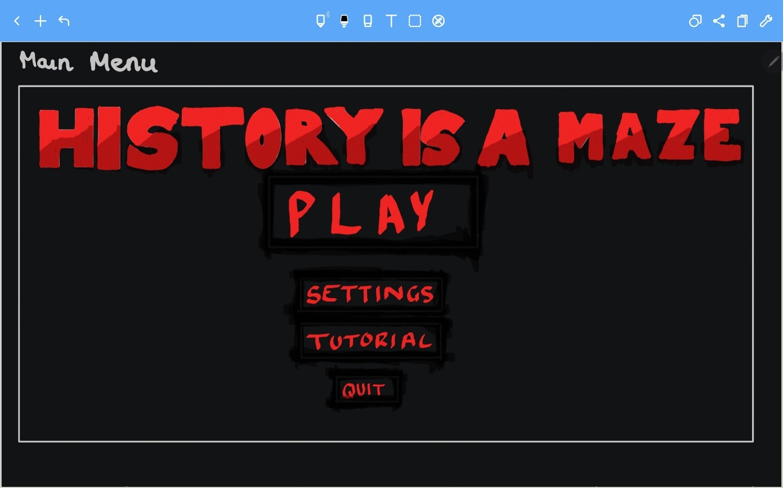**Main Menu**

This is a representation of the main menu. The background will be plain so that the user is not distracted by it, thereby drawing the user’s eye to the title of the game which will be the biggest item on the menu, and use a subtle colour gradient of reds. I have decided to make the text colour red on this screen as red signifies danger, and the user should be made aware that archaeology can be a dangerous job at times; it also initiates an ambient atmosphere which is further present when the user loads the first level. The main menu will contain the play, settings, tutorial, and quit buttons, where all but the quit button will take the user to their respective menus on being clicked. For example, the play button will take the user to the level select menu, where they can then load their chosen level. The text and buttons will be central to the menu as this would draw the user’s eye to it quicker. If the text was not central, it would feel like there is a lot of empty space on the screen, so it may be necessary to design a background, which would generate an extra amount of work that is completely unnecessary. When the cursor hovers over the buttons, they will be highlighted in red. This will stay in line with the colour theme, but more importantly, it will help interactivity with the page as it will be easier for the user to understand what they are looking at. Without this feature, the user may feel lost on the menu, which would negatively impact their first, critical impressions of the game.

**Tutorials**

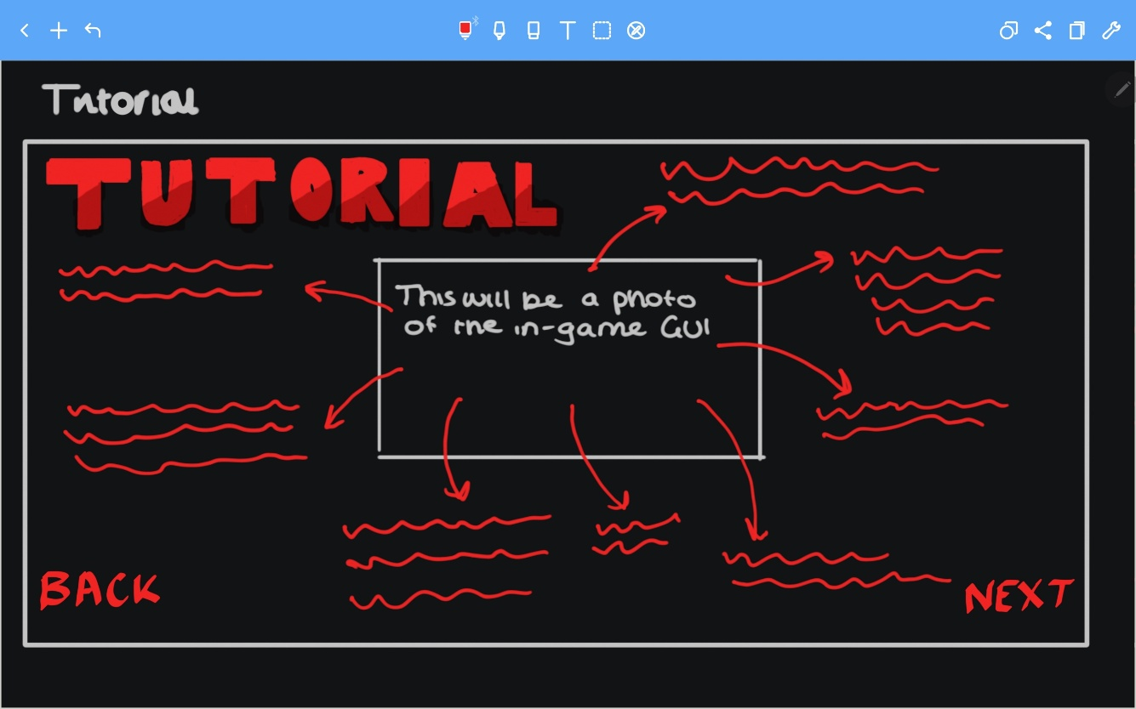

This is an initial sketch of what the tutorial menus will look like. It will have a large, red (in keeping with the colour theme) title, so that the user can easily see what they are looking at, although this text will be out of the user’s direct line of sight (in the corner of the screen) so that it does not obstruct the information of the tutorial. The tutorial will be made up of a photo of the in-game screen that has been annotated clearly so that the user cannot be confused by abstracted illustrations of objects within the game. If this was the case, the clarity of the tutorial would be reduced, effectively rendering it useless. As the game will be quite complex, it will be necessary to have multiple tutorials, one explaining the main mechanics of the game, but two explaining the different ways the game can be played (with keyboard controls and gamepad controls). Therefore, ‘next’ and ‘back’ buttons will most likely be necessary so that the user can click between the different screens. The buttons will also be red but they will be smaller than the title and positioned in the bottom corners of the screen to keep them out of the way.

**Level Select Menu**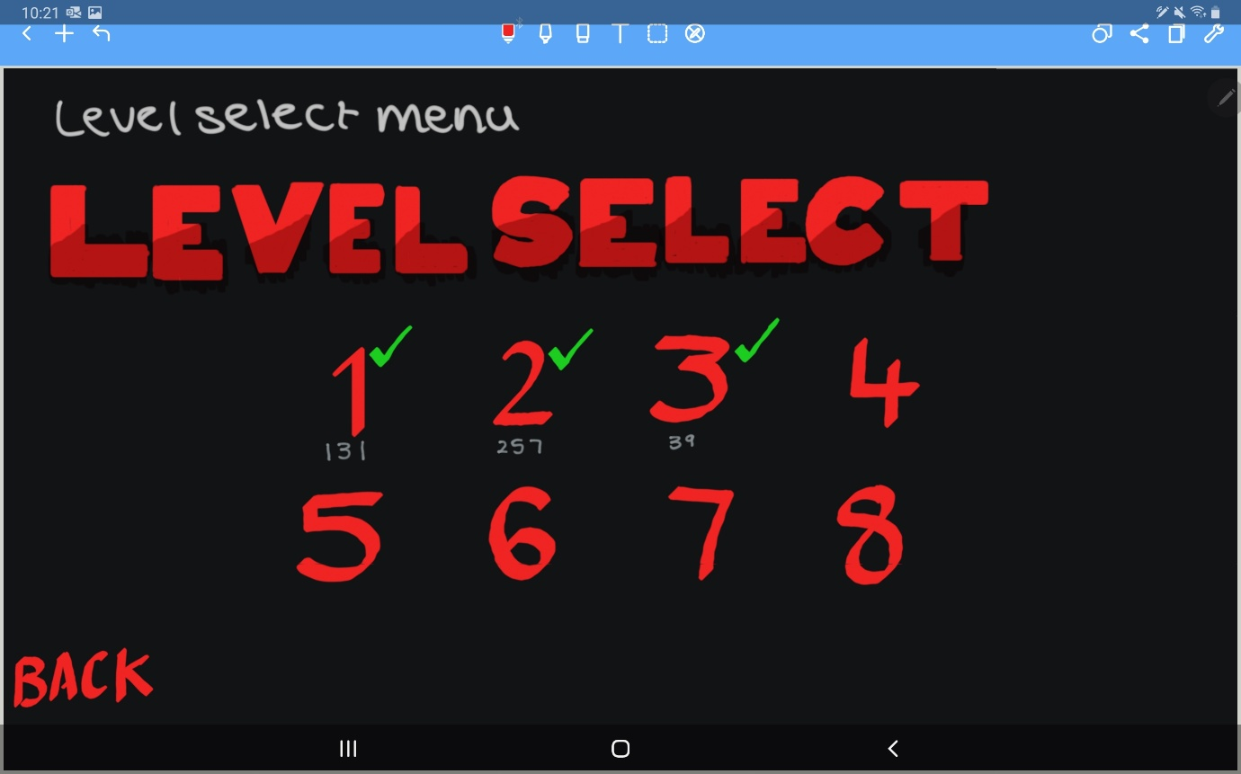

Here is a representation of the level select menu. It will include a list of buttons for every level in the game, indicating which one is which by the level number. As the client would like a high score that is persistent, this would be the optimal place to include it so that the user can easily see what score they have achieved on each level, making it simpler to understand whether they can or have beaten their high score. The user will be able to see their high score below each level, in a dark font. Another indicator that will be made available to the user on this GUI is level completion icons; these will be bright green ticks (to draw the user’s attention to it as this will be an important feature so they do not accidentally replay a level) that will appear above the level number if the user has completed that level. Furthermore, this screen will include a ‘back’ button so that the user can easily return to the main menu. Without this feature, the user would need to begin a level then return to the main menu from the in-game pause menu, which would be highly annoying for the user, discouraging them from playing the game.

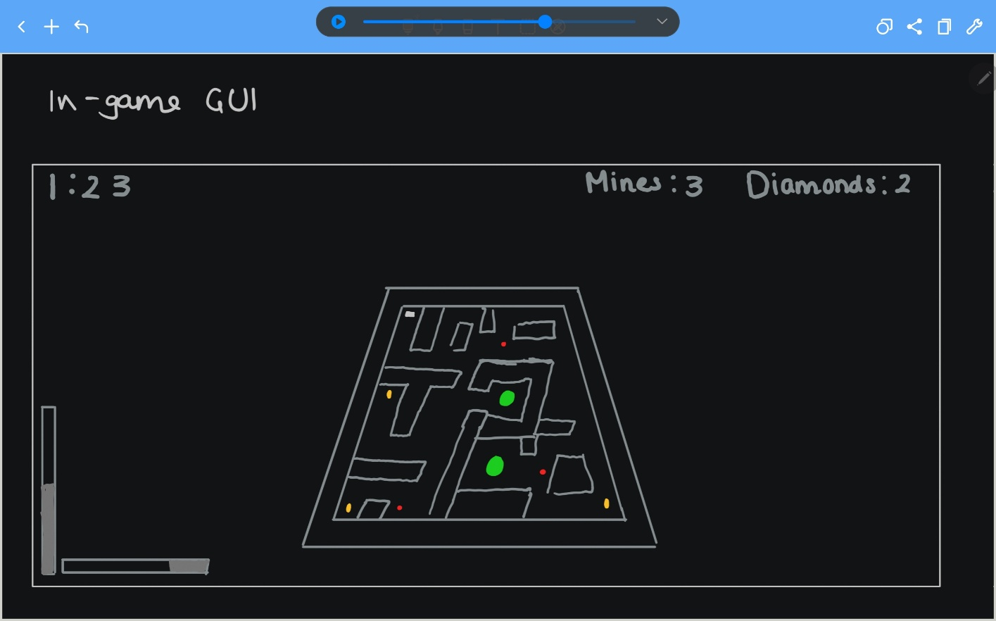**In-game GUI**

This sketch is a representation of the in-game GUI that the user will see when they playing the game. It will include a timer, mines and diamond counters, and rotation sliders. The timer will be necessary so that the user can measure how efficient their progress through the maze is, and, since the level will be restarted when the timer reaches 0, it would be unfair if this information was not clear to the user. Furthermore, the mines counter should be clear so that the user can know whether they have enough mines to be able to place one in the maze. This is important because the game should encourage the player to think logically (as this is a puzzle game) so if they can see how many mines they have, they can better plan out their route through the maze to maximise their score. The rotation sliders will aid the player throughout the level, as they help the player to be more precise with their inputs so they can control the ball better. Without this feature, the player may feel infuriated as the perspective the player views the maze from can be slightly distorted. The text displaying these variables will be a dark grey (against a black background) and stored along the top and bottom edges of the screen so that they do not obstruct the user’s view of the game but light enough so that they are easily visible – without requiring the user to strain their eyes. By contrast, the colours within the level will be bright and emissive, as these are important features of the game, so it should be easy for the user to understand the various objectives of the game.

## **Structure Diagram**

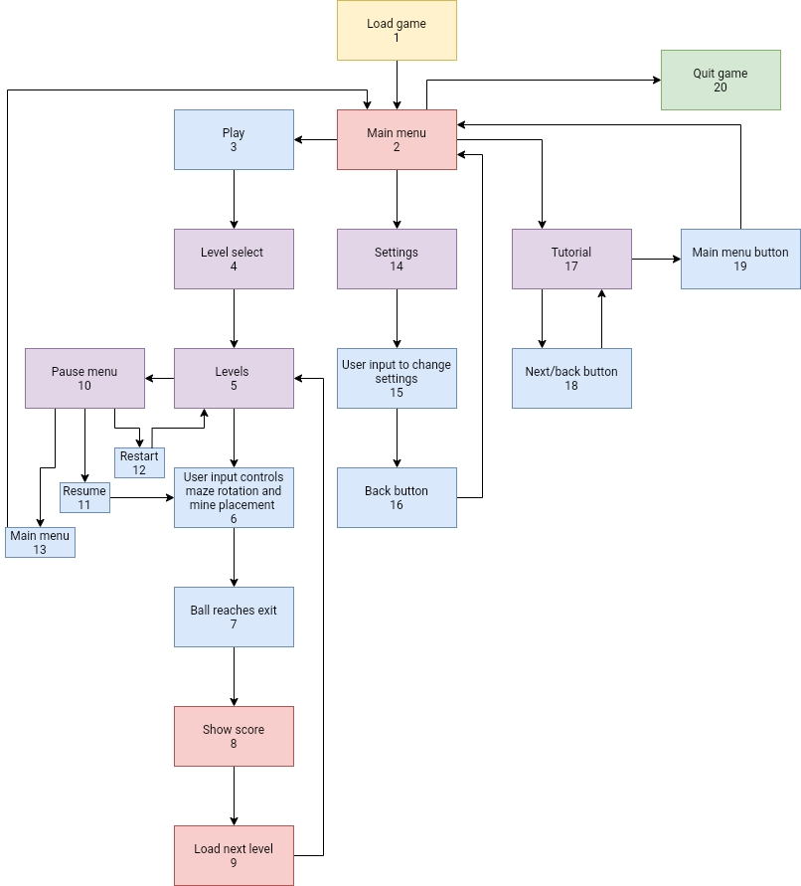

**Key:**

**Blue –** player inputs or results from player inputs. For example, player inputs used to create movement in-game.

**Red –** Scenes/events loaded in the game. For example, the menus or levels within the game.

**Yellow –** Events that cause the program to launch or close. For example, when the user presses the ‘Quit’ button.

**Purple –** combination of red and blue.

**Green –** combination of yellow and blue.

**1 - Load game –** when the file is loaded on the LearnFuture website.

**2 - Main menu –** The player will see the main menu first, where there will be different buttons available to them: Play, Tutorials, Settings, and Quit.

**3 - Play –** When the player presses the play button, the level select panel will be loaded.

**4 - Level select –** Here, the player can see which levels have previously been completed, and what their high scores are, and will be able to select which level number to load next, using buttons, then the corresponding level will be loaded.

**5 - Levels –** The game will contain 8 levels, therefore, the player will be able to choose from any of the 8 levels to play in any order, although it is recommended that they play in the correct order.

**6 - User input controls maze rotation and mine placement –** These are the main inputs in the game and control the main mechanics too. This is how the player will be able to guide the ball through the maze, unlock blocked areas, and reach the exit.

**7 - Ball reaches exit –** When the ball reaches the exit, the level will be completed, leading to showing the score and loading the next level.

**8 - Show score –** During the end sequence, the user’s final score (which will be calculated using a combination of time remaining and diamonds collected) will be displayed in large, bold writing in the centre of the screen before the scene transition occurs.

**9 - Load next level –** The screen will fade to black and the next level will be loaded. If the user is on the final level, the main menu will be loaded.

**10 - Pause menu –** Anytime during the game, the user can press escape to pause the game and bring up a menu. From the menu, they will be able to resume, restart the level, and return to the main menu.

**11 - Resume –** The time scale will return to normal and the user will be able to continue playing the game as though they had not paused it at all.

**12 - Restart –** The current level will be reloaded, so enemies, mines, diamonds, barriers, and the ball will return to their original starting position.

**13 - Main menu –** The user will be able to return to the main menu that they are presented with when the game first loads. From here, they will be able to use every function that was there at the start of the program.

**14 - Settings –** From this menu, the user will be able to alter volume, graphics quality, and the full-screen toggle.

**15 - User input to change settings –** The user will be able to use sliders, drop downs, and toggles to alter the settings to how they want to play the game.

**16 - Back button –** Once the user is happy with the settings, they can press the back button to return to the main menu.

**17 - Tutorial –** The user will be presented with the first of 3 tutorials. The tutorials will explain the main concepts of the game, and keyboard and gamepad controls.

**18 - Next/back buttons –** The user can toggle through the different tutorials using these buttons which will be located in the bottom corners of the screen.

**19 - Main menu –** When the user is on the final tutorial, the next button will be replaced by the main menu button. When the user presses this, they will be returned to the main menu.

**20 - Quit game –** When the user presses this button, the game in the browser will be closed and, if they were in full-screen, full-screen will be exited. If the user wanted to restart the game, they would have to refresh the web page.

## **Variables Table**

|  |  |  |  |  |
| --- | --- | --- | --- | --- |
| **Variable Name** | **Variable scope** | **Data Type** | **Value Ranges** | **Justification** |
| minX, maxX, minZ, maxZ | Local | Float | -1.0 – 1.0 | These variables will set limits for how much the maze can tilt along the x- and z-axes. These need to be local variables because they cannot be changed by other parts of the program, otherwise, the game would break and rotation would become too erratic. Furthermore, these variables will not affect any other objects in the solution so it would be unnecessary to have these variables with a global scope. These values will not change over the course of the program. |
| Speed | Local | Float | 30 | This variable will dictate the speed of rotation for the maze. It will remain local as its value will not be changed over the course of the program, so it should not be accessed and modified by any other part of the program. Speed will be used as a multiplier in the Tilt() function, which will control the rotation of the maze and will be affected by Time.deltaTime so that it remains constant regardless of what device and browser the game will be played on. |
| finalTimeText | Global | Text | N/A | This variable will control what is displayed on the UI when the game is finished. It is global because it will be used to access other scripts and get its value from there. It will use the Text.text = (“”) function to display the final information, which will be gotten when the player has touched the exit of the maze and shown before the screen fades to black and the next level is loaded. This is necessary to implement the feature the client specified where the user can view their previous score. |
| endGame | Local | Boolean | Initially, false  True, False | This private variable does not control the ending of the level, it simply reads when the level has been ended to tell the function in its script to start running. Specifically here, it will get the finalTime to be updated with the total time – the remaining time (both will be controlled in a separate timer script) then update the finalTimeText to be displayed on the UI for the user to see. |
| levelLoader | Global | Class | N/A | This variable will be used to access a class called LevelLoader. It is global because it needs to be able to refer back to functions in LevelLoader so it needs to be able to access that script and be accessed by other scripts to tell it that some condition has become true, therefore it needs to do ‘x’ then call a public function in the LevelLoader script. |
| diamondMultiplier | Local | Integer | 50 | This constant will be static throughout the whole program as there will never be a need for it to change. It will be local because it will never be needed in any other script than FinalScore and will never needed to be known to any other script. It will be used at the end to calculate the final score as a combination of the time left and diamonds collected. This is necessary as it gives the player more incentive to chase the diamonds rather than ignore them for the sake of a quicker time. Without this feature, the diamonds would only be worth one point so there would be no point in collecting them. |
| Level01Tick, Level02Tick,... | Local | Boolean | Initially, false  True, false | This set of variables will be used in the level select menu and will be assigned a value depending on what is stored in Player Preferences for each level. This is local because it only needs to be used in a single area of the program, in a single script. Here, the player preferences will be read and, since they cannot store Booleans, it will use integers ‘0’ and ‘1’ to represent true and false, and update these variables accordingly. |
| mineExplosion | Global | Particle System | N/A | This variable is necessary for instantiating the particle system into the scene when the mine detonates. It needs to be a global variable as it is accessing an external object within the Unity Engine. Without this variable, it would be far more inefficient to instantiate a particle explosion, as it would require it being created and modified all within the ‘Mine’ script, which is too complicated for what is necessary. |
| timeToDetonation | Global | Float | 3.0 | This variable will control how long the mine will be in the scene before it calls the ‘Explode()’ function, thereby destroying itself and the wall segment it has been placed on. This variable will be global for ease of use and testing in the Unity Engine, as it will allow the developer to change the value of the variable during run-time, so it is easy to see what amount of time is needed for the ball to get out of the way of the explosion. |
| enemyPoints | Global | Array of game objects | Initially, null. Can take in any game object | This array will store a series of game objects that are set in the scene, in a logical way so that the script that controls enemy movement from one place to the next. The array will be cycled through, updating the enemy position destination, so that the enemy will move along a set route. This variable needs to be global so that it is less confusing to set the enemy route, as the order of the game objects in the array and the game objects’ positions in the world will both be very important for enemy pathfinding. |
| isGamePaused | Local | Boolean | Initially, false.  True or false | This variable will be used in a function monitoring user input, so that when the user presses escape, the Boolean will turn true, and the pause menu will be enabled. This variable needs to be local so that it cannot be modified by other scripts in the program, which could cause the program to randomly pause during run-time, which would be extremely frustrating for the user. Without this feature, the game would not be able to be paused, which would be inconvenient for the user. |
| canMakeNoise | Local | Boolean | Initially, false, then sets to true | This variable will be needed to prevent the ball from producing the ‘thud’ noise when the scene is loaded. From previous experience, I know this is a problem, which implies that the product is of lower quality than it really is. This is because it is part of the user’s initial impression of the game, so it needs to be of high quality, otherwise, they will not bother continuing to play the game. This variable will be local as it should not be altered by any external parts of the program, only by the ball script. |
| Blocks | Global | Array of game objects | Set to all wall segments that can be highlighted | This variable will hold all game objects (specifically walls) that can be highlighted by the user, when they hold down a certain button. This will be necessary for the highlight function, as it will iterate through the array and compare its relative position to the ball, and check whether its relative distance is less than the value already held in a variable as the smallest distance. If so, the wall is highlighted. Without this function, it would be much harder to check which wall is the closest, and highlight it. It would also be harder to set which walls can or cannot be highlighted (as the walls surrounding the exit should not be able to be highlighted as it would allow the player to place a mine and destroy a wall surrounding the exit so they could ‘cheese’ the level). |
| highlightRange | Local | Float | 1 | This variable will be used for setting a maximum distance that the ball can be from a wall for it to be highlighted. The ball must be within this range for it to highlight a wall. Without this variable, the ball could be several Unity ‘units’ away from the wall (which for the purpose of this product, will be several metres) and the wall could still be highlighted, which would cause two problems: the game would appear to be of poorer quality, as though it had not been properly conceptualised; and it would make placing the mine on the intended wall very difficult, which would be more frustrating than challenging for the user. |
| distanceToClosestBlock | Local | Float | Initially, 100  Range: 0.5 – 100 | This variable is needed for measuring which wall is closest to the ball, therefore which one needs to be highlighted. Each time a wall is recognised as closer than this variable, the value in the variable will be changed to the relative distance between the ball and wall, so it can be checked using the new value. Without this variable, the program would not be able to select a single wall segment that is closest to the ball – it would be confused between all walls that are within the highlight range. |
| minePos | Local | Vector3 | X: -7.5 – 7.5  Y: 1.2  Z: -7.5 – 7.5 | This variable will be used to instantiate a mine in the correct position when the user presses the corresponding button/key. This will be local as it will be created and set within the PlaceMine() method, and based on the information about the closest wall when the button is pressed, so the user and other parts of the program cannot do anything to change the value in this variable. Without this variable, the mine would be placed within the closest wall, so there would be no visual cue for the user, which means that the wall would be destroyed out of nowhere, which would be confusing to the player. |
| Shake | Global | Coroutine | N/A | This coroutine will be responsible for causing the camera to shake when the ball hits the walls of the maze. It will be a subtle shake, used in conjunction with a thud sound. Without this coroutine, the camera shake would not be possible as efficiently, which would make the game feel ‘dead’ to the user, as in they would not be receiving any feedback when the ball hits the wall. |
| Explode() | Local | Method | N/A | This method will be attached to the Mine class and used for checking which wall segments are within a sphere around the mine. This will be necessary so that the walls destroyed by the mine are limited. Without this method, the mine would be destroyed instantly, taking away any visual cues, and would also destroy many wall segments, which means that the user could blitz through the level, without really thinking about a strategic route through the maze. |
| FindClosestBlock() | Local | Method | N/A | This method will be used to measure which wall segment is closest to the ball. It will check whether the wall it is checking in that iteration through the block array is closer than the previous closest wall, and if it is it replaces the value. This function will be local as it will not be accessed by any other part of the program. |
| Tilt() | Local | Method | N/A | This method will control the player’s input in relation to the rotation of the maze. This will rotate the maze, using deltaTime so it is constant on all browsers and computer systems, and the speed of rotation will be controlled by a speed variable in the Floor class. Without this method, the maze will not be able to be rotated, making the game broken. |
| PlayerBall | Global | Class | N/A | This class will contain all variables and methods relevant to the ball and player, including colliding with walls, collecting diamonds, pressing buttons, reaching the exit, and highlighting the nearest wall, among other functions. Without this class, the functions of the ball will be spread throughout the program in an incoherent manner, making the readability of the program worse, so it is easier to maintain. The class will be global as their will be functions in it that need to be accessed by other classes in the program. |

## **Algorithms**

Having completed the success criteria and essential features sections, and identified necessary variables above, I can design the algorithms needed to meet the success criteria using pseudocode.

**Controlling the maze algorithm:**

**Private float speed**

**Private float maxTilt = 45**

**Private float minTilt = -45**

**Tilt():**

**IF horizontal input > 0.1 AND xRotation <= maxTilt THEN //0.1 acts as a ‘dead zone’ in the key (keyboard) and joystick (gamepad) so the inputs are not too sensitive**

**Rotate(Vector3.right * speed) //Vector3.right is a function from the Unity library that signifies the vector (1, 0, 0)**

**ENDIF**

**IF horizontal input < -0.1 AND xRotation >= minTilt THEN //max and minTilt are used to set boundaries for the floor so it cannot be rotated past a certain point; it compares the current rotation against the boundary stored in this variable**

**Rotate(Vector3.left * speed) //Vector3.left is (-1, 0, 0)**

**ENDIF**

**IF vertical input > 0.1 AND zRotation <= maxTilt THEN**

**Rotate(Vector3.forward * speed) //Vector3.forward is (-1, 0, 0)**

**ENDIF**

**IF vertical input < -0.1 AND zRotation >= minTilt THEN**

**Rotate(Vector3.back * speed) //Vector3.back is (1, 0, 0)**

**ENDIF**

**ENDMETHOD**

This method is stored in the Floor class and controls the rotation of the maze based on user input. It defines 3 variables: speed (the speed of rotation of the floor), maxTilt (the boundary that applies to the positive x and z axes), and minTilt (the boundary for the negative x and z axes). This method will be constantly called from the Update() function so each potential input will checked every frame. When the user gives a relevant input, the program will compare the floor’s current rotation value in the corresponding axis with the value held in the max or minTilt variables and if the condition is met, the floor will rotate by 1 Unity ‘unit’ in the correct direction multiplied by the speed variable.

**Reaching the exit algorithm:**

**Private bool endGame = false**

**Public LevelLoader levelLoader**

**OnTriggerEnter(Collider other): //This will only be called when something has touched the trigger collider attached to the exit game object**

**IF other object == “Player” THEN //Compares the object that has just touched the exit with the tag ‘Player’**

**endGame = true**

**ENDIF**

**ENDMETHOD**

**Update(): //Checked every frame**

**IF endGame == true THEN //The following code is only run once this condition has been met (set in the above method)**

**Show final time //This is a summary of what will happen – this will call a method elsewhere to display the right information**

**Show final score //Likewise, this part will also call a method in a different class**

**Private int sceneNumber = Get scene index //This will use the SceneManager in Unity to collect the active build index, the sequence of which will be set when the game is compiled**

**SWITCH(sceneNumber): //Switch statement iterates through all build indexes until it finds the current one (main menu is 0 so does not need to be included)**

**CASE n:**

**Set Level n to ‘complete’ //These two lines will use Player Preferences**

**Set Level n score to finalScore**

**levelLoader.LoadNextLevel() //This will call the LoadNextLevel method in the LevelLoader, which will have a delay then begin a coroutine to load a scene transition and next level**

**BREAK //End of case / switch statement**

**ENDIF**

**ENDMETHOD**

Here is two methods included in the Exit class that are needed for storing any information from the level the user has just completed, and loading the next level after a short delay. The ‘OnTriggerEnter()’ method is used to track when the ball touches the exit, which will be an object within each scene, and sets the endGame Boolean to true when necessary. In the update function, it will check whether endGame has been set to true, and if so, it will run the set of instructions that stores the integer referring to a Boolean of completion of the level, and an integer that is the final score (calculated as a combination of time remaining and the amount of diamonds collected). Finally, it will call a coroutine in the LevelLoader class that makes the scene fade to black before loading the next scene. I have used a switch statement because it will be the most efficient way of iterating through each level to find the current one, so that important information can be saved about each one, then loading the next level if there is one to be loaded, or returning to the main menu if the user has completed the final level.

**Enemy pathfinding algorithm:**

**Public GameObject[] enemyPoints**

**Private int index**

**Private float speed**

**Start():**

**Index = 1 //Sets initial destination to the second index**

**enemyPosition = enemyPoints[0] position //Sets initial enemy position to the first index for ease**

**ENDMETHOD**

**Move():**

**IF enemyPosition != enemyPoints[index] position THEN //Compares current enemy position to the destination index**

**enemyPosition = Vector3.MoveTowards(enemyPoints[index] position, speed) //Unity function ‘MoveTowards’ makes the enemy travel towards the destination position at the defined speed**

**ELSE THEN**

**IF index < (length of enemyPoints) – 1 THEN //Checks that the enemy has not reached the last index in the enemyPoints array**

**Index ++ //If not, then it will increment index so the enemy knows what the next destination is**

**ELSE THEN**

**Index = 0 //If so, it will change index back to the first element so the enemy will repeat its loop again**

**ENDIF**

**ENDIF**

**ENDMETHOD**

These methods will dictate how the enemy pathfinding will work. In the start method, it will initialise the correct position and index of the enemy and enemyPoints, respectively. Then in the Move method, which is called every frame in the Update method, the enemy position is compared with the position of the indexed enemy point and the enemy moves towards the destination point. Every time it reaches its destination, it checks whether there is a higher index in the array, and if not, it reverts index back to zero (which represents the start position of the enemy route) Each enemy point is an invisible game object in the scene.

**Score display algorithm:**

**Update():**

**IF endGame == false THEN //Repeatedly checking whether the ball has reached the exit**

**finalScoreText disabled //This is an abstraction of the C# function ‘.enabled’**

**ELSE THEN**

**finalScoreText enabled //Final score is enabled when the ball reaches the exit**

**ENDIF**

**EndMethod**

**TotalScore(): //Will be called from the Exit class**

**finalScore = timeLeftInSeconds + (diamondsCollected * diamondsMultiplier) //This calculates the user’s final score based on how much time is remaining in the countdown and how many diamonds they collected; diamondsMultiplier will be a constant value**

**finalScoreText.text = (“SCORE: “ + str(finalScore) //Updates the string in the final score text to the value in the above finalScore variable**

**ENDMETHOD**

These methods are used to display the user’s score when they reach the exit of the maze. In the update method, it is checking for the end of game, as this is when it will set the final score text box to visible so that it appears on the UI in the level. TotalScore is calculating what the final score actually is and updating this value in the final score text box. It may need to collect data from other classes, e.g. the diamonds amount will probably be stored in a different class, which is more relevant to diamonds.

**Score display in main menu algorithm:**

**Public Image levelNTick //Level n is just an abbreviation meaning any level number**

**Public Text levelNScore**

**Start():**

**IF PlayerPrefs.GetInt(“LevelN”) == 1 THEN //Checks whether the level n has been completed (completed is 1, incomplete is 0)**

**levelNTick enabled //Enables an image of a tick on the level select panel**

**levelNScore.text = PlayerPrefs.GetInt(“levelNScore”) //Collects score from player preferences and puts it in the text box**

**ENDIF**

**ENDMETHOD**

This method is one half of the score system which is displays the user’s score in the level select menu. This method is attached to a script controlling all functions in the level select menu (this will also include the back button). This method will check whether each level has been completed and if so it will enable the tick image which will be positioned above and to the right of each level button (check the level select menu design from the GUI section), and the score will be set and positioned just below the level button.

**Highlighting walls algorithm:**

**Private GameObject closestBlock**

**Private float distanceToClosestBlock**

**Public GameObject blocks[]**

**Public Material originalBlock**

**Public Material highlightedBlock**

**Update():**

**FindClosestBlock() //Finds the closest block to the ball every frame (constantly updated)**

**IF distanceToClosestBlock <= highlightRange THEN //Checks whether the closest block is within the highligh range so block can only be highlighted when the ball is very close to it**

**IF input = leftShift OR input = LBButton AND closestBlock != null THEN //Checks for the correct user input to highlight the block**

**HighlightClosestBlock() //Calls method that highlights the block**

**canPlaceMine = true //Means the user can only place a mine when the bloc has been highlighted**

**ELSE THEN**

**canPlaceMine = false**

**ENDIF**

**ENDIF**

**ENDMETHOD**

**FindClosestBlock():**

**closestBlock = null //Removes any game object stored in closestBlock**

**distanceToClosestBlock = 100 //Set to a massive number so every block will be closer to begin with – the distance will be narrowed down through every iteration in that frame**

**FOR i in blocks THEN**

**IF blocks[i] != null THEN //Prevents the program throwing errors in levels where no walls are added to the blocks array**

**Float distance = Vector3.Distance(position of ball, position of blocks[i]) //Unity function that takes two positions and uses Pythagoras theorem to calculate the distance between the two**

**IF distance < distanceToClosestBlock THEN**

**closestBlock = blocks[i] //Replaces the value of closestBlock only if a block has been found that is closer to the ball than the value in distanceToClosestBlock**

**distanceToClosestBlock = distance //Replaces closest distance if a closer distance has been found**

**ENDIF**

**ENDIF**

**NEXT i**

**ENDMETHOD**

**HighlightClosestBlock():**

**FOR i in blocks THEN**

**IF blocks[i] != null THEN**

**Set block[i] material = originalBlock //Sets all walls to the original material colour**

**ENDIF**

**NEXT i**

**Set closestBlock material = highlightedBlock //Then, sets the closest block to an emissive, highlighted material. This happens so fast that the wall will just look highlighted the whole time it is supposed to be**

**ENDMETHOD**

These methods are used to select and highlight a block when the user presses the corresponding button. Every frame, the program is finding the closest block to the player, so that it is ready when the user presses the highlight button. The highlight material will be predefined in the Unity Engine, which is the same for the original colour material. When the player highlights the block, it will set every block to the original colour, then set the closest block to the highlighted material. This is so that, if the player moves and a different block becomes the closest block, the previous block will be changed back to normal colour and the new block will be set to the highlighted colour.

**Mines algorithm:**

**PlaceMine():**

**Vector3 minePos = closestBlock(xPosition) , closestBlock(yPosition + 0.59), closestBlock(zPosition) //Creates a variable holding the position that the mine will be instantiated at, but moves it up by 0.59 on the y-axis so that the mine appears on top of the wall and gives a visual cue to the player**

**mineSet = Instantiate(mine, minePos) //Creates a mine object at the defined position**

**mineSet setParent(floor) //Sets the mine as a child of the floor. This is so that, in the delay before the mine detonates, when the player tilts the maze, the mine moves with that rotation**

**minesAmount -- //Decrements the mine counter, which measures how many mines the player has. It cannot place another mine when the counter is 0**

**ENDMETHOD**

This method is contained in the PlayerBall class and controls the placement and positioning of the mine within the scene. It will be called in the update function when all conditions to place a mine have been met (this includes the wall being highlighted – see above) it uses the closestBlock variable which has its value set in the fineClosestBlock method from above. The reason for the y-position being shifted up by 0.59 units is so that the mine is visible on top of the wall; this gives the player an obvious visual cue that a mine has been placed. Finally, minesAmount is decreased. This variable will act as a sort of ‘inventory’ for the player, as they will collect a mine pick-up in the maze which will add three mines to their counter. They must use these mines to find the most efficient and beneficial (i.e. picking up diamonds on the way) route through the maze.

**Mine detonation algorithm:**

**Private bool canExplode = true**

**Update():**

**IF timeToDetonation <= 0 THEN //Only detonates mine after a few seconds countdown**

**IF canExplode THEN**

**Explode()**

**canExplode = false //Setting this to false instantly means that only one Explode method will be called, otherwise it will repeatedly try to destroy walls and itself**

**ENDIF**

**ELSE THEN**

**timeToDetonation -= Time.deltaTime //Countdown starts as soon as mine is instantiated; Time.deltaTime is a Unity function that returns the time since the last frame**

**ENDIF**

**ENDMETHOD**

**Explode():**

**Collider[] wallsToExplode = OverlapSphere(minePosition, 0.1) //This creates an array which will append any colliders attached to objects within the radius (0.1) of the sphere created on the mine’s position**

**FOREACH Collider in wallsToExplode THEN //It then iterates through every element in the new array**

**wallDestroy.DestroyWall() //This is calling a method attached to the Wall class that tells the wall to ‘self-destruct’**

**NEXT collider**

**Instantiate(mine explosion, mine position) //Just before the mine is destroyed, it will instantiate a particle explosion and sound effect at its position. These will both self-destruct a few seconds later**

**Instantiate(explosion sound effect, mine position)**

**Destroy mine //Then, it will destroy itself**

**ENDMETHOD**

These methods will be attached to the mine class; this means they will only start running once a mine object has been instantiated in the scene. Once it exists, it will start a countdown, lasting a few seconds, that allows the player to move out of the explosion radius of the mine. When it explodes, it draws a sphere around itself that appends all colliders it touches to an list. It then iterates through all elements in this array and tells each collider attached to a wall object to destroy itself. This gives the user the impression that the mine has destroyed every wall it is touching. Finally, the mine will create a particle explosion and an appropriate sound effect and destroy itself, leaving only a gap in the maze where a wall once was.

**Barrier algorithm:**

**OnTriggerEnter(Collider other): //Attached to PlayerBall script**

**IF other object = “Button” THEN //Checks whether the ball has just collided with a game object with the tag ‘Button’**

**IF barrier != null THEN //This is checking that the button has a script attached to it (this just prevents any errors occurring by accident)**

**Barrier.OpenBarrier() //Calls method attached to the button object, which causes the barrier blocking the exit to be lowered so the ball can reach the exit**

**ENDIF**

**ENDIF**

**ENDMETHOD**

**OpenBarrier: //Attached to the barrier script**

**Destroy barrier //Tells the mine barrier object to self-destruct**

**ENDMETHOD**

These methods will control the removal of the barrier blocking the path to the exit when the ball touches a button that will be positioned on the floor of the maze. The ball will detect a collision with an object with tag: ‘Button’, then call the OpenBarrier() method in the barrier script. This will cause the barrier to be removed, opening the ball’s path to the exit.

**Pause menu algorithm:**

**Update():**

**IF Input = Escape THEN //This is the keyboard input, there will also be one for gamepad**

**IF isGamePaused = true THEN //Acts as a toggle for whether the pause menu is active or not**

**Resume()**

**ELSE THEN**

**Pause()**

**ENDIF**

**ENDIF**

**ENDMETHOD**

**Resume():**

**Disable pauseMenuUI //Pause menu is a panel on the canvas, this sets it to ignore inputs from the user**

**timeScale = 1 //timeScale is a Unity function that controls the speed of events, 1 is full speed**

**isGamePaused = false //Sets the bool so that the toggle (above) works regardless of what state the game is in**

**ENDMETHOD**

**Pause():**

**Enable pauseMenuUI //Sets it to detect inputs from the user**

**timeScale = 0 //0 makes the game idle**

**isGamePaused = true**

**ENDMETHOD**

**RestartLevel():**

**timeScale = 1 //Need to set time to 1 so that the LevelLoader can work**

**levelLoader.ReloadLevel() //Calls ReloadLevel method in the LevelLoader which will invoke the coroutine to control the scene transition**

**ENDMETHOD**

**LoadMenu():**

**timeScale = 1 //This also needs to be set to 1 to allow the LevelLoader to work**

**levelLoader.LoadMainMenu() //LoadMainMenu will load the level with index 0, as this is what will refer to the main menu in the build settings**

**ENDMETHOD**

**QuitGame():**

**Quit Application //Uses a Unity function to exit the program and stop it running**

**ENDMETHOD**

These series of methods correspond to all buttons available to the user when the enable the pause menu by pressing ‘Escape’ on the keyboard. This includes stopping the game, so that the events in the game do not continue whilst the user has no control over the maze. RestartLevel() calls a method belonging to the LevelLoader class which will collect the active scene index and store it in a variable, then use that variable to load a new scene (which will be the same one, but in its initial state). LoadMainMenu() will also call a method in the LevelLoader class, which sets the needed level index to 0 (as this is the index that will belong to the main menu) then calls the transition animation. Finally, the user will be able to exit the program from within the level. This is for ease of use and uses a simple Unity function (Application.Quit()) to stop the running of the program.

## **Sequence of Algorithms**

This diagram demonstrates how the algorithms I have planned above will be implemented to create a working solution for the client:

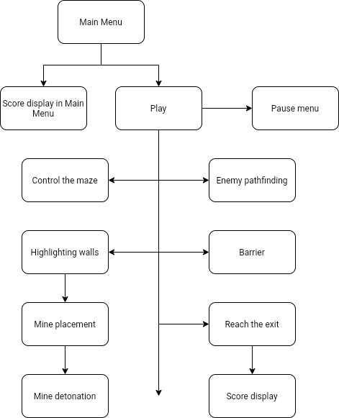This diagram shows how the defined algorithms will be used to create a solution for the client. The program will be made up of many different components and functions, which is why the ‘play’ state has many algorithms branching off from it. Some algorithms can only be run once a specific event occurs, so the arrows show this where it applies. However, for the most part, algorithms like controlling the maze and enemy pathfinding can be run at any point during the course of the main program, so the arrows represent that.

## **Planning Test Data for Development**

### Game State 1: Main Menu

This game state includes the main menu, settings menu, level select menu, and tutorial menu. It covers how the user will navigate between all panels.

|  |  |  |
| --- | --- | --- |
| **What is being tested** | **Data Input** | **Expected output** |
| The ‘play’ button loads the level select menu | Left mouse click on ‘play’ button | Main menu panel is disabled and level select panel is enabled |
| The level buttons in the level select menu load the corresponding levels. | Left mouse click in ‘1’ button. | Scene transition begins and loads the scene with title ‘Level1’. |
| The ‘settings’ button opens the settings menu. | Left mouse click on ‘settings’ button. | Main menu panel is disabled and settings panel is enabled. |
| Volume slider alters the master volume. | Left mouse click and slide on the volume slider. | Master audio channel volume is altered so it is in proportion to the percentage of the volume slider filled. |
| Graphics dropdown changes the graphics quality. | Left mouse click on button, then left mouse click on dropdown menu. | Graphics quality is altered to the setting selected by the player. |
| Fullscreen toggle causes the game to become full screen. | Left mouse click on full screen toggle. | The game becomes full screen if there is a tick in the toggle, and not if there is no tick. |
| ‘Tutorial’ button loads tutorials. | Left mouse click on ‘tutorial’ button. | Main menu is disabled and tutorial panel is enabled. |
| ‘Back’ button loads main menu. | Left mouse click on ‘back’ button. | The current panel is disabled and the main menu panel is enabled. |
| ‘Quit’ button causes the application to close. | Left mouse click on ‘quit’ button. | The program shuts down. |

These tests are all necessary because the main menu will be a crucial part of the user’s first impression of the game. This means that everything needs to work perfectly and seamlessly so that the user has a good first impression of the solution. This is important because the user will not bother playing the game if it feels clunky and unpolished. Without this testing, buttons could load the wrong panel or scene, which would be confusing and frustrating for the player, causing them to turn the program off. Furthermore, the settings menu also needs to work so that the user can tailor the program to their needs, and without this testing, the game may be inaccessible to some users (for example, if they could only play on a small screen, full screen would be preferable to a windowed view so the program is big enough to properly see on their screen).

### Game State 2: Levels

This section will cover all functions working in the levels of the game. This includes tilting the maze, rolling the ball, highlighting walls, placing mines, pressing buttons, and reaching the exit.

|  |  |  |
| --- | --- | --- |
| **What is being tested** | **Data input** | **Expected output** |
| User input causes the maze to rotate. | ‘WASD’ or gamepad joysticks. | When the user presses ‘w’, ‘s’, or the pushes the right joystick, the floor will tilt along the z-axis, and when the user presses ‘a’, ‘d’, or pushes the left joystick, the maze will rotate around the x-axis. |
| Ball rolls using the Unity physics system. | Rotation of maze does not equal 0. | The ball will roll along the maze floor, depending on which way the maze is rotated, so that is travels in the direction of the downward slope. |

These tests are necessary for ensuring that the user can rotate the maze, as this is the core mechanic of the game. This means that the user needs to be able to rotate the maze, and subsequently, the ball needs to move in a suitable direction depending on the rotation so that the user can guide the ball through the maze. Without testing these features, the whole program could be made redundant if these features do not work, or do not work properly. For example, if the controls are inverted or do not do what the user expects, this would make the game too complicated for the user to realistically learn given that they are not expected to spend a long time playing each game on the LearnFuture website.

|  |  |  |
| --- | --- | --- |
| **What is being tested** | **Data input** | **Expected output** |
| Highlighting walls. | Holding ‘left shift’ or LB (or equivalent). | The nearest wall segment to the player will have its material changed to a lighter, emissive colour, then when the player lets go of these inputs, the wall segment returns to its original material. |
| Highlighting walls when the ball is moving. | Holding ‘left shift’ or LB (or equivalent) and tilting the maze so the ball moves. | As a new wall segment becomes closer to the ball than the currently highlighted wall, the new wall will become highlighted and the original wall will return to the original material colour. |
| Placing mines. | Press ‘space’ or RB (or equivalent) whilst holding ‘left shift’ or LB (or equivalent). | A mine object will be instantiated on top of the highlighted wall. |
| Mines destroying walls. | The mine has been placed. | The mine will destroy the wall it has been placed on, then instantiate a particle effect and sound effect, then destroy itself. |

This test table covers user input that directly affects the ball, which encompasses highlighting walls, placing mines, and destroying walls. These tests are necessary because they ensure certain elements are working, and these elements are important to add strategic puzzle features to the game. Without testing these mechanics, the player would be unable to complete some of the later levels that require the player to blow up a path through the maze. This means that the player would not finish the game, so they would not get the best experience from it.

|  |  |  |
| --- | --- | --- |
| **What is being tested** | **Data input** | **Expected output** |
| Pressing button opens barrier. | The ball rolls over the button in the maze. | The barrier blocking the exit will be removed. |
| Reaching exit triggers score display and loads new scene. | The ball rolls over the exit area. | The score will be displayed on the screen, then the screen will fade to black and the next scene will be loaded. |
| Score display. | Reaching exit with 1 minute remaining and no diamonds collected. | The value ‘60’ should appear on the screen before the it fades to black. |

These tests relate to getting to the end of the level, and what happens when the ball gets to the exit. These tests are necessary because the player needs to have be presented with a challenge before they can reach the exit. This also encourages them to explore the maze some more before heading to the exit, so they might try and collect more diamonds. These tests also ensure that the player can access the next level with ease. Otherwise, they would have to open the pause menu to return to the main menu, so they can select the next level from the level select menu. Without testing this, there is a possibility that these mechanics do not work, which would be annoying for the player, which could cause them to turn the game off.

### Game State 3: Pause Menu

|  |  |  |
| --- | --- | --- |
| **What is being tested** | **Data input** | **Expected output** |
| Opening pause menu. | Press ‘escape’. | The game is paused and the pause menu panel is enabled. |
| Closing pause menu. | Press ‘escape’ or the ‘resume’ button. | The pause menu panel is disabled and the game time scale is set back to 1. |
| Restart level. | Press ‘restart’ button. | The scene transition begins and the same level is reloaded so everything is returned to its default position. |
| Main menu. | Press ‘main menu’ button. | The current scene is unloaded and the main menu scene is loaded, along with the scene transition. |
| Quit. | Press ‘quit’ button | The program stops running. |

These tests are necessary for ensuring the buttons all work as intended in the pause menu. This is important because the pause menu will act as a hub of functions for the player, meaning that they can either resume the level, restart, quit, or return to the main menu. Therefore, the pause menu allows the user to return to any scene they want to (within reason). Without testing this, the pause menu may not work, which would give the user a bad playing experience, causing them to turn the product off.

## **Testing Strategies in relation to the project**

Testing will be important throughout the whole development process of the project, as this is what will be used to identify any syntax or logical errors in the program. Therefore, to identify errors in the most efficient way, the project will be tested after each iteration of development, so that when errors do occur, it is much easier to narrow down its location. This is because I will already know which parts have previously worked, and can deduce that any errors are involved in new parts of the program. I will be making use of four testing strategies: white box, black box, alpha, and beta.

White box testing will be used in areas of the program where each event is dependent on the result of a condition. White box testing is where the developer tests small parts of the program alongside its code. This will be particularly relevant in class that controls highlighting the walls, and placing the mines. This will be important in these situations because it will give the developer a closer, more atomic insight into the running of the program so they can implement the program in an efficient way suitable to the previous operations and conditions, and identify logical errors much easier. For example, when testing highlighting the walls, it will be important that the developer can see the value held in the distanceToClosestBlock so they can tell that the value is updating as the ball moves and it updates again when the ball moves closer to a different wall. In this situation, this would help them know if an error is occurring in finding the closest distance, or if it is not updating the material of the wall. Without this testing strategy, identifying the location of errors will be much harder as the only way of finding what works would be by trial and error, which is time-consuming and inefficient.

Black box testing can be used in stages of development where the program has single functions or where individually tested modules start to be implemented into a single, cohesive program. Black box testing is where the developer tests parts of the program independent of the code. Staying with how the highlighting walls and placing mines functions can be tested, black box testing can also be used here to test that the sequence of events and functions work logically. For example, assuming highlighting walls and placing mines has already been individually tested, black box testing can be used to test that when the user presses the correct button, the wall is highlighted, then when they press the other button, a mine is placed. Then, when the mine detonates, a sound effect and particle effect is created. Black box testing is sensible in these areas because it is not important for the developer to know when the button has been pressed or when a function is called because they will have visual and auditory cues that show them that this is happening. Without this testing strategy, testing larger sections of the program would be harder because the developer would be having to deal with all of the data that would be gotten from white box testing, when this is unnecessary for putting together parts of the program that the developer already know work as intended.

Once the solution is built, the developer will complete alpha testing for the product. This will help the developer understand where they have met (or not met) the client’s specification. This is important so that the developer can decide whether they are happy with the solution before they present a final working version to the stakeholders. This testing strategy will involve testing the whole solution to see how it feels to play, and that it follows the structure diagram created previously. Without this type of testing, the developer would not be able to create a user manual or documentation for the game which is cohesive to the user, and would not know whether the game works and meets all the criteria given by the client.

Finally, beta testing will be carried out by a small team of testers, including the stakeholders and members of the target audience. This testing will be essential to the success of the game as the developer will be able to get feedback from potential users to see whether they enjoyed playing the game and get feedback from the client so the developer knows that the client is happy that the game meets their specification. Without this testing strategy, the game may not be of the highest quality before it is released on the LearnFuture website, or levels may have certain exploits that the developer did not manage to identify because they know how the game is supposed to be played.

## **Input Validation**

Input validation will be necessary in the solution to prevent the user being able to use erroneous data. This is because the user should not be able to break the game or use it as the developer has not intended. Without input validation, the user could exploit the game, thereby breaking it, causing them to find cheats that make it too easy or allow them to bypass certain parts of levels. Examples of input validation in my project include: only taking in certain user inputs; only allowing certain inputs when something else is being pressed; only being able to place mines when the mine counter is more than zero; and only being able to adjust master volume within a given range.

Validation will be used to prevent the user from giving more inputs than the program is expecting. For example, the user will only be able to use ‘WASD’ or the gamepad joy sticks to rotate the maze; the maze will not be rotated if they press any other button. Likewise, the walls will only be highlighted when the user presses ‘left shift’ or ‘LB’. This will be achieved by not assigning any functionality to any of the other buttons that are not needed in the solution.

Validation will also be used when the user is placing a mine in the maze. This is because it will only be possible to place a mine if a wall is being highlighted. This means that a mine will only be placed if the user is holding ‘left shift’ or ‘LB’ and if they are close enough to a wall that it is highlighted. Validation will be needed here as well to prevent the user placing a mine if their mine counter is empty (zero), even if a wall is being highlighted. Without this use of validation, the program would not know where to place a mine when the user tells it to, and the user would also not be able to specify which wall they want to place the mine on, making it inaccurate and quite frustrating. Furthermore, the second level of validation is needed to prevent the user exploiting the game and placing an infinite amount of mines around the maze, making the game too easy.

Finally, validation will be used in the settings menu to specify a range of volume that the master channel can be at any given time. This will be between 0 (muted) and 10 (maximum volume/loud). The user input will be regulated by making the user use a slider to alter the volume, as this automatically sets boundaries that the setting can be at. Without this form of validation, the user could set the volume to a negative value, which does not make sense and would cause the program to throw errors, or crash in a worst case scenario. Therefore, it is important that the developer can control what the user can do, pre-emptively.

## **Post-development tests**

|  |  |  |  |  |
| --- | --- | --- | --- | --- |
| **Success criteria** | **Potential test** | **How I will record the data** | **Input data** | **Justification** |
| 5-10 discrete levels. | Getting a member of the target audience to play all levels in the game and give their opinions on each one afterwards. | The data will be a user playing all levels until they have completed the game, and their feedback on each level after they have played them. | The player will be using the keyboard controls, so this will include ‘WASD’, left shift, and space bar. | This test is important because it ensures that the player can access all levels. Without this test, the game may not feel long enough so the player will not be able to enjoy the game properly. |
| Control the maze rotation. | Getting a member of the target audience to rotate the maze. | The data will be the transform.rotation values of the maze object. | The user will be using the keyboard controls, so they will use ‘WASD’. | This test is important because it ensures that the user can operate the maze, as this is how they will be able to guide the ball through the maze to the exit, thereby completing each level. Without this test, the maze may not rotate, making the game unplayable. |
| Simple 3D graphics. | A member of the intended audience will give their feedback on the graphical design of the game. | The user will complete a short questionnaire, giving their feedback on the graphics of the game. | The user will be assessing this whilst playing the game, so they will be using all keyboard inputs available to them. | This test is important it is checking that the game meets the success criteria set out by the client. Without this test, the graphics could be too complex for the platform the game will be run on, impacting performance. Therefore, it is essential that graphics are kept quite simple. |
| New puzzle elements introduced as game progresses. | A member of the target audience will play the whole game (all levels). | The data collected will be a combination of quantitative and qualitive data: it will ensure that the intended new mechanics are introduced as the game progresses, and I will also get feedback from the user to check that it does not introduce them too fast. | The user will be playing the whole game, so they will be using all keyboard inputs available to them. | This test is important because it confirms that I have met the client’s success criteria by introducing new mechanics as the game progresses, but have also done it in a way that is not confusing for the user. Without this test, the user may be put off the game by the overwhelming use of new mechanics, causing them to turn the program off. |
| Main menu including settings, level select, and tutorial menus  Levels can be restarted from the pause menu. | The alpha testing team (i.e. the developer) will use all of these menus to test that they work as intended. | This data will be evidenced using photos and videos of the menus working. | The user will use the left mouse button and the ‘escape’ key to navigate and use the menus. | This test is important because the menus will be essential tools to navigating the separate scenes of the game. Without this test, some functions of the menu may not work, which could give the user a bad impression of the game, particularly if there are faults in the main menu. |
| Scores are stored persistently. | The alpha testing team will complete a series of random levels to set their score, they will then check what score is in the level select menu against the score that appeared on their screen at the end of the level, and check the score again when they restart the game. | The data will be collected using a set of data tables, including the level score and the menu score headings, and videos. | The user will be playing through levels, so they will use all keyboard inputs available to them, then using the menu inputs to return to the level select menu, then use the quit button to exit the game. | This test is important because the user should not feel like they have to blitz the game in one sitting, so that they can compare scores with other players, as this will become frustrating, as it forces the player to sit and play a casual game for a long period of time. Without this test, the scores could change every time the user exits the game, or may not be stored at all, which would be frustrating to them, as they would lose the competitive aspect of the game which encourages discussion with their peers. |
| Ambient music. | Here, the alpha testing team will ensure that the soundtrack plays when the game starts, it is persistent throughout all scenes, that it loops when it is finished, and that its volume can be controlled in the settings menu. | This data will be evidenced using a video of the soundtrack working, and its volume being changed. | The user will need to use mouse clicks to alter the volume, and access different scenes to make sure that the soundtrack works as intended. | This test is important because the soundtrack could have some unidentified faults in it, such as it could be repeated on top of the one that is already playing when a new scene is loaded, or the volume may not be able to be changed, so it could be too overpowering for the user. Without this test, the faults in this feature could become annoying to the user and cause them to turn the game off. |

## **Final checks for post-development**

After development, I will use destructive testing to try and break the game. This will be a final, definitive check of any errors that could still exist in the game, such as spelling mistakes or starting values of variables. There will be some scenarios where it will be possible to test with extreme / boundary data; for example, if the ball reaches the exit with a second left on the timer.

I will use this table when I have finished the development of the product to check that everything is working properly. When everything passes these tests, I will know that the solution is ready to present to the client for final approval and it meets all client success criteria. From there, it can be handed to the beta testing team for feedback.

|  |  |  |
| --- | --- | --- |
| **Actions to test** | **The purpose of testing** | **Passed?** |
| Check all menus and counters for spelling mistakes. | This kind of mistake is quite easy to make, particularly when you spend a long time on a project. However, it will also be an obvious mistake to the client and the user. Therefore, if there are spelling mistakes in the program, it will make the game look like it has been sloppily built so the user will not bother spending as much time playing it. This means the project would be poorly received, if I did not complete final checks for spelling. |  |
| Check all buttons take the user to the correct scene / do the intended purpose. | This is important so that the program makes logical sense to the user. For example, when the user presses the ‘quit’ button, they expect the game to be closed down, and if it does not do that, then the user will not be able to know how to close the game. Without checking this, it could be possible to have missed assigning a function to a button, so the buttons would not work, and the developer would have no idea about it until they start getting .complaints from the users/ |  |
| User begins each level with no mines. | This test is important because the user needs to be encouraged to pick up a set of mines. This adds to the puzzle elements of the game, as the user must first manoeuvre the ball to the mine pick-up before they can use the mines to blow a path through the maze. Without this test, the player may have access to mines as soon as the level loads, meaning that they can bypass a section of the level. This is bad because the levels will be designed to push the player towards the mine pick-up. |  |
| User can only place mines if a wall is highlighted and they have 1+ mines. | This test will be necessary to limit the amount of mines the user can place per level. This is important because it is part of the puzzle elements that are crucial to the client. Without doing this test, the user may be able to endlessly place mines, which means they could effectively blow up the whole maze so that the level becomes too easy. |  |
| User cannot highlight exterior walls or walls surrounding the exit. | This test is important because the player should not be able to destroy walls surrounding the maze, as these are what keep the ball boxed in so it cannot roll off the maze (this would be bad as the program will not be designed to deal with this situation) and so they cannot destroy the walls surrounding the exit. This is important because, if the player can highlight these walls, then they can place a mine on it, so that it is destroyed. If the player could destroy the walls surrounding the exit, they could complete each level very easily by just destroying one wall. Without this test, the player may be able to destroy these walls, which would make the rest of each level redundant. |  |
| User begins each level with no diamonds. | This test is important because the diamonds encourage the player to explore the maze more. Therefore, if they already had diamonds when the level started, they would not bother wasting time collecting diamonds that are positioned in the maze. Without this test, the player could a very high score relatively easily, as the diamonds will be used to calculate a final score at the end. |  |
| Level begins with the correct time on timer. | This test is important because the user needs an adequate amount of time to complete each level. Without this test, levels could have a start time that is too high, which would be bad as there would be no real challenge for the player to complete the level quickly, or too low, which would make the level way too difficult for the player. If this were the case, the player would be more likely to turn the game off in frustration, which, given that the target audience is 12-15, is not what is intended. |  |
| Level begins with barrier blocking the exit. | This test is necessary because the barrier is used to guide the player around the maze, by forcing them to roll the ball over the button, which will be out of the way. This is also important because it gives the player a reason to collect diamonds as well. Without this test, the barrier may not be blocking the exit, which means the path through the maze will be too easy. |  |
| Opening the pause menu pauses the game. | This test is important because pausing the game gives the player some control over the ball. For example, the ball will not roll into the enemy’s path whilst the player is in the pause menu and does not have any direct control over what the ball and the maze is doing. Without this test, the game may not pause, and the player could lose the level, which would be very unfair. This would cause them to turn the game off in frustration. |  |
| Closing the pause menu resumes the game. | This test is necessary because the game needs to resume when the user exits the pause menu. This is for two reasons: when the user presses ‘restart’ or ‘main menu’, the time scale needs to return to normal for the scene transition to work; and when the user presses ‘resume’ the time scale needs to return to normal so that they can keep playing the game. Without this test, the game may not resume, which means that the user would be able to finish the level. This would mean that they should not access the pause menu unless they want to exit the level. |  |
| User can mute and alter the volume levels. | This test is necessary so that the user can alter the volume settings to suit them. This is important because some players may find the sound track too overpowering and distracting, so they should have the option to turn the volume down. Without this test, the volume slider may not work, or may do something unexpected. This would make the game feel unpolished. |  |
| User can toggle full screen. | This test is necessary because the user needs to have the option to make the game window full screen. This is important because some players may need to play in full screen so that the window is large enough to see on a small screen. Without this test, the full screen may not work so the game would be inaccessible to some players. |  |
| User can alter graphics qualities. | This test is important because some of the models used in the game (for the walls) will be made of many polygons, so the user needs to be able to adjust the graphics quality for their device. Without this test, the dropdown menu may not work, or the options in it may not correspond to the right setting. This would be confusing for the user because they would not then be able to understand why setting the quality to ‘low’ would make the game run worse than when it is on ‘high’, for example. |  |
| The next scene is loaded when the ball reaches the exit. | This test is necessary because it allows the user to easily progress through the game. This guides the user through the game, which is easier than telling them to return to main menu to access the next level. Without this test, levels could be loaded in the wrong sequence (e.g. level 2 is followed by level 5) which would be confusing for the player, as the levels are supposed to progressive. Therefore, the player would be thrown into a level that includes placing mines to complete when they are still learning the controls. |  |
| The high score of each level is stored on the level select menu. | This test is necessary because it relates to one of the features specified by the client. This is important because the player should be able to access their previous high scores so that they know what they have to beat. Without this test, the level select menu may present the wrong data to the user. |  |
| The level completion indicator is stored on the level select menu if the level has been completed. | This test is important because the user should be able to tell which levels they have completed. This means that, if they leave the game and come back to it later, they w do not have to remember what levels they completed, as the game will tell them. Without this test, the ticks may not appear, or they may appear on levels that have not been completed, which would be confusing to the user. |  |

# **Development Story**

## **Iterative Development Cycle 1**

### **1.1 – Rotating the maze**

public float maxTilt;

public float minTilt;

public float speed;

void Tilt() //This function controls the rotation of the maze, depending on player input. It is called every frame in the Update() function.

{

if ((Input.GetAxis("Horizontal") > 0.1 || Input.GetAxis("LeftJoyStickHort") < 0.2) && transform.rotation.x <= maxTilt) //0.1 specifies whether 'a' or 'd' has been pressed according to the Unity Engine input settings, and 0.2 acts as a dead zone for the joysticks so they are not too sensitive. When the player presses 'd' or pushes the left joystick to the right, and the maze rotation is not at its boundary:

{

transform.Rotate(Vector3.right * speed * Time.deltaTime); //The maze will rotate in the positive x-direction (to the right). This uses the Unity Function 'rotate()' which updates the object's rotation in a specified direction and with a specified speed, which is moderated by Time.deltaTime

}

if ((Input.GetAxis("Horizontal") < -0.1 || Input.GetAxis("LeftJoyStickHort") > -0.2) && transform.rotation.x >= minTilt) //When the player presses 'a' or pushes the left joystick to the left, and the maze rotation is not at its boundary:

{

transform.Rotate(Vector3.left * speed * Time.deltaTime); //The maze will rotate in the negative x-direction (to the left).

}

if ((Input.GetAxis("Vertical") > 0.1 || Input.GetAxisRaw("RightJoyStickVert") > -0.2) && transform.rotation.z <= maxTilt) //When the player presses 'w' or pushes the right joystick awawy from them, and the maze rotation is not at its boundary:

{

transform.Rotate(Vector3.forward * speed * Time.deltaTime); //The maze will rotate in the positive z-direction (away from the player).

}

if ((Input.GetAxis("Vertical") < -0.1 || Input.GetAxis("RightJoyStickVert") < 0.2) && transform.rotation.z >= minTilt) //When the player presses 's' or pushes the right joystick towards them, and the maze rotation is not at its boundary:

{

transform.Rotate(Vector3.back * speed * Time.deltaTime); //The maze will rotate in the negative z-direction (towards the player).

}

}

This code deals with player input to generate an appropriate response in the rotation of the maze. This allows the player to move each axis independently, or at the same time, according to what kind of movement the player requires to help them navigate through the maze quickly and painlessly. This takes in user inputs from both keyboards and gamepads, to allow the user some amount of flexibility in how they choose to play.

This function is necessary in the program because the second success criteria is ‘responsive controls that operate the axes of rotation separately’, which means this is the essential first step to creating the program to meet my client’s needs. This is also important because the core mechanics of the game is the maze rotating so that the player can guide the ball to the exit. Therefore, without this, the player would not be able to complete the game, so the game would be rendered redundant.

|  |  |  |  |  |  |  |
| --- | --- | --- | --- | --- | --- | --- |
| **Test** | **Purpose of test** | **Input** | **Expected Output** | **Actual Output** | **Proposed remedial action** | **Justification of action** |
| Maze rotates in the x-direction. | This test checks that the maze works as expected when the user gives an input using a keyboard. | Press and hold ‘a’ and ‘d’, but not at the same time. | The maze will rotate to the left then to the right, in the x-direction. | The maze rotates to the left then the right. | No remedial action. | This is because this feature works as intended so does not need to be fixed. |
| Maze rotates in the x-direction. | This test checks that the maze works as expected when the user gives an input using a gamepad. | Push and hold left joy stick to the right, then to the left. | The maze will rotate to the right then the left, in the x-direction. | The maze rotates to the left then right. | This is simply a logical error, so all that needs fixing is the ‘<>’ signs, as they are currently inverted. | This fix is necessary because the maze needs to rotate in a direction that is logical to the user. For example, you would not expect that when you press ‘right arrow’ that a character goes left. |
| Maze rotates in z-direction. | This test checks that the maze works as expected when the user gives an input using a keyboard. | Press and hold ‘w’, then ‘s’. | Maze will rotate away from player, then towards the player, in the z-direction. | The maze rotates away from the player, then towards. | No remedial action. | This is because this feature works as intended so does not need to be fixed. |
| Maze rotates in z-direction. | This test checks that the maze works as expected when the user gives an input using a gamepad. | Push and hold right joy stick forward then back. | Maze will rotate away from player, then towards the player, in the z-direction. | The maze rotates towards the player, then away. | This is also a logical error, so all that needs fixing is flipping the ‘<>’ in the correct areas. | This action is necessary to ensure that the program works as intended, and how the user would expect it to. Without fixing this, the maze rotation would not work logically which could be frustrating for the user. |
| Maze does not rotate further than boundaries. | This test is largely for defensive design, to ensure that the player cannot rotate the maze further than intended, which could potentially break the game. | Hold ‘w’ for a 10 seconds. | Maze will rotate away from player, but will stop rotating when the value in the z-rotation is 15. | The maze rotates to 11.59 in the z-direction. | No remedial action will be needed. | I will not be taking any remedial action because 15 was just an estimation and the product so far works as intended with 11.59 as the boundary. Therefore, it will be a waste of time and resources to figure out how to set the boundary to 15. |
| Can rotate in both directions at once. | This test ensures that the player can use the maze effectively, so that they can guide the ball precisely. | Hold ‘w’ and ‘d’ at the same time. | Maze will rotate to the right and away from the player at the same time. | The maze rotates away from the player and to the right at the same time. | No remedial action needed. | This is because this feature works as intended so does not need to be fixed. |

|  |
| --- |
| **Videos:**   * Maze rotates in both directions simultaneously * Maze rotates in x-direction |

### **1.2 – Moving the ball**

This function in the program does not require any scripting, as I have used Unity’s built-in Physics engine to attach a ‘Rigidbody’ to a spherical object that I will be using as the ball in the maze. This component’s mass has been set to a very small value so that the mass of the ball does not have any effect on the user’s ability to rotate the maze quickly and responsively. If its mass was a large value, then the maze rotation would feel sluggish, or something would happen which would be comical to begin with, but would then become annoying as it means the user cannot easily finish the game, such as the ball being catapulted off the maze because the maze has built up too much velocity because of the ball’s mass. Likewise, the ball’s Rigidbody has also been told to use gravity. This is because, with the ball being so light, it would be possible for the maze to cause the ball to ‘jump’. This would become a problem if the ball could then not collect any diamonds or interact with buttons or enemies in the maze, or even worse, could ‘float’ over the walls. Therefore, it is important that, since the ball can rise, it also needs to fall. This could be used later on in the implementation phase when I add ‘thud’ sound effects to the ball when it collides with other objects.

|  |  |  |  |  |  |  |
| --- | --- | --- | --- | --- | --- | --- |
| **Test** | **Purpose of test** | **Input** | **Expected Output** | **Actual Output** | **Proposed remedial action** | **Justification of action** |
| Ball rolls down the slope of the maze. | Checks that the ball works properly in Unity’s physics engine. | Hold ‘a’ then ‘d’ to recentre the ball, then holds ‘s’. | The ball will roll to the right, then left, then towards the player. | The ball does not roll, it just stops the maze rotating it by trapping it. | Need to add a Rigidbody to the maze object as well. | Currently, the Unity physics engine is only registering one object, but I need it to register the maze as well. Therefore, adding a Rigidbody to the floor will include it in the physics engine. Without this fix, the game would not work. |
| Ball falls off the edge of the maze. | Checks that the ball is affected by gravity. | Hold ‘a’ until the ball rolls off the maze. | The ball will roll to the left then fall off the maze. | The ball rolls to the left then falls off the maze. | No remedial action needed. | This is because this feature works as intended so does not need to be fixed. |
| The ball does not make the maze rotate. | Checks that the maze cannot be rotated simply by the mass of the ball, as this would be unfair. | Press ‘d’ then ‘a’ so the ball is off-centre but stationary. | The maze will not rotate at all once the ball is stationary. | The maze does not rotate once the ball is stationary. | No remedial action needed. | This is because this feature works as intended so does not need to be fixed. |

|  |
| --- |
| **Videos:**   * Failed ball rolling test * Fixed ball rolling test |

### **1.3 – Moving the ball around the maze**

This part of development has no code attached to it, as all that is added is walls in the maze. This is making use of Unity’s scene editor to drag-and-drop some cubes and cuboids into the scene and arrange them into a maze. This is also using very simple shapes, although this is just for the initial stages of development as they will be replaced later with suitable custom 3D models.

This iteration is very important as it is building up the foundation of the game; i.e. it is at this point that a ‘game’ (however simple) has been made. All levels that will be made in the future will be possible because of this early prototype and following tests. Without this iteration, adding further features would be more difficult as I would not be able to know the relative positions or, for example, sensible speeds of different objects. This would also mean that the first time I try using walls in the game would be once I have created the 3D models, which could be completely time-consuming and pointless if it then does not work – at least this way I can have a good idea of what the models needs to be/have to work.

|  |  |  |  |  |  |  |
| --- | --- | --- | --- | --- | --- | --- |
| **Test** | **Purpose of test** | **Input** | **Expected output** | **Actual output** | **Proposed remedial action** | **Justification of action** |
| Walls move with the floor of the maze, without the ball in the maze. | This ensures that, as the player rotates the maze, the walls move at the same time and in the direction, so the maze does not ‘break’. | Hold ‘w’ until it hits the boundary, then hold ‘d’ until it hits the other boundary. | The whole maze will rotate away from the player then to the right. | The whole maze rotates away from the player then to the right. | No remedial action needed. | This is because this feature works as intended so does not need to be fixed. |
| Walls stay in place if hit by the ball. | This is to check that the ball does not move static objects and break their Rigidbodies in the physics engine. | Hold ‘s’ to make the ball collide with the wall. | The ball will hit the wall, but the ball will not move the wall, and the ball will bounce slightly. | The ball hits the wall, the wall does not move, and the ball bounces slightly. | No remedial action needed. | This is because this feature works as intended so does not need to be fixed. |

|  |
| --- |
| **Videos:**   * Walls rotating with the floor of the maze |

### **Prototype 1 – The maze and ball**

In the first development cycle, I have developed a simple prototype of the maze and a ball that rolls around it, depending on user input. The prototype includes the maze rotating, the ball rolling around, and the maze walls functioning as intended too. This has developed a strong foundation for the additional features of the game, and allows me to fully implement a solution that the client will be happy with (based on their success criteria).

|  |  |  |  |  |  |  |
| --- | --- | --- | --- | --- | --- | --- |
| **Test** | **Purpose of test** | **Input** | **Expected output** | **Actual output** | **Proposed remedial action** | **Met the success criteria?** |
| The maze rotation is responsive with keyboard controls. | This test ensures that user input is processed as quickly as possible with keyboard controls, and that the ball does not weigh down the maze. | Pressing and holding the ‘WASD’ keys in any order. | The maze will rotate in the corresponding directions, as and when the user presses one of the ‘WASD’ keys. | The maze does move in the right directions when the ‘WASD’ keys are pressed, and it is very responsive. | No remedial action needed. | This test shows that the success criteria has been met as the maze does rotate responsively with keyboard inputs. |
| The maze rotation is responsive with gamepad controls. | This test ensures that user input is processed as quickly as possible with gamepad controls, and that the ball does not weigh down the maze. | Pushing the left and right joy sticks in any direction and in any order. | The maze will rotate in the corresponding directions, as and when the user pushes one of the gamepad joy sticks. | The maze does move in the right directions when the joy sticks are pushed, and it is very responsive. | No remedial action needed. | This test shows that the success criteria has been met as the maze does rotate responsively with gamepad inputs. |
| The maze rotates on separate axes. | This test guarantees that the user can control the maze’s rotation on separate axes. Without this test, the user may not be able to separate the axes, so they would not have precise control over the maze. | Push and hold ‘W’ for two seconds, then push and hold ‘A’ for two seconds. | The maze will rotate away from the player, then to the left. | The maze does rotate away from the player and then to the left. | No remedial action needed. | This test shows that the success criteria of being able to operate each axis of rotation separately has been met. |
| The ball rolls around the maze in a logical way. | This test ensures that the maze’s rotation causes the ball to move in a way that is sensible to the player. For example, the player would not expect that rotating the maze slightly catapults the ball out of the scene, so it should not do this. | Press ‘W’, then ‘A’. | The ball will roll away from the player, then will start to travel left whilst also moving further away from the player if possible (i.e. not obstructed by a wall). | The ball rolls away from the player, then travels left and further away where this is possible. | No remedial action needed. | This meets the success criteria as it fulfils the essential feature of ‘controlling the maze to move the ball’. |
| The ball cannot roll over, or through, any walls | This test ensures that the colliders and Rigidbodies of the ball and walls are working as intended so that the ball does not break the maze’s layout, or so that the ball cannot phase through the wall, allowing the levels to be exploited. | Press ‘WASD’ keys in a combination that takes the ball through the whole maze. | The ball will roll around the maze, and hit walls, without going through them, and roll along walls. | The ball rolls around the maze, without going through or over any of the walls, and colliding with the walls does not break the maze’s layout. | No remedial action needed. | This test ensures there are no game-breaking bugs in the solution that the player would be able to exploit to make the game too easy. |

These tests show that the first prototype does meet the success criteria of ‘responsive controls that operate the axes of rotation separately’ as the tests have demonstrated that this is true, and I have also implemented the essential feature of ‘rotating the maze to move the ball’. This means that the first prototype has begun to complete some of the client’s specification, although more iterative development cycles will be needed to create a solution that meets all of the client’s needs.

|  |
| --- |
| **Videos:**   * Ball rolling around the maze |

## **Iterative Development Cycle 2**

### **2.1 – Entrance, exit, and loading to a new scene**

public LevelLoader levelLoader; //This is attaches to the exit object

void OnTriggerEnter(Collider other) //Called when an external object collides with the exit object

{

if (other.gameObject.tag == "Player") //Checks that the collision has occurred between the exit and the ball

{

Debug.Log(“Has Reached Exit”);

levelLoader.LoadNextLevel();

}

}

public Animator transition; //This is attached to the LevelLoader object

public float delayTilLoad = 1f;

public void LoadNextLevel()

{

StartCoroutine(LoadLevel(SceneManager.GetActiveScene().buildIndex + 1)); //calls a coroutine that starts a scene transition and loads the scene with the next build index.

}

IEnumerator LoadLevel(int levelIndex) //This is a co-routine

{

yield return new WaitForSeconds(delayTilLoad); //Creates a delay before the scene transition begins

transition.SetTrigger("Start"); //This begins the scene transition animation (fade to black)

yield return new WaitForSeconds(delayTilLoad); //This delay is needed so that the scene transition has a chance to play before the next scene is loaded

SceneManager.LoadScene(levelIndex); //Loads the next scene according to the build settings

}

This set of code comes from two objects: the first code is attached to the exit object (which has a spherical collider attached to it), and the second piece of code is attached to the level loader object. In the exit script, the exit is checking for anything that collides with it. If it is the ball (that is controlled by the player – hence the use of the tag ‘Player’), then it knows that the end of the level has been reached so the player has completed the level and the next level needs to be loaded. Therefore, it calls the LoadNextlevel method attached to the level loader. This method calls the coroutine called ‘LoadLevel’ and gives it the next scene index as a parameter. The coroutine is responsible for playing a scene transition (fade to black) and loading the scene with the index it has just been handed. Overall, this means that the next level is loaded when the player reaches the exit.

This feature is necessary because it means that there is a way for the game to signify to the player that they have completed a level. Furthermore, ‘reaching the exit’ is one of the specified essential features so it definitely needs to be included in the final solution. Without this feature, the player, currently, would have no way to continue to the next level, so they would be stuck in the first level forever. Even as the game develops and the main menu is added, it would still be inconvenient for the player to have to return to the main menu to select a new level each time they complete one. Therefore, this feature makes the game easier to use for the player, adding to their experience in a positive way.

|  |  |  |  |  |  |  |
| --- | --- | --- | --- | --- | --- | --- |
| **Test** | **Purpose of test** | **Input** | **Expected output** | **Actual output** | **Proposed remedial action** | **Justification of action** |
| When the ball touches the exit, the collision is detected and dealt with. | This test is important for breaking down the process that has just been implemented. By adding in a ‘Debug.Log’ line in the exit script, I can see whether the collision has been detected. I will disable the levelLoader for this test. | Ball touches the exit object. | ‘Has Reached Exit’ will be printed to the console as the ball touches the exit. | ‘Has Reached Exit’ is printed to the console but not as soon as the ball touches the exit. | To fix this issue, I need to enlarge the size of the collider attached to the exit object. | This will fix the problem as it means that the collision detection will occur earlier so that, to the player, it looks as though the game has recognised that the level has been completed as soon as the ball touches the exit. Without this fix, the end sequence is called but it happens too late so, to the player, it looks like the ball has to be almost in the centre of the exit object for the end to be called, which does not make much sense. |
| The end of the level is recognised when the ball rolls over the exit object quickly. | Unlike the previous test which uses extreme test data, this test reflects what the user is most likely going to do as the ball reaches the exit, therefore, it is important that this also works as intended. I will disable the levelLoader for this test. | Ball rolls over the exit object. | ‘Has Reached Exit’ will be displayed on the console when the ball rolls over the exit object. | ‘Has Reached Exit’ is printed out as the ball rolls over the exit object. | No remedial action needed. | This feature now works as intended so there is no point altering it, as that would waste time and resources. |
| The level loader starts the scene transition and loads the next scene. | This test ensures that the scene transition and loading the next scene work cohesively so that there are no long delays before the scene moves onto the next, as this would appear disjointed to the user, reducing their overall impression of the game. | This will use a temporary input of ‘E’ to call the ‘LoadNextLevel’ method. | The scene will fade to black, and when it is completely black, a new scene will be loaded and it will fade from black. | The scene fades to black, and a new scene is loaded, which fades from black. | No remedial action needed. | This feature now works as intended so there is no point altering it, as that would waste time and resources. |
| The scene transitions when the ball rolls over the exit. | This test Is putting together the features from the previous tests to ensure that they all work together. This test is important as one last check to ensure that it all works as intended. | Use ‘WASD’ keys to roll the ball over the exit. | When the ball rolls over the exit, the scene transition will begin and a new scene will be loaded. | The scene transition begins and a new level is loaded when the ball rolls over the exit. | No remedial action needed. | This feature now works as intended so there is no point altering it, as that would waste time and resources. |

|  |
| --- |
| **Videos:**   * Scene transition when ‘e’ pressed * Scene transition when ball reaches the exit |

### **2.2 – Diamonds and diamond counter**

public Text diamondNo;

public int diamondAmount;

void Start()

{

diamondAmount = 0; //Ensures that the player always starts with a diamond value of 0

}

void OnTriggerEnter(Collider other) //The collision takes a parameter that is the external object

{

if (other.gameObject.tag == "Diamond") //Checks whether the ball object has collided with a diamond object

{

CollectDiamond(other); //Calls this method (see below)

}

}

void CollectDiamond(Collider other) //Takes the diamond that has been collided with as a parameter so it can be easily destroyed

{

Destroy(other.gameObject); //Destroys the diamond and all components attached to it

diamondAmount++; //Add one to diamond counter

diamondNo.text = (diamondAmount); //Updates the text in the diamondNo UI element

}

These methods are both to the ball object. They control what happens when the ball collides with a diamond: it should appear to the player as though it has been picked up and their diamond counter should increase. This is done by checking for any collisions the ball has, and if it collides with a diamond, the diamond is destroyed and the diamond counter is increased. The user has a visual representation of how many diamonds they have picked from the text labelled ‘Diamonds: ‘ on their UI.

These features are necessary to give the player more incentive to explore the maze more instead of beelining for the exit. This is important to introduce more puzzle elements to the game, whilst also not forcing the player through a hard challenge that they may feed too frustrating – this way they have the choice of tackling the puzzle. Without these features, the player would have any way of adding to their score (when it is added) in a substantial way, so they would have no choice between trying to speed through each level, or taking the time to collect each diamond, in order to maximise their score.

|  |  |  |  |  |  |  |
| --- | --- | --- | --- | --- | --- | --- |
| **Test** | **Purpose of test** | **Input** | **Expected output** | **Actual output** | **Proposed remedial action** | **Justification of action** |
| The diamond is destroyed when the ball collides with it. | This test ensures that a visual cue is given to the player when the ball collides with the diamond. This is important so that the player can clearly tell when they have collided with the diamond so that they know to move onto the next part of the maze. | Use ‘WASD’ keys to manoeuvre the ball to a diamond then collide with it. | The diamond object will be destroyed so it is no longer present in the scene. | The diamond object is destroyed. | No remedial action needed. | This test has shown that the diamond object is destroyed as intended, therefore no remedial action is necessary. |
| The diamond counter is incremented by one when the ball collides with a diamond object. | This test is important as it checks that the UI text element updates properly when the ball collides with a diamond. Without this test, it may not update at all or may not stop incrementing and updating, which is obviously not intended. | Use ‘WASD’ keys to manoeuvre the ball to a diamond then collide with it. | The diamond counter is incremented by one. | The counter is incremented but it does no longer say ‘Diamonds:’ | I need to change the line that updates the text so that it prints: ‘Diamonds:’ + diamonds. | This fix is necessary so that the UI elements stay consistent throughout the whole game. If this wasn’t the case, the player may try to check how many diamonds they have collected but would not know which UI element refers to diamonds that have been collected. Therefore, this fix is for clarity to the user. |
| The diamond counter should not increment with every collision. | This test is important as it ensures that the diamond counter is not increased with every collision, as this bug would allow the player to get a ridiculously high score just by hitting the ball off the walls of the maze. | Use ‘WASD’ keys to manoeuvre the ball to a diamond then collide with it, then collide with a wall. | The counter should go up to a value of one, but should not increase beyond that. | The counter maxes out at one, and does not increase when walls are hit. | No remedial action needed. | No action is needed here as the feature works as intended and cannot be exploited by the player. |
| The diamond’s collider is also destroyed when the ball collides with it. | This test is important as it ensures that the player cannot keep rolling over one spot in the maze to infinitely increase their score. Without this test, the game could potentially be exploited by the player making it unfair. | Use ‘WASD’ keys to manoeuvre the ball to a diamond then collide with it, then roll back over the spot where the diamond previously was. | The counter should increase once when the ball initially collides with the diamond, but it should be increased again when the ball rolls over the same area. | The counter increases to one, but does not increase again after this. | No remedial action needed. | No action is needed here as the feature works as intended and cannot be exploited by the player. |

|  |
| --- |
| **Videos:**   * Failed collecting diamond and UI counter * Fixed collecting diamond and UI counter |

### **2.3 – Barriers and buttons**

public Barrier barrier1;

void OnTriggerEnter(Collider other)

{

if (other.gameObject.tag == "Button") //Checks whether the ball has collided with a button

{

if (barrier1 != null) //Ensures that an object has been assigned to this value so that it does not throw an error

{

barrier1.OpenBarrier(); //Calls open barrier which destroys the barrier object

}

}

}

void Start()

{

transform.position = new Vector3(transform.position.x, 1 , transform.position.z); //Sets the initial position so that it is definitely blocking the player's path

}

public void OpenBarrier()

{

Destroy(gameObject); //Deletes itself and all components attached to it

}

This piece of code controls the functions relevant to the player colliding with the button and, subsequently, removing the barrier that blocks the player’s path. The first set of code belongs to the ball object, and checks for when the ball has collided with the button. There is a bit of defensive design included as it also checks that it has a class value in ‘barrier1’ before it calls a method in that class. This is important so that random errors are not thrown when the player presses a button. Likewise, I do not expect that there will be a scenario where this occurs; it is mainly for testing purposes. Furthermore, I have also labelled the barrier class as ‘barrier1’. This is because it allows for expandability later on in development, such as if I decide to add a level where there are multiple barriers to be opened before the ball can reach the exit. The second piece of code is attached to the barrier object. When the scene is initialised, its y-coordinate is set to 1, which is to ensure that it is at the correct height to prevent the ball from being able to go through it. When the ball touches the button, the barrier is immediately destroyed, opening a path through the maze for the player.

This feature is important as it forces the player to go the long way through the maze, which will also encourage them to collect diamonds as they traverse the maze. This is important to add more puzzle elements to the game, as this is what my client has asked for in the specification. Without this feature, the would not be encouraged to explore the outer reaches of the maze that deviate from one of the paths to the exit. This would be bad as it would make the game too easy and would not challenge the player in any way.

|  |  |  |  |  |  |  |
| --- | --- | --- | --- | --- | --- | --- |
| **Test** | **Purpose of test** | **Input** | **Expected output** | **Actual output** | **Proposed remedial action** | **Justification of action** |
| The ball cannot roll through or go over the barrier. | This test ensures that the player cannot exploit a bug in the program and reach the exit without first navigating the maze to reach the button to open the barrier. Without this test, the ball could roll through the barrier making it a pointless addition to the game. | Use ‘WASD’ keys to roll the ball to the barrier without pressing the button. | The ball will not roll through or over the barrier. | The ball is stopped by the barrier and does not roll any further. | No remedial action needed. | No action is necessary here as the feature works as intended so it would be pointless trying to fix it, as there is nothing to be fixed. |
| Errors are not thrown if the ball rolls over the button again. | This test is important as the user should not be getting any error messages or crashes as they play the game, as this reduces the immersion of the game. Without this test, the user could receive error lists which, given the target audience is young teens, they may not know what to do with, which would give them a bad impression of the product. | Use ‘WASD’ keys to roll over the button twice. | The barrier opens the first time, but no errors are thrown. | Barrier opens and no errors occur. | No remedial action needed. | No action is necessary here as the feature works as intended so it would be pointless trying to fix it, as there is nothing to be fixed. |
| Pressing the button opens the barrier. | This test ensures that this new feature works as intended. This is important because it adds a new puzzle element to the game which fulfils the client’s specification. | Use ‘WASD’ keys to press the button. | The barrier will be removed when the ball rolls over the button. | The barrier is removed. | No remedial action needed. | No action is necessary here as the feature works as intended so it would be pointless trying to fix it, as there is nothing to be fixed. |
| Destroying the barrier also destroys its collider. | This test is important because I need to know that removing the barrier visually also removes physically so that the ball can roll through the path. Without this test, it would be confusing for the player because it would look to them as though there is path to the exit but if the collider remains then they would still not be able to reach the exit. | Use ‘WASD’ keys to roll over the button then roll through where the barrier was. | The barrier should open and the ball should be able to roll through the space where the barrier was. | The barrier opens and the ball can also roll through the space. | No remedial action needed. | No action is necessary here as the feature works as intended so it would be pointless trying to fix it, as there is nothing to be fixed. |

|  |
| --- |
| **Videos:**   * Ball cannot go through barrier until button is pressed |

### **Prototype 2 – Objects in the maze**

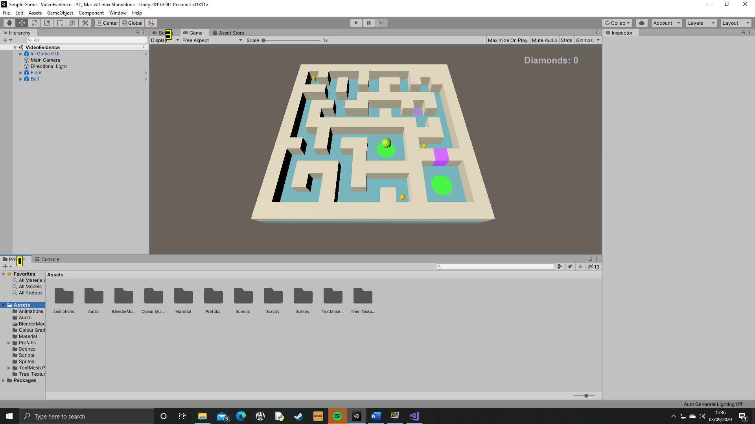

In the second iteration of the development cycle, I have built upon the features from the previous development cycle by adding objects that the ball interacts with in the maze. This includes, entrances and exits, diamonds, and buttons. This prototype is essential to further developing the product as this adds the features of the game that make it more interesting and challenging for the player, so that they can be easily implemented in other levels of the game.

|  |  |  |  |  |  |  |
| --- | --- | --- | --- | --- | --- | --- |
| **Test** | **Purpose of test** | **Input** | **Expected output** | **Actual output** | **Proposed remedial action** | **Met the success criteria?** |
| The exit works as intended. | This test ensures that the exit object correctly starts the scene transition and causes the next scene to be loaded. This test is important because it makes it easier for the player to access the next level of the game, which is necessary to maintain good player experience. | Use ‘WASD’ keys to roll over the exit. | The scene will fade to black, then the next scene will be loaded. | The scene fades to black and the next scene is loaded. | No remedial action needed. | This test shows that the success criteria is being met, as the exit does work as intended, and the exit is one of the pre-defined essential features of the game. |
| The diamond pick-up works as intended. | This test is important to check that the diamond pick-ups work, so that they can be used again later in the game. Without this test, I have no way of knowing if the diamonds do work, so implementing them later in the game could cause bugs to arise. | Use ‘WASD’ keys to roll the ball into a diamond. | The diamond should be destroyed. | The diamond is destroyed. | No remedial action needed. | This test shows that the success criteria is being met, as the diamonds do work as intended, and diamonds are one of the pre-defined essential features of the game. |
| The diamond counter works as intended. | This test guarantees that the diamond counter works as well as the diamond pick-ups. This is important because the user should be able to easily tell how many diamonds they have collected on each level, as this will eventually contribute to the score they achieve on each level. | Use ‘WASD’ keys to roll into diamond. | The diamond counter should be incremented. | The counter is increased by one. | No remedial action needed. | This test shows that the success criteria is being met, as the diamond counter does work as intended, and the diamond counter is one of the pre-defined essential features of the game. |
| The button and barrier work as intended. | This test ensures that the button and barrier work properly. This is important because the button must work so that the player can exit the maze. At the same time, the barrier also needs to work so that the player is forced to take a longer route around the maze to reach the button. | Use ‘WASD’ keys to roll the ball over the button. | The barrier should be destroyed. | The barrier is destroyed and the ball can roll through. | No remedial action needed. | This test shows that the success criteria is being met, as the button and barrier both work as intended, and they are part of the pre-defined essential features of the game. |
| All of these features add a new puzzle element to the game. | This test is important as it will help me understand whether these new features meet the client’s success criteria and essential features, as this is what I will measure the success of the solution against. Without this test, the client may not feel that the project meets their needs, and will not be happy or satisfied with the project. | Use ‘WASD’ keys to play through the level, and collect all the diamonds and reach the exit. | The features will give additional puzzle elements to the game, meaning it takes longer to complete the level. | It does take longer to complete the level, and the new features do give the puzzle elements to the game. | No remedial action needed. | This test shows that the new features do fulfil the first success criteria of ‘levels with challenging puzzle elements’. The features also meet the some of the essential features, including diamonds and barriers. |

This prototype once again meets some of the client’s success criteria and essential features, although more work is still needed to meet all of them. Even though, only some of the criteria has been met in this development cycle, the features that have been implemented here can be used later on in development to complete more criteria.

## **Iterative Development Cycle 3**

### **3.1 – Enemies**

public Transform enemyStart;

public Transform enemyDest;

private bool goToStart;

private bool goToDest;

public float speed;

void Start()

{

transform.position = enemyStart.position;

goToDest = true;

}

void Update()

{

if (goToStart == true) //These statements are used to call the mthods every frame so that the enemy's position and destination is always being updated

{

GoToStart();

}

else if (goToDest == true)

{

GoToDest();

}

}

void GoToDest()

{

if (transform.position != enemyDest.position) //This is checking whether the enemy's position is equal to the position of an invisible object in the scene

{

transform.position = Vector3.MoveTowards(transform.position, enemyDest.transform.position, speed * Time.deltaTime); //The enemy should move towards the destination marker

}

else //When the enemy has reached their destination...

{

goToDest = false;

goToStart = true; //They should start heading towards their original position

}

}

void GoToStart() //This method is identical to GoToDest but in reverse; i.e. the enemy travels to their original position

{

if (transform.position != enemyStart.position)

{

transform.position = Vector3.MoveTowards(transform.position, enemyStart.transform.position, speed * Time.deltaTime);

}

else

{

goToStart = false;

goToDest = true;

}

}

This set of code controls the movement of enemies around the maze. The enemies will continuously move between two points. Currently, the ball has no way of interacting with the enemies, although this will be implemented shortly. The code works by measuring whether the enemy’s position is equal to the position of an invisible marker in the maze. If it is, then the enemy is told to travel to the other marker.

This feature is necessary to add an extra challenge to the game. This is important as, before now, there has been no way to fail so the game is not particularly hard in any way. Furthermore, adding enemies creates more puzzles for the player. For example, they may have to learn the speed of an enemy so that they can time rolling the ball through a gap to reach diamond. Without this feature, the game would be fairly boring, which is not what the client is after, given that the target audience is young teens.

### **3.15 – Refurbished enemies**

[This page has been added retrospectively as I believe that the previous implementation did not provide an adequate solution. I had realised this before testing the previous version.]

public GameObject[] enemyPoints; //This is an array of the invisible markers in the maze

private int index; //Index acts as a variable to hold the destination marker

public float speed;

void Start()

{

index = 1; //Tells the enemy to start moving to the next marker

transform.position = enemyPoints[0].transform.position; //Sets the initial position of the enemy when the scene is intialised

}

void Update()

{

Move();

}

void Move()

{

if (transform.position != enemyPoints[index].transform.position) //If the enemy is not at the destination...

{

transform.position = Vector3.MoveTowards(transform.position, enemyPoints[index].transform.position, speed * Time.deltaTime); //...move towards it

}

if (transform.position == enemyPoints[index].transform.position) //However, if the enemy is at the destination...

{

if (index < enemyPoints.Length - 1) //The destination changes to the next invisible marker

{

index++;

}

else

{

index = 0; //If the enemy has reached the final object in the enemyPoints array, then it needs to be reset back to the first object so the enemy travels back to that and starts a new cycle

}

}

}

This implementation builds upon the features present in the original code. For example, it still using invisible markers in the maze to tell the enemy its route, and is also using Unity’s ‘MoveTowards()’ function. However, this solution is more practical because it is designed to give an enemy a route of any size, which means their route is not limited to a straight line. I changed this because, as I was pre-emptively designing the first levels, I realised that having all enemies follow a straight line would be too easy for the player. The way of fixing that problem with what I had, was to over-populate the maze with enemies; this then makes it too hard for the player. This solution also allows for more interesting puzzles, for example, if an enemy can follow a complex L-shaped circuit, then player might be forced to follow the enemy around their circuit to reach a diamond, or could try to squeeze through in the opposite direction to the enemy’s path and reach the diamond before the enemy comes round to the ball. Evidently, this is a better solution.

The difference with this solution is that it uses an array, and instead of telling the enemy where the next destination is, it is keeping the destination variable the same but changing its value. This leads to the index of the array being incremented each time the enemy reaches a marker. Alternatively, the index could be set back to 0 if the enemy has reached the final marker in the array. This is so the enemy will infinitely repeat the same circuit.

This feature is necessary for the same reasons as listed previously in 3.1.

|  |  |  |  |  |  |  |
| --- | --- | --- | --- | --- | --- | --- |
| **Test** | **Purpose of test** | **Input** | **Expected output** | **Actual output** | **Proposed remedial action** | **Justification of action** |
| The enemy follows its designated route. | This test ensures that the enemy does follow its invisible markers so that I can easily define the routes of each enemy when they are added to each level. This test is important as this feature will be used later on in development to dd more enemies to the game. | Load the level, no further input needed. | The enemy will move in a square, turning a corner when it has reached a marker. | The enemy does complete its route. | No remedial action needed. | There will be no need to waste time and resources fixing something when there is no error, therefore no fix is necessary. |
| The route is reset when the enemy travels back to the initial marker. | This test is important as it will show that the enemy will continue around its route while the scene is active, meaning that the player can learn the enemy routes to plan their path through the maze. Without this test, the markers could be deleted or moved as the enemy passes them which would break the game in a matter of seconds. | Load the level, no further input needed. | The enemy will go around its route twice, with no change in the route in the second pass. | The route is not changed in the second pass. | No remedial action needed. | There will be no need to waste time and resources fixing something when there is no error, therefore no fix is necessary. |
| The route can contain as many markers as necessary. | This test is important so that I can check that this implementation of enemy pathfinding succeeds where the previous one fails. The enemy needs to be able to follow any route I define for it. Without this test, the amount of markers I can use may be limited, which could cost me more time later on if I discover it after planning the levels. | In the Unity editor, create an enemy path with twenty markers. | The enemy should be able to complete its route. | The enemy can do the route. | No remedial action needed. | I cannot see a situation where the enemy will need a route with any near as many as twenty markers, as it would be too complex for the player, and I am also aware that the longer the array, the more memory it is using during run-time, so this works fine and does not need fixing. |
| The enemy can follow the route infinitely. | This test is a bit exaggerated – once the timer is added there will be a limit to how long a scene will be loaded for before it is reset, but I still need to test that the enemy will follow its route for a substantial amount of time so that I know it will work regardless of what the time limit is set to. | Load the level, no further input needed. Leave it running for twenty minutes. | The enemy should continue following its route for the whole duration of the test. | The enemy follows its routes for twenty minutes. | No remedial action needed. | There will be no need to waste time and resources fixing something when there is no error, therefore no fix is necessary. |
| The enemy can still follow its route even when the maze is being rotated. | This test is the most important one as the enemy needs to still be able to follow its route whilst the player is playing he game and rotating the maze to roll the ball to the exit. Without this test, a silly mistake could have been made that stops this feature from working. | Use ‘WASD’ keys to rotate the maze. | The enemy should still follow its route which will adapt to the rotation of the maze. | The enemy phases through the maze as it rotates as the markers do not move with the maze. | I need to attach the enemy markers to the maze object as a child. | This will fix the issue as it will make the markers position relative to the maze’s. This means that the markers will move as the maze rotates so to the player, the enemies’ routes will still the same as they rotate the maze. Without this fix, the game would not be playable, so the success criteria would not be met. |

|  |
| --- |
| **Videos:**   * Enemies follow their routes * Failed route moves with maze rotation |

### **3.2 – Player-enemy collision**

public LevelLoader levelLoader;

public ParticleSystem deathParticles;

private bool gameOver = false; //Initially set to false as the game only wants to ended when the ball hits the enemy

void Update()

{

if (gameOver == true)

{

GameOverSequence(); //Calls function that handles ending the game

}

}

void OnTriggerEnter(Collider other)

{

if (other.gameObject.tag == "Enemy") //Checks that the ball has collided with an object with the enemy tag

{

gameOver = true; //Allows the game over sequence to be called from the update function

void GameOverSequence()

{

Vector3 pos = new Vector3(transform.position.x, transform.position.y + 1.0f, transform.position.z); //Gets and alters the variable containing the position of the ball

Instantiate(deathParticles, pos, Quaternion.identity); //Creates particle explosion that signifies the ball has touched the enemy

levelLoader.ReloadLevel(); //Uses the level loader to restart the level

gameOver = false; //Stops this method being called repeatedly

Destroy(gameObject); //Finally destroys the ball so that the end of the level is fully dealt with before it is deleted

}

public void ReloadLevel()

{

StartCoroutine(LoadLevel(SceneManager.GetActiveScene().buildIndex)); //Calls a coroutine that starts the scene transition and reloads the scene

}

This code deals with the player-enemy collision. This adds the first game over mechanic in the game. In this scenario, the scene transition will start and the level will be restarted. This uses the same coroutine as the one created in 2.1. A benefit of using the coroutine here is that I can specify a delay before the scene transition starts, which means that the particle explosion has enough time to play before the scene is reloaded.

This feature is necessary to implement a way of losing in the game. This means that there is a greater challenge for the player and more interesting puzzles can be made. Furthermore, the ‘GameOverSequence()’ can be reused later in development when I add a timer. Without this feature, there would be no way for the player to fail, so the game would be too easy. This would be bad as the game is designed to stretch the player’s problem-solving skills so that the product represents a career in archaeology.

|  |  |  |  |  |  |  |
| --- | --- | --- | --- | --- | --- | --- |
| **Test** | **Purpose of test** | **Input** | **Expected output** | **Actual output** | **Proposed remedial action** | **Justification of action** |
| Colliding with the enemy destroys the ball. | This test ensures that the player will get a visual cue when the ball hits an enemy. This is important so that the player can easily tell when they have failed the level. Without this test, the ball may not be destroyed, meaning that the whole game over sequence would occur but the player would not see that it is because they have collided with an enemy. | Use ‘WASD’ keys to make the ball roll into an enemy. | The ball will be destroyed. | The ball is destroyed. | No remedial action needed. | No fix is needed as the feature works as intended so there is no point is wasting time. |
| The game over method calls the reload level method. | This test is important to check that the level loader script is attached to ball object so that the level is reloaded when need be. Without this test, the game over sequence could happen without the level being reloaded, so it would make the game look buggy, which gives the user a bad experience. | Use ‘WASD’ keys to make the ball roll into an enemy. | The scene transition starts. | The scene transition is started. | No remedial action needed. | No fix is needed as the feature works as intended so there is no point is wasting time. |
| The reload level method restarts the level. | This test checks that level loader correctly restarts the current scene. This means that the ball and enemies and diamonds should all return to their default starting positions. Without this test, the level may not restart properly. This test is important as it means I can add a restart option in the pause menu when I create it. | Use ‘WASD’ keys to make the ball roll into an enemy. | The level should be restarted. | The level is restarted. | No remedial action needed. | No fix is needed as the feature works as intended so there is no point is wasting time. |
| The game over method is only called once. | This test is important so that the particle explosion is only created once, and the level loader is only called on once, otherwise, an infinite loop would be created of reloading the level, which would break the game for the user. | Use ‘WASD’ keys to make the ball roll into an enemy. | There should only be one ‘Game over’ message on the console. | There is only one ‘Game over’ message on the console. | No remedial action needed. | No fix is needed as the feature works as intended so there is no point is wasting time. |
| Colliding with the enemy creates a particle explosion. | This test checks that the user gets a visual cue when they collide with an enemy so that they are given an indication before the level is restarted. This is important because the user will feel they have been wronged if the level ends without giving them any indication first. | Use ‘WASD’ keys to make the ball roll into an enemy. | The particle explosion effect is instantiated, but only once. | The particle explosion is only created once. | No remedial action needed. | No fix is needed as the feature works as intended so there is no point is wasting time. |

|  |
| --- |
| **Videos:**   * Failed particle explosion * Fixed particle explosion * Level reloads when the ball collides with an enemy |

### **3.3 – Player-wall collision**

public Rigidbody rb;

public BallThud ballThud;

public CameraShake cameraShake;

public float cameraShakeMagnitude;

void Start()

{

rb = GetComponent<Rigidbody>(); //Needed to calculate the force in multiplier variable

}

void OnCollisionEnter(Collision other) //This method is needed as the ball should not be able to go through the wall as the walls' colliders are not triggers

{

if(other.gameObject.tag == "Wall") //Checks whether the ball has collided with a wall

{

float multiplier = other.relativeVelocity.magnitude; //Works out a volume multiplier value based on the force that the ball hits the wall

ballThud.PlayThud(multiplier); //Calls the method that plays the sound effect

StartCoroutine(cameraShake.Shake(cameraShakeMagnitude)); //Calls a coroutine in the CameraShake script that causes the camera to shudder

}

}

public AudioSource audioSource;

public AudioClip[] thuds;

public void PlayThud(float multiplier) //Takes a parameter passed from the ball script that represents the force that the ball hits a surface

{

audioSource.volume = 0.1f * multiplier; //Sets the volume of the thud in proportion to the force that the ball hits a wall

audioSource.PlayOneShot(thuds[Random.Range(0, thuds.Length - 1)]); //Plays one of four audio samples, that is chosen randomly

}

public class CameraShake : MonoBehaviour

{

public IEnumerator Shake (float magnitude)

{

Vector3 initialPos = transform.localPosition; //Used as a temporary variable so the camera cam return to its original position

float timeLeft = 0.1f;

while (timeLeft >= 0) //Sets a time limit on how long the shake will occur for

{

float x = Random.Range(-1f, 1f) * magnitude;

float y = Random.Range(-1f, 1f) * magnitude; //These three lines all give a random position to change the camera to, which is multiplied by the shake's size

float z = Random.Range(-1f, 1f) * magnitude;

transform.localPosition = new Vector3(x, y, z); //Tells the camera to set its new position as the values given above

timeLeft -= Time.deltaTime; //Increments timePassed by the time that has elapsed since the last frame. This is a way of creating a timer

yield return null;

}

transform.localPosition = initialPos; //Resets the position of the camera when the shake is done

}

}

This code is responsible for creating a ‘thud’ sound effect and a camera wobble when the ball collides with the walls of the floor of the maze. It does this by waiting for a collision to occur between the ball and an object with the ‘wall’ tag. This includes the walls and the floor. When this happens, a random thud sound (all of which are stored in an array attached to the BallThud script) is selected from the array and is played once, and the camera shakes for a short duration.

These features are not necessary, but they do add a lot for the user experience. For example, before this was added, the ball hitting the walls felt unresponsive and boring, but now, these new features tell the player that they are supposed to bounce off the walls to get around the maze easily – i.e. the walls are supposed to be used to quickly kill the momentum of the ball. Therefore, this is important to signify to the player that the walls can be used, which gives them a subtle hint about maximising their speed through each level.

|  |  |  |  |  |  |  |
| --- | --- | --- | --- | --- | --- | --- |
| **Test** | **Purpose of test** | **Input** | **Expected output** | **Actual output** | **Proposed remedial action** | **Justification of action** |
| The thud plays when the ball hits the wall. | This test checks that the player can hear a thud when the ball collides with the maze. This is important for the same reason stated above – it shows them it is alright to use the walls. Without this test, there could be an undetected problem with the collider that prevents a collision being detected. | Use ‘WASD’ keys to roll the ball into a wall. | A thud sound effect will play. | The sound effect is played. | No remedial action needed. | No action is needed because the feature works as intended. |
| The thud’s volume is variable depending on the collisions force. | This test ensures that the volume of the thud sound effect is proportionate to the relative force of the collision. This is important to add to player impressions of the game, as it makes it feel more responsive to the user’s actions so they will find it more immersive. | Use ‘WASD’ keys to roll ball into walls at different speeds. | When the ball rolls into a wall slowly, the thud will be quieter, and when it quickly rolls into a wall, it creates a loud thud. | The volume is proportionate to the speed of the ball and force of the collision. | No remedial action needed. | No action is needed because the feature works as intended. |
| A random thud is played every time. | This test ensures that there will be variance in the sound effect that is played. This is important so that it does not get repetitive for the player, and they cannot tell that the same sound is being played over and over again, which would be boring. | Use ‘WASD’ keys to roll into walls eight times. | Across the eight tries, each different ‘thud’ effect should be played at least once. | All sounds play at least once. | No remedial action needed. | No action is needed because the feature works as intended. |
| The camera shake plays when the ball hits the wall. | This test is important as the camera shake should play when the collision happens. If this does not happen, the user will have very little feedback from the game, which would be bad as the user would not know to use the walls to their advantage. | Use ‘WASD’ keys to roll ball into wall. | Camera shake should start when the ball hits the wall, then end soon after. | The shake starts and ends appropriately. | No remedial action needed. | No action is needed because the feature works as intended. |
| The thud and shake do not happen when the scene is started. | As I have been completing the other tests, I have realised that a problem occurs when the scene is initialised – the thud and shake happen. This test is important to prove this error so that I can formally fix it. | Start the scene. | The thud and shake should not happen. | The thud and shake do happen. | I need to create a Boolean that is initially false, but is set to true a second after the scene is started. Every time the ball collides with the maze, it needs to check if this Boolean is true. | This fix is necessary as it feels clunky to have a random thud play when the scene starts. Therefore, this fix needs to be implemented to make the game feel more polished for the player. |

|  |
| --- |
| **Videos:**   * Ball thud and camera shake * No thud or camera shake when scene starts |

### **Prototype 3 – Enemies and collisions**

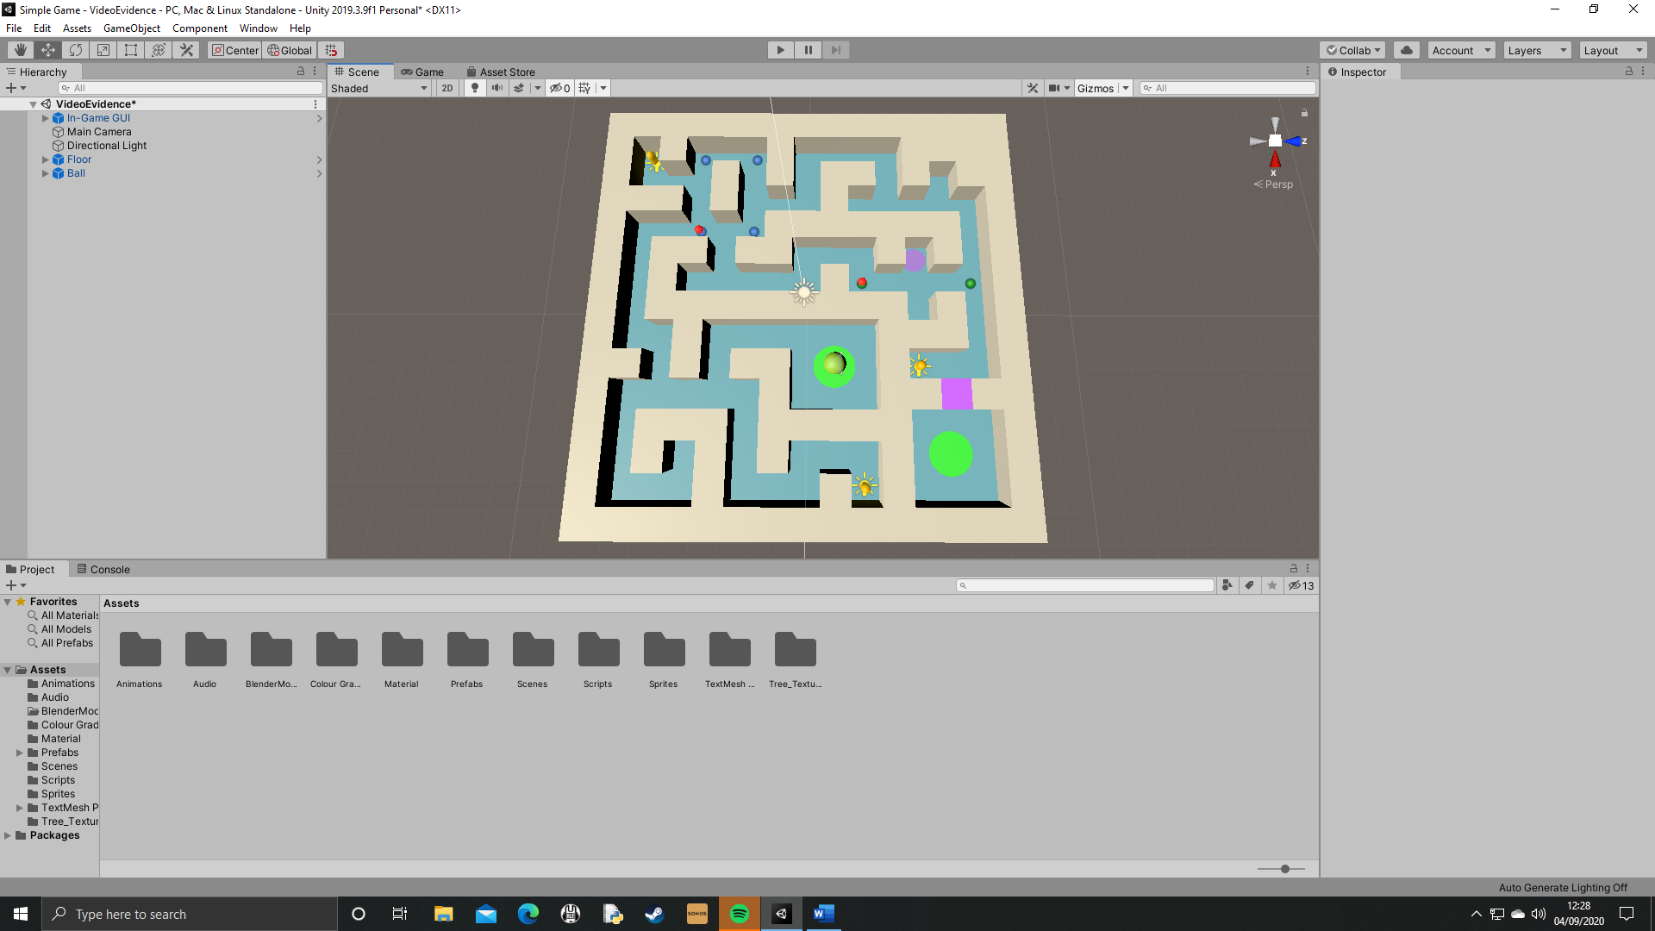

In this development cycle, I have created the enemies and all functions relating to them, and added some interactivity between the ball and the maze. This again is part of creating the core mechanics of the game that can be implemented into additional levels when they are made. These features all add to the player’s experience of the game, as they either present a new challenge to the player or give the user more visual cues to work with.

|  |  |  |  |  |  |  |
| --- | --- | --- | --- | --- | --- | --- |
| **Test** | **Purpose of test** | **Input** | **Expected output** | **Actual output** | **Proposed remedial action** | **Met the success criteria?** |
| The enemies work as intended. | This test ensures that the enemy pathfinding and collisions work. This is important because the enemies are designed to add another layer of puzzle to the game, so that the game meets the client’s success criteria. | Wait for an enemy route to be completed, then use ‘WASD’ keys to roll the ball into the enemy. | The enemy will complete its route (and continue it while the ball gets to the enemy) then when the ball hits the enemy, a particle explosion will be created and the level will restart. | The enemy pathfinding and collision both work as intended. | No remedial action needed. | This test has shown that the client’s success criteria is being met as the enemy introduces a new puzzle element to the solution, and the enemy collision also creates a way to fail the level which is very important. |
| The game over sequence works as intended. | This test is important so I can check that the level is restarted when the ball collides with the enemy. Without this test, there could be a problem that has been created by adding the camera shake and ‘thud’ sound effect, as this is another form of collision. | Use ‘WASD’ keys to roll ball into enemy. | Scene should fade to black, then the same scene should be reloaded. | Scene transition starts and the scene is restarted. | No remedial action needed. | This shows that the success criteria has been met, as the ability to fail comes under the ‘challenging puzzle elements’ criteria. Without this feature, the user would have unlimited time and lives to redo every puzzle before they reach the exit in each level, which does not present any challenge at all. |
| The ‘thud’ sound effect is created when the ball collides with a wall. | This test is important as the ‘thud’ sound effect adds a level of interactivity between the ball and the maze that gives the player feedback when the ball collides with the wall. | Use ‘WASD’ keys to roll ball into wall. | Thud sound should play. | I can hear ‘thud’. | No remedial action needed. | This test has checked that the sound effects work, which is important as, even though it is not one of the client’s success criteria, it adds to the immersion of the game, which is an essential feature to creating a better atmosphere for the player. |
| The camera shakes when the ball hits the wall. | This test is important as the camera shake adds to the atmosphere of the game. Without this test, the camera shake may not work as intended, which could be game-breaking for the player. | Use ‘WASD’ keys to roll ball into wall. | Camera should wobble when the ball collides with the wall. | Camera shakes correctly. | No remedial action needed. | This test has checked that the camera shake works, which is important as, even though it is not one of the client’s success criteria, it adds to the immersion of the game, which is an essential feature to creating a better atmosphere for the player. |

This prototype does meet the client’s success criteria as it adds another puzzle element to the game that challenges the player. At this point, there is only a small amount left to do before the game meets all the client’s specification.

|  |
| --- |
| **Videos:**   * Fixed ball thud and camera shake |

**Iterative Development Cycle 4**

**4.1 – Highlighting walls**

public GameObject[] blocks;

public float highlightRange;

private GameObject closestBlock;

public Material originalBlock;

public Material highlightedBlock;

private float distanceToClosestBlock=100;

private bool canPlaceMine = false;

void Update()

FindClosestBlock(); //This is called every frame so that the program always knows what the closest wall to the ball is

{

if (distanceToClosestBlock <= highlightRange) //Stops the user being able to highlight walls that are too far away from it - the ball needs to be almost touching a wall to highlight it

{

if (Input.GetKeyDown(KeyCode.LeftShift) || Input.GetButton("LBButton") && closestBlock != null) //Takes keyboard and gamepad inputs; the last statement checks that there is a wall in range of the ball, so it does not throw errors if there is not

{

HighlightClosestBlock();

canPlaceMine = true; //Means that the player can only place a mine whilst a wall is being highlighted, this is to prevent any accidental mine placements

}

else

{

canPlaceMine = false;

}

}

}

void FindClosestBlock()

{

closestBlock = null;

distanceToClosestBlock = 100; //Sets the value ridiculously large so that every wall in the maze will be closer, so it can check every wall for its relative distance to the ball; reset every frame

for (int i = 0; i < blocks.Length; i++) //Iterates through all walls in the maze, which are stored in an array called blocks

{

if (blocks[i] != null) //Stops errors being produced in levels where the user cannot highlight any walls

{

float distance = Vector3.Distance(transform.position, blocks[i].transform.position); //Finds the relative distance between the ball and wall

if (distance < distanceToClosestBlock)

{

closestBlock = blocks[i]; //Sets the so-far nearest wall in this variable

distanceToClosestBlock = distance; //Overwrites the distance so that it is the distance between the new closest block and the ball, so the program will know if another, closer wall has been found

}

}

}

}

void HighlightClosestBlock()

{

for (int i = 0; i < blocks.Length; i++)

{

if (blocks[i] != null)

{

blocks[i].GetComponent<Renderer>().material = originalBlock; //Sets all walls to the original material (which is not emissive)

}

}

closestBlock.GetComponent<Renderer>().material = highlightedBlock; //Overwrites the closest wall to set its material to a bright, emissive one

}

This code adds the ability to highlight walls in the maze. This is one of the biggest features in this game and will be essential to adding another puzzle element to the solution. What this code does is constantly set every wall’s material to the original colour, whilst finding which wall is closest to the ball, so that that wall’s material can be overwritten as a bright, emissive material that is obvious to the user. This feature will allow me to add being able to place mines that detonate in the maze, which is why I have pre-emptively added a ‘canPlaceMine’ Boolean in the update function.

This feature is necessary so that I can start to fulfil the client’s success criteria of ‘adding new puzzle elements as the game progresses’ and also implement the mine to meet the essential features. This is important to make sure that the product is made to a quality that my client is happy with. Without this feature, they would not be satisfied with the solution, so I should not expect them to pay me for my efforts.

Testing this feature using white box testing will be difficult as the walls have not been named in any sensible order – they were just positioned in the maze. This means, whilst there is a way of me testing whether finding the closest block works, it will be more complicated than testing the whole implementation at once.

|  |  |  |  |  |  |  |
| --- | --- | --- | --- | --- | --- | --- |
| **Test** | **Purpose of test** | **Input** | **Expected output** | **Actual output** | **Proposed remedial action** | **Justification of action** |
| The chosen wall will be highlighted when specified. | This test is important to attempt to break down some of the functions of the new feature. This means that this test will ensure that changing the material of the walls works correctly. Without this test, I would not be able to decompose the feature enough to determine where an error occurs, should it occur. In this test, I will create a variable to hold a single wall object and replace closestBlock with this variable. | Press and hold ‘left shift’. | Whilst the key is pressed, the selected wall will be highlighted. | The wall is highlighted when intended. | No remedial action needed. | No action is needed because the feature works as intended. |
| The wall is un-highlighted when the player releases the input. | This test checks that the game updates when the user stops giving the necessary input. This is important so that the project feels responsive to their commands. Without this test, It may not work which would leave walls in the maze highlighted even though the player has ‘turned off’ the highlight function. | Press and hold ‘left shift’, then release it. | When the user relinquishes input, the wall that was highlighted should return to its normal material. | The wall does not resume its normal material. | I need to set the material back to original once the program is no longer receiving an input to highlight walls. I will use an ‘else’ statement after the statement checking for input. | This fix is needed because, even though I am already using a line to set the original material, this is inside the highlight function which only happens whilst the player is holding ‘left shift’, so I need to give it the same instruction when input is no longer being given. |
| The nearest wall is highlighted. | This test will be split into two parts (see below for part two). This means all it is checking is that the target wall will be highlighted, when the target wall is changing value. This test is important to ensure that assigning the value of closestBlock works as intended. Without this test, it could be set to null, which would stop any walls being highlighted, which is obviously not what is required of the program. | Press and hold ‘left shift’ whilst using ‘WASD’ keys to roll the ball around the maze. | As the ball rolls around the maze, the highlighted wall should change. | The wall does not change as the ball moves. | This is a simple fix; I just need to change ‘GetKeyDown’ to ‘GetKey’. | This fix will work as, the current, broken code only returns true in the first frame that the key is pressed, whereas ‘getKey’ returns true whilst the key is pressed. This is important as the player should be able to move around the maze and have the walls be updated automatically. |
| The nearest wall is highlighted. | Since previous tests have now been fixed if needed, I can reliably test that the nearest wall to the ball is the one that is highlighted. This test is important because this is a major feature in the game that will allow the player to creatively approach each puzzle and solve it in a way they choose. Without this test, this feature may not work which would result in the game failing to meet the success criteria. | Press and hold ‘left shift’ whilst using ‘WASD’ keys to roll the ball around the maze. | When the ball gets closer to a different wall, the first wall should return to its original material and the new closest wall should be highlighted. | The highlighting works and switches between walls correctly. | No remedial action needed. | No action is needed because the feature works as intended. |
| The walls will not be highlighted if the ball is not in range. | This test is important as the player should not still be able to highlight a wall when they are nowhere near it. This would be bad game design and could allow the user to exploit the game, which should not be able to happen. | Without rotating the maze, hold ‘left shift’. | None of the walls should be highlighted as the player is out of range in the entrance chamber. | The walls are not highlighted, | No remedial action needed. | No action is needed because the feature works as intended. |
| Highlighting walls works with gamepad input. | This test is important as a player may choose to use a gamepad to play the game. This means that the game should be built to a high standard and support gamepad inputs so that this player will have as good an experience as any other player. | Press and hold ‘LB’ or equivalent whilst using joysticks to roll the ball around the maze. Finally let go of ‘LB’. | The wall will be highlighted, and will change as a different wall gets closer and will stopped being highlighted when the user stops giving an input. | The highlighting works as intended. | No remedial action needed. | No action is needed because the feature works as intended. |

|  |
| --- |
| **Videos:**   * Failed nearest wall highlighted * Failed wall is un-highlighted when input is released |

**4.2 – Placing mines**

private GameObject closestBlock;

private bool canPlaceMine = false;

private float timeSinceMinePlaced = 0;

public float timeBetweenMines = 5;

public GameObject mine;

public GameObject floor;

private int minesAmount = 0;

void Update()

{

if (timeSinceMinePlaced >= timeBetweenMines) //Stops the user being able to place mines in quick succession, also stops it from setting several mines in one click

{

if (canPlaceMine && minesAmount > 0 && (Input.GetKeyDown(KeyCode.Space) || Input.GetButton("RBButton"))) //Checks that the user at least one mine to use and that they have given the corresponding input

{

PlaceMine(); //Calls the function below

timeSinceMinePlaced = 0f; //Resets the time since a mine has been placed so the timer above is reset

}

}

else

{

timeSinceMinePlaced += Time.deltaTime; //Part of the timer

}

void PlaceMine()

{

Vector3 minePos = new Vector3(closestBlock.transform.position.x, closestBlock.transform.position.y + 0.59f, closestBlock.transform.position.z); //Creates a variable that is positioned just on top of the closest wall

Quaternion mineRot = new Quaternion(0f, 0f, 0f, 0f); //Sets it so there will be no rotation on the mine.

GameObject mineSet = Instantiate(mine, minePos, mineRot); //Creates a mine in the maze, this starts a countdown timer before it explodes. This is handled in the mine script

mineSet.transform.SetParent(floor.transform); //This means that the maze can still be rotated while the mine has not yet exploded

mineSet.transform.rotation = new Quaternion(0f, 0f, 0f, 0f);

minesAmount--; //Reduces the amount of mines the user has by one so they cannot place an infinite amount in the maze

}

public float timeToDetonation = 3f;

public ParticleSystem mineExplosion;

public PlayerBall destroyWall;

public float explosionRadius;

public GameObject explosionSound;

private bool canExplode;

void Start()

{

canExplode = true; //This means that the mine will destroy walls, but is part of a function that stops it repeatedly exploding

}

void Update()

{

if (timeToDetonation <= 0f) //Explodes after the mine is in the scene for three seconds

{

if (canExplode)

{

Explode();

canExplode = false; //Prevents mine exploding several times

}

}

else

{

timeToDetonation -= Time.deltaTime; //Part of the countdown

}

}

void Explode()

{

Collider[] wallsToExplode = Physics.OverlapSphere(transform.position, explosionRadius); //Creates a sphere around the mine object that collects all colliders inside it and stores it in this variable

foreach (Collider wall in wallsToExplode) //Iterates through all colliders in the array created above

{

WallDestroy wallDestroy = wall.GetComponent<WallDestroy>(); //Sets the WallDestroy class to this variable

if (wallDestroy != null)

{

wallDestroy.DestroyWall(); //Calls a method that destroys the object it is attached to

}

}

Instantiate(mineExplosion, transform.position, Quaternion.identity); //Creates a particle explosion effect; this is destroyed a few seconds later

Instantiate(explosionSound, transform.position, Quaternion.identity); //Plays an explosion sound effect; this is also destroyed in a bit

Destroy(gameObject); //Finally, the mine itself is destroyed

}

This code deals with the placement of the mine within the maze and the detonation of it, when it destroys the wall it has been placed on. It does this by instantiating a mine on the closest wall when it is highlighted (this is dealt with in 4.1). The mine then waits for three seconds before capturing all colliders within a certain radius of itself (the radius is very small so it will only actually destroy the wall it has been placed on) then destroys them.

This code is essential to help meet the client’s success criteria as this will add a new way to approach puzzles as the game progresses. Furthermore, this also encourages the user to think creatively and logically to solve the problem as they will also have to consider where the best place to lay a mine is as they will only have a limited number each level.

For this phase of testing, the player will be given ten mines to begin with.

|  |  |  |  |  |  |  |
| --- | --- | --- | --- | --- | --- | --- |
| **Test** | **Purpose of test** | **Input** | **Expected output** | **Actual output** | **Proposed remedial action** | **Justification of action** |
| The player must wait three seconds before they can place another mine. | This test is important because the user should not be able to place several mines in one click, as this will waste their mines. This would be bad as it would most likely be annoying for them, as it would make some levels incompletable. | Hold ‘left shift’ then press ‘space’ repeatedly for 5 seconds. | Two mines should be placed – one on the first click, and one on the input given after three seconds since the first. | Two mines are placed, three seconds apart. | No remedial action needed. | No action is needed because the feature works as intended. |
| The mine is placed when the user gives the correct keyboard input. | This test ensures that the user will be able to access this feature when playing the game with keyboard controls. Without this test, it may not work, which would reduce from the user’s impression of the game, as some levels would be made impossible for them. | Hold ‘let shift’ then press ‘space’. | Mine will be placed. | Placed mine. | No remedial action needed. | No action is needed because the feature works as intended. |
| The mine is placed when the user gives the correct gamepad input. | This test ensures that the user will be able to access this feature when playing the game with gamepad controls. Without this test, it may not work, which would reduce from the user’s impression of the game, as some levels would be made impossible for them. | Hold ‘LB’* then Press ‘RB’*.  *or equivalent. | Mine will be placed. | Placed mine. | No remedial action needed. | No action is needed because the feature works as intended. |
| The mine is positioned on top of the highlighted wall. | This test ensures that the mine gives the correct visual cues to the player. For example, it would not make sense if the mine was placed on the previously highlighted wall, therefore this would be unfair for the player. Furthermore, the mine needs to be positioned on top of the wall so it will catch the wall’s collider to destroy and also so the player can see it. | Hold ‘left shift’ then press ‘space’. | Mine should be placed on top of the highlighted wall. | Mine is placed on top of the highlighted wall. | No remedial action needed. | No action is needed because the feature works as intended. |
| The mine destroys the wall it is placed on. | This test is important as the purpose of the mine is to open up a new pathway in the maze for the player. This means that the mine should destroy the wall it is placed on, however, it is also important that the mine does not destroy too many walls either. | Place the mine. | The mine only destroys the wall it has been placed on after it has counted down. | The mine destroys several walls around it. | I need to reduce the value of the explosionRadius variable. | This would fix the problem as it would reduce the size of the sphere surrounding the mine so less colliders are caught in it. This is important as the game needs to encourage the player to be cautious about where they place the mines. |
| When the mine is destroyed, there is a particle explosion and sound effect. | This test is important as it will give the player visual and auditory cues when the mine has exploded. Without this test, these features may not work which would detract from the player’s overall experience of the game. | Place the mine. | When the mine is destroyed, the sound effect and particle explosion play for a short duration. | The cues play for a little while. | No remedial action needed. | No action is needed because the feature works as intended. |
| The mine destroys itself. | This test is important as a detonated mine should not be left in the maze as this could be confusing to the player. Without this test, the detonation loop could continue several times which means the effect of the mine exploding would become irritating. | Place the mine. | The mine should be destroyed when the sound effect plays. | The mine is destroyed at the correct time. | No remedial action needed. | No action is needed because the feature works as intended. |
| Mines cannot be placed when the user has none in their counter. | This test is important as the player should be able to place an infinite amount of mines in the maze. This is because the game should encourage them to think strategically so that they can navigate the maze in the most efficient way. | Place ten mines then try to place another. | The first ten mines should be placed, but then the player should be able to place anymore. | The player cannot place any more than ten mines. | No remedial action needed. | No action is needed because the feature works as intended. |
| Mines cannot be placed without highlighting walls. | This test ensures that the user can only place mines when they are highlighting walls. This is to help them as highlighting the walls gives them greater precision when placing mines. Without this test, the user might be able to place mines without highlighting walls, which they could do by accident which would be frustrating for them, if they have to restart a level because they placed a mine in the wrong place. | Press ‘space’ when near to a wall. | The user should not be able to place a mine. | No mine is placed. | No remedial action needed. | No action is needed because the feature works as intended. |

|  |
| --- |
| **Videos:**   * Failed mine detonation * Fixed mine detonation * Mine is placed on top of highlighted wall |

### **4.3 – Picking up mines and mine UI counter**

public Text minesText;

private int minesAmount = 0;

void Update()

{

minesText.text = "Mines: " + minesAmount; //Updates the UI text element every frame so that it will recognise when minesAmount has been changed (when a mine is placed or picked up)

}

void OnTriggerEnter(Collider other)

{

if (other.gameObject.tag == "Mine") //Checks whether the ball has collided with a 'mine pick-up' object

{

Destroy(other.gameObject); //Destroys the mine pick-up object

minesAmount += 3; //Increases the amount of mines available to the user

}

}

This code is attached to the playerBall script along with the previous code in 4.1 and 4.2. The main feature added here is the mine pick-ups which can be added throughout the maze. This allows the player to get some mines (they will start with none) so that they can get through the maze quicker. The other feature added here is a UI text element that tells the player how many mines they currently have.

These features are important to finish off the mine feature. This means that the mines can now be used to encourage the player to think strategically on each level as they will have a limited number of mines per level. Without this feature, the player would be able to place mines all throughout the maze without a limit on the amount, which would mean that there would be no challenge for the player as they can place as many mines as necessary. The UI text is also necessary to help the player know how many mines they currently have so that they can plan where all their remaining mines will go.

|  |  |  |  |  |  |  |
| --- | --- | --- | --- | --- | --- | --- |
| **Test** | **Purpose of test** | **Input** | **Expected output** | **Actual output** | **Proposed remedial action** | **Justification of action** |
| The mine pick-up is destroyed when the ball collides with it. | This test checks that the pick-up is destroyed after it has been collided with once. This is important as, otherwise, the player would be able to keep rolling the ball over it and getting a huge amount of mines. This would make the levels too easy, which would be bad. | Use ‘WASD’ keys to roll ball over mine pick-up. | The pick-up will be destroyed. | The pick-up is destroyed. | No remedial action needed. | No action is needed because the feature works as intended. |
| The mine pick-up gives three mines to the player. | This test ensures that the mine pick-up gives an appropriate amount of mines to the player. This is because levels will be designed to require the player to use between two and three mines each level. Therefore, without this test, some levels will be made impossible if not enough mines are given. | Use ‘WASD’ keys to roll ball over mine pick-up. | The player will be given three mines. If the text does not update, then they should still only be able to place three mines. | The player is given three mines. | No remedial action needed. | No action is needed because the feature works as intended. |
| The mine counter text is updated. | This test is important to make sure that the UI text is updated when necessary. This is so that the player will get constant information on how many mines they can use. | Use ‘WASD’ keys to roll over mine pick-up then place a mine. | The counter will increase to three, then decrease by one. | The counter increases to three, then decreases by one. | No remedial action needed. | No action is needed because the feature works as intended. |

|  |
| --- |
| **Videos:**   * Mine pick-up |

### **Prototype 4 – Mines**

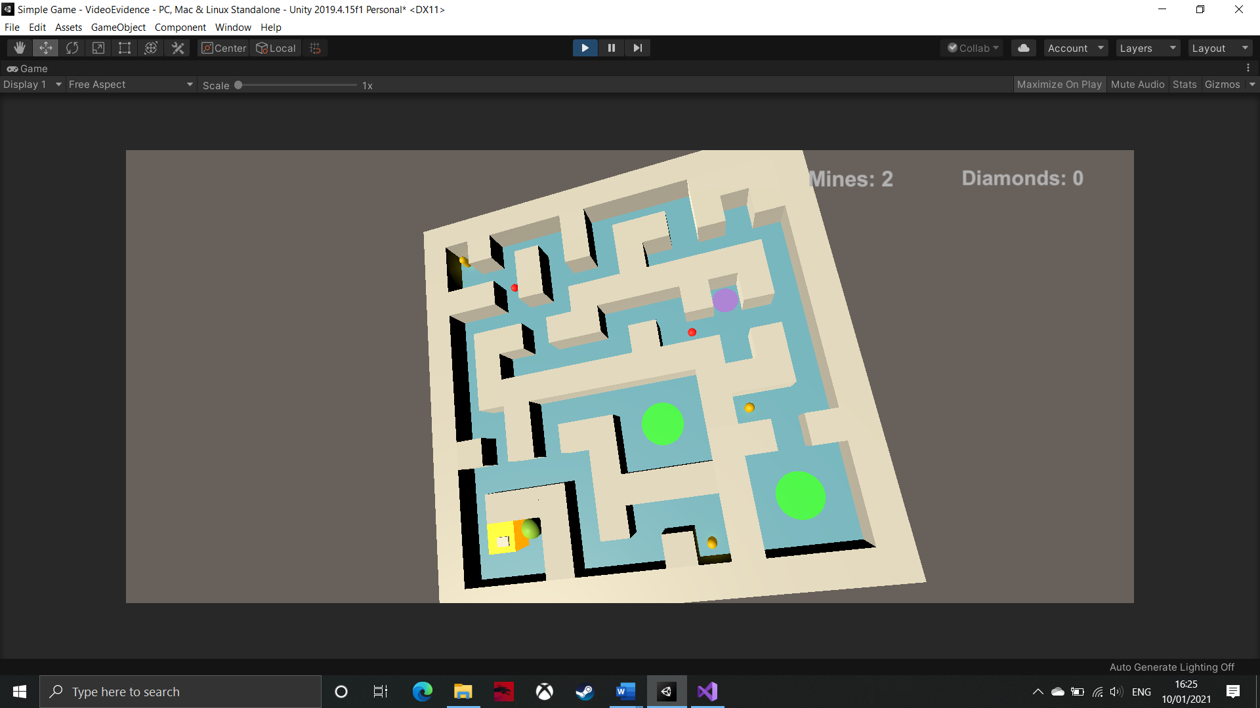

In this development cycle, I have implemented all mechanics relating to the mines. This includes: placing, detonating and picking up the mines, and highlighting walls. At this point, the project is nearing ‘completion’, in that all of the main features are nearly implemented – all that is left is some UI elements. Then, I can create more levels.

|  |  |  |  |  |  |  |
| --- | --- | --- | --- | --- | --- | --- |
| **Test** | **Purpose of test** | **Input** | **Expected output** | **Actual output** | **Proposed remedial action** | **Met the success criteria?** |
| Highlighting walls works as intended. | This test checks that: only one wall is highlighted at a time, the highlighted wall is the nearest one to the ball, and that no walls are highlighted if out of range. This is important as one of the final checks for this feature, so I must know that it works. | Use ‘WASD’ keys to move the ball, and use ‘left shift’ to highlight walls. | This feature should do everything outlined previously (in purpose of test). | Highlighting the walls works exactly as intended. | No remedial action needed. | This feature does not explicitly meet the success criteria or essential features, however it is very important in creating the mines so that they are easy for the player to understand and use. This means that highlighting the walls is an essential step towards meeting the client’s success criteria. |
| Mines work as intended. | This test is important as this feature is what adds a massive puzzle element to the game. This means that it is this step that largely fulfils some of the client’s success criteria so this step must be working properly. | Use ‘WASD’ keys to roll ball, ‘left shift’ to highlight walls, then ‘space’ to place a mine. | When the mine is placed, there will be a short delay then the mine will detonate, destroying the wall it is on and creating a sound effect and particle explosion. | The mine explodes as intended. | No remedial action needed. | This feature does meet the client’s success criteria, as the mine will be the puzzle element that is implemented as the game progresses. Furthermore, it also meets the essential features as the mine is a feature that the client specifically asks for. This means that I have met the client’s specification. |
| Mine pick-ups work as intended. | This test is important to ensure that the user will be limited in how many mines they can use each level. Without this test, they may be given too many, making the level too easy, or not enough, which would make some levels incompletable. | Use ‘WASD’ keys to roll ball over mine pick-up. | The player should be given three mines to use. | They are given three mines. | No remedial action needed. | Similarly to highlighting the walls, this feature is more important for how it affects how the player can use the mines. This means that it does not meet any success criteria itself, but this part of the mines is absolutely essential to making the mines an additional puzzle element in the game. |

In this development cycle, I have implemented one of the final features of the game – all that is left after this is a timer, menus, and polishing up. This means that from here, it should be fairly simple to make the game meet the rest of the client’s success criteria and essential features.

|  |
| --- |
| **Videos:**   * Highlighting the walls (fixed) |

## **Iterative Development Cycle 5**

### **5.1 – Timer**

public Text text;

public Text finalTimeText;

public float startTime;

private bool endGame = false;

public LevelLoader levelLoader;

private float timeLeft;

private string timeText;

void Update()

{

timeLeft = startTime - Time.timeSinceLevelLoad; //Unity is automatically logging the time since the scene was loaded. This works as there is no delay before the player can start controlling the maze

int minutes = Mathf.FloorToInt(timeLeft / 60f); //This is calculating how many minutes are left in 'timeLeft'

int seconds = Mathf.FloorToInt(timeLeft - minutes * 60f); //This is calculating how many seconds are left in 'timeLeft'

timeText = string.Format("{0:0}:{1:00}", minutes, seconds); //Defines the format of the text - I am telling it that I want it to show minutes:seconds

if (endGame == false) //Whilst the user has not reached the exit

{

text.text = timeText; //Updates the timer, which is in the user's UI

}

if (timeLeft <= 0) //When the player has ran out of time

{

text.text = "0"; //Easy way of stopping the timer going negative

finalTimeText.text = "YOU RAN OUT OF TIME"; //Displays this in large writing on the UI; it is not set a value until this point so should not be seen on the UI until then

levelLoader.ReloadLevel(); //Restarts the level

endGame = true; //Stops the first if statement from running

}

}

This code creates a timer for the game. It does this by counting the amount of time the scene has been active for (I do not expect this to cause a problem when a pause menu is added) and updating the timer text every frame. This means that the timer that the user will see on the UI will be very accurate. Furthermore, I have also implemented the ability to lose when the user runs out of time. When this happens, the level will be automatically restarted so the user can have another go at it.

This feature is important because it adds the final challenge for the player; they will now have to complete each level within a set time. This means that, as they learn the mechanics of the game, they may have to sacrifice getting some diamonds in the maze to make sure that the reach the exit in time. Without this feature, once the user learns how to use each feature, the game will most likely feel very easy, whereas adding this timer means that it will be harder for them to learn the layout of each level, meaning each level will feel like more of a mad rush.

|  |  |  |  |  |  |  |
| --- | --- | --- | --- | --- | --- | --- |
| **Test** | **Purpose of test** | **Input** | **Expected output** | **Actual output** | **Proposed remedial action** | **Justification of action** |
| When the level is started, the timer has the correct time. | This test ensures that I can change what time the player will have to complete each level. This is important so that I know that each time limit I set for each level will work. For example, the later levels will be more complex, so the player will need more time to complete it in, so I must ensure that the timer accepts any initial input. | Start the scene. | The timer will initially say ‘1:30’. | The timer says ‘1:30’. | No remedial action needed. | No action is needed because the feature works as intended. |
| The format works correctly. | This test is important because the timer needs to present information to the user in a way that makes sense to them. This means that the user should be able to read the time as ‘minutes:seconds’ and will not be expected to read an amount of seconds and know how much time this equates to. This is unreasonable to expect of the player, regardless of their age. | Start the scene and leave it running. | The timer should appear as ‘minutes:seconds’ and when it reaches zero seconds, the minute will be decremented and seconds will back up to 59. | The timer is in the correct format and adjusts its values when needs be. | No remedial action needed. | No action is needed because the feature works as intended. |
| ‘You ran out of time’ is displayed and the level is restarted when the timer hits zero. | This test is very important as it is this feature of the timer that makes it an important part of the game. Without this test, the level may not restart properly or it may restart without telling the player why which would be confusing for them. This would be bad because it could make the player feel like they have been treated unfairly, giving them a bad impression of the game. | Start the scene and leave it running. | The timer should count down to zero, then ‘you ran out of time’ should be displayed on the UI and the level should be restarted. | When the timer reaches zero, the level restarts but the user does not see a message about it. | I need to make use of the enabled function for UI elements. I should set it to false whilst the level is running, but enable it when the player runs out of time. | This fix is necessary for reasons outlined previously in ‘purpose of test’. This is important because the user needs to be able to clearly see the reason for their failure, otherwise, the game would very quickly become frustrating for them as they would not know how to improve. |
| The timer counts down each second. | This test is important to ensure that the timer works at the same speed as ‘actual’ time – i.e. if the game tells the player they have 90 seconds, then they should have 90 seconds before the level restarts. If this was not tested, the timer could go too fast making some levels way too hard, or it could go too slow, making other level too easy. | Start the scene and leave it running, whilst timing it with a separate stopwatch. | The level should restart as the stopwatch reaches 90 seconds. | The timer and stopwatch match each other. | No remedial action needed. | No action is needed because the feature works as intended. |

|  |
| --- |
| **Videos:**   * Timer * Failed ‘you ran out of time’ displayed when timer runs out |

### **5.2 – UI maze rotation indicators**

public Slider xSlider;

public Slider zSlider;

private float rotXPercent;

private float rotZPercent;

void FillAxes() //This method is called every frame in the Update() method

{

float xBound = 11.5f; //These values come from the rounded rotation values of the maze when it is at its boundaries

float zBound = 11.5f;

Quaternion rot = transform.rotation; //Collects the maze's rotation values and sticks them in 'rot'

rotXPercent = rot.x * 115 / xBound * 100; //Works out the percentage of the maze's current rotation in the x-axis out of its potential rotation

xSlider.value = rotXPercent; //Sets the UI slider (which has its inputs removed) filled percentage equal to the percentage to calculated

rotZPercent = rot.z * 115 / zBound * 100; //This is repeated for the data in the z-axis

zSlider.value = rotZPercent;

}

This code controls a new UI element that is designed to help the player understand how far the maze is rotated. It achieves this by calculating a percentage of how much the maze is rotated in the x- or z-direction then setting the percentage that two UI sliders (one for each axis) are filled by. The default position of the fill will be in the middle of the slider so that it fills accordingly with the direction (positive or negative) of rotation.

These sliders are important as a pre-emptive step for implementing graphics into the game. I intend to make the graphical style very dark and gloomy to make it atmospheric. However, this will mean that the player will not be able to see the maze’s outline very clearly. Therefore, the sliders are necessary to add some indication of the maze’s rotation for the player. Without this feature, the game may be too confusing for the player, making it frustrating and causing the player to quit the game with a bad impression of it. Obviously, this is not good, as the game has been designed to interest the player in archaeology as a potential career.

|  |  |  |  |  |  |  |
| --- | --- | --- | --- | --- | --- | --- |
| **Test** | **Purpose of test** | **Input** | **Expected output** | **Actual output** | **Proposed remedial action** | **Justification of action** |
| When the maze is at its maximum x-rotation, the x-slider is at its maximum. | These tests ensure that the sliders make logical sense for the player. This is important because the sliders are designed to aid the player and make the game slightly easier for them. Therefore, it would counterintuitive for the sliders to be non-sensical, as this takes away from their utility. Without this test, the sliders may not be filled when the maze is at its boundary, or it may overshoot the slider, meaning that the player would be able to see some of the bar as it would be off the left side of the screen, making it useless to them. | Hold ‘D’ for five seconds. | The maze will rotate to its maximum x-boundary and the x-slider will be filled. | The x-slider is completely filled. | No remedial action needed. | No action is needed because the feature works as intended. |
| When the maze is at its minimum x-rotation, the x-slider is at its minimum. | Hold ‘A’ for five seconds. | The maze will rotate to its minimum x-boundary and x-slider will be empty. | The x-slider is empty. | No remedial action needed. | No action is needed because the feature works as intended. |
| When the maze is at its maximum z-rotation, the z-slider is at its maximum. | Hold ‘W’ for five seconds. | The maze will rotate to its maximum z-boundary and the z-slider will be filled. | The z-slider is full. | No remedial action needed. | No action is needed because the feature works as intended. |
| When the maze is at its minimum z-rotation, the z-slider is at its minimum. | Hold ‘S’ for five seconds. | The maze will rotate to its minimum z-boundary and z-slider will be empty. | The z-slider is empty. | No remedial action needed. | No action is needed because the feature works as intended. |

### **Prototype 5 – UI elements**

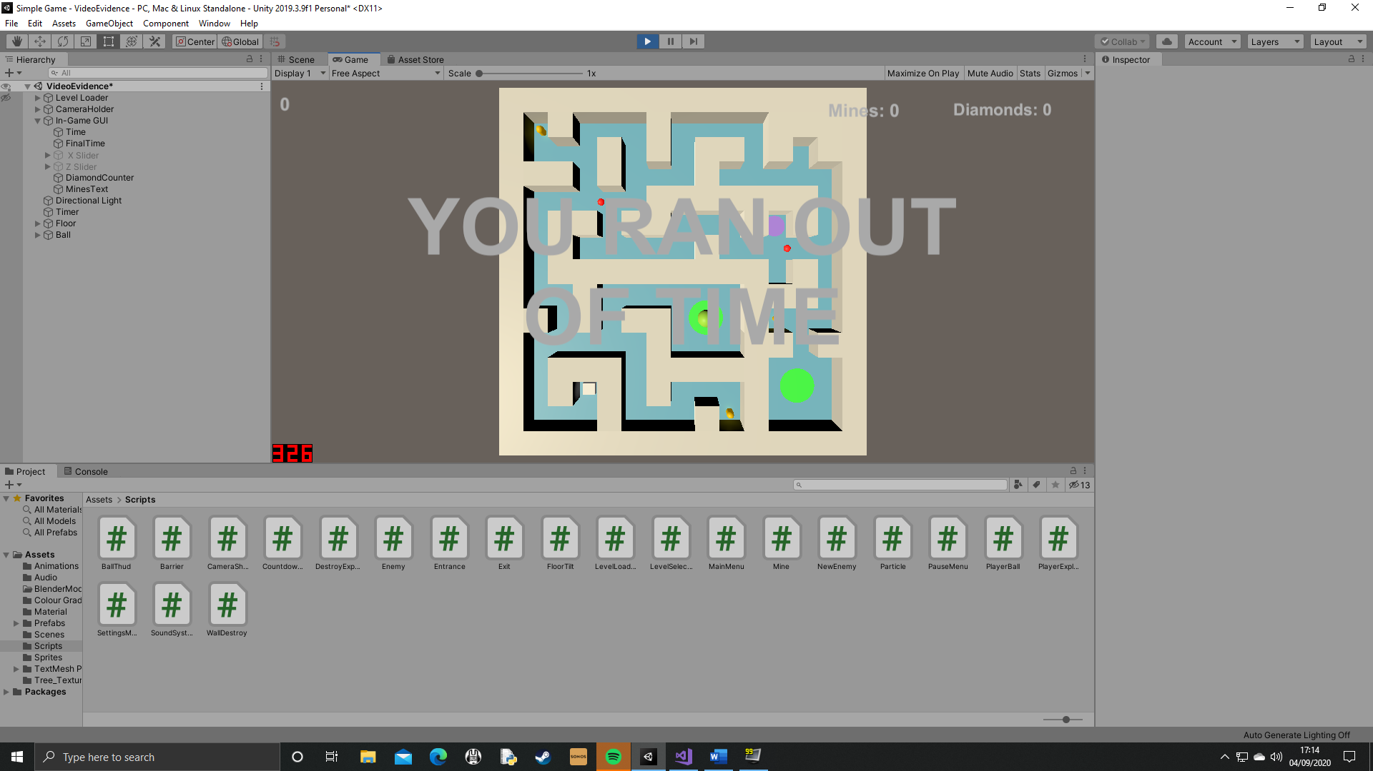

In this development cycle, I have implemented features for the UI that can be utilised by the player to help them throughout the levels. In addition to this, the timer can also be used to hinder them, as the level will be restarted when it reaches zero, meaning that they ‘failed’. This prototype is final one that adds new features to the actual game (although I will still have to create menus for the game), which means, from here, I can start building the final game, including levels and graphics.

|  |  |  |  |  |  |  |
| --- | --- | --- | --- | --- | --- | --- |
| **Test** | **Purpose of test** | **Input** | **Expected output** | **Actual output** | **Proposed remedial action** | **Met the success criteria?** |
| The timer works as intended. | This test checks that the timer works as specified so that I can confidently say that it meets the client’s success criteria. This is important as the solution needs to follow the success criteria so that it is suitable for the LearnFuture website. | Start the scene and leave it running. | The timer should count down for 1 minute, 30 seconds, then ‘you ran out of time’ should be displayed and the level restarted. | The timer counts down then the user sees the display message and the scene restarts. | No remedial action needed. | This test shows that the timer does meet the client’s success criteria as, now that I know the timer works as intended, I also know that the timer can be used to introduce a greater challenge for the player, as they now have more than one way to fail a level. |
| The UI sliders work as intended. | This test is important as the sliders will play a crucial role in helping the player throughout each level. Without this test, I cannot know with certainty that the sliders work as part of the whole project so this test will assure me that they do. | Use ‘WASD’ keys to rotate the maze. | The sliders will change ‘full-ness’ corresponding with the degree of rotation of the maze. | The sliders work in-sync with the maze’s rotation. | No remedial action needed. | Whilst the client has not specifically asked for these sliders, I believe it is necessary given the graphical style the game will be using. This is because the graphics will be dark and will take away some of the user’s sensory information. Therefore, these sliders will make it easier to be accurate with rotation. This may be necessary in scenarios where the player needs the ball to be stationary to let an enemy pass, so they will need to re-centre the maze’s rotation. |
| The timer adds another challenge to the game. | This test is important to ensure that adding the timer does actually fulfil the client’s success criteria of ‘levels with challenging puzzle elements’. This means that the timer must add a reasonable challenge, even if the intensity of this challenge varies with each level. | Use all available inputs to complete the level in 1 minute, 30 seconds. | The level should feel significantly harder, maybe even failing a few times. | I completed the level with only a few seconds remaining, meaning that the timer does definitely add a new sense of urgency. | No remedial action needed. | This test proves that the timer does create a new challenge for the player, as I have far more practise than an average player will and I struggled to complete the level so quickly. However, this is not necessarily bad as, if I can create each level to be so ‘down to the wire’, then the timer will force the player to prioritise getting some diamonds and leaving others, giving them a reason to replay levels and improve. |

This prototype includes the final new mechanics of the game, which means that I will move onto to polishing up and menus in order to finish the game off. The next stage will be adding graphics, as this means that creating the style for the menus will be easier later on.

|  |
| --- |
| **Videos:**   * Fixed ‘you ran out of time’ display * UI maze rotation indicators |

## **Iterative Development Cycle 6**

### **Prototype 6 – Graphics**

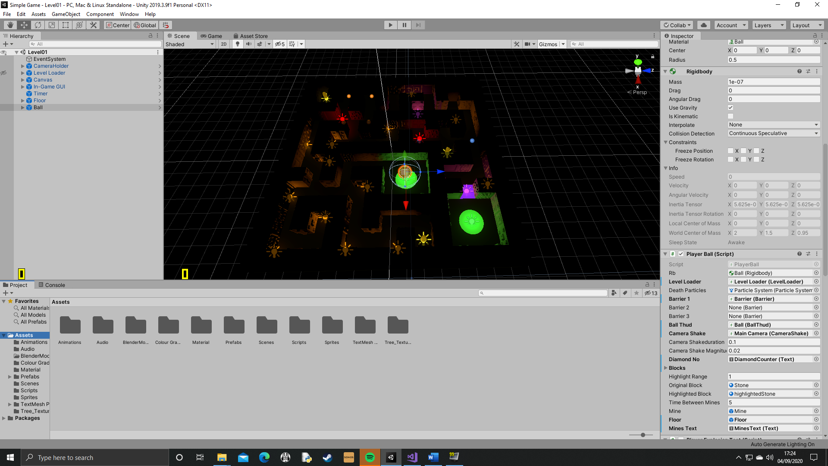

In this development cycle, I have created 3D models for all the walls in Blender. This includes seven different designs, then sets of models with designs on just one face, two faces, three faces, or all four faces. This excludes the faces on the top and bottom of the model, as that just would not make sense, as the player would not be able to see these. I have replaced the standard cubes with these, so this is the same layout that has been in all previous iterations of development, and I believe this will become ‘level 1’ as I have already done lots of testing on this level. I have also added lighting around the maze, including orange lights to illuminate the maze, green lights in the entrance and exit, purple lights on the button and barrier, yellow lights on diamonds, and, red lights that travel with the enemies. Finally, I have changed the skybox to black. Overall, I think this makes for a very cool, atmospheric level, which definitely elevates the product to a new standard.

|  |  |  |  |  |  |  |
| --- | --- | --- | --- | --- | --- | --- |
| **Test** | **Purpose of test** | **Input** | **Expected output** | **Actual output** | **Proposed remedial action** | **Met the success criteria?** |
| The graphics are simple, and abstracted. | This test ensures that the visual style I have created meets the client’s success criteria and essential features. This is important because I need to make sure that the product aligns with the client’s vision for it, and also that the graphics do not put a too heavy load on the computer system. If it did, then the game would be probably struggle to run at all on a web browser. A reason that these graphics would be too intense for the browser would be because the 3D models have too many polygons to render, or because real-time lighting is fairly intensive. | Start the scene, and use ‘WASD’ keys to roll the ball about. | The graphics should not cause any performance problems. | Performance is almost completely unaffected by the new graphics. | No remedial action needed. | This test shows that the graphics do meet the client’s success criteria and essential features as the graphics, whilst they add a lot to the game, are still simple enough to not cause any problems with it. |
| Rotating the maze does not cause any problems with the lighting or models. | This test is important to ensure that all the models and lights are set as children of the maze so that they rotate together and around the same pivot. Without this test, I may have missed one of the assets when setting the maze as a parent, which would make the game look really odd, but could potentially break the Unity physics system by knocking other colliders out of position. | Use ‘WASD’ keys to rotate the maze. | All of the walls and lights should maintain a fixed relative position in the maze. | All of the walls and lights stay in the same relative position. | No remedial action needed. | This test shows that the graphics do not make the game fail to work. Therefore, the graphics are an effective addition to the game, adding a much better atmosphere to the level. This means that the client’s success criteria of ‘simple 3D graphics’ has been met. |
| Collisions with the models do not cause any problems. | This test ensures that any form of collision with the walls do not cause them to do anything unexpected. Collisions include the ball hitting off them, and the mine being placed on them. This is important as the new 3D models should not cause the game to run any differently. | Use ‘WASD’ keys to roll ball into walls. | The ball should hit the walls, and the walls should maintain their position. | The ball rolls through the walls. | I forgot to add the colliders to the walls. This needs to be fixed now, or the last tests will fail too. | As I have now fixed this issue, it means that the new models can meet the success criteria as it allows the user to place mines in the maze (which is one of the essential features) and use the walls to help the ball around the maze faster. |
| Walls can still be highlighted. | These tests ensure that the 3D models have not caused any errors to occur with existing features that have already been thoroughly tested. This is important so that if any issues do arise then it will be easy enough to fix before more is added to the game. Without doing this, I could end up adding more features then discover there is a problem with the wall models, so I would have to waste more time undoing what has been done since and trying to fix the problem. | Hold ‘left shift’ when the ball is near a wall. | The wall should be highlighted with a bright, emissive material. | The wall is highlighted. | No remedial action needed. | This test shows that the new models do meet the client’s success criteria as highlighting walls still works which means that the mines can still work. |
| Mines can still be placed on walls. | Hold ‘left shift’, then press ‘space’ when near to a wall. | A mine should be placed on the highlighted wall. | A mine is placed. | No remedial action needed. | This test shows that the success criteria and essential features are met as the player can still use the game in the intended way. |
| Mines still destroy walls. | Place a mine on a wall. | The mine should detonate after a small delay and destroy the wall it is on. | The wall is not destroyed, but the mine is. | I need to add the ‘WallDestroy’ script to the new models. | Since this issue is now fixed, it means that the user can still play the game with all of its implemented features. This means that the client’s success criteria and essential features are being met as the features that the player can use have all been made in accordance with the success criteria. |

This prototype has been very important in completing the client’s success criteria, as the solution now has ‘simple and abstracted 3D graphics’. Furthermore, the features that already had been implemented continue to work as intended. Therefore, this prototype also continues to meet many of the client’s essential features including controlling the maze, reaching the exit, enemies, mines, diamonds, buttons, and barriers. This means the final two essential features (a score system and main menu) will be added in the next development cycle, along with the majority of the success criteria.

|  |
| --- |
| **Videos:**   * Creating 3D models in Blender * Graphics demonstration |

## **Iterative Development Cycle 7**

### **7.1 -Main menu**

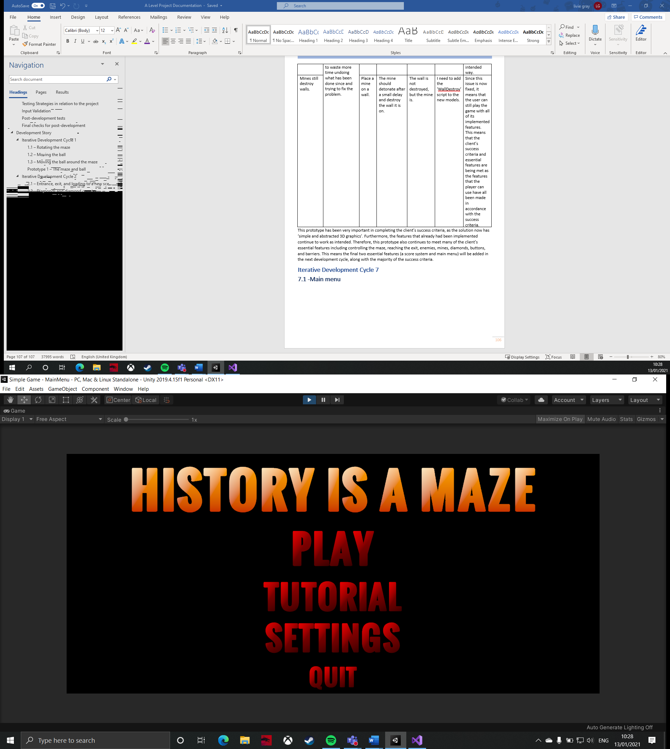

public void QuitGame() //This function is called when the user presses the 'quit' button

{

Application.Quit(); //Closes down the program

}

The above code is actually the only code relevant to the main menu; the other functions will just enable and disable the various panels (for example, the level select menu, or the settings menu). The ‘quit’ button exits the game and closes it down. The main menu is necessary as a hub of functions for the player, which means that, from the main menu, the player can access many mechanics in the game, such as the tutorial or the actual game. For the purposes of testing, I will create the other panels and test them all together. This way it will be easier to see that each button that loads up a new panel works as intended (there is no point in creating an ad-hoc panel which will be deleted very soon afterwards).

|  |  |  |  |  |  |  |
| --- | --- | --- | --- | --- | --- | --- |
| **Test** | **Purpose of test** | **Input** | **Expected output** | **Actual output** | **Proposed remedial action** | **Justification of action** |
| The ‘quit’ button closes the application. | In this test, I will use a debugging tool to ensure the method is called, as I cannot properly test this until I have compiled the final build. This test is important as the user needs a way of shutting the game when they want to. If there was not a ‘quit’ button or it did not work, then they would have to use task manager to close the application, which not all users may know how to do. This would lead to confusion for some and not give them a good impression of the solution. | Click on the ‘quit’ button. | ‘Quit App’ will be printed to the console. | ‘Quit App’ is printed. | No remedial action needed. | No action is needed because the feature works as intended. |

### **7.125 – Level select menu**

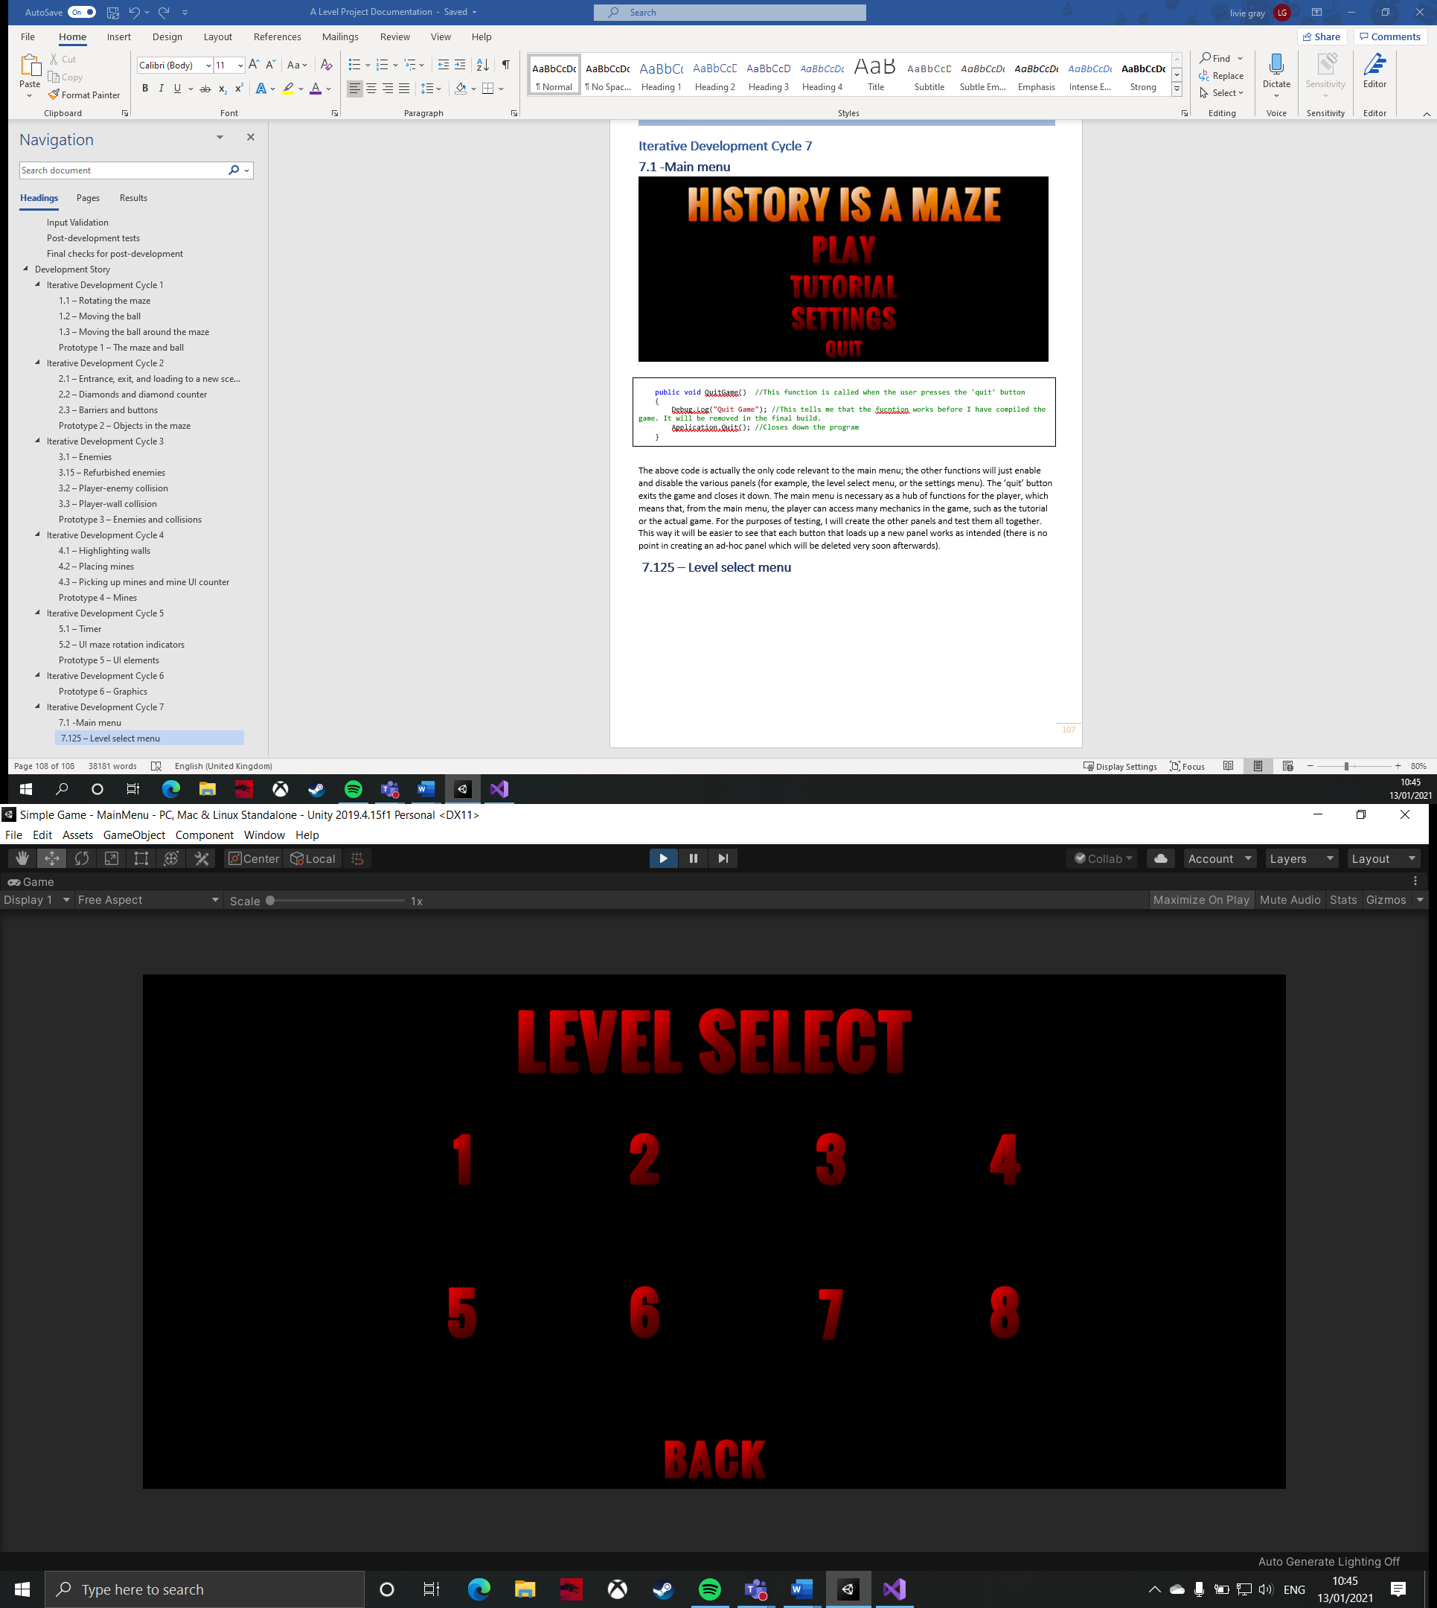

public Image level01Tick;

public Image level02Tick;

public Image level03Tick;

public Text level01Score;

public Text level02Score;

public Text level03Score;

void Start()

{

if ((PlayerPrefs.GetInt("Level01")) == 1) //As PlayerPrefs does not use Booleans, I have used integers as a form of binary boolean, where 1 represents true (i.e. the level has been completed)

{

level01Tick.enabled = true; //The tick shows the level has been completed

level01Score.text = (PlayerPrefs.GetInt("Level01Score")).ToString(); //This displays the highest score the player has achieved on the level

}

else

{

level01Tick.enabled = false; //Does not show a tick if the level has not been completed

}

if ((PlayerPrefs.GetInt("Level02")) == 1) //This is the same for all levels on the level select menu

{

level02Tick.enabled = true;

level02Score.text = (PlayerPrefs.GetInt("Level02Score")).ToString();

}

else

{

level02Tick.enabled = false;

}

if ((PlayerPrefs.GetInt("Level03")) == 1)

{

level03Tick.enabled = true;

level03Score.text = (PlayerPrefs.GetInt("Level03Score")).ToString();

}

else

{

level03Tick.enabled = false;

}

public void LoadLevel01() //When the player presses the '1' button, level 1 will be loaded.

{

SceneManager.LoadScene(1);

}

public void LoadLevel02() //This is the same for all other numbered buttons on the level select menu

{

SceneManager.LoadScene(2);

}

public void LoadLevel03()

{

SceneManager.LoadScene(3);

}

The above code deals with loading the corresponding level when the user presses one of the buttons, and storing the player’s high score from each level they have completed. Unfortunately, the latter function is currently unused as there is no method that deals with calculating the user’s high score and setting the PlayerPrefs value as such. This will have to be tested in the prototype tests, when the high score system will have been implemented. This menu is necessary so that the player can access each level of the game and also so that there is a competitive element to the solution that creates discussion among the user and their peers.

|  |  |  |  |  |  |  |
| --- | --- | --- | --- | --- | --- | --- |
| **Test** | **Purpose of test** | **Input** | **Expected output** | **Actual output** | **Proposed remedial action** | **Justification of action** |
| Pressing ‘1’ loads level 1. | This test checks that when the user presses the button to load a specific scene, the correct scene is loaded. This is important as the game gets progressively harder in later levels, so the player will ideally want to play the levels in numeric order. The ‘2’ button should load an empty scene as that is all it is at the minute. | Press ‘1’. | Level 1 should be loaded. | Level 1 is loaded. | No remedial action needed. | No action is needed because the feature works as intended. |
| Pressing ‘2’ loads level 2. | Press ‘2’. | Level 2 should be loaded. | Level 2 is loaded. | No remedial action needed. | No action is needed because the feature works as intended. |
| Pressing ‘back’ loads the main menu. | This test is important as the player needs to have the option to return to the main menu if they decide they do not want to play a level now; this could be because they want to re-check the tutorials. Therefore, it would be unfair to force the player straight into a level, and would probably leave them with a negative impression of the game. | Press ‘back’. | The main menu should be loaded. | The main menu is loaded. | No remedial action needed. | No action is needed because the feature works as intended. |

|  |
| --- |
| **Videos:**   * 1 button loads level 1 * Back button loads main menu |

### **7.15 – Tutorial menu**

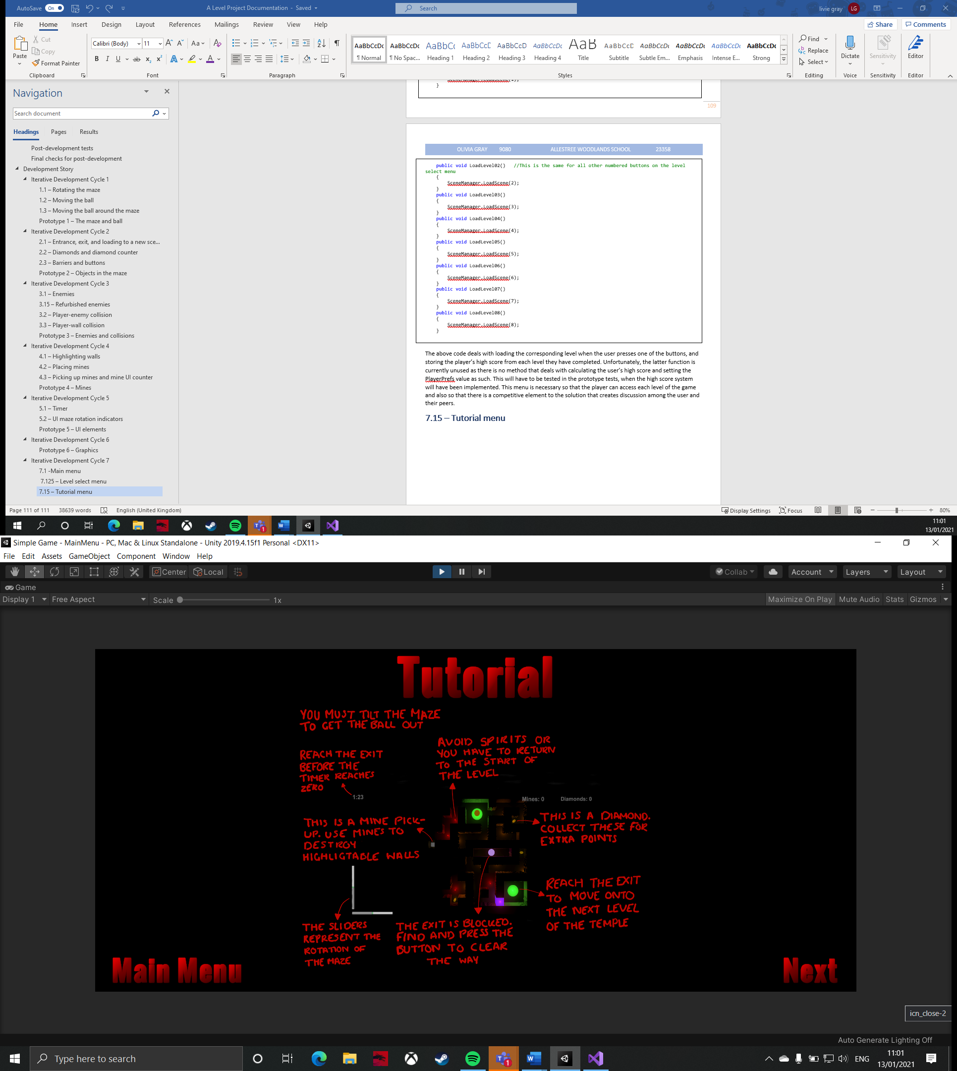

This is the tutorial menu that will help explain all of the mechanics and controls of the game to the user. This part of the menu has no code attached to it, as its only function is switching between different panels, which I can implement from within the Unity editor using the ‘SetActive’ function. This menu is critical to the player’s understanding of the game. Without it, the player may feel lost and confused whilst playing the game, which would cause them frustration and perhaps to turn the game off, which would not generate a positive reaction to the game amongst their peers.

|  |  |  |  |  |  |  |
| --- | --- | --- | --- | --- | --- | --- |
| **Test** | **Purpose of test** | **Input** | **Expected output** | **Actual output** | **Proposed remedial action** | **Justification of action** |
| The ‘next’ button brings up the next tutorial screen. | This test is important to ensure that the player can access all tutorials. This is because the tutorial is sectioned into three images: the main mechanics, keyboard controls, and gamepad controls. Therefore, they will need to able to see at least two of the images to understand how to play the game. Without this test, they may not be able to access the tutorials which would make the game too complicated to learn, which goes against the intended purpose of the game. | Press the ‘next’ button twice. | The user should see all three tutorial screens. | The tutorial screens are all accessible. | No remedial action needed. | No action is needed because the feature works as intended. |
| The ‘back’ button returns to the previous tutorial screen | This test ensures that the user can easily cycle through all of the tutorial screens. This is important because, in order to learn the controls easily, the player should be able have the information quickly available to them. Without this test, the player would have to go back to the main menu to return to the first tutorial so they could then go to the second and third, which is just too much effort. | From the final tutorial screen, press ‘back’ twice. | The user should return to the first tutorial screen. | The main menu is loaded. | I need to tell each back button to enable a tutorial screen, not the main menu. | This issue has come from duplicating the ‘back’ button from the level select menu, which goes back to the main menu. This means that the tutorial menu is not even disabled – it is just covered by the main menu. However, this can be easily rectified from within the Unity editor by ensuring that I am disabling and enabling the correct panels. |
| The ‘main menu’ button returns to the main menu. | This test is important as the player should not be forced to click through all of the tutorial menus in order to return to the main menu, as this will become a frustration very quickly. This means that this test ensures that the menus are easy to use and navigate for the player. | From any tutorial menu, press ‘main menu’. | The user should be returned to the main menu panel. | The main menu panel is enabled. | No remedial action needed. | No action is needed because the feature works as intended. |

|  |
| --- |
| **Videos:**   * Next and back buttons |

### **7.175 – Settings menu**

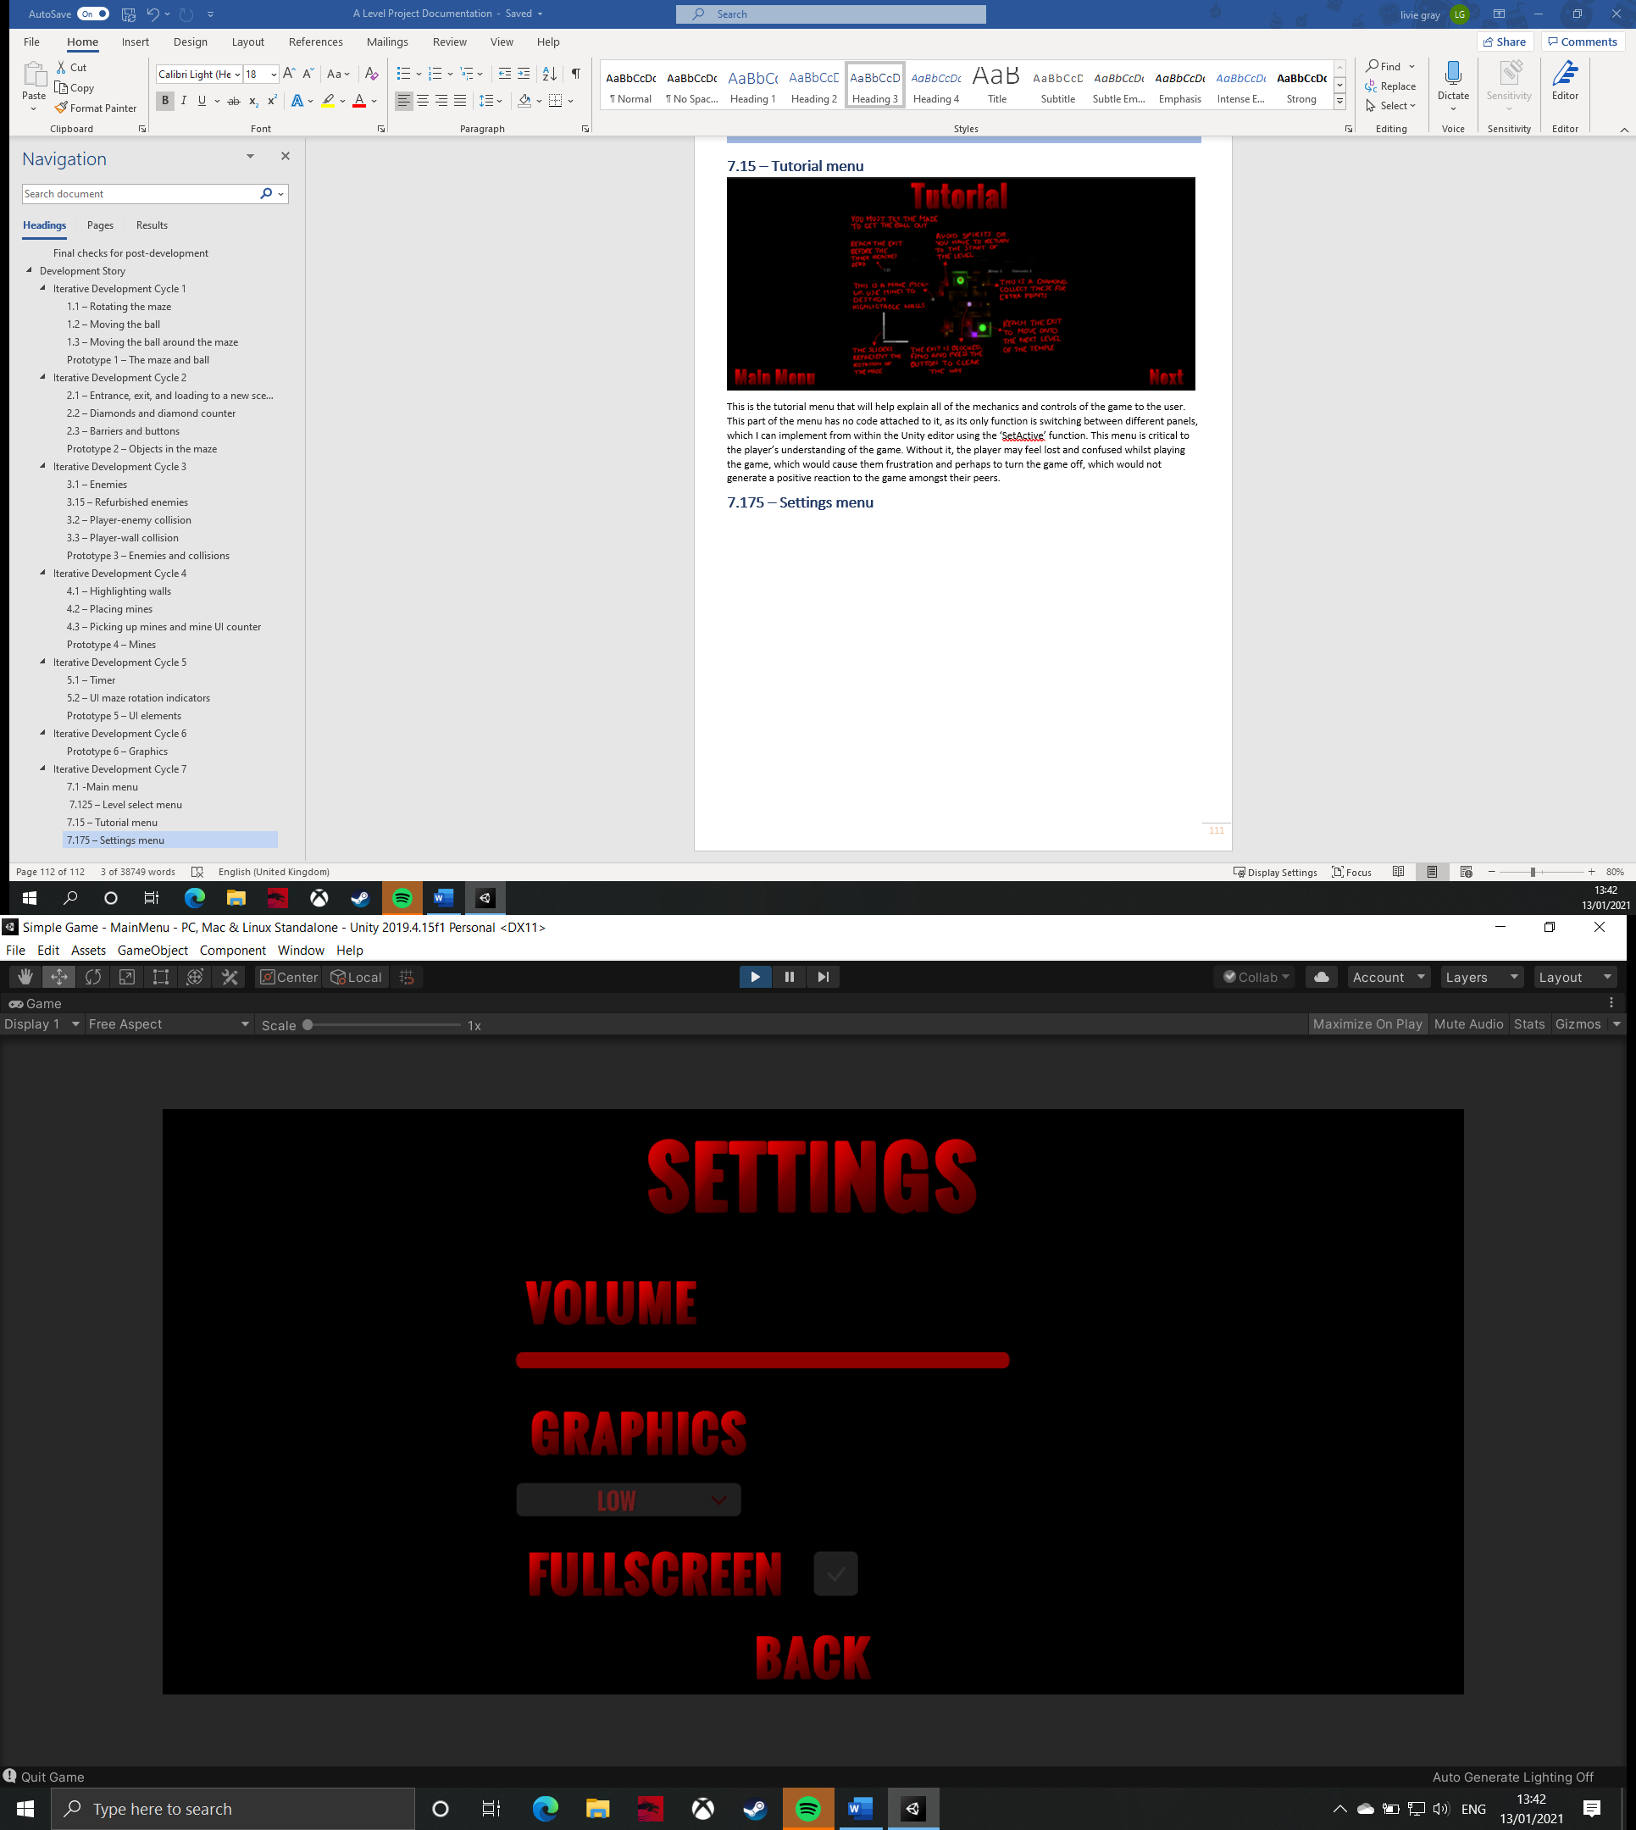

public AudioMixer audioMixer; //This is the channel that all sound comes through to be outputted

public void SetVolume(float vol) //Takes a value between -80 and 0 (with 0 being the maximum volume) that has been set by the player using a slider

{

audioMixer.SetFloat("vol", vol); //Sets the volume of all audio in the master channel to the value from the slider

}

public void SetGraphics(int graphicsDropdownIndex) //Takes the index that has been selected by the player in the graphics dropdown tab

{

QualitySettings.SetQualityLevel(graphicsDropdownIndex); //Uses Unity's build settings to set a graphics quality setting based on the previous index

}

public void SetFullscreen (bool fullscreen) //Gets a Boolean from a toggle

{

Screen.fullScreen = fullscreen; //Sets full screen to true of false accordingly

}

This code deals with all the functions of the settings menu. This allows the user to customise the game a bit so that it is more suitable to their device. The settings menu includes a volume adjustment, graphics quality adjustment, and a full screen toggle. Without the menu, the user may be put off the game by the fact that they cannot adjust certain aspects to their liking. For example, they many find the music (when it is added) too overpowering and drowns out the sound effects, or they might find that the game is too small on their screen, so the full screen button would give them an easy fix to this problem. This is important so that the player feels like the game caters for them. Otherwise, they would not have a good initial impression of the game, and would probably turn it off before they have even started playing.

|  |  |  |  |  |  |  |
| --- | --- | --- | --- | --- | --- | --- |
| **Test** | **Purpose of test** | **Input** | **Expected output** | **Actual output** | **Proposed remedial action** | **Justification of action** |
| Using the slider changes the volume. | This test ensures that the slider does allow the user to change the master volume of the game. This is important so that they can adjust the game’s settings to what suits them. This test will use a debugging tool to print a float to the console as it is changed. | Use the ‘LMB’ to slide the handle of the slider all the way to the left. | ‘-80’ will be outputted to the console. | ‘-80’ is outputted. | No remedial action needed. | No action is needed because the feature works as intended. |
| Using the dropdown menu changes the graphics quality. | This test is important so that the player can lower their graphical settings if they need to so that the game runs smoother on their system. This test will use the quality tab in project settings to monitor if the graphics are being changed. | Use ‘LMB’ to select ‘high’ in the dropdown menu. | The high graphics tier will be selected in the quality tab. | The low graphics tier is selected. | I need to switch the order of options in the dropdown menu to ‘low, medium, high’. | This fix will work as the graphics tiers go from low to high in the project settings, so the dropdown indexes will now correspond with the tiers in the build settings. This fix is important because it would not make sense for the game performance to worsen when a lower graphics quality is selected (because it would actually be going to a high graphics quality. |
| Using the toggle swaps to and from full screen. | This test is Important because the user should have the choice to toggle full screen while playing the game. Without this test, the full screen toggle may not do anything, which means that the user would not be able to enlarge the their screen, which would be particularly bad if the user was playing on a small device. This test will use the Debug.Log function to show whether the toggle is setting the full screen Boolean to true or false. | Use ‘LMB’ to click on the full screen toggle. | When there is a tick in the toggle box, the full screen Boolean should be set to true, and when the toggle box is empty, the full screen Boolean will be false. | The Boolean is set to true and false on the correct input. | No remedial action needed. | No action is needed because the feature works as intended. |
| The ‘back’ button returns the user to the main menu. | This test is important as the user needs to be able to return to the main menu from settings. This is necessary because the game will not persistently store settings so, if they had to force close the game to return to the main menu, then they would lose all of their preferred settings, making the settings menu effectively redundant. | Press the ‘back’ button. | The main menu panel will be loaded. | The user is returned to the main menu. | No remedial action needed. | No action is needed because the feature works as intended. |

**7.1 Final Testing Table**

|  |  |  |  |  |  |  |
| --- | --- | --- | --- | --- | --- | --- |
| **Test** | **Purpose of test** | **Input** | **Expected output** | **Actual output** | **Proposed remedial action** | **Justification of action** |
| Pressing ‘play’ loads the level select menu. | This test ensures that the user can access the menu that allows them to load each level. This is important as the user would not be able to play the game at all if they could not reach any of the levels, which would make the whole product a complete waste of time. | Press the ‘Play’ button. | The level select menu will be loaded. | The level select menu is loaded. | No remedial action needed. | No action is needed because the feature works as intended. |
| Pressing ‘tutorial’ loads the first tutorial screen. | This test checks that the user can view the tutorials. If this feature did not work, then the user would not know how to play the game as they would not be able to view any of the tutorials. This would lead to frustration and could cause the player to give up playing the game. | Press the ‘Tutorial’ button. | The first tutorial image should be loaded. | The first tutorial screen is loaded. | No remedial action needed. | No action is needed because the feature works as intended. |
| Pressing ‘settings’ loads the settings menu. | This test is important as the player should also be able to access the settings menu. This then allows them to adjust some of the settings in the game to better fit their device or web browser. Without this, the game may be too technically difficult to play on smaller devices. | Press the ‘Settings’ button. | The settings menu should be loaded. | The first tutorial screen is loaded. | I need to change the ‘settings’ button’s function so that it enables the settings panel as opposed to the tutorial panel. | This would fix the issue because it will specify the correct panel that the button needs to load. This fix is important because it allows the user to access the settings menu, but also because it allows them to access the screen they were expecting to see. |

|  |
| --- |
| **Videos:**   * Play button loads level select menu * Failed settings button loads settings menu |

### **7.2 – Pause menu**

public static bool isGamePaused = false;

public GameObject pauseMenuUI;

public LevelLoader levelLoader;

void Update()

{

if (Input.GetKeyDown(KeyCode.Escape)) //Checks if 'escape' has been pressed

{

if(isGamePaused) //Used to toggle the pause menu on and off

{

Resume();

}

else

{

Pause();

}

}

}

public void Resume()

{

pauseMenuUI.SetActive(false); //Disables the pause menu panel so it is invisible

Time.timeScale = 1f; //Resumes the game

isGamePaused = false;

}

void Pause()

{

pauseMenuUI.SetActive(true); //Enables the pause menu panel so the user can see it

Time.timeScale = 0f; //Stops the game from progressing further so it is effectively 'paused'

isGamePaused = true;

}

public void RestartLevel()

{

Time.timeScale = 1f; //This is necessary so that the level loader can start the scene transition. Otherwise, it would restart the level, but there would be no transition

levelLoader.ReloadLevel(); //Calls the function in the level loader that calls the coroutine to load a level with a scene transition

}

public void LoadMenu()

{

Time.timeScale = 1f; //This is also necessary so that the scene transition works

levelLoader.LoadMainMenu(); //Calls the function in levelLoader that sets the target build index to 0, as this is what the main menu is stored as

}

public void QuitGame()

{

Application.Quit(); //Shuts the game down

}

This code deals with all functions relating to the in-game pause menu for the user. This includes pausing the game, resuming the game, restarting the level, returning to the main menu, and quitting the game. These mechanics are all split up into separate methods in order to keep the code organised. The player will be able to enable and disable the pause menu using the ‘escape’ key, and can then use the LMB or joysticks and ‘select’ button to use the buttons on the menu.

The pause menu is important to allow the user access to different states of the solution from within each level. This will be good because it means that they can control their progress through the game, and will not be forced to complete the whole game in one sitting before they can return to the main menu. Without this feature, the user would have no way of exiting the game at their own will, so they would have to force close the application which would not provide a particularly good user experience.

|  |  |  |  |  |  |  |
| --- | --- | --- | --- | --- | --- | --- |
| **Test** | **Purpose of test** | **Input** | **Expected output** | **Actual output** | **Proposed remedial action** | **Justification of action** |
| Pressing ‘escape’ opens the pause menu. | This test ensures that the user can access the pause menu. This is important because the user will be able to able to return to the main menu and restart the level from the pause menu. Without this feature, the user would not have as much control over the game so would most likely have to force close the game if they wanted to exit it, which is time-consuming and annoying for the user. | Press ‘escape’. | The game will be paused and the pause menu panel will be shown. | The game is paused and the pause menu panel is shown. | No remedial action needed. | No action is needed because the feature works as intended. |
| Pressing ‘escape’ closes the pause menu. | This test is important because the user needs to be able to return to the game when they want to. Without this feature, the user would not be able to use the pause menu as a way of pausing the game to have a break, where they intend to come back to it. This is bad because this is what pause menus are often used for, and it is particularly important in this product because the game runs against a timer | Press ‘escape’. | The game will be resumed and the pause menu will be closed. | The pause menu is closed and the game is resumed at normal time scale. | No remedial action needed. | No action is needed because the feature works as intended. |
| Pressing the ‘resume’ button closes the pause menu. | Press the ‘resume’ button. | The game will be resumed and the pause menu will be closed. | The pause menu is closed and the game is resumed at normal time scale. | No remedial action needed. | No action is needed because the feature works as intended. |
| Pressing the ‘restart’ button reloads the level. | This test will check that the user can restart the level easily. This is important because the user may feel like they have not approached a puzzle in the maze right which had cost them some time. Therefore, rather than having to wait for the timer to run out, they should be able to access the pause menu to restart the level when they want. | Press the ‘restart’ button. | The scene transition should start and the level should be reloaded. | The level is reloaded. | No remedial action needed. | No action is needed because the feature works as intended. |
| Pressing the ‘main menu’ button returns the user the main menu. | The test is important because the user should be able to go back to the main menu when they want to. This may because they want to reread some of the tutorial or because they want to adjust their settings. This means they should be able to do this if they want to. Without this feature, the only way to return to the main menu would be to either complete the final level, or to quit the program and restart it, both of which are too time-consuming for the average user. | Press the ‘main menu’ button. | The user will be returned to the main menu. | The main menu is loaded. | No remedial action needed. | No action is needed because the feature works as intended. |
| Pressing the ‘quit’ button closes the program down. | This test checks that the user will be able to easily exit the game when they feel like it. This is important because the user will not want the game to be downloading data constantly, even when they are no longer playing it, as this consume their bandwidth and slow down their network speeds, which is bad. Without this feature, they would have to return to main menu to quit the application, which is indirect and frustrating. This test will use a debugging tool to print an output to the console when necessary. | Press the ‘quit’ button. | ‘Quit’ should be printed to the console. | ‘Quit’ is printed to the console. | No remedial action needed. | No action is needed because the feature works as intended. |

### **7.3 – Sound system**

private SoundSystem soundSystem = null;

private new AudioSource audio;

private void Awake() //Called before the scene is even initialised

{

if (soundSystem == null) //Checks whether there is already a value given to the soundSystem variable

{

soundSystem = this; //If not, I set the current instance of the soundtrack as the value of soundSystem

DontDestroyOnLoad(gameObject); //Then, tell it not to be destroyed as new scenes are loaded

}

else if (soundSystem == this) //This line checks whether soundSystem has a value

{

Destroy(gameObject); //If it does already, then it needs to destroy the new one

}

}

void Start()

{

audio = GetComponent<AudioSource>(); //Gets an audiosource component attached to the soundSystem object

audio.Play(); //Plays the pre-set sound track audio through this audio source

}

This code is used play the game’s soundtrack throughout the whole game, and in all of its states. Specifically, this code plays the music persistently, meaning that the music continues through all scenes. It does this by assigning a value to the ‘soundSystem’ variable if there is not one already, or by destroying the new value if a value already exists in it.

This feature is important because, with the sound track only being about 20 seconds long, it will be repeated a lot throughout the user’s play-time. Therefore, it would be ideal to reduce the duration that it repeats for (by only repeating it when it reaches the end of itself, rather than starting again when a new scene is loaded). Without this feature, the user may find the music too repetitive, as it will take less time for them to recognise when its repeats itself. This could be bad as the music would then not add anything to creating the atmosphere in the game because the music would just fade into the background.

|  |  |  |  |  |  |  |
| --- | --- | --- | --- | --- | --- | --- |
| **Test** | **Purpose of test** | **Input** | **Expected output** | **Actual output** | **Proposed remedial action** | **Justification of action** |
| The music is persistent throughout all scenes. | This test is important for the reasons outlined above – it is all about reducing the repetition of the sound track for the user as I want to maintain the eerier and spooky atmosphere of the game for as long as possible. | Start the game in the main menu then open level 1. | The music will continue from the main menu to level. | The music does continue but level 1 also starts playing the sound track on top of it as well. | I need to delete the sound system object out of level 1, as the whole sound system object from the main menu is being transferred into level 1. | This will fix the problem as it prevents two sound system objects from being in one scene. Furthermore, this fix is necessary because this problem will only get worse and more obvious with the more levels the user plays in one sitting ass, for example, when the user goes to level 2, there will then be three sound system objects. This will become convoluted and will most likely just frustrate the user. |
| The music plays on a loop. | This test is important as the sound track should not just play once then stop; it needs to accommodate for users who will all play the game for different durations. With the sound track only being 20 seconds long, this is even more important a the music is designed to create a spooky atmosphere in the game, which will be immediately lost if the music stops after one run. | Start the game. | The music will loop continuously. | The music loops. | No remedial action needed. | There is a small pause between the end of the track and restarting it, but I know form previous experience that this issue will be fixed when the game is compiled into a final build. Therefore, no action is needed because the feature works as intended. |

|  |
| --- |
| **Videos:**   * Music is persistent throughout scenes   **Audio:**   * Soundtrack |

### **7.4 – High score system**

private bool winGame = false;

public LevelLoader levelLoader;

public CountdownTimer timer;

public PlayerBall player;

private int diamondsAmountAtEnd;

public FinalScore finalScore;

private int score;

void Update()

{

if (winGame == true)

{

timer.ShowTimeLeftOnWin(); //Tells the timer to give its final time to the score script

finalScore.GetDiamondAmount(diamondsAmountAtEnd); //Gives the diamond amount to the score script

finalScore.TotalScore(); //Tells the score script to calculate the final score

finalScore.CheckForEndOfGame(); //Tells the score script that it is the end of the game

score = finalScore.finalScore; //Recollects what the final score is from the score script that has just calculated it

int sceneNumber = SceneManager.GetActiveScene().buildIndex; //Used to recognise what the current scene index is for the following switch statement

switch (sceneNumber)

{

case 1:

PlayerPrefs.SetInt("Level01", 1); //Using 1 to represent a completed level

int previousScore1 = PlayerPrefs.GetInt("Level01Score"); //Gets the score already held in PlayerPrafs

if (previousScore1 <= score) //And compares it with the new score

{

PlayerPrefs.SetInt("Level01Score", score); //If the new score is higher, then the highscore is updated

}

levelLoader.LoadNextLevel(); //Loads the next level

break;

case 2:

PlayerPrefs.SetInt("Level02", 1); //This repeats for all levels

int previousScore2 = PlayerPrefs.GetInt("Level02Score");

if (previousScore2 <= score)

{

PlayerPrefs.SetInt("Level02Score", score);

}

levelLoader.LoadNextLevel();

break;

}

}

}

void OnTriggerEnter(Collider other) //Called when an external object collides with the exit object

{

if (other.gameObject.tag == "Player") //Checks that the collision has occurred between the exit and the ball

{

winGame = true;

diamondsAmountAtEnd = player.diamondAmount; //Collects the diamonds amount from the ball script

}

}

if (endGame == false) //Whilst the user has not reached the exit

{

text.text = timeText; //Updates the timer, which is in the user's UI

finalTimeText.enabled = false; //This is used to show the player when time is up, therefore it is set to false whilst the player is still 'playing' the level

finalTimeInSeconds = timeLeft; //Collects the remaining time into this variable

}

public void ShowTimeLeftOnWin() //Called from the exit script

{

endGame = true; //Sets the game to ended so the timer stops running and a final time can be collated

finalScore.GetTimeLeft(finalTimeInSeconds); //Sends the final time to the final score script so a score can be calculated

}

private float timeLeftSeconds;

private float diamondsCollected;

private float diamondMultiplier = 50f;

public int finalScore;

public Text finalScoreText;

private bool endGame = false;

void Update()

{

if (endGame == false)

{

finalScoreText.enabled = false; //This prevents any score being shown before the user has reached the exit

}

else

{

finalScoreText.enabled = true; //When the user has reached the exit, the score text will be shown and the score variable will be updated so it displays the correct score

}

}

public void GetTimeLeft(float time) //Collects the time that the timer was on when the user reached the exit

{

timeLeftSeconds = time; //And stores it in this variable so it can be used easily in this script

}

public void GetDiamondAmount(int diamonds) //Collects the amount of diamonds the user had when they reached the exit

{

diamondsCollected = diamonds; //And stores it in this variable so it can be used easily in this script

}

public void TotalScore()

{

float score = timeLeftSeconds + (diamondsCollected * diamondMultiplier); //Calculates a final score based on time remaining and diamonds collected

finalScore = Mathf.RoundToInt(score); //Prevents the final score being a float

finalScoreText.text = ("SCORE: " + finalScore.ToString()); //Updates the final score text so the user can see what they scored on that level

}

public void CheckForEndOfGame() //Causes an update in this script that tells it the user has reached the exit so it knows when to display the final score text

{

endGame = true;

}

The red code represents the code which has previously been implemented but is necessary for the function of this code.

This code handles calculating the user’s score for the level and deciding whether it is their highest score, and, therefore, whether to update the Player Preferences value for the level select menu. This code becomes quite messy because it is collating information from many different scripts and passing values to and from to get the desired result. The first set of code is attached to the exit object, which is acting as a hub of control to the latter two scripts. This is because the exit is the object that is monitoring for a collision with the ball, and therefore when the game ends. The seconds piece of code from the timer object which was previously implemented. The only addition to this is collecting the final time so it can be sent to the final score script, which is the final set of code. The final score script is collating all of the parameters so a final score can be calculated. The final score is displayed on the UI for the user and is also passed back to the exit object so it can compare this score to the score in Player Preferences (this should be the highest score yet). If the new score is higher, the PlayerPrefs value is replaced with the new score.

This feature is necessary because the client has specified that they want a high score system in the solution in their success criteria. Therefore, without this feature, the client would not be happy with the game as it would not meet their expectations. The high score system is a very important addition in generating discussion around the game among the target audience.

|  |  |  |  |  |  |  |
| --- | --- | --- | --- | --- | --- | --- |
| **Test** | **Purpose of test** | **Input** | **Expected output** | **Actual output** | **Proposed remedial action** | **Justification of action** |
| The score is calculated accurately. | This test ensures that the final score is accurate. If this does not work, it may not be such a big deal if score decreases with the more time passed, but if score increases as time decreases, then this will just be confusing for the user. Furthermore, they will also be able to exploit by completing the maze in the longest time possible, which does not make the game particularly competitive. | Use ‘WASD’ keys to roll the ball over the exit when the time is 1:25 (the ball will be positioned outside the exit for the purpose of the test). | The score should be displayed ass 85. | The score is 85. | No remedial action needed. | No action is needed because the feature works as intended. |
| The final score is displayed on the user’s UI. | This test is important because the user should be able to see what score they achieved for every level they do, regardless of whether they have beaten their high score or not. Without this test, the competitive element would not be as strong in the solution, which would be bad as the competition that is encouraged can be used to create discussion around the game, which is important for its purpose to help the audience consider what their future careers could be. | Use the ‘WASD’ keys to roll the ball over the exit. | The user’s score should be displayed in large text on the UI. | The score is displayed on the UI. | No remedial action needed. | No action is needed because the feature works as intended. |
| The highest score is displayed on the level select menu. | This test ensures that the user can see what their high score is. This is important to increase the replay-ability of the game as it will encourage the user to beat their own high score and to compete against their peers. Without this test, the level select menu may not display any score, which makes the high score system entirely redundant. | Complete the level, then open the level select menu. | The highest score should be displayed on the level select menu. | The highest score is displayed on the level select menu. | No remedial action needed. | No action is needed because the feature works as intended. |

|  |
| --- |
| **Videos:**   * Final score is displayed on UI |

### **Prototype 7 – Polishing Up**

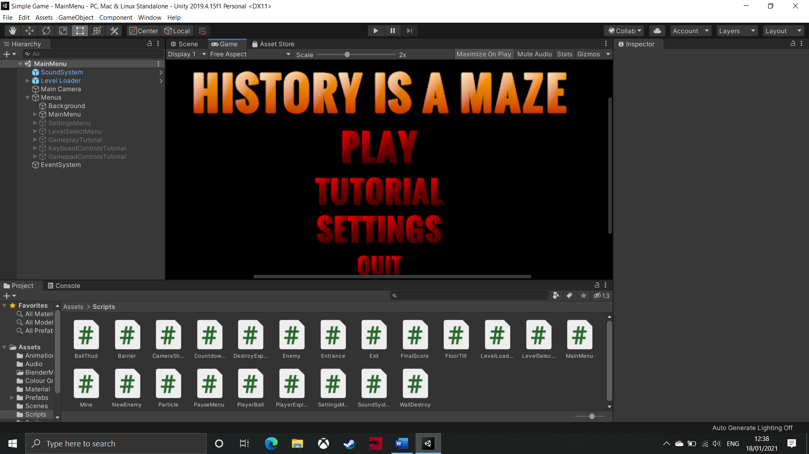

In this prototype, I have created all of the menus for the game and developed all of their functions. Furthermore, I have also implemented the high score system which is built upon the early foundations of the exit object and the diamond collection system which were both created in iterative development cycle 2. This prototype includes all features in the game, which means that all levels can be very easily built using the Unity editor and prefabs.

|  |  |  |  |  |  |  |
| --- | --- | --- | --- | --- | --- | --- |
| **Test** | **Purpose of test** | **Input** | **Expected output** | **Actual output** | **Proposed remedial action** | **Met the success criteria?** |
| All buttons in the main menu work as intended. | This test will check that the main menu completely works so that the user can use it any intended way. Without this test, a small error could have been so far undetected which would be bad if the user were to be the first one to find this error. | Press all the buttons on the main menu to check they go where specified. | All buttons should take the user to the correct screen. | All of the buttons work. | No remedial action needed. | This test shows that the main menu does meet the client’s success criteria of ‘main menu including settings, level select and tutorial menus’. This because I can now confidently say that the main menu works as intended. |
| All buttons in the pause menu work properly. | This test is important so that I can show that the pause menu meets the client’s success criteria. This is because the client required an easy way to restart the level from within the game, and this is what the pause menu allows the player to do. Furthermore, the pause menu also allows the player to access other states of the game which are essential for the making the game easy to use. | Press all the buttons on the pause menu to check they do what is specified. | All buttons should carry out the correct function. | All buttons work as intended. | No remedial action needed. | This test has shown that the pause menu does work, which means that it also fulfils the client’s success criteria of ‘level can be restarted easily from within the level without having to go back to the main menu’, which is important for ease of use in the game. |
| The sound system’s volume can be controlled using the volume slider in the settings menu. | This test is important as, now all the new features are in a completed prototype, it will be easy to test that all the new features work together cohesively. Without this test, the features, whilst they work separately, may not work together which would make both of them pointless. | Use the volume slider in the settings menu to lower the volume. | The volume of the soundtrack should decrease. | The volume of the soundtrack decreases. | No remedial action needed. | This test shows that the user has control over the sound system, which is one of the client’s success criteria (‘ambient music’). This is important because the solution will only be adequate the client’s requirements if their success criteria is met. |
| The volume of the sound track is persistent through all scenes. | This test checks that the sound system works in conjunction with another new feature from this development cycle (the volume adjustment slider). This is important because the volume slider will be pointless if it does not adjust the sound track volume as well as the in-game sound effects, or if the user can only reduce the volume in the main menu scene but it returns to full volume when the user accesses the levels. | Lower the volume slider, then load level 1. | The volume should remain lowered in level 1. | The volume is the same in level 1 as in the main menu. | No remedial action needed. | This test shows that this feature helps the solution meet the client’s success criteria of ‘ambient music’. This is because, for the music to class as ‘ambient’ it should not be overpowering, or too quiet for the user so they should be able to adjust to how they want. |
| The score on the level select menu is not overwritten by a lower score. | This test ensures that the high score system works as intended. This is important because the point of having a high score system is so that the user can see the best score they have achieved on each level, so if the score is being incorrectly overwritten, then it makes the feature fairly redundant and will probably just annoy the user. Without this feature, the user will not be able to compare scores with their peers, which detracts from the competitive element in the game. | Play level 1 twice, getting a lower score on the second run. | The level select menu will display the first run’s score. | The first score is displayed as this was the higher score. | No remedial action needed, | This test shows that the high score system does work properly, therefore fulfils the client’s essential features specification. This is important because the high score system is an integral feature to encouraging the target audience to discuss the game amongst themselves, and discussion is a very important part of deciding what to do with your future, so it will help the game complete its purpose. |
| The score on the level select menu is stored persistently | This test is important because there is no point to a high score system if it only stores the high score volatilely , and loses the data when the game is closed. For example, Pac-Man would not have been particularly good in the arcade, if there was no high score system, because there would be no point to the game other than ‘complete that level, now complete this level’, so the high score system gave it a new breath of life that made it so popular. This test will use the data from the previous test as it is already stored in Player Preferences. | Close the game, then start it again. | 118 should still be shown on the level select menu when the game is reloaded. | 118 is still displayed over level 1 on the level select menu. | No remedial action needed. | This test ensures that the solution meets the ‘scores from each level should be saved even if user closes the game’ success criteria. This is important because the solution needs to meet all of the client’s success criteria in order to be received well by the client and their target market. |

Through these tests, I have shown that all of the new features meet several success criteria and essential features, including: ‘main menu with settings, tutorials, and level select’; ‘level can restarted in-game’; ‘scores are stored persistently’; and ‘ambient music’. This means that all essential features have now been met, and the only success criteria left to be fulfilled are ‘5-10 discrete levels with challenging elements’ so I have designed 8 levels that can be created in the next development cycle, and ‘introduces new puzzle elements as the game progresses’. For this criterion, all of the puzzles have been created and prefabbed, so they just need to added to the new levels as they are created. Therefore, the final development cycle will lead to the completion of the project!

|  |
| --- |
| **Videos:**   * Buttons in the main menu * Buttons in the pause menu * Music volume is changed with the volume slider |

## **Iterative Development Cycle 8**

The tests carried out in this section will largely be repetitive as, at this point, everything has been tested, and these are just checks to ensure that each level has been built correctly.

### **8.1 – Level 1**

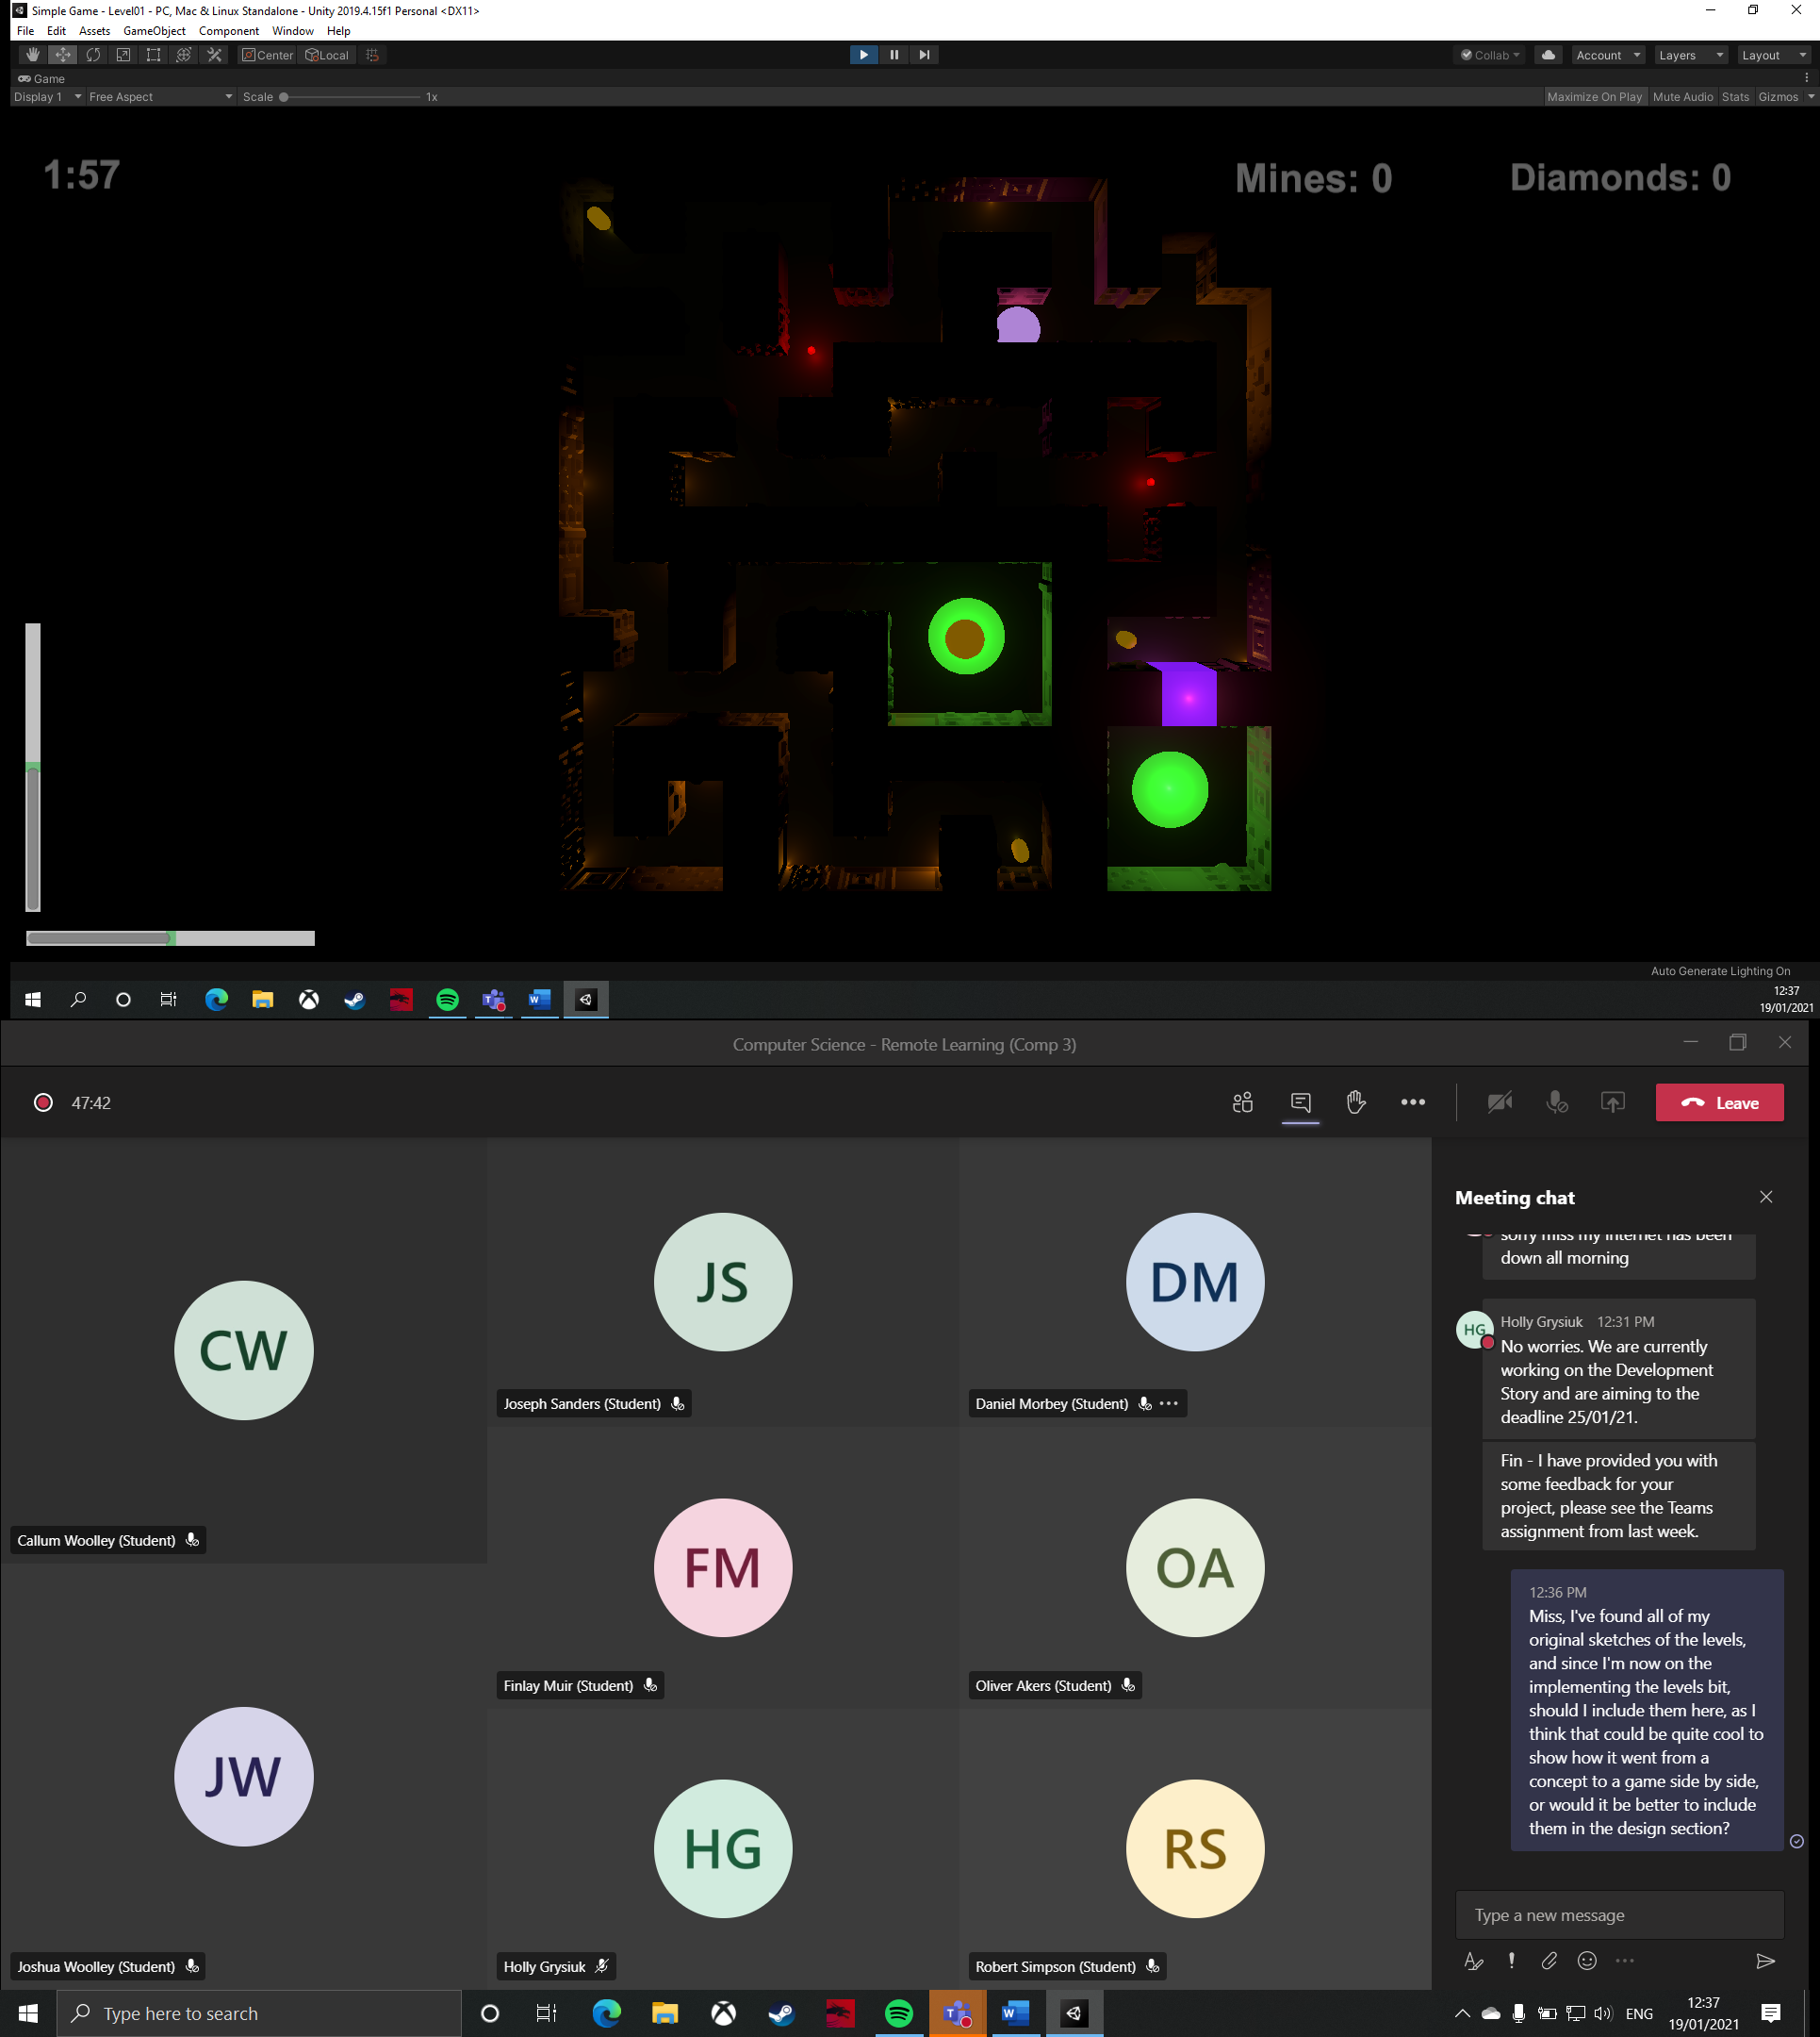

This is the first level of the game, which is the same layout as has been used all throughout development. In this level, there are three diamonds to collect, and one button to press to open up the exit. Mines will not be used on this level. The user will also have two minutes in which to complete the level; this should give them enough time to reach the exit and collect all the diamonds in the maze, with a bit of practice.

|  |  |  |  |  |  |  |
| --- | --- | --- | --- | --- | --- | --- |
| **Test** | **Purpose of test** | **Input** | **Expected output** | **Actual output** | **Proposed remedial action** | **Justification of action** |
| Is this level possible? | This test checks that the user will be able to complete the level and collect all the diamonds in the set time. This is important as the player needs to have a fair chance to be able to complete the whole level, otherwise, they may never be able to collect all of the diamonds and maximise their score, which would just detract from the competitive element of the game and make the user have a negative impression of the game, particularly if they are competitive. Furthermore, this also tests that the enemies move at an appropriate speed so that the user will be able to tackle the challenges they bring. Ideally, the level should be completed with 15-30 seconds left. | Use any available inputs to complete the level and collect all diamonds. | It should be possible to collect all diamonds and reach the exit in the time limit. | The level is completed with 40 seconds left. | I will not change this time limit as this is the first level so the game should not be impossibly hard at this stage. | No action is needed because the feature works as intended. |
| All necessary walls can be highlighted. | This test is important because it ensures that all of the walls that should be destroyable are added to the ‘blocks’ array in the ball script so that they can be highlighted. If the walls can be highlighted, it means they can be destroyed (I have previously tested this feature so can confidently know this is true). Without this test, I may have accidentally added too many walls, which could allow the player to exploit it, or not added enough walls to the array, which would most likely just be an oversight rather than a problem, as there would probably be another pace for the mine to be placed. | Hold ‘left shift’ and use ‘WASD’ to roll the ball around the maze, so the ball is near all walls. | All walls (excluding the exterior walls and the walls surrounding the exit) should be highlightable. | All necessary walls are highlighted when they are closest to the ball. | No remedial action  needed. | No action is needed because the feature works as intended. |
| Enemies follow their designated route. | This test ensures that I have correctly set up the enemy routes. This is important because the enemies ae designed to present a challenging puzzle to the player. Therefore, if I had set up the routes incorrectly, then the enemies may not be much a puzzle for the player, possibly making them too easy to dodge, or it could make some of them too hard to get around, effectively blocking off parts of the maze, which could be bad if they need to reach a diamonds or a button. | Start the scene and let it run for 30 seconds. | All enemies should use their designated routes. | All enemies follow the correct routes. | No remedial action needed. | No action is needed because the feature works as intended. |
| Everything rotates around the same pivot. | This test is very important because the user needs to be able to rotate everything in the maze and the maze itself around the same pivot, so that objects are being absorbed by the maze when it is rotated, therefore, all rotation needs to be relative to the maze. Without this test, I may have forgotten to set the walls, lights, enemies, diamonds, or mine pick-ups as children of the maze object, which would cause the aforementioned problems to occur. | Use ‘WASD’ keys to rotate the maze in all directions. | All objects should maintain a rotation and position relative to the maze. | Everything keeps its relative position and rotation. | No remedial action needed. | No action is needed because the feature works as intended. |
| The level can be accessed through the level select menu. | This test is important as the user needs to be able to access any level from the main menu. This means that the user can access level 1 by pressing ‘1’ or level 2 through the ‘2’ button, etc…. Without this test, I may have assigned the wrong value to the button, causing it to load the wrong level, or not load any level. | Press the ‘1’ button. | Level 1 should be loaded. | Level 1 is loaded. | No remedial action needed. | No action is needed because the feature works as intended. |

|  |
| --- |
| **Videos:**   * Level 1 |

### **8.2 – Level 2**

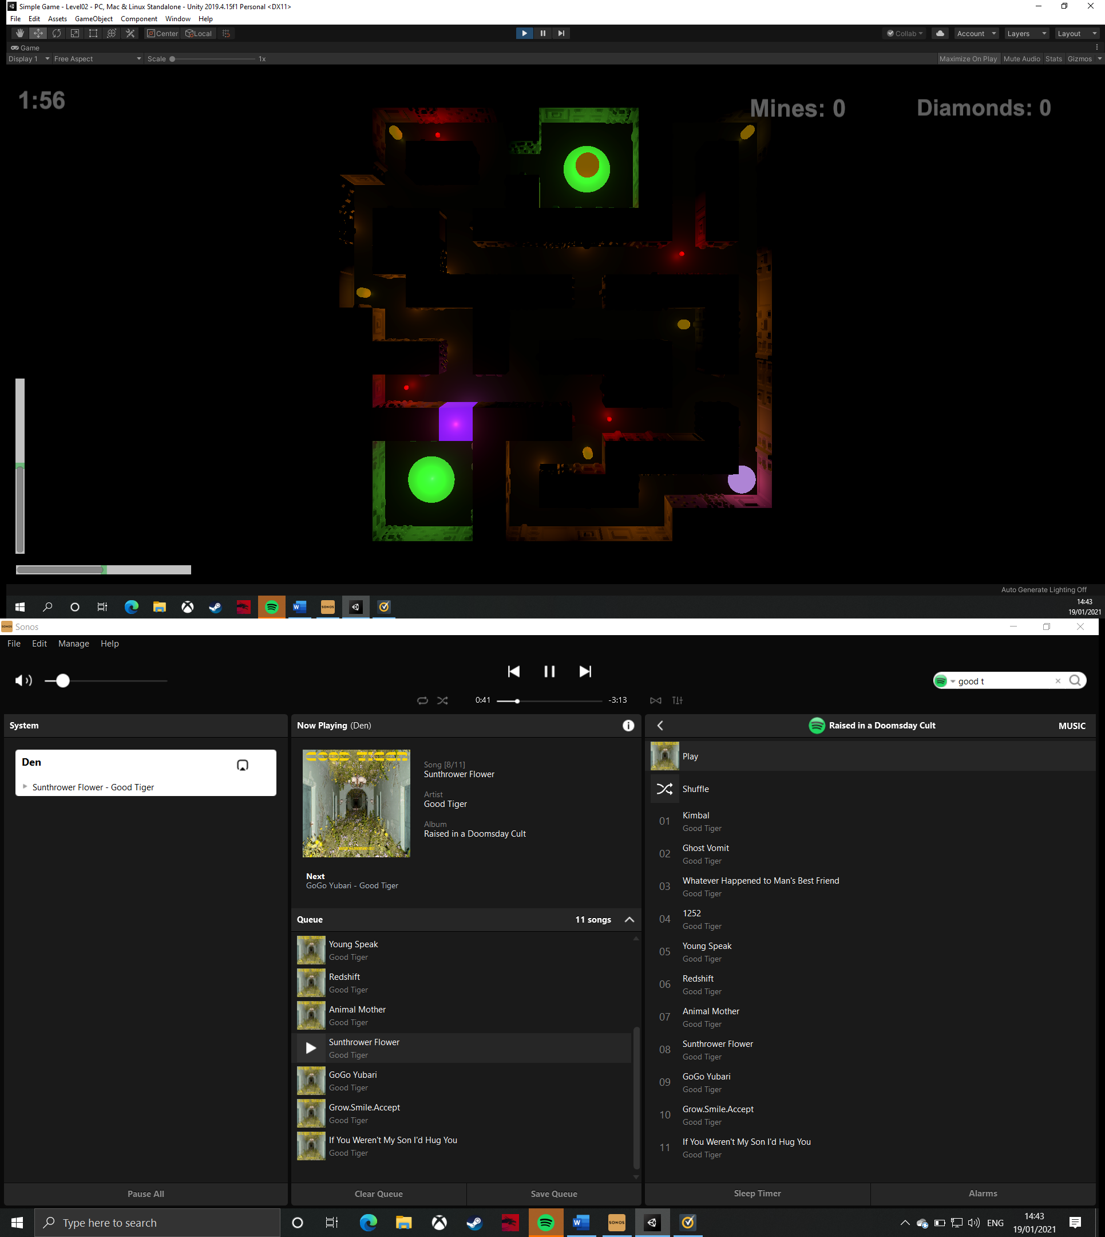

This is level 2. In this level, there are five diamonds to collect, and one button to press. There are four enemies, one of has a fairly complex route to follow. The enemies also present more of a challenge here as the player will now have to time the movement of the ball against the enemies’ movements so that they can squeeze through gaps in their patrols. The player will have two minutes to complete the level.

|  |  |  |  |  |  |  |
| --- | --- | --- | --- | --- | --- | --- |
| **Test** | **Purpose of test** | **Input** | **Expected output** | **Actual output** | **Proposed remedial action** | **Justification of action** |
| Is this level possible? | This test checks that the user will be able to complete the level and collect all the diamonds in the set time. This is important as the player needs to have a fair chance to be able to complete the whole level, otherwise, they may never be able to collect all of the diamonds and maximise their score, which would just detract from the competitive element of the game and make the user have a negative impression of the game, particularly if they are competitive. Furthermore, this also tests that the enemies move at an appropriate speed so that the user will be able to tackle the challenges they bring. Ideally, the level should be completed with 15-30 seconds left. | Use any available inputs to complete the level and collect all diamonds. | It should be possible to collect all diamonds and reach the exit in the time limit. | The level is completed with 33 seconds left. | No remedial action needed. | No action is needed because the feature works as intended. |
| All necessary walls can be highlighted. | This test is important because it ensures that all of the walls that should be destroyable are added to the ‘blocks’ array in the ball script so that they can be highlighted. If the walls can be highlighted, it means they can be destroyed (I have previously tested this feature so can confidently know this is true). Without this test, I may have accidentally added too many walls, which could allow the player to exploit it, or not added enough walls to the array, which would most likely just be an oversight rather than a problem, as there would probably be another pace for the mine to be placed. | Hold ‘left shift’ and use ‘WASD’ to roll the ball around the maze, so the ball is near all walls. | All walls (excluding the exterior walls and the walls surrounding the exit) should be highlightable. | All necessary walls are highlighted when they are closest to the ball. | No remedial action  needed. | No action is needed because the feature works as intended. |
| Enemies follow their designated route. | This test ensures that I have correctly set up the enemy routes. This is important because the enemies ae designed to present a challenging puzzle to the player. Therefore, if I had set up the routes incorrectly, then the enemies may not be much a puzzle for the player, possibly making them too easy to dodge, or it could make some of them too hard to get around, effectively blocking off parts of the maze, which could be bad if they need to reach a diamonds or a button. | Start the scene and let it run for 30 seconds. | All enemies should use their designated routes. | All enemies follow the correct routes. | No remedial action needed. | No action is needed because the feature works as intended. |
| Everything rotates around the same pivot. | This test is very important because the user needs to be able to rotate everything in the maze and the maze itself around the same pivot, so that objects are being absorbed by the maze when it is rotated, therefore, all rotation needs to be relative to the maze. Without this test, I may have forgotten to set the walls, lights, enemies, diamonds, or mine pick-ups as children of the maze object, which would cause the aforementioned problems to occur. | Use ‘WASD’ keys to rotate the maze in all directions. | All objects should maintain a rotation and position relative to the maze. | Everything keeps its relative position and rotation. | No remedial action needed. | No action is needed because the feature works as intended. |
| The level can be accessed through the level select menu. | This test is important as the user needs to be able to access any level from the main menu. This means that the user can access level 1 by pressing ‘1’ or level 2 through the ‘2’ button, etc…. Without this test, I may have assigned the wrong value to the button, causing it to load the wrong level, or not load any level. | Press the ‘2’ button. | Level 2 should be loaded. | Level 2 is loaded. | No remedial action needed. | No action is needed because the feature works as intended. |

|  |
| --- |
| **Videos:**   * Level 2 |

### **8.3 – Level 3**

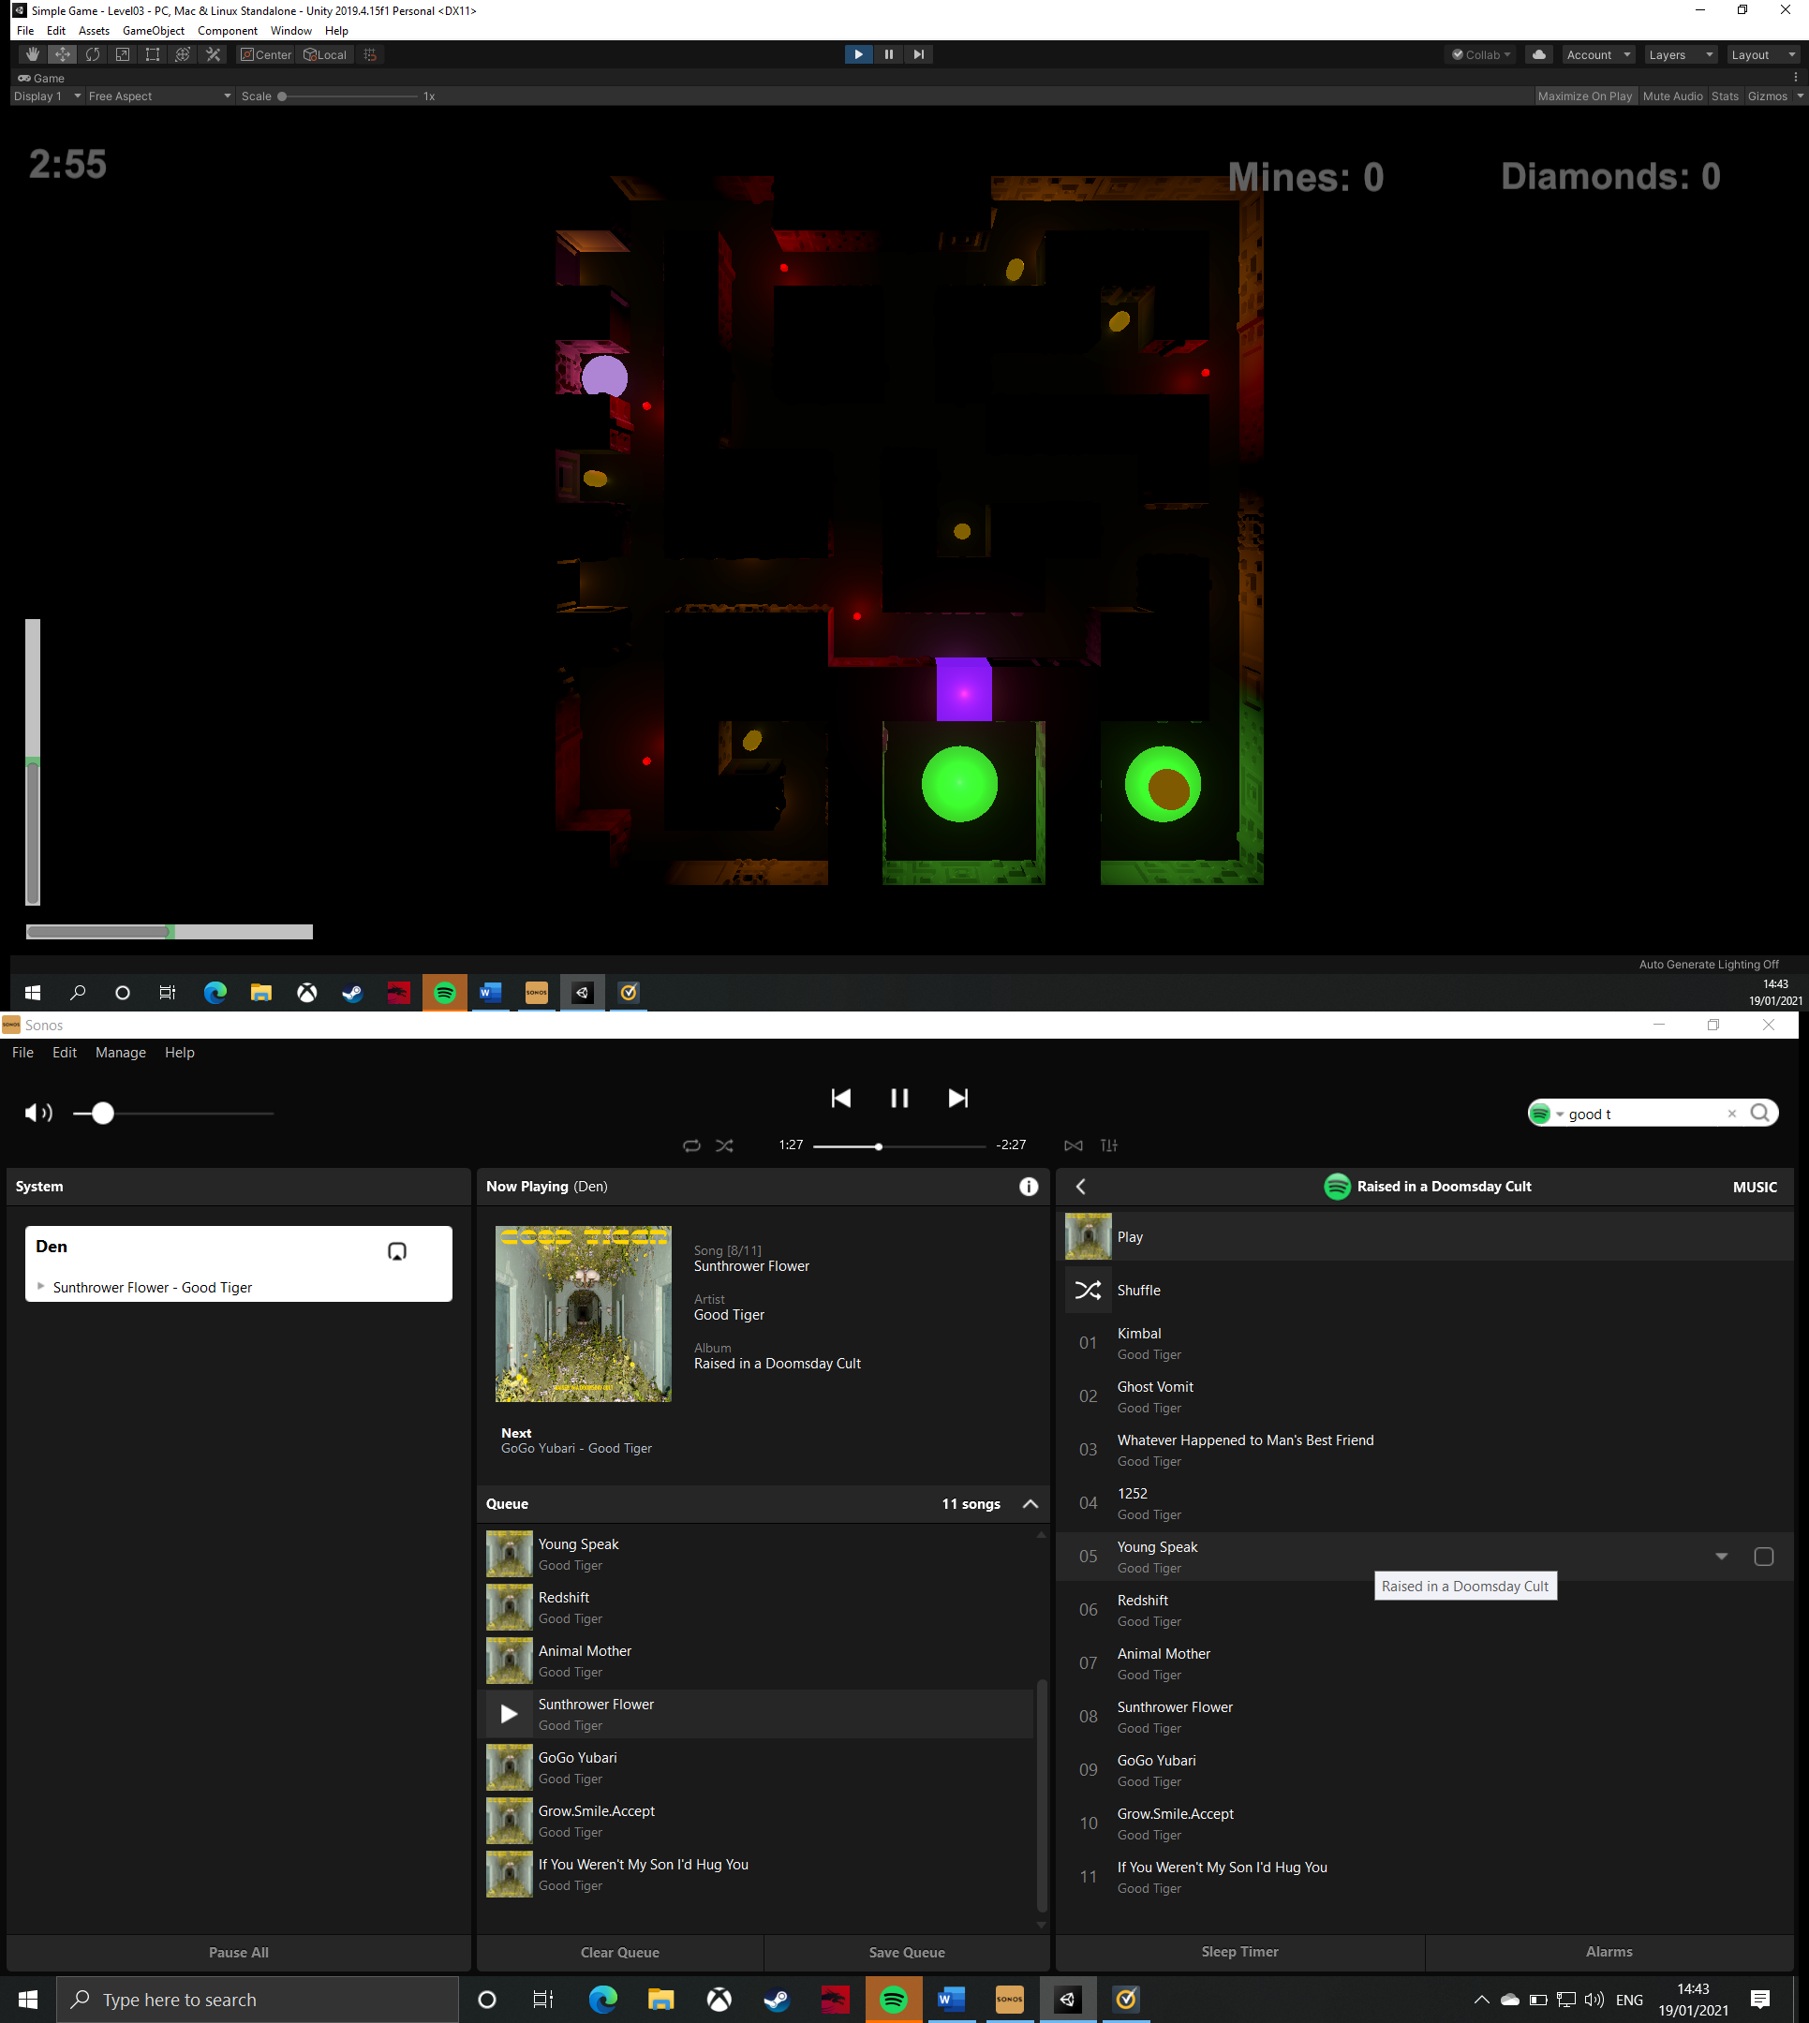

This is level 3. In this level, the player has five diamonds to collect and one button to press. There are five enemies in this level, and here, the enemies present a challenge for the player where they have to duck into nooks and crannies in the maze to allow the enemy to pass them. This is encouraged by the placement of the button in the top left corner. The user will have three minutes to complete the level.

|  |  |  |  |  |  |  |
| --- | --- | --- | --- | --- | --- | --- |
| **Test** | **Purpose of test** | **Input** | **Expected output** | **Actual output** | **Proposed remedial action** | **Justification of action** |
| Is this level possible? | This test checks that the user will be able to complete the level and collect all the diamonds in the set time. This is important as the player needs to have a fair chance to be able to complete the whole level, otherwise, they may never be able to collect all of the diamonds and maximise their score, which would just detract from the competitive element of the game and make the user have a negative impression of the game, particularly if they are competitive. Furthermore, this also tests that the enemies move at an appropriate speed so that the user will be able to tackle the challenges they bring. Ideally, the level should be completed with 15-30 seconds left. | Use any available inputs to complete the level and collect all diamonds. | It should be possible to collect all diamonds and reach the exit in the time limit. | The level is completed with 49 seconds remaining. | I will reduce the time limit by 30 seconds. | This will reduce the timer to 2:30, which means that the player will have to begin to polish their technique in the game so they can complete the level. This is important as it will make it harder, and make the timer a substantial challenge for the player. Without this adjustment, the level may feel too easy meaning that players begin to lose interest in the game. |
| All necessary walls can be highlighted. | This test is important because it ensures that all of the walls that should be destroyable are added to the ‘blocks’ array in the ball script so that they can be highlighted. If the walls can be highlighted, it means they can be destroyed (I have previously tested this feature so can confidently know this is true). Without this test, I may have accidentally added too many walls, which could allow the player to exploit it, or not added enough walls to the array, which would most likely just be an oversight rather than a problem, as there would probably be another pace for the mine to be placed. | Hold ‘left shift’ and use ‘WASD’ to roll the ball around the maze, so the ball is near all walls. | All walls (excluding the exterior walls and the walls surrounding the exit) should be highlightable. | None of the walls can be highlighted. | I need to add all necessary walls to the blocks array. | This fix is not absolutely necessary as mines are not included in level 3. However, the player should still have the option to do so, therefore, adding the walls to the blocks array will allow the ball script to find the closest wall to the ball, so that the player can then highlight it. Without this feature, not much will be lost on this specific level, but I need to ensure that I do not make the same mistake in level 5, 6, 7, and 8. |
| Enemies follow their designated route. | This test ensures that I have correctly set up the enemy routes. This is important because the enemies ae designed to present a challenging puzzle to the player. Therefore, if I had set up the routes incorrectly, then the enemies may not be much a puzzle for the player, possibly making them too easy to dodge, or it could make some of them too hard to get around, effectively blocking off parts of the maze, which could be bad if they need to reach a diamonds or a button. | Start the scene and let it run for 30 seconds. | All enemies should use their designated routes. | All enemies follow the correct routes. | No remedial action needed. | No action is needed because the feature works as intended. |
| Everything rotates around the same pivot. | This test is very important because the user needs to be able to rotate everything in the maze and the maze itself around the same pivot, so that objects are being absorbed by the maze when it is rotated, therefore, all rotation needs to be relative to the maze. Without this test, I may have forgotten to set the walls, lights, enemies, diamonds, or mine pick-ups as children of the maze object, which would cause the aforementioned problems to occur. | Use ‘WASD’ keys to rotate the maze in all directions. | All objects should maintain a rotation and position relative to the maze. | Everything keeps its relative position and rotation. | No remedial action needed. | No action is needed because the feature works as intended. |
| The level can be accessed through the level select menu. | This test is important as the user needs to be able to access any level from the main menu. This means that the user can access level 1 by pressing ‘1’ or level 2 through the ‘2’ button, etc…. Without this test, I may have assigned the wrong value to the button, causing it to load the wrong level, or not load any level. | Press the ‘3’ button. | Level 3 should be loaded. | Level 3 is loaded. | No remedial action needed. | No action is needed because the feature works as intended. |

|  |
| --- |
| **Videos:**   * Level 3 |

### **8.4 – Level 4**

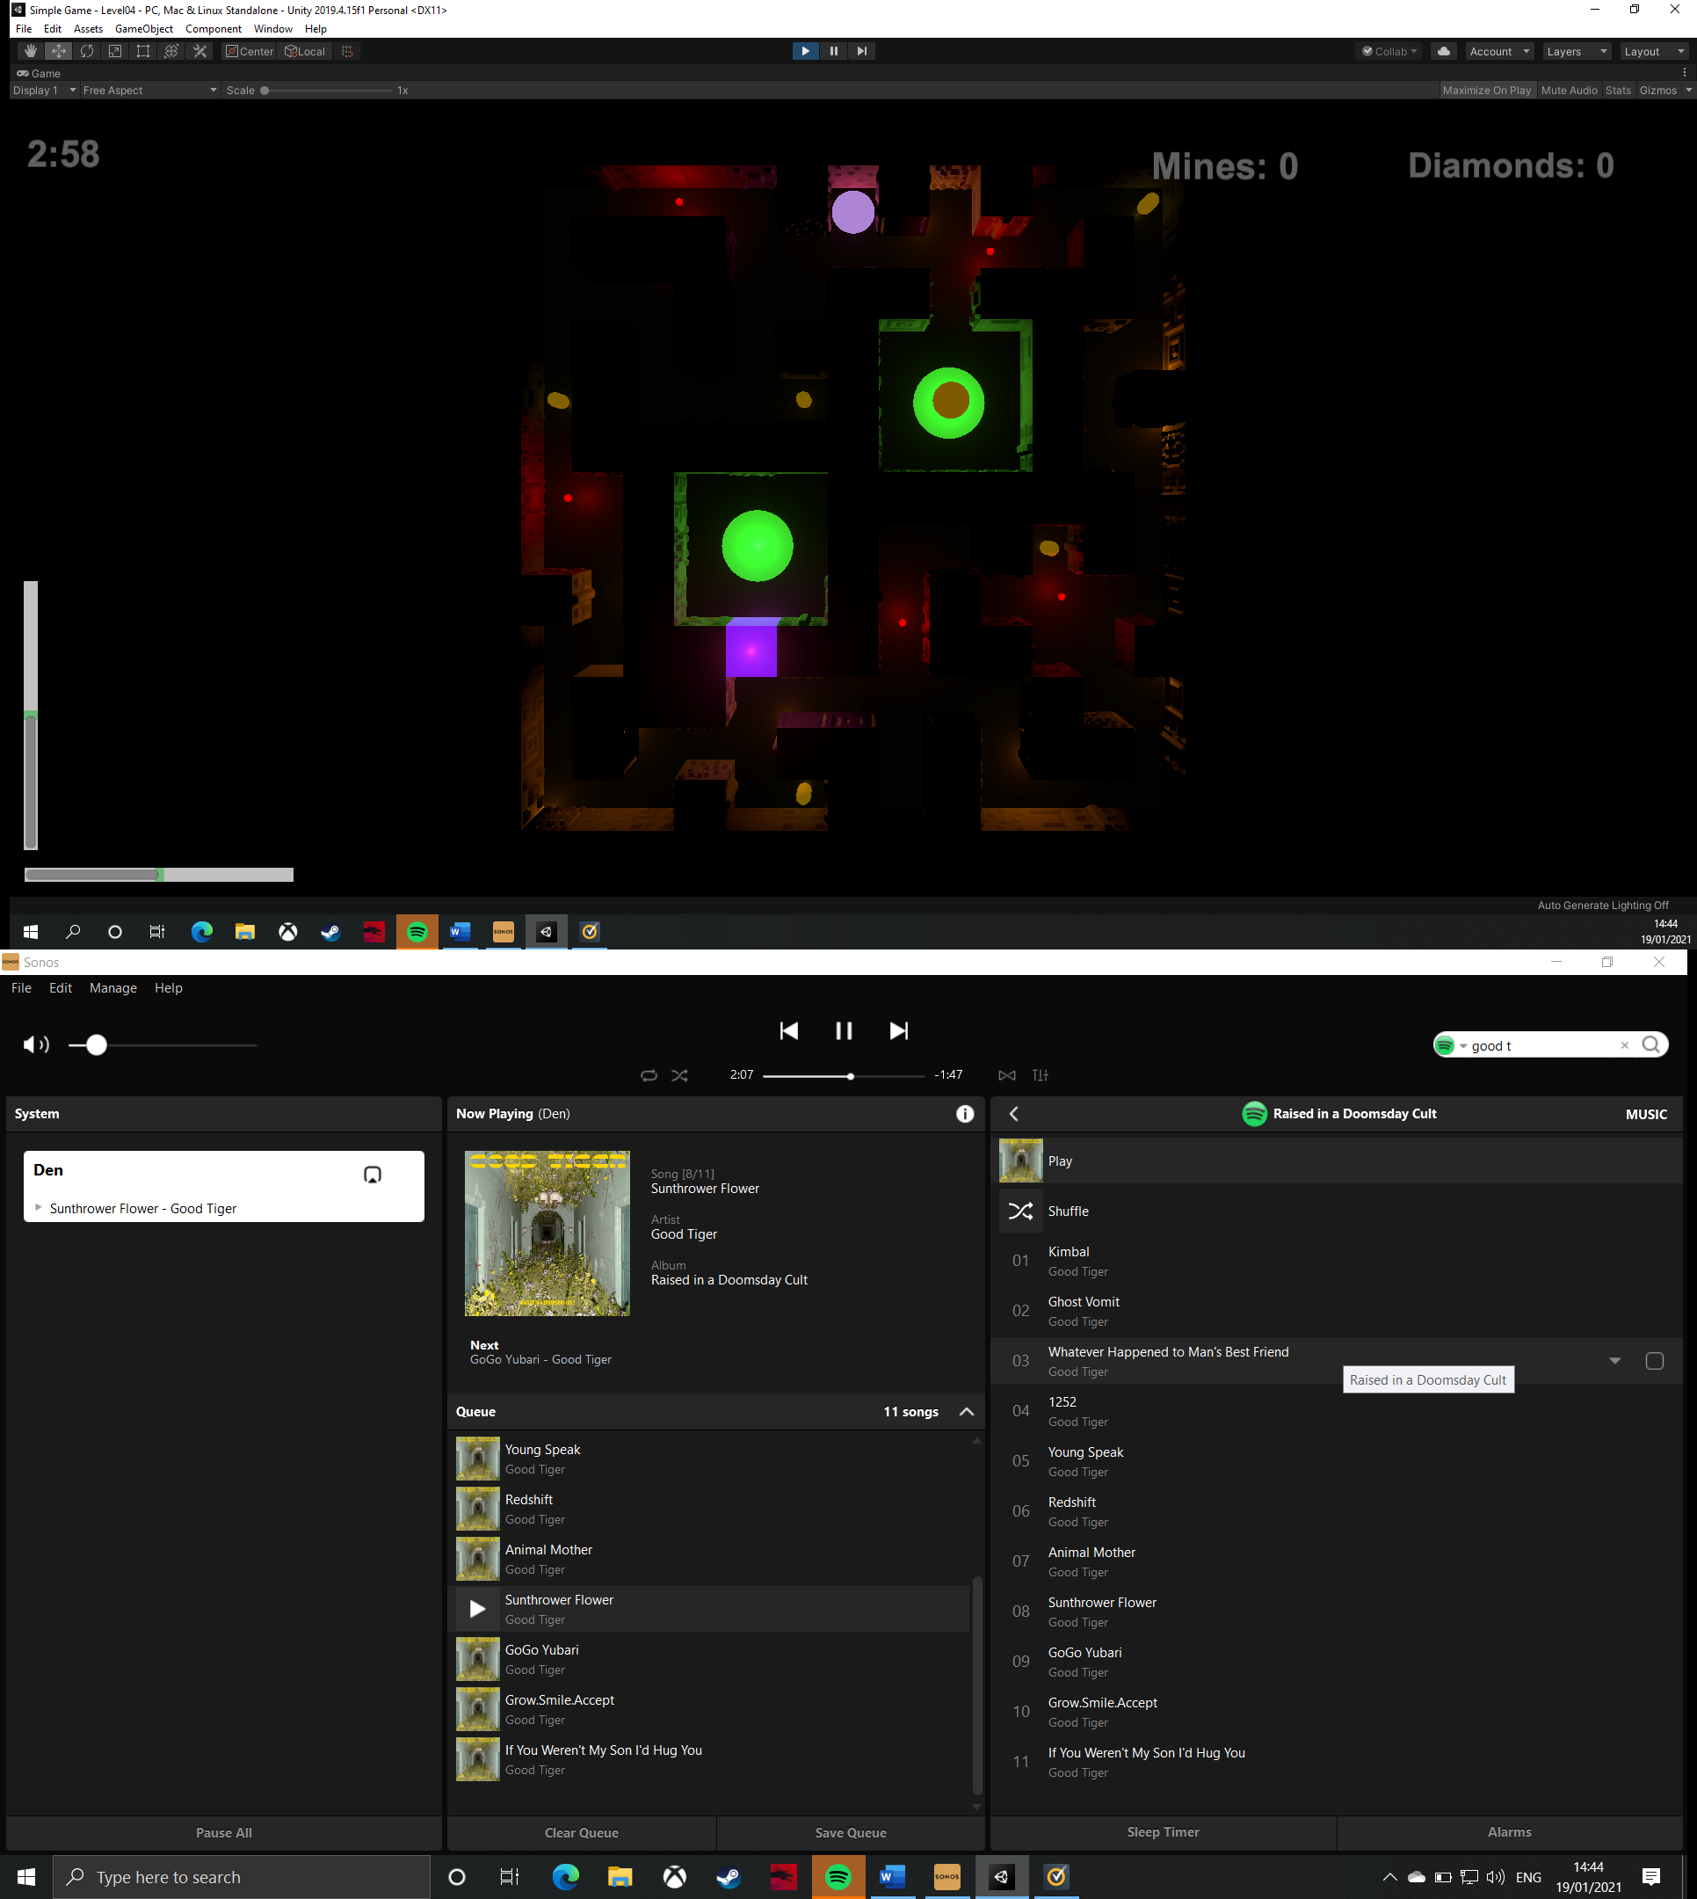

This is level 4. There are another five diamonds in this maze, five enemies, and one button. The challenge in this level comes from the awkward placement of diamonds throughout the maze, which mean that a player who is aiming for a high score would need to tackle several tricky puzzles. Furthermore, to maximise their score they will need to complete all puzzles without colliding with any enemies, which should prove to be quite difficult. The player has three minutes to complete this level.

|  |  |  |  |  |  |  |
| --- | --- | --- | --- | --- | --- | --- |
| **Test** | **Purpose of test** | **Input** | **Expected output** | **Actual output** | **Proposed remedial action** | **Justification of action** |
| Is this level possible? | This test checks that the user will be able to complete the level and collect all the diamonds in the set time. This is important as the player needs to have a fair chance to be able to complete the whole level, otherwise, they may never be able to collect all of the diamonds and maximise their score, which would just detract from the competitive element of the game and make the user have a negative impression of the game, particularly if they are competitive. Furthermore, this also tests that the enemies move at an appropriate speed so that the user will be able to tackle the challenges they bring. Ideally, the level should be completed with 15-30 seconds left. | Use any available inputs to complete the level and collect all diamonds. | It should be possible to collect all diamonds and reach the exit in the time limit. | The level is completed with 27 seconds left. | No remedial action needed. | No action is needed because the feature works as intended. |
| All necessary walls can be highlighted. | This test is important because it ensures that all of the walls that should be destroyable are added to the ‘blocks’ array in the ball script so that they can be highlighted. If the walls can be highlighted, it means they can be destroyed (I have previously tested this feature so can confidently know this is true). Without this test, I may have accidentally added too many walls, which could allow the player to exploit it, or not added enough walls to the array, which would most likely just be an oversight rather than a problem, as there would probably be another pace for the mine to be placed. | Hold ‘left shift’ and use ‘WASD’ to roll the ball around the maze, so the ball is near all walls. | All walls (excluding the exterior walls and the walls surrounding the exit) should be highlightable. | All necessary walls are highlighted when they are closest to the ball. | No remedial action needed. | No action is needed because the feature works as intended. |
| Enemies follow their designated route. | This test ensures that I have correctly set up the enemy routes. This is important because the enemies ae designed to present a challenging puzzle to the player. Therefore, if I had set up the routes incorrectly, then the enemies may not be much a puzzle for the player, possibly making them too easy to dodge, or it could make some of them too hard to get around, effectively blocking off parts of the maze, which could be bad if they need to reach a diamonds or a button. | Start the scene and let it run for 30 seconds. | All enemies should use their designated routes. | All enemies follow the correct routes. | No remedial action needed. | No action is needed because the feature works as intended. |
| Everything rotates around the same pivot. | This test is very important because the user needs to be able to rotate everything in the maze and the maze itself around the same pivot, so that objects are being absorbed by the maze when it is rotated, therefore, all rotation needs to be relative to the maze. Without this test, I may have forgotten to set the walls, lights, enemies, diamonds, or mine pick-ups as children of the maze object, which would cause the aforementioned problems to occur. | Use ‘WASD’ keys to rotate the maze in all directions. | All objects should maintain a rotation and position relative to the maze. | Everything keeps its relative position and rotation. | No remedial action needed. | No action is needed because the feature works as intended. |
| The level can be accessed through the level select menu. | This test is important as the user needs to be able to access any level from the main menu. This means that the user can access level 1 by pressing ‘1’ or level 2 through the ‘2’ button, etc…. Without this test, I may have assigned the wrong value to the button, causing it to load the wrong level, or not load any level. | Press the ‘4’ button. | Level 4 should be loaded. | Level 4 is loaded. | No remedial action needed. | No action is needed because the feature works as intended. |

|  |
| --- |
| **Videos:**   * Level 4 |

### **8.5 – Level 5**

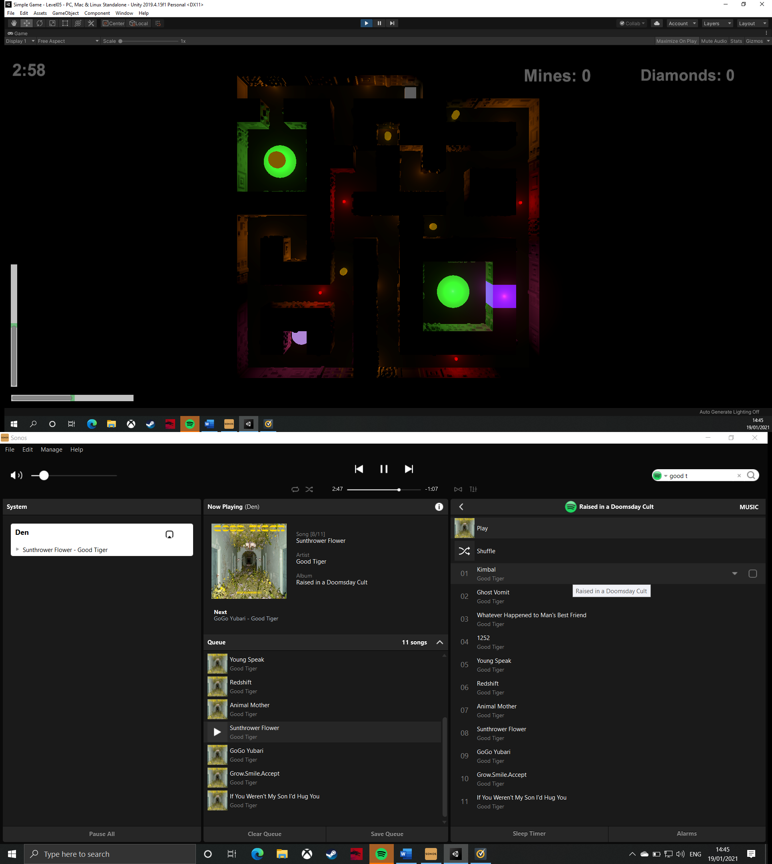

This is level 5. It includes four diamonds, four enemies, and one button. This is also the first level to include the mines and highlight-able walls. Therefore, this level guides the player straight to the mine pick-up, to indicate to them that they need to use the mines to complete the level. The level layout itself is not too complicated as this level acts as an introduction to the mines feature. The user will have three minutes to complete this level.

|  |  |  |  |  |  |  |
| --- | --- | --- | --- | --- | --- | --- |
| **Test** | **Purpose of test** | **Input** | **Expected output** | **Actual output** | **Proposed remedial action** | **Justification of action** |
| Is this level possible? | This test checks that the user will be able to complete the level and collect all the diamonds in the set time. This is important as the player needs to have a fair chance to be able to complete the whole level, otherwise, they may never be able to collect all of the diamonds and maximise their score, which would just detract from the competitive element of the game and make the user have a negative impression of the game, particularly if they are competitive. Furthermore, this also tests that the enemies move at an appropriate speed so that the user will be able to tackle the challenges they bring. Ideally, the level should be completed with 15-30 seconds left. | Use any available inputs to complete the level and collect all diamonds. | It should be possible to collect all diamonds and reach the exit in the time limit. | The level is completed with 1:40 remaining. | I need to reduce the timer by 1:15. | This will reduce the timer to 1:45. This is important as it will challenge the player more, which is imperative to a puzzle game. Without this adjustment, the game will become repetitive and easy, which will take away from its core purpose. |
| All necessary walls can be highlighted. | This test is important because it ensures that all of the walls that should be destroyable are added to the ‘blocks’ array in the ball script so that they can be highlighted. If the walls can be highlighted, it means they can be destroyed (I have previously tested this feature so can confidently know this is true). Without this test, I may have accidentally added too many walls, which could allow the player to exploit it, or not added enough walls to the array, which would most likely just be an oversight rather than a problem, as there would probably be another pace for the mine to be placed. | Hold ‘left shift’ and use ‘WASD’ to roll the ball around the maze, so the ball is near all walls. | All walls (excluding the exterior walls and the walls surrounding the exit) should be highlightable. | All necessary walls are highlighted when they are closest to the ball. | No remedial action needed. | No action is needed because the feature works as intended. |
| Enemies follow their designated route. | This test ensures that I have correctly set up the enemy routes. This is important because the enemies ae designed to present a challenging puzzle to the player. Therefore, if I had set up the routes incorrectly, then the enemies may not be much a puzzle for the player, possibly making them too easy to dodge, or it could make some of them too hard to get around, effectively blocking off parts of the maze, which could be bad if they need to reach a diamonds or a button. | Start the scene and let it run for 30 seconds. | All enemies should use their designated routes. | All enemies follow the correct routes. | No remedial action needed. | No action is needed because the feature works as intended. |
| Everything rotates around the same pivot. | This test is very important because the user needs to be able to rotate everything in the maze and the maze itself around the same pivot, so that objects are being absorbed by the maze when it is rotated, therefore, all rotation needs to be relative to the maze. Without this test, I may have forgotten to set the walls, lights, enemies, diamonds, or mine pick-ups as children of the maze object, which would cause the aforementioned problems to occur. | Use ‘WASD’ keys to rotate the maze in all directions. | All objects should maintain a rotation and position relative to the maze. | Everything keeps its relative position and rotation. | No remedial action needed. | No action is needed because the feature works as intended. |
| The level can be accessed through the level select menu. | This test is important as the user needs to be able to access any level from the main menu. This means that the user can access level 1 by pressing ‘1’ or level 2 through the ‘2’ button, etc…. Without this test, I may have assigned the wrong value to the button, causing it to load the wrong level, or not load any level. | Press the ‘5’ button. | Level 5 should be loaded. | Level 5 is loaded. | No remedial action needed. | No action is needed because the feature works as intended. |

|  |
| --- |
| **Videos:**   * Level 5 |

### **8.6 – Level 6**

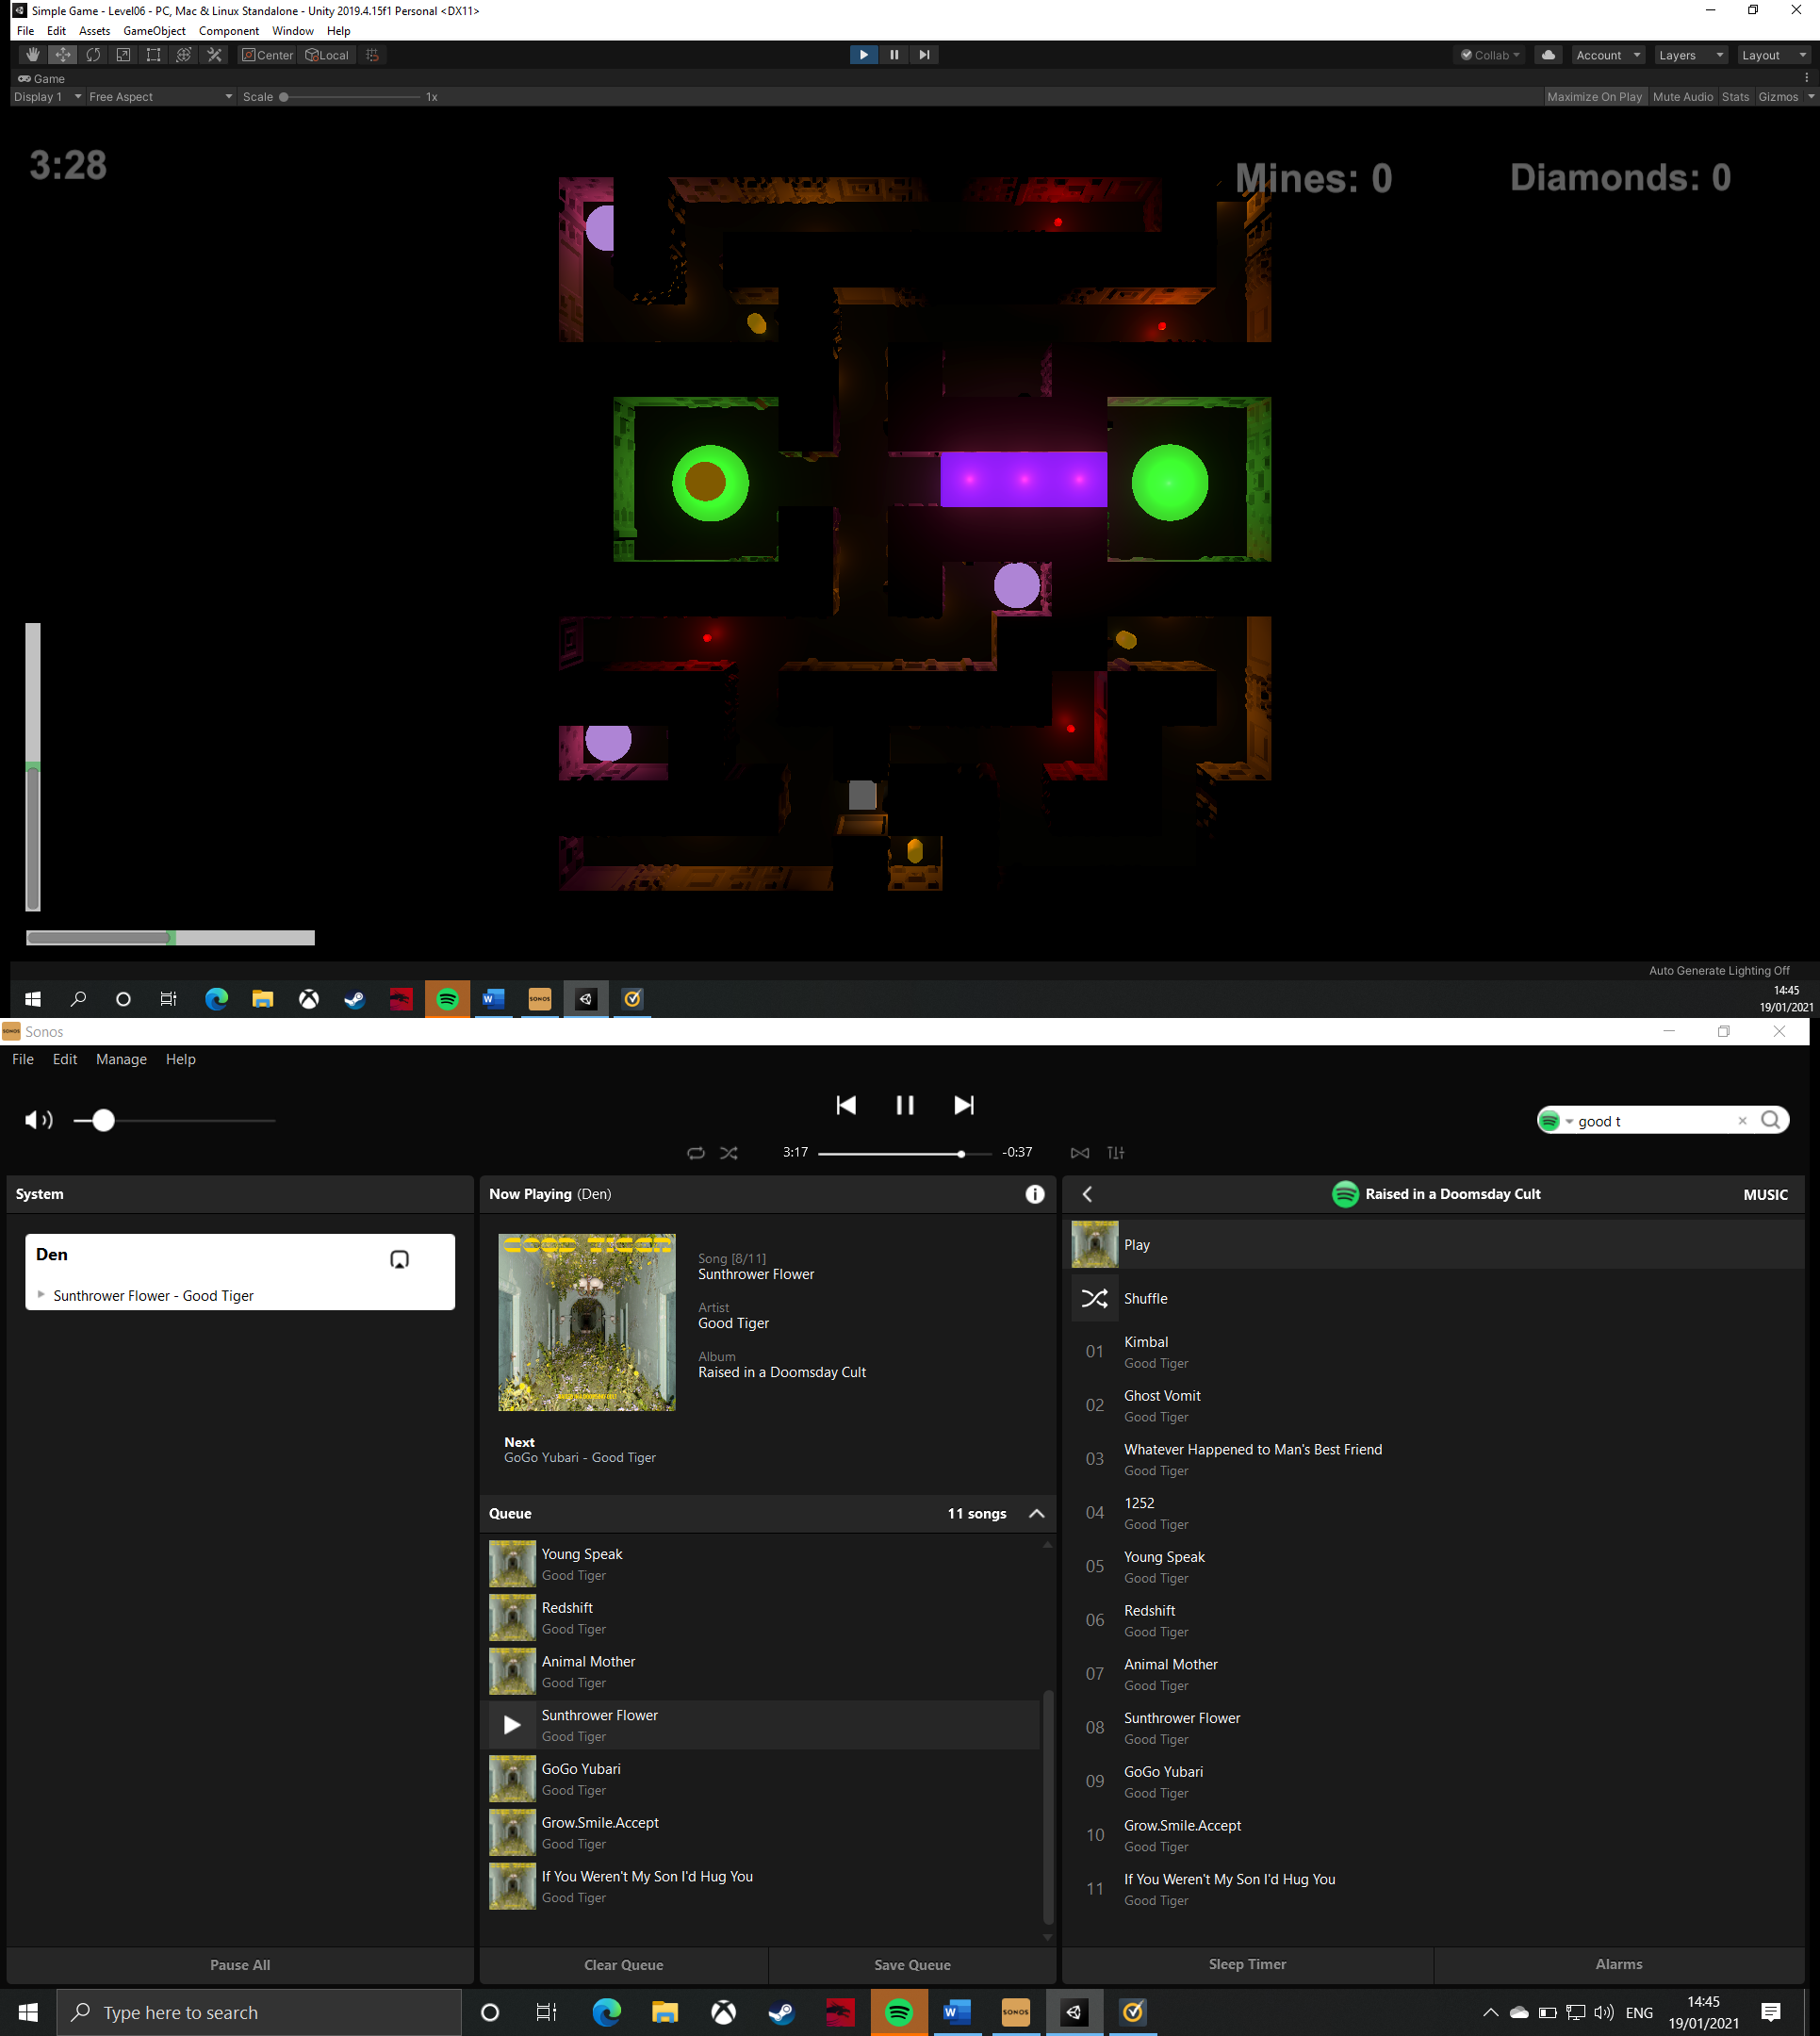

This is level 6. In this level, the player will have to collect three diamonds, evade four enemies, press three buttons, and use the mines to open pathways through the maze. The difficulty in this level comes from having three buttons to press as this forces the player to navigate the ball all over the maze, which is time-consuming. Therefore, the three-and-a-half minutes should present a challenge to the player.

|  |  |  |  |  |  |  |
| --- | --- | --- | --- | --- | --- | --- |
| **Test** | **Purpose of test** | **Input** | **Expected output** | **Actual output** | **Proposed remedial action** | **Justification of action** |
| Is this level possible? | This test checks that the user will be able to complete the level and collect all the diamonds in the set time. This is important as the player needs to have a fair chance to be able to complete the whole level, otherwise, they may never be able to collect all of the diamonds and maximise their score, which would just detract from the competitive element of the game and make the user have a negative impression of the game, particularly if they are competitive. Furthermore, this also tests that the enemies move at an appropriate speed so that the user will be able to tackle the challenges they bring. Ideally, the level should be completed with 15-30 seconds left. | Use any available inputs to complete the level and collect all diamonds. | It should be possible to collect all diamonds and reach the exit in the time limit. | The level is completed with 1:07 remaining. | The timer needs to be reduced 45 seconds. | This will make the timer start at 2:45. This is important as it will challenge the player more, which is imperative to a puzzle game. Without this adjustment, the game will become repetitive and easy, which will take away from its core purpose. |
| All necessary walls can be highlighted. | This test is important because it ensures that all of the walls that should be destroyable are added to the ‘blocks’ array in the ball script so that they can be highlighted. If the walls can be highlighted, it means they can be destroyed (I have previously tested this feature so can confidently know this is true). Without this test, I may have accidentally added too many walls, which could allow the player to exploit it, or not added enough walls to the array, which would most likely just be an oversight rather than a problem, as there would probably be another pace for the mine to be placed. | Hold ‘left shift’ and use ‘WASD’ to roll the ball around the maze, so the ball is near all walls. | All walls (excluding the exterior walls and the walls surrounding the exit) should be highlightable. | All necessary walls are highlighted when they are closest to the ball. | No remedial action needed. | No action is needed because the feature works as intended. |
| Enemies follow their designated route. | This test ensures that I have correctly set up the enemy routes. This is important because the enemies ae designed to present a challenging puzzle to the player. Therefore, if I had set up the routes incorrectly, then the enemies may not be much a puzzle for the player, possibly making them too easy to dodge, or it could make some of them too hard to get around, effectively blocking off parts of the maze, which could be bad if they need to reach a diamonds or a button. | Start the scene and let it run for 30 seconds. | All enemies should use their designated routes. | All enemies follow the correct routes. | No remedial action needed. | No action is needed because the feature works as intended. |
| Everything rotates around the same pivot. | This test is very important because the user needs to be able to rotate everything in the maze and the maze itself around the same pivot, so that objects are being absorbed by the maze when it is rotated, therefore, all rotation needs to be relative to the maze. Without this test, I may have forgotten to set the walls, lights, enemies, diamonds, or mine pick-ups as children of the maze object, which would cause the aforementioned problems to occur. | Use ‘WASD’ keys to rotate the maze in all directions. | All objects should maintain a rotation and position relative to the maze. | Everything keeps its relative position and rotation. | No remedial action needed. | No action is needed because the feature works as intended. |
| The level can be accessed through the level select menu. | This test is important as the user needs to be able to access any level from the main menu. This means that the user can access level 1 by pressing ‘1’ or level 2 through the ‘2’ button, etc…. Without this test, I may have assigned the wrong value to the button, causing it to load the wrong level, or not load any level. | Press the ‘6’ button. | Level 6 should be loaded. | Level 6 is loaded. | No remedial action needed. | No action is needed because the feature works as intended. |

|  |
| --- |
| **Videos:**   * Level 6 |

### **8.7 – Level 7**

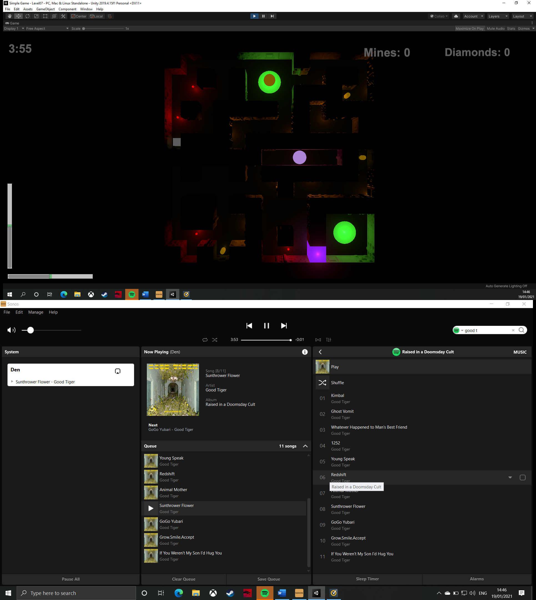

This is level 7. This level includes four enemies, three diamonds, one button, and a mine-pick-up. In order to get the mines, the player will have to go through a challenging puzzle created by the enemy routes, as there is a part where the enemy routes overlap, so the player must time it perfectly through the gap, or they will get sandwiched between two enemies. Once they have the mines, they will have to carefully consider where to place them as this level feels like there are a lot of places where it would be sensible to place a mine, but the player will be limited to three mines. They will have four minutes to complete the level.

|  |  |  |  |  |  |  |
| --- | --- | --- | --- | --- | --- | --- |
| **Test** | **Purpose of test** | **Input** | **Expected output** | **Actual output** | **Proposed remedial action** | **Justification of action** |
| Is this level possible? | This test checks that the user will be able to complete the level and collect all the diamonds in the set time. This is important as the player needs to have a fair chance to be able to complete the whole level, otherwise, they may never be able to collect all of the diamonds and maximise their score, which would just detract from the competitive element of the game and make the user have a negative impression of the game, particularly if they are competitive. Furthermore, this also tests that the enemies move at an appropriate speed so that the user will be able to tackle the challenges they bring. Ideally, the level should be completed with 15-30 seconds left. | Use any available inputs to complete the level and collect all diamonds. | It should be possible to collect all diamonds and reach the exit in the time limit. | The level is completed with 2:21 left. | The timer needs to be reduced by 2 minutes. | This will reduce the timer to 2 minutes. This is important because the player will have to begin to polish their technique in the game so they can complete the level. This is important as it will make it harder, and make the timer a substantial challenge for the player. Without this adjustment, the level may feel too easy meaning that players begin to lose interest in the game. |
| All necessary walls can be highlighted. | This test is important because it ensures that all of the walls that should be destroyable are added to the ‘blocks’ array in the ball script so that they can be highlighted. If the walls can be highlighted, it means they can be destroyed (I have previously tested this feature so can confidently know this is true). Without this test, I may have accidentally added too many walls, which could allow the player to exploit it, or not added enough walls to the array, which would most likely just be an oversight rather than a problem, as there would probably be another pace for the mine to be placed. | Hold ‘left shift’ and use ‘WASD’ to roll the ball around the maze, so the ball is near all walls. | All walls (excluding the exterior walls and the walls surrounding the exit) should be highlightable. | All necessary walls are highlighted when they are closest to the ball. | No remedial action needed. | No action is needed because the feature works as intended. |
| Enemies follow their designated route. | This test ensures that I have correctly set up the enemy routes. This is important because the enemies ae designed to present a challenging puzzle to the player. Therefore, if I had set up the routes incorrectly, then the enemies may not be much a puzzle for the player, possibly making them too easy to dodge, or it could make some of them too hard to get around, effectively blocking off parts of the maze, which could be bad if they need to reach a diamonds or a button. | Start the scene and let it run for 30 seconds. | All enemies should use their designated routes. | All enemies follow the correct routes. | No remedial action needed. | No action is needed because the feature works as intended. |
| Everything rotates around the same pivot. | This test is very important because the user needs to be able to rotate everything in the maze and the maze itself around the same pivot, so that objects are being absorbed by the maze when it is rotated, therefore, all rotation needs to be relative to the maze. Without this test, I may have forgotten to set the walls, lights, enemies, diamonds, or mine pick-ups as children of the maze object, which would cause the aforementioned problems to occur. | Use ‘WASD’ keys to rotate the maze in all directions. | All objects should maintain a rotation and position relative to the maze. | Everything keeps its relative position and rotation. | No remedial action needed. | No action is needed because the feature works as intended. |
| The level can be accessed through the level select menu. | This test is important as the user needs to be able to access any level from the main menu. This means that the user can access level 1 by pressing ‘1’ or level 2 through the ‘2’ button, etc…. Without this test, I may have assigned the wrong value to the button, causing it to load the wrong level, or not load any level. | Press the ‘7’ button. | Level 7 should be loaded. | Level 7 is loaded. | No remedial action needed. | No action is needed because the feature works as intended. |

|  |
| --- |
| **Videos:**   * Level 7 |

### **8.8 – Level 8**

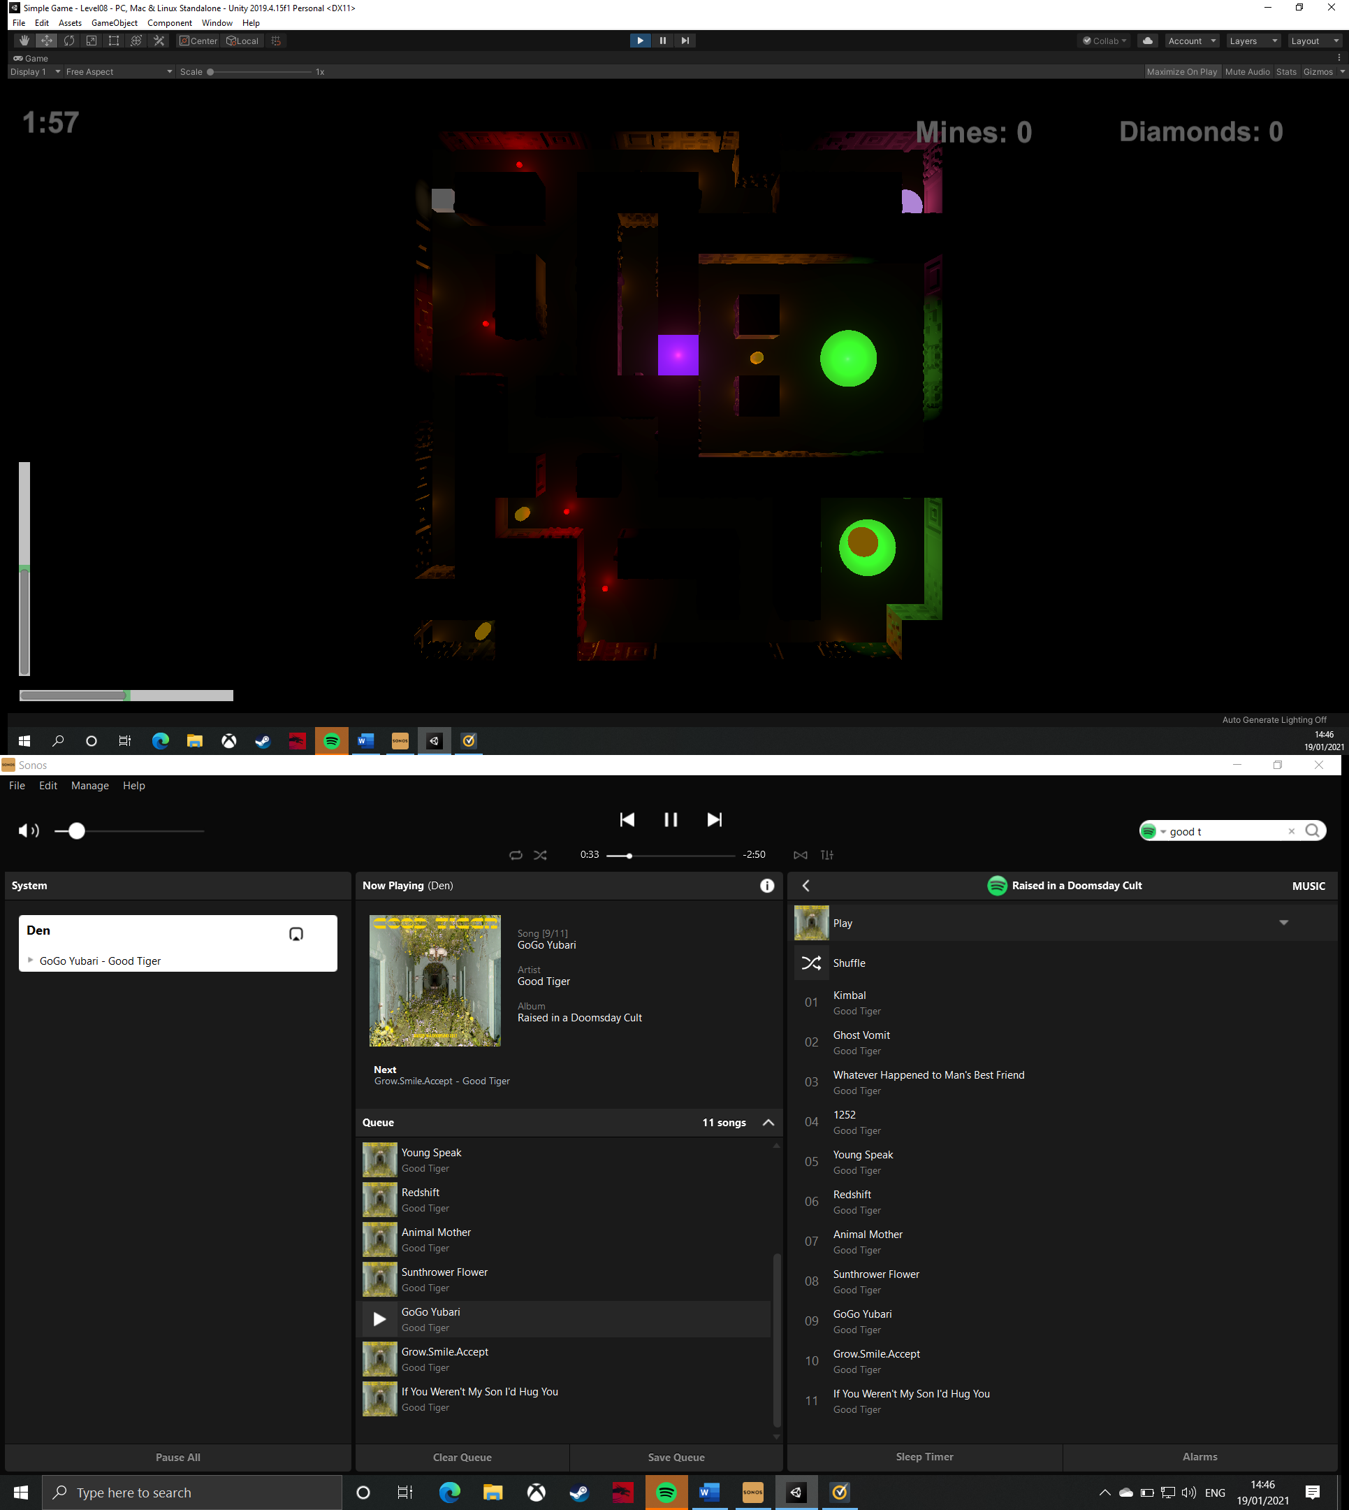

This is level 8. This includes three diamonds, four enemies, one button, and a mine pick-up. This level is fairly easy compared to the previous few, so the time limit has been reduced to two minutes, so the user still feels like there is a challenge. The reason for this level being easier is that the exit is in a large antechamber-esque room, which is designed to make the user feel like they have reached the grand exit of the maze, after they have spent all that time playing the game.

|  |  |  |  |  |  |  |
| --- | --- | --- | --- | --- | --- | --- |
| **Test** | **Purpose of test** | **Input** | **Expected output** | **Actual output** | **Proposed remedial action** | **Justification of action** |
| Is this level possible? | This test checks that the user will be able to complete the level and collect all the diamonds in the set time. This is important as the player needs to have a fair chance to be able to complete the whole level, otherwise, they may never be able to collect all of the diamonds and maximise their score, which would just detract from the competitive element of the game and make the user have a negative impression of the game, particularly if they are competitive. Furthermore, this also tests that the enemies move at an appropriate speed so that the user will be able to tackle the challenges they bring. Ideally, the level should be completed with 15-30 seconds left. | Use any available inputs to complete the level and collect all diamonds. | It should be possible to collect all diamonds and reach the exit in the time limit. | The level is completed with 11 seconds left. | No remedial action needed. | No action is needed because the timer does not leave the player with much room for error. This is very important for challenging the player, especially given this is the final level of the game, so the user should be encouraged to use everything they have been taught to complete this level. |
| All necessary walls can be highlighted. | This test is important because it ensures that all of the walls that should be destroyable are added to the ‘blocks’ array in the ball script so that they can be highlighted. If the walls can be highlighted, it means they can be destroyed (I have previously tested this feature so can confidently know this is true). Without this test, I may have accidentally added too many walls, which could allow the player to exploit it, or not added enough walls to the array, which would most likely just be an oversight rather than a problem, as there would probably be another pace for the mine to be placed. | Hold ‘left shift’ and use ‘WASD’ to roll the ball around the maze, so the ball is near all walls. | All walls (excluding the exterior walls and the walls surrounding the exit) should be highlightable. | All necessary walls are highlighted when they are closest to the ball. | No remedial action needed. | No action is needed because the feature works as intended. |
| Enemies follow their designated route. | This test ensures that I have correctly set up the enemy routes. This is important because the enemies ae designed to present a challenging puzzle to the player. Therefore, if I had set up the routes incorrectly, then the enemies may not be much a puzzle for the player, possibly making them too easy to dodge, or it could make some of them too hard to get around, effectively blocking off parts of the maze, which could be bad if they need to reach a diamonds or a button. | Start the scene and let it run for 30 seconds. | All enemies should use their designated routes. | All enemies follow the correct routes. | No remedial action needed. | No action is needed because the feature works as intended. |
| Everything rotates around the same pivot. | This test is very important because the user needs to be able to rotate everything in the maze and the maze itself around the same pivot, so that objects are being absorbed by the maze when it is rotated, therefore, all rotation needs to be relative to the maze. Without this test, I may have forgotten to set the walls, lights, enemies, diamonds, or mine pick-ups as children of the maze object, which would cause the aforementioned problems to occur. | Use ‘WASD’ keys to rotate the maze in all directions. | All objects should maintain a rotation and position relative to the maze. | Everything keeps its relative position and rotation. | No remedial action needed. | No action is needed because the feature works as intended. |
| The level can be accessed through the level select menu. | This test is important as the user needs to be able to access any level from the main menu. This means that the user can access level 1 by pressing ‘1’ or level 2 through the ‘2’ button, etc…. Without this test, I may have assigned the wrong value to the button, causing it to load the wrong level, or not load any level. | Press the ‘8’ button. | Level 8 should be loaded. | Level 8 is loaded. | No remedial action needed. | No action is needed because the feature works as intended. |

|  |
| --- |
| **Videos:**   * Level 8 |

### **Prototype 8 – Levels**

In this development cycle, I have implemented all of the levels into the game. This means that the product is ready (in theory) to be compiled into a final build and presented to the client.

|  |  |  |  |  |  |  |
| --- | --- | --- | --- | --- | --- | --- |
| **Test** | **Purpose of test** | **Input** | **Expected output** | **Actual output** | **Proposed remedial action** | **Met the success criteria?** |
| All levels load the correct next scene. | This means that, when the ball reaches the exit, level 1 should load level 2, level 2 loads level 3, etc… until level 8, which should the main menu. This is important so that the player does not have to navigate through the main menu after every level. Without this feature, they may be more tempted to quit after a few levels, but if they are automatically thrown into the next level, they are more likely to say ‘oh, just one more go’. | In level 3, use ‘WASD’ keys to roll the ball over the exit. | Level 4 should be loaded. | Level 4 is loaded. | No remedial action needed. | This test shows that the solution meets the essential feature of ‘reaching the exit’ as the appropriate scene is always loaded when the exit is rolled over. |
| In level 8, use ‘WASD’ keys to roll the ball over the exit. | The main menu should be loaded. | The main menu is loaded. | No remedial action needed. |

These levels also fulfil the last two incomplete success criteria: between 5 and 10 discrete levels with challenging puzzle elements’ and ‘introduces new puzzle elements as the game progresses’. I know this as I have designed each level with a specific puzzle in mind (which have been explained in 8.1-8.8) so I know that the former criterion has been met, as each level does have challenging puzzle elements in them. I can also confidently say the latter criterion has been completed as the mines are introduced in level 4, which causes the player to have to adopt a new strategy through the mazes, as there is no longer clear paths through the levels anymore. All of this is important as it means that the solution will fulfil its purpose as a physics-based puzzle game, which should entice the target audience into archaeology so they can explore it as a future career.

# **Evaluation**

## **Post-Development Testing**

|  |  |  |  |  |  |
| --- | --- | --- | --- | --- | --- |
| **Test number** | **Success criteria / essential feature** | **How this will be tested** | **Input data** | **Is the success criteria met?** | **Justification of result** |
| Test 1 | 5-10 discrete levels. | I will ensure that all levels can be access from the level select menu and all levels are possible in the given time. | This will use a combination of the LMB, WASD, left shift, and spacebar. | This success criterion has been met. | The criterion has been met as this shows that the game does include eight levels, which are all discrete from one another. This is important as it means that the user can play the game as they like and will not feel as though they have to play through a massive chunk of the game in one sitting. If this criterion was not met, the game could have been too short or may have forced the player to blitz through it in one sitting, which is not the intended use of the game. |
| Test 2 | Control the maze rotation. | The ‘WASD’ keys will be used to check that the maze can be rotated. | The ‘WASD’ keys will be used. | This criterion is met. | This test shows the success criterion has been met as the user will be able to use the ‘WASD’ keys to rotate the maze when they play the game. This is important as this is the most integral mechanic in the game, because this is how the ball will be navigated to the exit. Without this feature, the user would have no way to interact with the ball, making the whole game broken. |
| Test 3 | Simple 3D graphics. | I will play level 1 in the game, to check that the graphics do not impact the performance, and that the user will be able to see the models’ textures as they rotate the maze. | The ‘WASD’ keys will be used. | This criterion is met. | The success criterion has been met as the 3D models have relatively few polygons in them, meaning that they look very simple, but stylised when inside the game. This is important because it means that the graphics will not impact the game’s performance when it is run in a web browser. Without this criterion being met, the graphics could have been made too complicated which would have had two negative consequences: it would have taken too long to make the models, and the game may not have run particularly well in a web browser. |
| Test 4 | New puzzle elements introduced as game progresses. | Level 4 will be completed, then level 5 will be completed. | The ‘WASD’ keys, left shift, and space will be used. | The criterion is partially met. | The reason this criterion is only partially met is because there could have been more opportunities to insert a new mechanic in other levels, so that overall the user learns 2 or 3 new things as they progress through the game. However, given this game is very short, only adding one new feature (the mines) as the game progresses probably is not a big deal, but it could have been nice to add some more. |
| Test 5 | Main menu including settings, level select, and tutorial menus. | I will use all of these menus to ensure that the work and correctly interact with each other. | This will use the LMB. | This criterion is met. | This success criterion has been met as all of the menus carry out their functions correctly, and all menus can be accessed in the intended way. This is important because the menus provide a hub of functions for the player, meaning that from the main menu, they can access settings or the levels, or tutorials, and from the pause menu they can access the main menu or restart their level. Without this criterion being met, the user would be presented with a very unpolished final product, as, even though they are playing on a web browser, they will still expect to be using a finished product. |
| Test 6 | Levels can be restarted from the pause menu. | This will use the pause menu from within level 1. | Use LMB to press the restart button. | The criterion is met. | This is because the level 1 is restarted when the button is pressed. This is important because the user should feel like they are able to complete a level in the fastest time they can. For example, if a player wants to speed-run a level then they may make use of the restart button when they make a small mistake in the level that would impact their time. Likewise, if a player is just getting a feel for the level, then they might want to restart it if they do not have enough time left to complete the level before it restarts. Without this feature, the timer could be a source of frustration for the user, more than a new challenge for them, which would negatively impact their playing experience. |
| Test 7 | Scores are stored persistently. | The level 1 score on the level select menu will be checked, then the game will be exited, then reloaded and the score will be checked again. | Use LMB in the main menu and level select menu to carry out the specified functions. | The criterion is met. | This is because the user’s high score is retained despite the application being closed. This is important as the user is not expected to play the whole game in one sitting, so they should be able to see what their previous high scores have been when they reload the game. If this criterion was not met, there would be no point in having a high score system, as the user’s high score would be lost every time they close the program. |
| Test 8 | Ambient music. | The music will be temporarily removed from the game, then added back in and the effect will be compared. | Use all available inputs to play the level like normal. | The criterion is met. | This test makes it absolutely clear that the music adds so much ambience to the game; without the music, the game feels flat and dead which makes it less interesting. The music definitely adds an eerie sense to the levels. This is important because the user will probably be less interested in the game if it does not feel alive. Without this feature, the user would be more likely to stop playing the game because it does not create an appropriate atmosphere in the levels. |
| Test 9 | Reaching the exit | The ball will be rolled over the exit, and the next level should be loaded. | Use ‘WASD’ keys to rotate the maze. | The essential feature is included. | This shows this essential features is being met as the scene transition plays and the correct scene is loaded when the ball rolls over the exit. This is important because the user should not have to go through the main menu every time they finish a level. Without this criterion being met, the user may be more likely to quit the game when they finish a level, because they would be presented with the main menu which has a large quit button on it, whereas they may be more tempted to just keep playing if they are put straight into the next level. |
| Test 10 | Enemy AI | The level will be started and the enemies follow their routes. | Start level 2, and use ‘WASD’ keys to rotate the maze whilst the enemies move. | The essential feature is being met. | The essential feature is working as the enemies in level 3 (although this is true for all other levels as it was checked in Development Cycle 8) all follow their pre-defined routes, even when the maze is being rotated by the user. This is important because the enemies are designed to add a large challenge to the game, which helps it fulfil its ‘puzzle genre’ classification. Without this essential feature, the player may find the game too monotonous, which may cause them to turn it off. |
| Test 11 | High score system | Level 7 will be completed and its score should be checked on the level select menu. | Use all available inputs to complete level 7 then use the pause menu to reach the level select menu. | This essential feature is included. | This test shows that this essential feature is working as the level 7 score is displayed for the user when they roll the ball over the exit, then when they return to the level select menu, they can see the same score below the level 7 button. This is important because it adds a competitive element to the game, which will encourage the user to discuss the game among their peers, which they might find helpful when using the LearnFuture website to explore various career paths. |
| Test 12 | Mines | The mines will be used in level 5. | Use all available inputs to complete level 5. | The essential feature is working. | The feature works as the user can highlight the nearest wall to them, and place a mine on top of this wall. The mine then explodes after a few seconds, destroying the wall it was placed on. This is important as the mines create a unique puzzle element in the game that encourages the player to think strategically so that they can access blocked areas of the maze with their limited number of mines. Without this feature, the game would start to feel monotonous as the success criteria of ‘new puzzles are introduced as the game progresses’ would not be met at all, which would mean the user could learn the game very easily and it never gets any harder throughout all eight levels. |
| Test 13 | Diamonds | The user will collect all the diamonds in level 4. | Use ‘WASD’ keys to rotate the maze and roll the ball through all diamonds. | The essential feature is met. | This feature is met as the user can collect all of the diamonds in the maze as the ball rolls over them. This is important as the diamonds encourage the player to explore areas of the maze that is not necessarily in their direct route through the maze. Without this feature, there would be no reward for exploring the maze which means there is no incentive to, but with the diamonds, there is a massive score boost to be gotten by collecting the diamonds, which makes exploring the maze worthwhile. |
| Test 14 | Barriers | The user will use the barriers in level 6 to complete the level. | Use all available inputs to complete the level. | The feature works as intended. | This feature works as the user cannot go through the barrier, which blocks the exit, until they have rolled the ball over the button and removed the barrier. This is important as it means the user is forced to follow an indirect route around the maze, which makes it more tempting to try and collect the diamonds as well. Without this feature, the game would probably be too easy as it would be possible for the user to go straight through the maze without bothering to deal with any of the puzzles offered by collecting the diamonds or reaching the button. |
| Test 15 | Gamepad inputs | The user will complete level 8 using only gamepad controls. | Use all available gamepad controls to complete level 8. | The feature works just as well as the keyboard inputs. | Gamepad controls allow the user to control the game in the same way as using a keyboard. This is important as it gives the user a choice of what input device to use, which shows that the game caters for the range of previous gaming experience that the target audience will have. This means that a user can use a gamepad if they want, and they will not be at an advantage or disadvantage as a result. Without this feature, users who do not often use a keyboard to play games (and are therefore not used to WASD) may struggle to adjust to the game’s controls, which could cause them to quit. |

|  |
| --- |
| **Videos:**   * Test 1 – Ensuring level 1 is accessible and possible * Test 2 – Control the maze rotation * Test 3 – Simple 3D graphics * Test 4 – New puzzle elements introduced as the game progresses * Test 5 – Menus * Test 6 – Level can be restarted from the pause menu * Test 7 – Scores are stored persistently * Test 8 – Ambient music * Test 9 – Reaching the exit * Test 10 – Enemies * Test 11 – High score system * Test 12 – Mines * Test 13 – Diamonds * Test 14 – Barriers * Test 15 – Gamepad inputs |

### **Final Checks**

|  |  |  |  |  |
| --- | --- | --- | --- | --- |
| **Test number** | **Actions to test** | **The purpose of testing** | **Passed?** | **Why did it fail?** |
| Test 16 | Check all menus and counters for spelling mistakes. | This kind of mistake is quite easy to make, particularly when you spend a long time on a project. However, it will also be an obvious mistake to the client and the user. Therefore, if there are spelling mistakes in the program, it will make the game look like it has been sloppily built so the user will not bother spending as much time playing it. This means the project would be poorly received, if I did not complete final checks for spelling. | No | When a diamond is picked up, the diamond counter says ‘Diamond’ instead of ‘Diamonds’. |
| Test 17 | Check all buttons take the user to the correct scene / do the intended purpose. | This is important so that the program makes logical sense to the user. For example, when the user presses the ‘quit’ button, they expect the game to be closed down, and if it does not do that, then the user will not be able to know how to close the game. Without checking this, it could be possible to have missed assigning a function to a button, so the buttons would not work, and the developer would have no idea about it until they start getting .complaints from the users/ | Yes | N/A |
| Test 18 | User begins each level with no mines. | This test is important because the user needs to be encouraged to pick up a set of mines. This adds to the puzzle elements of the game, as the user must first manoeuvre the ball to the mine pick-up before they can use the mines to blow a path through the maze. Without this test, the player may have access to mines as soon as the level loads, meaning that they can bypass a section of the level. This is bad because the levels will be designed to push the player towards the mine pick-up. | Yes | N/A |
| Test 19 | User can only place mines if a wall is highlighted and they have 1+ mines. | This test will be necessary to limit the amount of mines the user can place per level. This is important because it is part of the puzzle elements that are crucial to the client. Without doing this test, the user may be able to endlessly place mines, which means they could effectively blow up the whole maze so that the level becomes too easy. | Yes | N/A |
| Test 20 | User cannot highlight exterior walls or walls surrounding the exit. | This test is important because the player should not be able to destroy walls surrounding the maze, as these are what keep the ball boxed in so it cannot roll off the maze (this would be bad as the program will not be designed to deal with this situation) and so they cannot destroy the walls surrounding the exit. This is important because, if the player can highlight these walls, then they can place a mine on it, so that it is destroyed. If the player could destroy the walls surrounding the exit, they could complete each level very easily by just destroying one wall. Without this test, the player may be able to destroy these walls, which would make the rest of each level redundant. | Yes | N/A |
| Test 21 | User begins each level with no diamonds. | This test is important because the diamonds encourage the player to explore the maze more. Therefore, if they already had diamonds when the level started, they would not bother wasting time collecting diamonds that are positioned in the maze. Without this test, the player could a very high score relatively easily, as the diamonds will be used to calculate a final score at the end. | Yes | N/A |
| Test 22 | Level begins with the correct time on timer. | This test is important because the user needs an adequate amount of time to complete each level. Without this test, levels could have a start time that is too high, which would be bad as there would be no real challenge for the player to complete the level quickly, or too low, which would make the level way too difficult for the player. If this were the case, the player would be more likely to turn the game off in frustration, which, given that the target audience is 12-15, is not what is intended. | Yes | N/A |
| Test 23 | Level begins with barrier blocking the exit. | This test is necessary because the barrier is used to guide the player around the maze, by forcing them to roll the ball over the button, which will be out of the way. This is also important because it gives the player a reason to collect diamonds as well. Without this test, the barrier may not be blocking the exit, which means the path through the maze will be too easy. | Yes | N/A |
| Test 24 | Opening the pause menu pauses the game. | This test is important because pausing the game gives the player some control over the ball. For example, the ball will not roll into the enemy’s path whilst the player is in the pause menu and does not have any direct control over what the ball and the maze is doing. Without this test, the game may not pause, and the player could lose the level, which would be very unfair. This would cause them to turn the game off in frustration. | Yes | N/A |
| Test 25 | Closing the pause menu resumes the game. | This test is necessary because the game needs to resume when the user exits the pause menu. This is for two reasons: when the user presses ‘restart’ or ‘main menu’, the time scale needs to return to normal for the scene transition to work; and when the user presses ‘resume’ the time scale needs to return to normal so that they can keep playing the game. Without this test, the game may not resume, which means that the user would be able to finish the level. This would mean that they should not access the pause menu unless they want to exit the level. | Yes | N/A |
| Test 26 | User can mute and alter the volume levels. | This test is necessary so that the user can alter the volume settings to suit them. This is important because some players may find the sound track too overpowering and distracting, so they should have the option to turn the volume down. Without this test, the volume slider may not work, or may do something unexpected. This would make the game feel unpolished. | Yes | N/A |
| Test 27 | User can toggle full screen. | This test is necessary because the user needs to have the option to make the game window full screen. This is important because some players may need to play in full screen so that the window is large enough to see on a small screen. Without this test, the full screen may not work so the game would be inaccessible to some players. | Yes | N/A |
| Test 28 | User can alter graphics qualities. | This test is important because some of the models used in the game (for the walls) will be made of many polygons, so the user needs to be able to adjust the graphics quality for their device. Without this test, the dropdown menu may not work, or the options in it may not correspond to the right setting. This would be confusing for the user because they would not then be able to understand why setting the quality to ‘low’ would make the game run worse than when it is on ‘high’, for example. | Yes | N/A |
| Test 29 | The next scene is loaded when the ball reaches the exit. | This test is necessary because it allows the user to easily progress through the game. This guides the user through the game, which is easier than telling them to return to main menu to access the next level. Without this test, levels could be loaded in the wrong sequence (e.g. level 2 is followed by level 5) which would be confusing for the player, as the levels are supposed to progressive. Therefore, the player would be thrown into a level that includes placing mines to complete when they are still learning the controls. | Yes | N/A |
| Test 30 | The high score of each level is stored on the level select menu. | This test is necessary because it relates to one of the features specified by the client. This is important because the player should be able to access their previous high scores so that they know what they have to beat. Without this test, the level select menu may present the wrong data to the user. | Yes | N/A |
| Test 31 | The level completion indicator is stored on the level select menu if the level has been completed. | This test is important because the user should be able to tell which levels they have completed. This means that, if they leave the game and come back to it later, they w do not have to remember what levels they completed, as the game will tell them. Without this test, the ticks may not appear, or they may appear on levels that have not been completed, which would be confusing to the user. | Yes | N/A |

|  |
| --- |
| **Videos:**   * Test 16, 17 – Checking for spelling mistakes and checking all buttons work * Test 18 – User begins level with no mines * Test 19 – Mine can only be placed when highlighting and user has 1+ mine * Test 20 – Cannot highlight exterior walls * Test 21 – User begins level with no diamonds * Test 22- Level begins with correct time on timer * Test 23 – Barrier is blocking exit at start * Test 24, 25 – Pause menu pauses and resumes the game * Test 26 – User can alter and mute the volume * Test 27 – User can toggle Fullscreen * Test 28 – User can alter graphics quality * Test 29 – The next scene is loaded when the ball reaches the exit * Test 30, 31 – Score and completion indicator is shown on the level select menu |

### **Usability Testing**

All videos in this section entail the user playing the game.

**Features being tested:**

1. Main menu
2. Level select menu
3. Tutorial menu
4. Settings menu
5. Pause menu
6. Rotating the maze
7. Enemies
8. Highlighting the maze
9. Placing mines
10. Collecting diamonds
11. Pressing the button and opening the barrier

**Main menu**

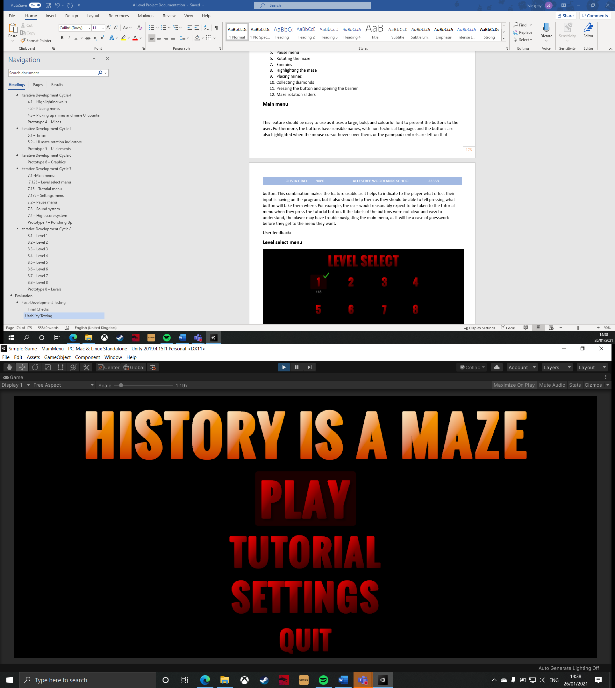

This feature should be easy to use as it uses a large, bold, and colourful font to present the buttons to the user. Furthermore, the buttons have sensible names, with non-technical language, and the buttons are also highlighted when the mouse cursor hovers over them, or the gamepad controls are left on that button. This combination makes the feature usable as it helps to indicate to the player what effect their input is having on the program, but it also should help them as they should be able to tell pressing what button will take them where. For example, the user would reasonably expect to be taken to the tutorial menu when they press the tutorial button. If the labels of the buttons were not clear and easy to understand, the player may have trouble navigating the main menu, as it will be a case of guesswork before they get to the menu they want.

**Videos:**

* Asking the user to access the level select menu
* Asking the user to access the options menu

**User feedback:**

‘The main menu is very clear, because the text is very bold and the choice of language is simple to understand. When the play button is clicked, it loads the next menu quickly and loads the menu I expected. When I hovered over a button, a box was created to show some feedback, so I knew that I would not accidentally select a different menu.’

**Rating of usability out of 10:** 10

**Level select menu**

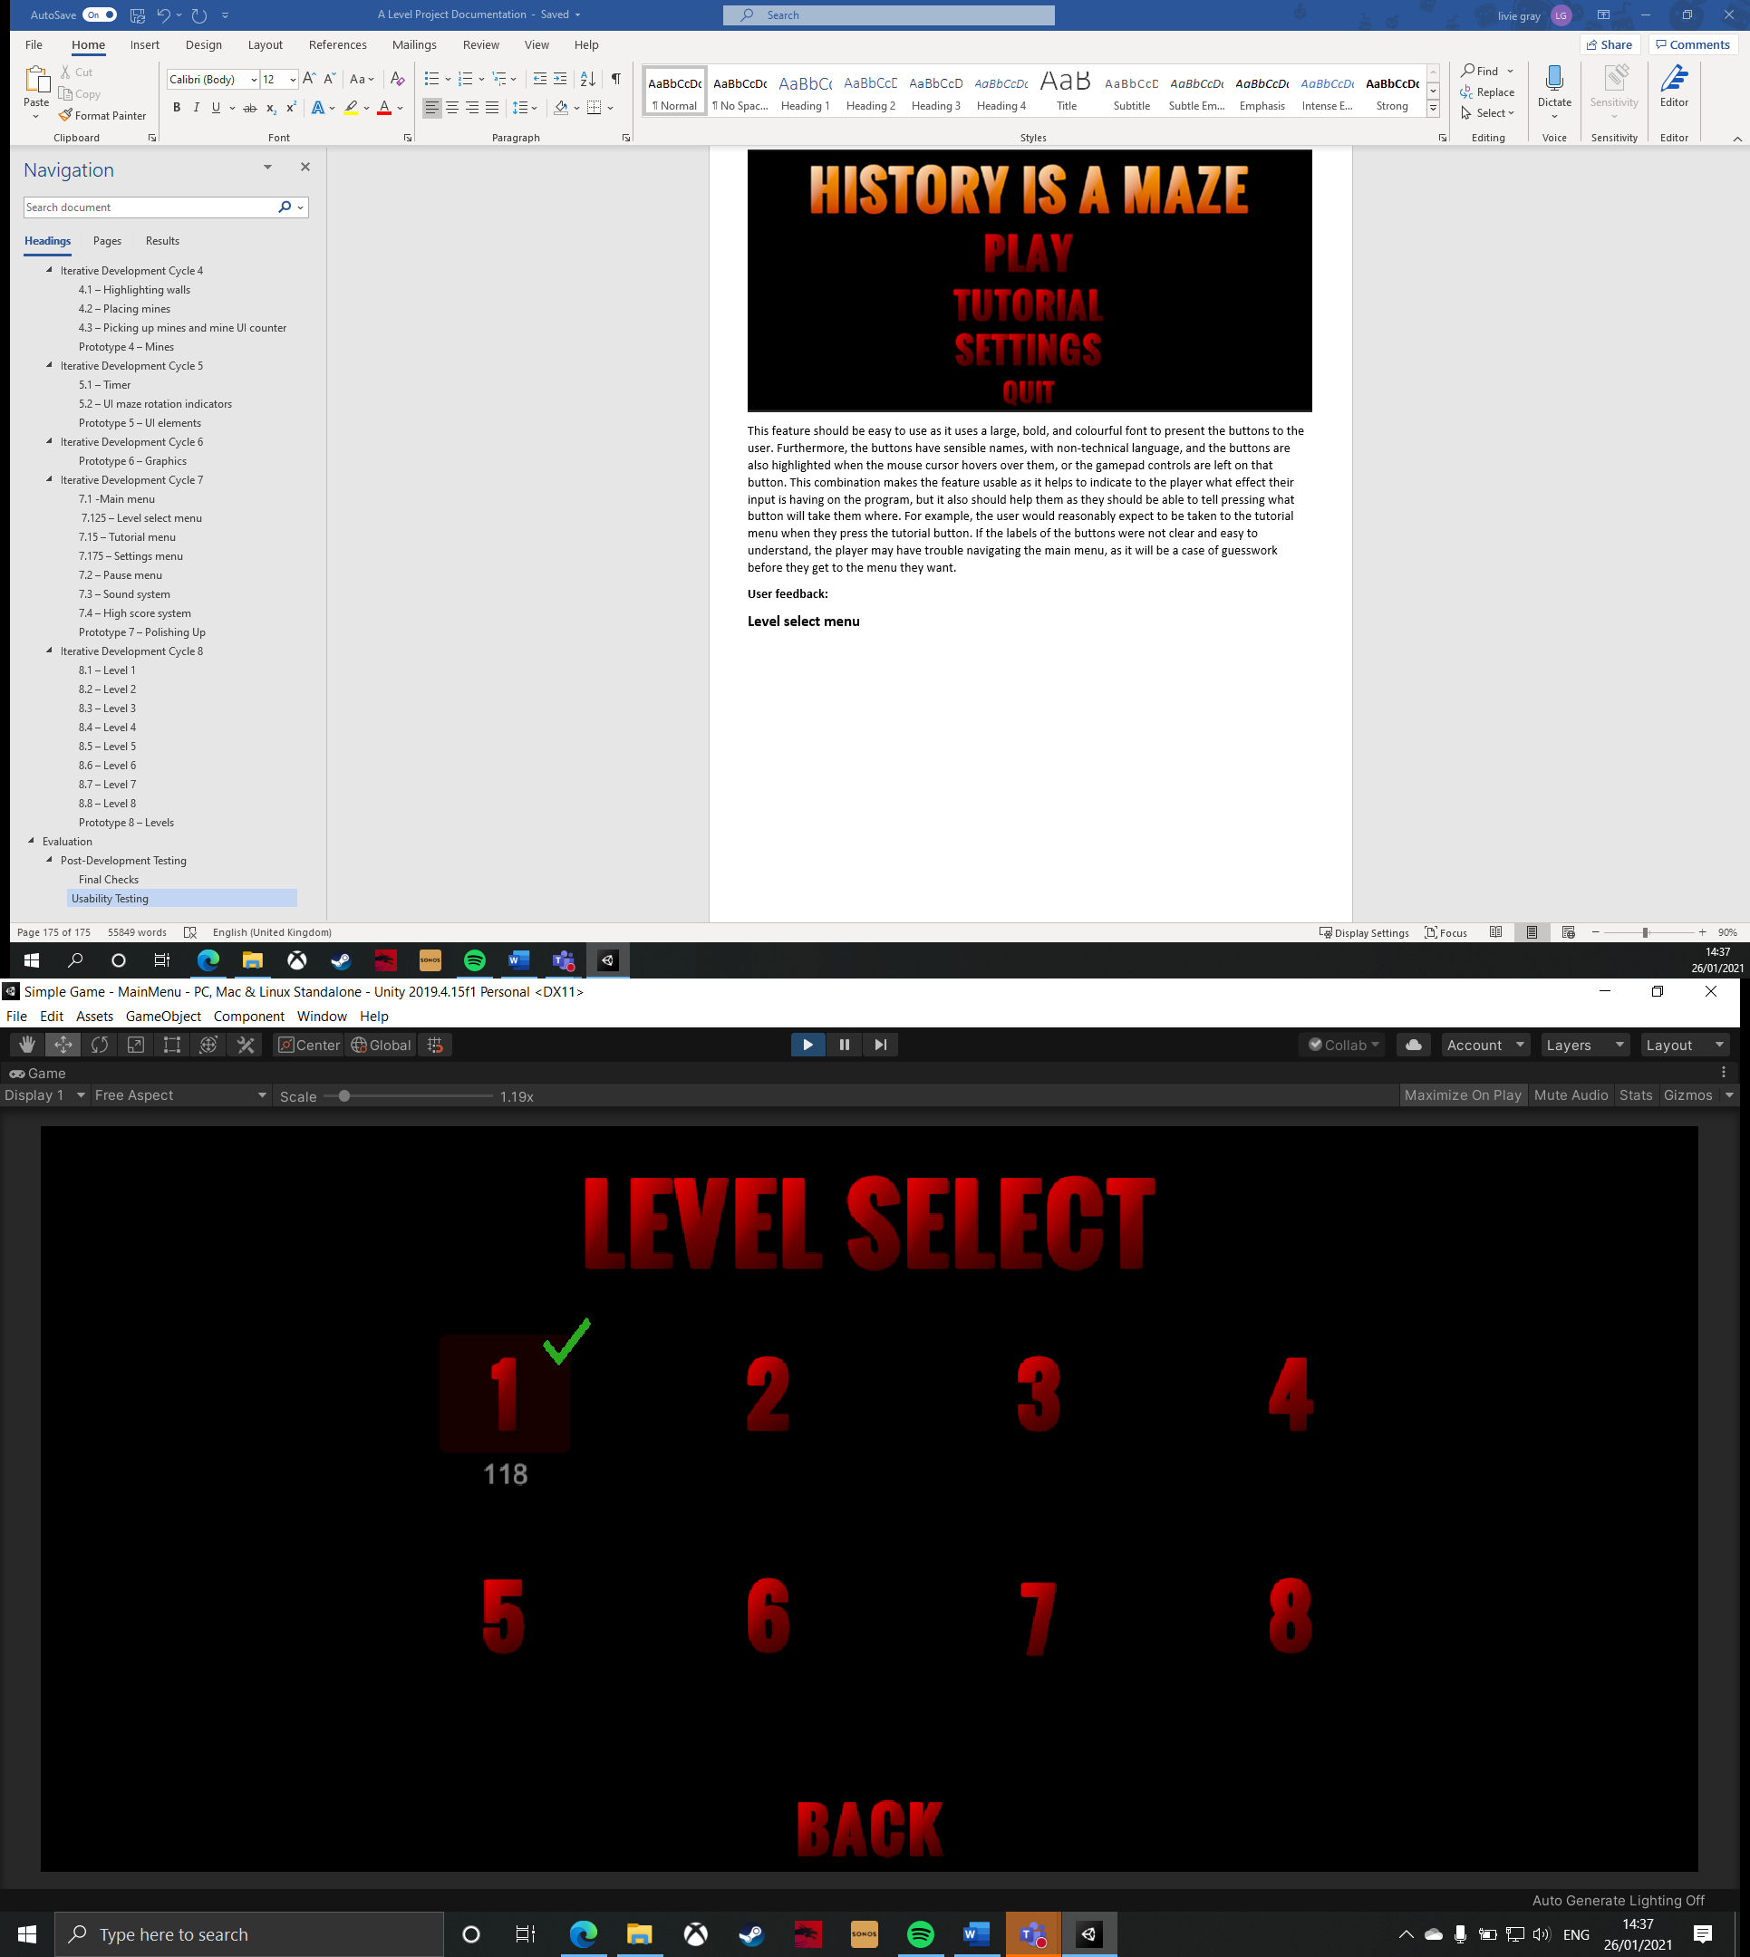

This feature has similar usability markers as the main menu – clear labels, highlightable buttons, and a bright font. These usability features are important to help the user understand what information is being presented to them on this screen, by highlighting a button when they are hovering over it. This can be useful, particularly on this screen, as the buttons’ labels are just numbers, which load the corresponding level number, but this may not be as clear initially. If this screen was not very easy to use, the user may have difficulty getting into the actual game, which is the most important part of this product.

**Videos:**

* Asking the user to load level 6
* Asking the user to return to the main menu from the level select menu

**User feedback:**

‘The number buttons are obvious to the user, particularly because the red text contrasts the background. Furthermore, the red box appears when you hover over the button, which illuminates the fact that the numbers are buttons, instead of just images. However, the back button could be placed higher on the screen to make it more obvious, but that is my only qualm with it.’

**What do you think the number under level 1 means?** ‘I think it means the high score of someone who has previously played the game.’

**What do you think the tick above level 1 means?** ‘I think this means that someone has successfully completed the level.’

**Usability rating out of 10:** 7

**Tutorial menu**

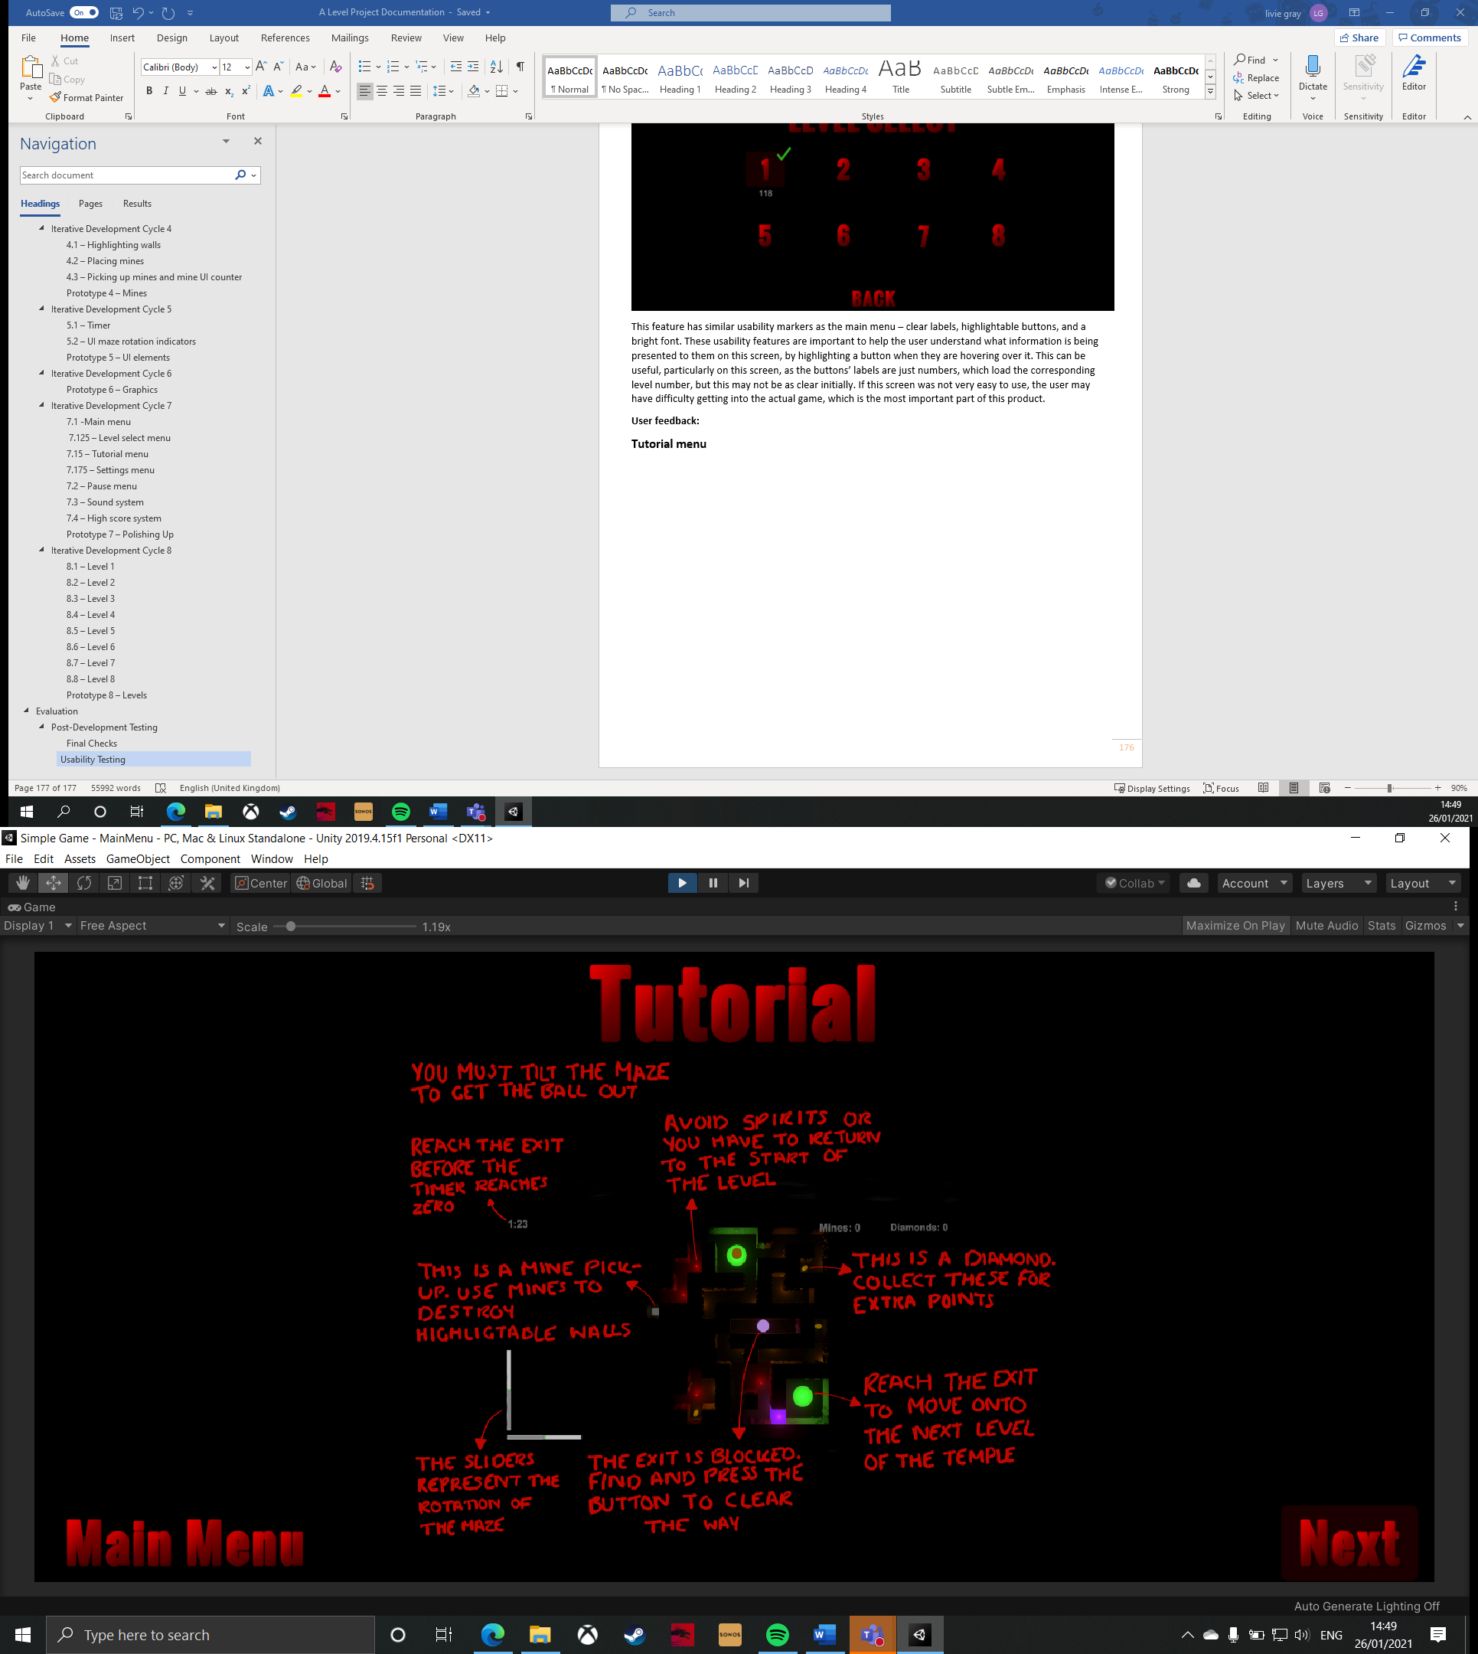

Similarly to the previous features, this screen uses bright colours for text and highlightable buttons to help the user understand what is going on in this menu. However, a new addition is writing the tutorial explanations in block capitals. This is important as the tutorial text was handwritten in top of an image of a level, which means that it could be harder to read than a standard computer-generated font. If this writing was not clear, then the user would not be able to understand the mechanics and controls of the game very well, meaning that all of the in-game features that I will be usability testing would probably fail because the user has not understood what controls to operate to use the other features.

**Videos:**

* Asking the user to access the gamepad tutorial
* Asking the user to return to the main menu from the tutorial

**User feedback:**

‘The tutorials have clear pictures and the arrows help show where each point links up to. The buttons have clear labels so I know what they do. The tutorial being split into three screens makes it very thorough and easy to understand. The text is easy to read, and is concise.’

**Usability rating out of 10:** 10

**Settings menu**

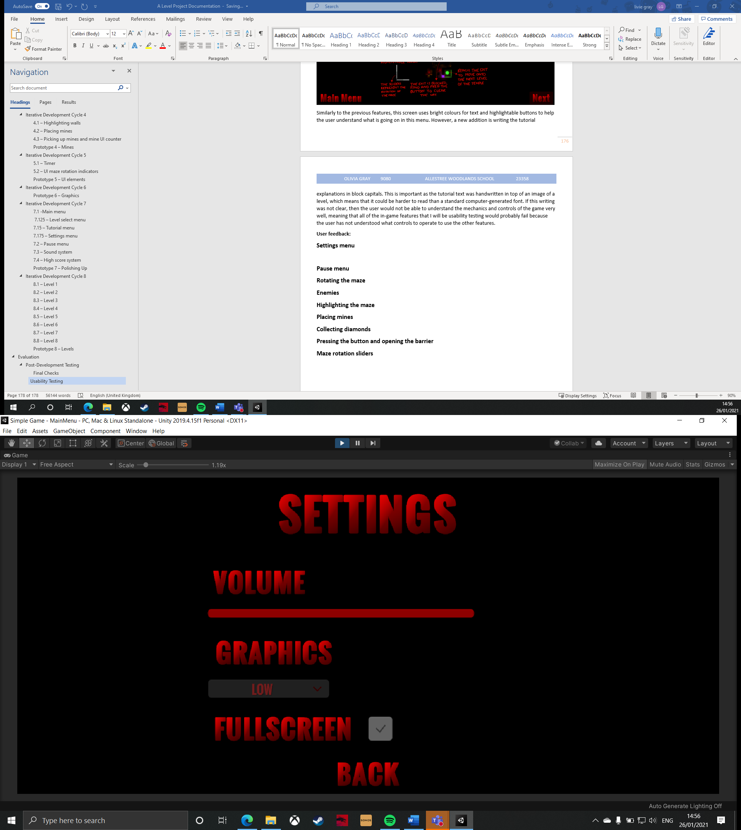

The additional usability features on this menu are the volume slider, graphics quality dropdown menu, and full screen toggle. These are important because they allow the user to easily adjust the settings of the game so it is more appropriate to their device, instead of having to fiddle with the game window or the device’s main audio output. If these were not easy to use, then the user would have trouble fine-tuning the application to their desires, which may make the program less appealing to the user.

**Videos:**

* Asking the user to lower the volume

**User feedback:** ‘The settings menu is neatly arranged, which makes it easy to navigate and makes it seem professionally built. It is clear to see the changes you have made in the settings, such as when you click full screen, the tick appears in the checkbox. This makes it easy to use because it is simple.’

**Usability rating out of 10:** 10

**Pause menu**

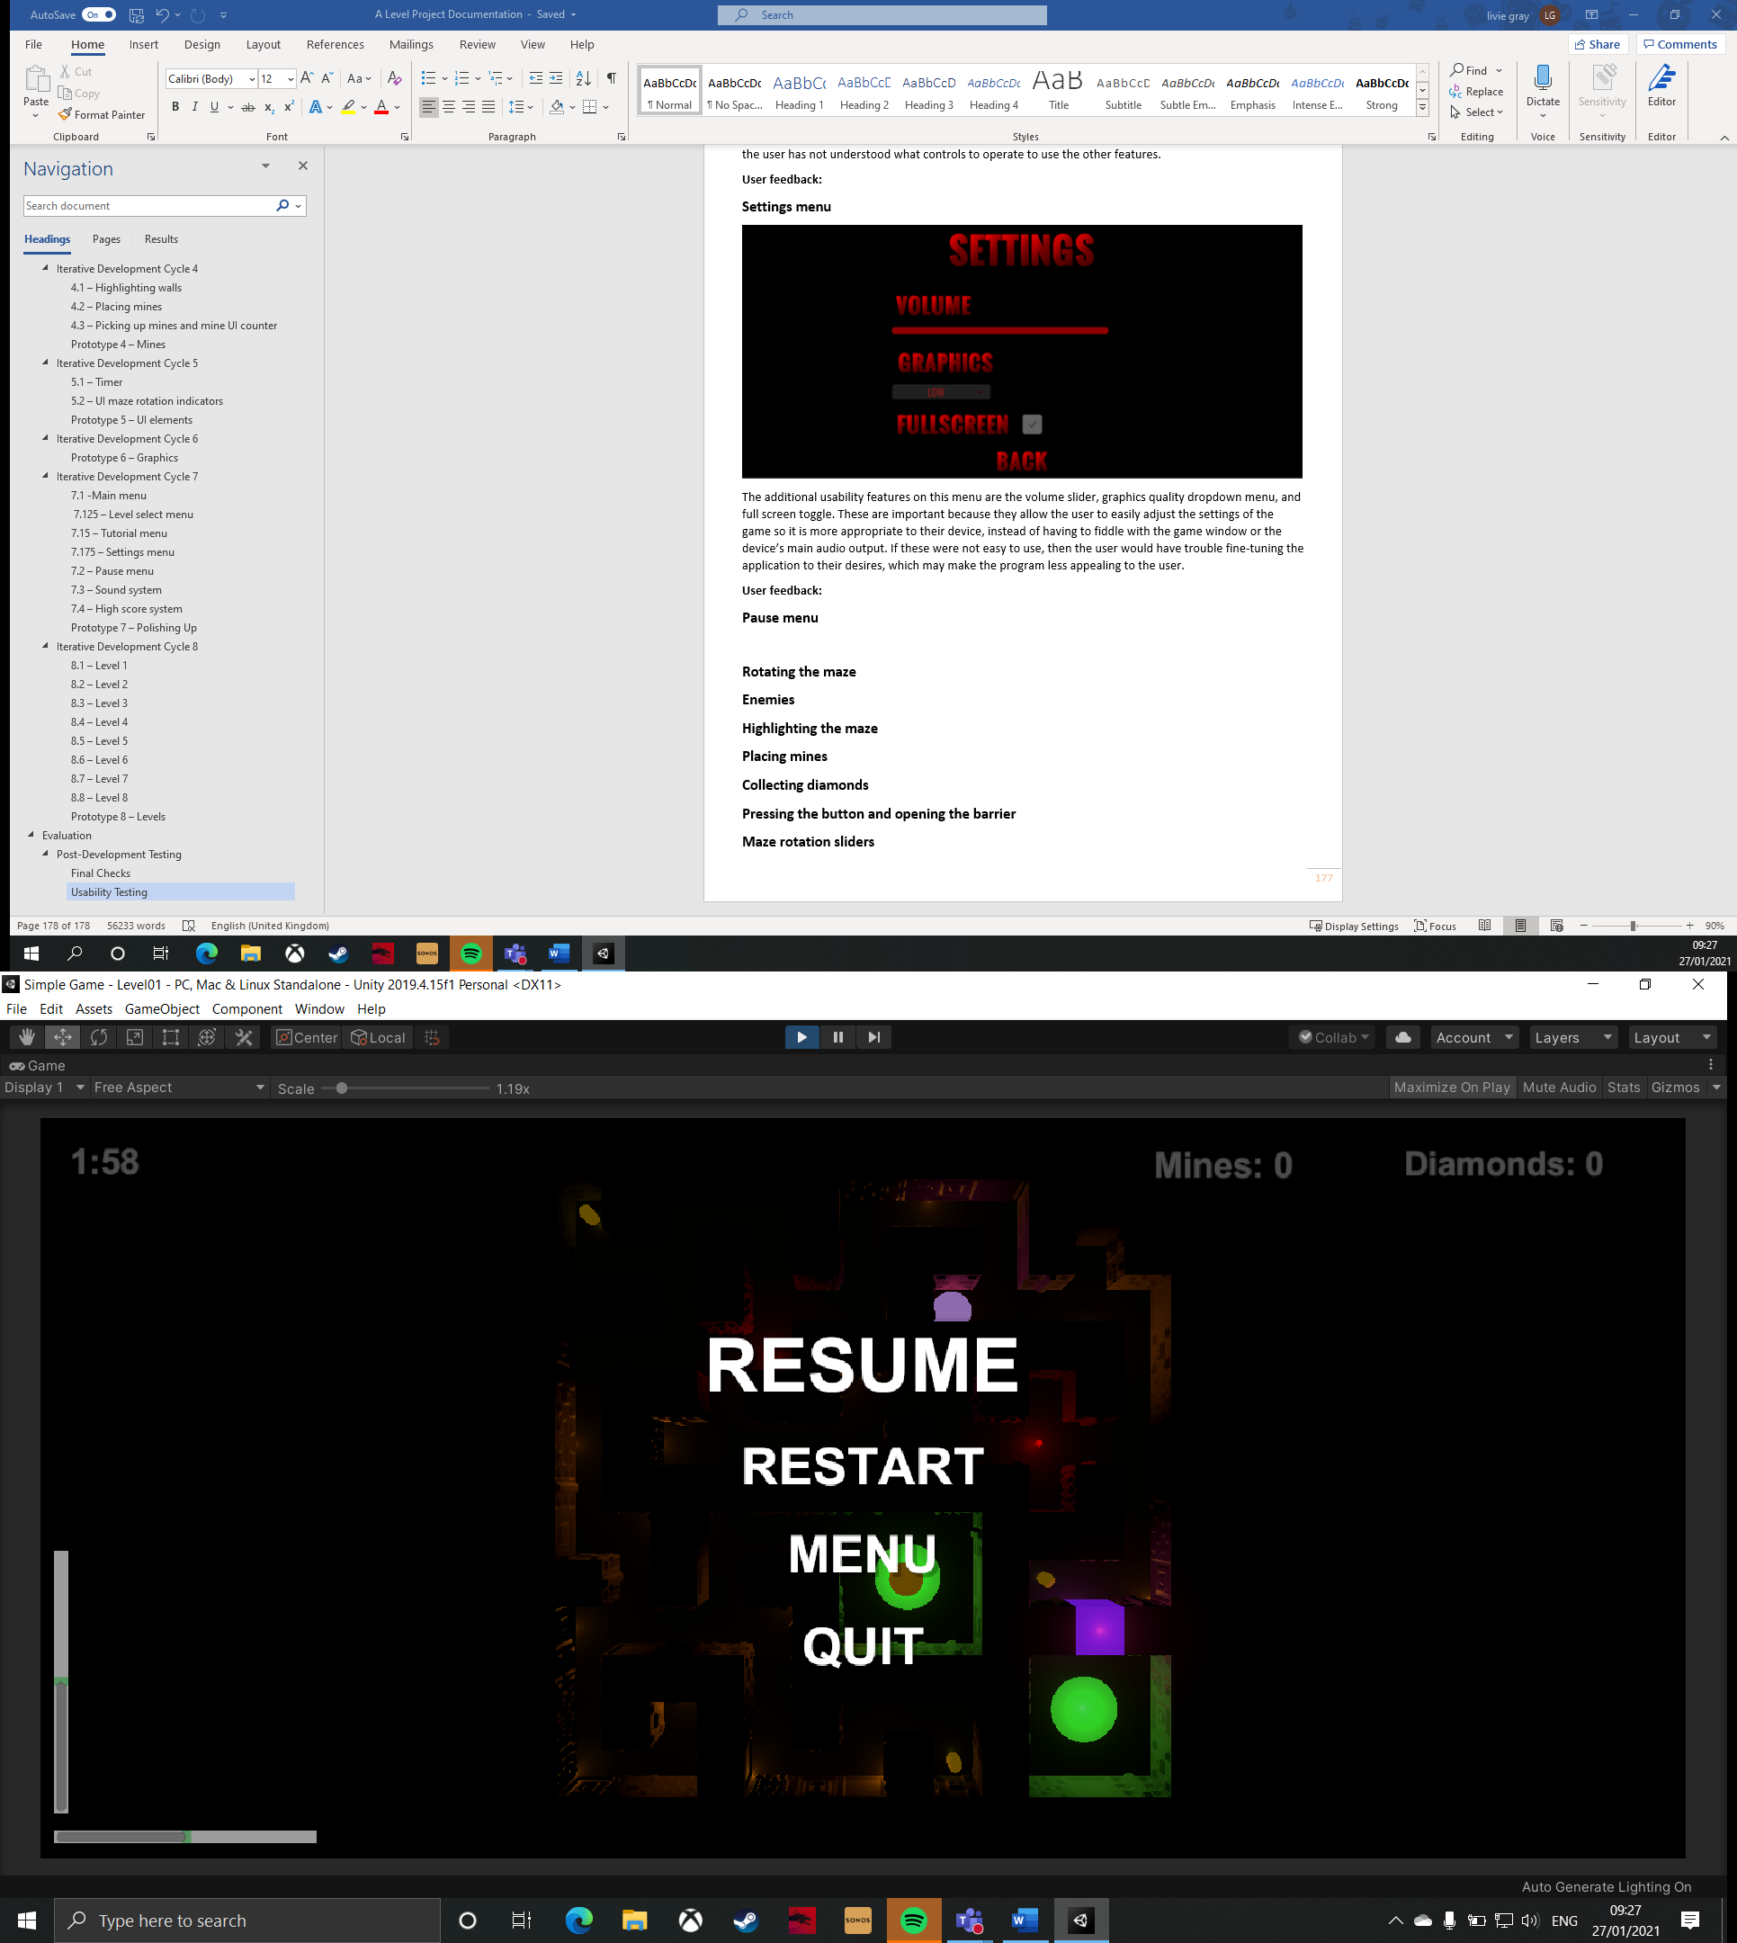

In this feature, clear button names and bright colours have been used to help make this menu easy to use and navigate. This is supposed to make it easier for the user to control as the bright colours and large font of the text is designed to draw the user’s eye towards it so they can easily distinguish the text from the level which is behind it. Furthermore, this menu does not use red font, in keeping with the theme of the main menus, because there are red objects in the maze, so it would be harder to identify the writing this way. If this was not easy to use, the player may have problems trying to use the functions in the pause menu, which would negatively affect the success criteria of being able to easily restart the level from inside the game. This would be bad as the success criteria needs to be met as best as possible so that the client is happy with the final product.

**Videos:**

* Asking the user to open the pause menu
* Asking the user to restart the level
* Asking the user to return to the main menu from a level

**User feedback:**

‘The contrast in the colour of the text and the dark background of the level makes it easy to see, and the buttons’ names are straightforward to understand. However, there is too much delay between pressing the restart or menu button and the game following through. This makes it harder to use because you are not sure whether your input has done anything.’

**Usability rating out of 10:** 8

**Rotating the maze**

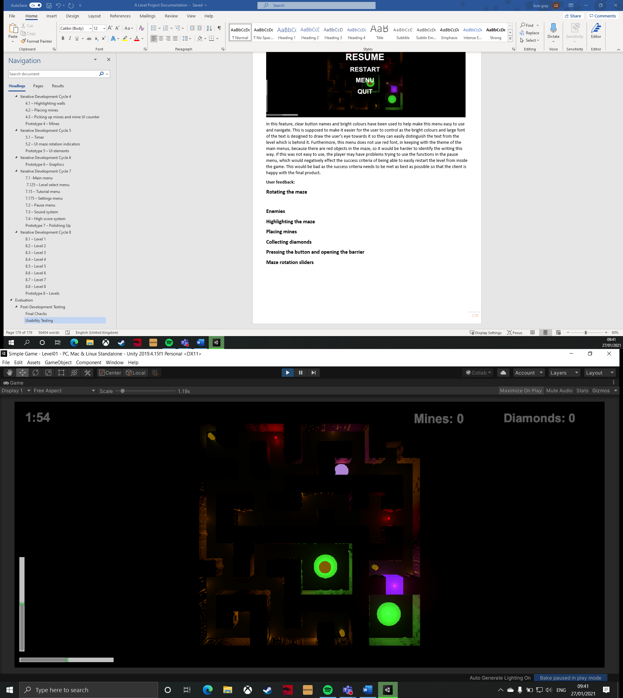

This feature should be easy to use and understand for the user as this is the core mechanic of the game, and how the user makes the ball reach the exit. The usability feature in this part is the UI sliders (in the bottom left of the image). These should make rotating the maze easier as it allows the user to be more precise with their inputs; for example, if the player wanted the ball to be still for a few seconds to let an enemy pass an opening they are waiting at, then they would need the sliders to ensure that they have recentred the maze’s rotation. Without the sliders, rotating the maze accurately could be very hard, as the player loses a lot of visual aids with the camera angle being almost vertical and with the scene being so dark. This could make the game too hard, which would eventually just become frustrating for the user, maybe causing them to quit the game.

**Videos:**

* Asking the user to rotate the maze

**User feedback:** ‘The maze was easy to rotate with familiar controls, which meant that it was easy to adjust to the game. The rotation is not too sensitive, or not sensitive enough, which provides an adequate challenge. The sliders are helpful for accurate rotations, however, they could be positioned a bit nearer to the centre of the screen.’

**Is it obvious what the rotation bars are for?** Yes, because they are covered in the tutorial.

**Usability rating out of 10:** 8

**Enemies**

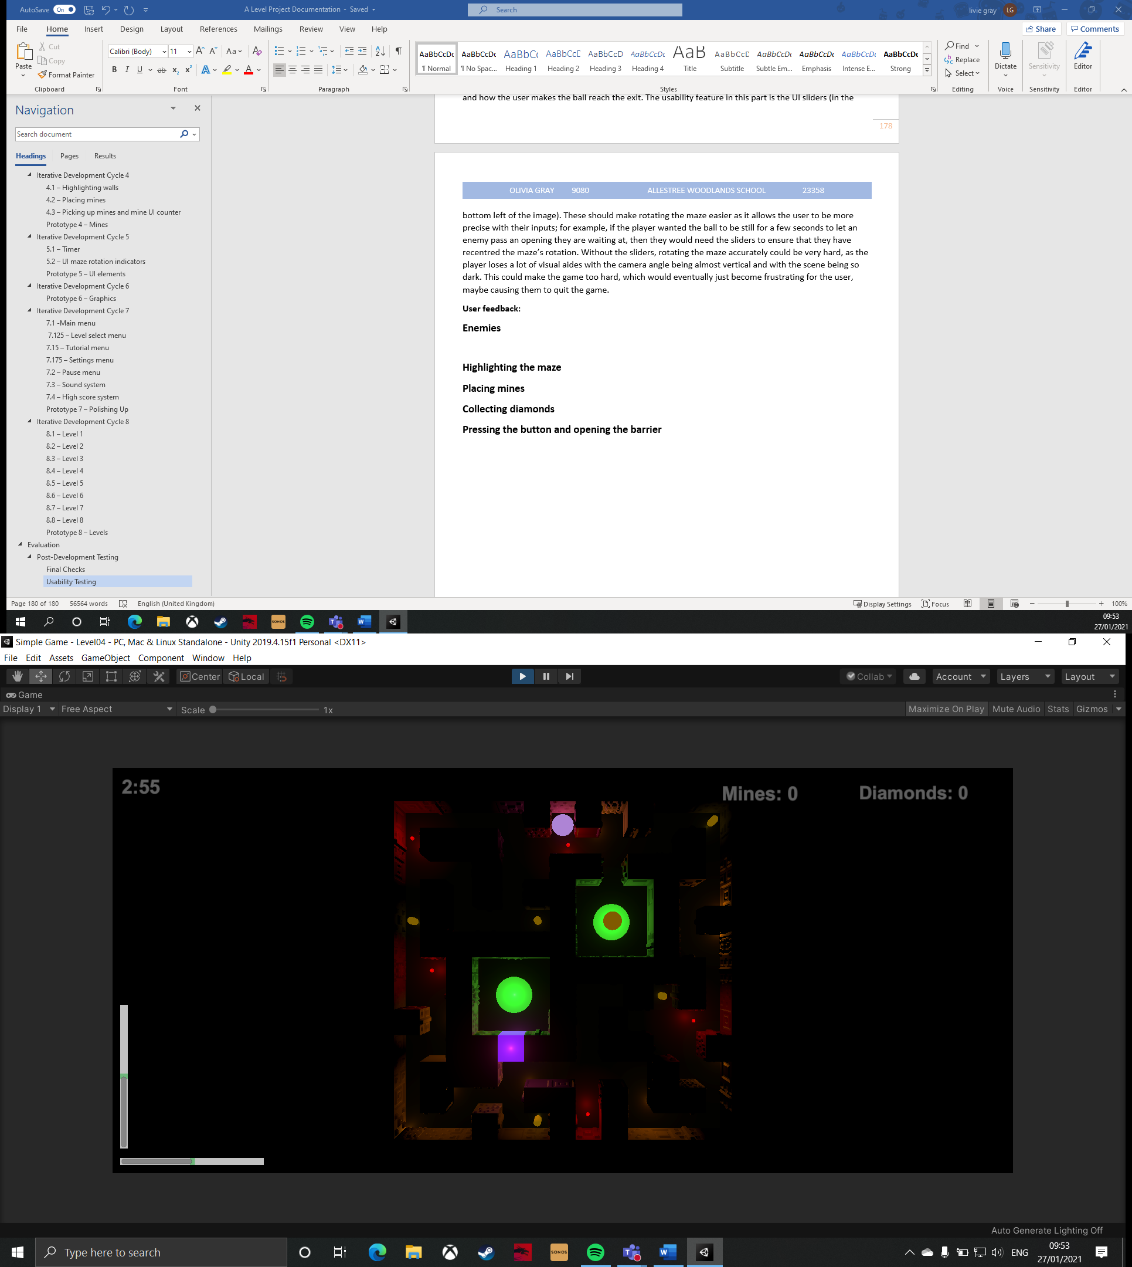

The enemies are surrounded by green circles in the image above – this is just for the purpose of highlighting them in the documentation, but they do not have green circles around them in the game.

The usability features of the enemies is that they are a bright, emissive red colour. This is because it makes them stand out against the dark maze, but also because red signifies danger, which should give the user a clear idea that they do not want to be colliding with the enemy. Furthermore, the tutorial menu also constitutes as a usability feature here, as it is there where the user will have the enemy mechanics explained to them. If the enemies were not easy to identify, then the player may keep accidentally rolling into them because they are too hard to pick out in the dark scene. This would be annoying for the player as it would be unfair to make them restart every time they cannot see an enemy. If the tutorial did not explain the enemies to the player, they might think that nothing happens when they collide with them, or that something good should happen in the maze (e.g. if the player thinks they work like diamonds), which means they will get a nasty surprise when they do collide with them, which is not particularly fair.

**Videos:**

* Asking the user to deal with an enemy puzzle in level 7

**User feedback:** ‘The enemies are easy to see in the maze, so you are not confused about their position in the maze, or why you might have died. The red contrasts the black well, meaning that the colours are more clear, and red also signifies that the enemies mean danger, just in case you have forgotten the tutorial. The enemies present an appropriate level of difficulty which varies enough to lull you into the trap of thinking they are not a challenge.’

**Usability rating out of 10:** 10

**Highlighting the maze**

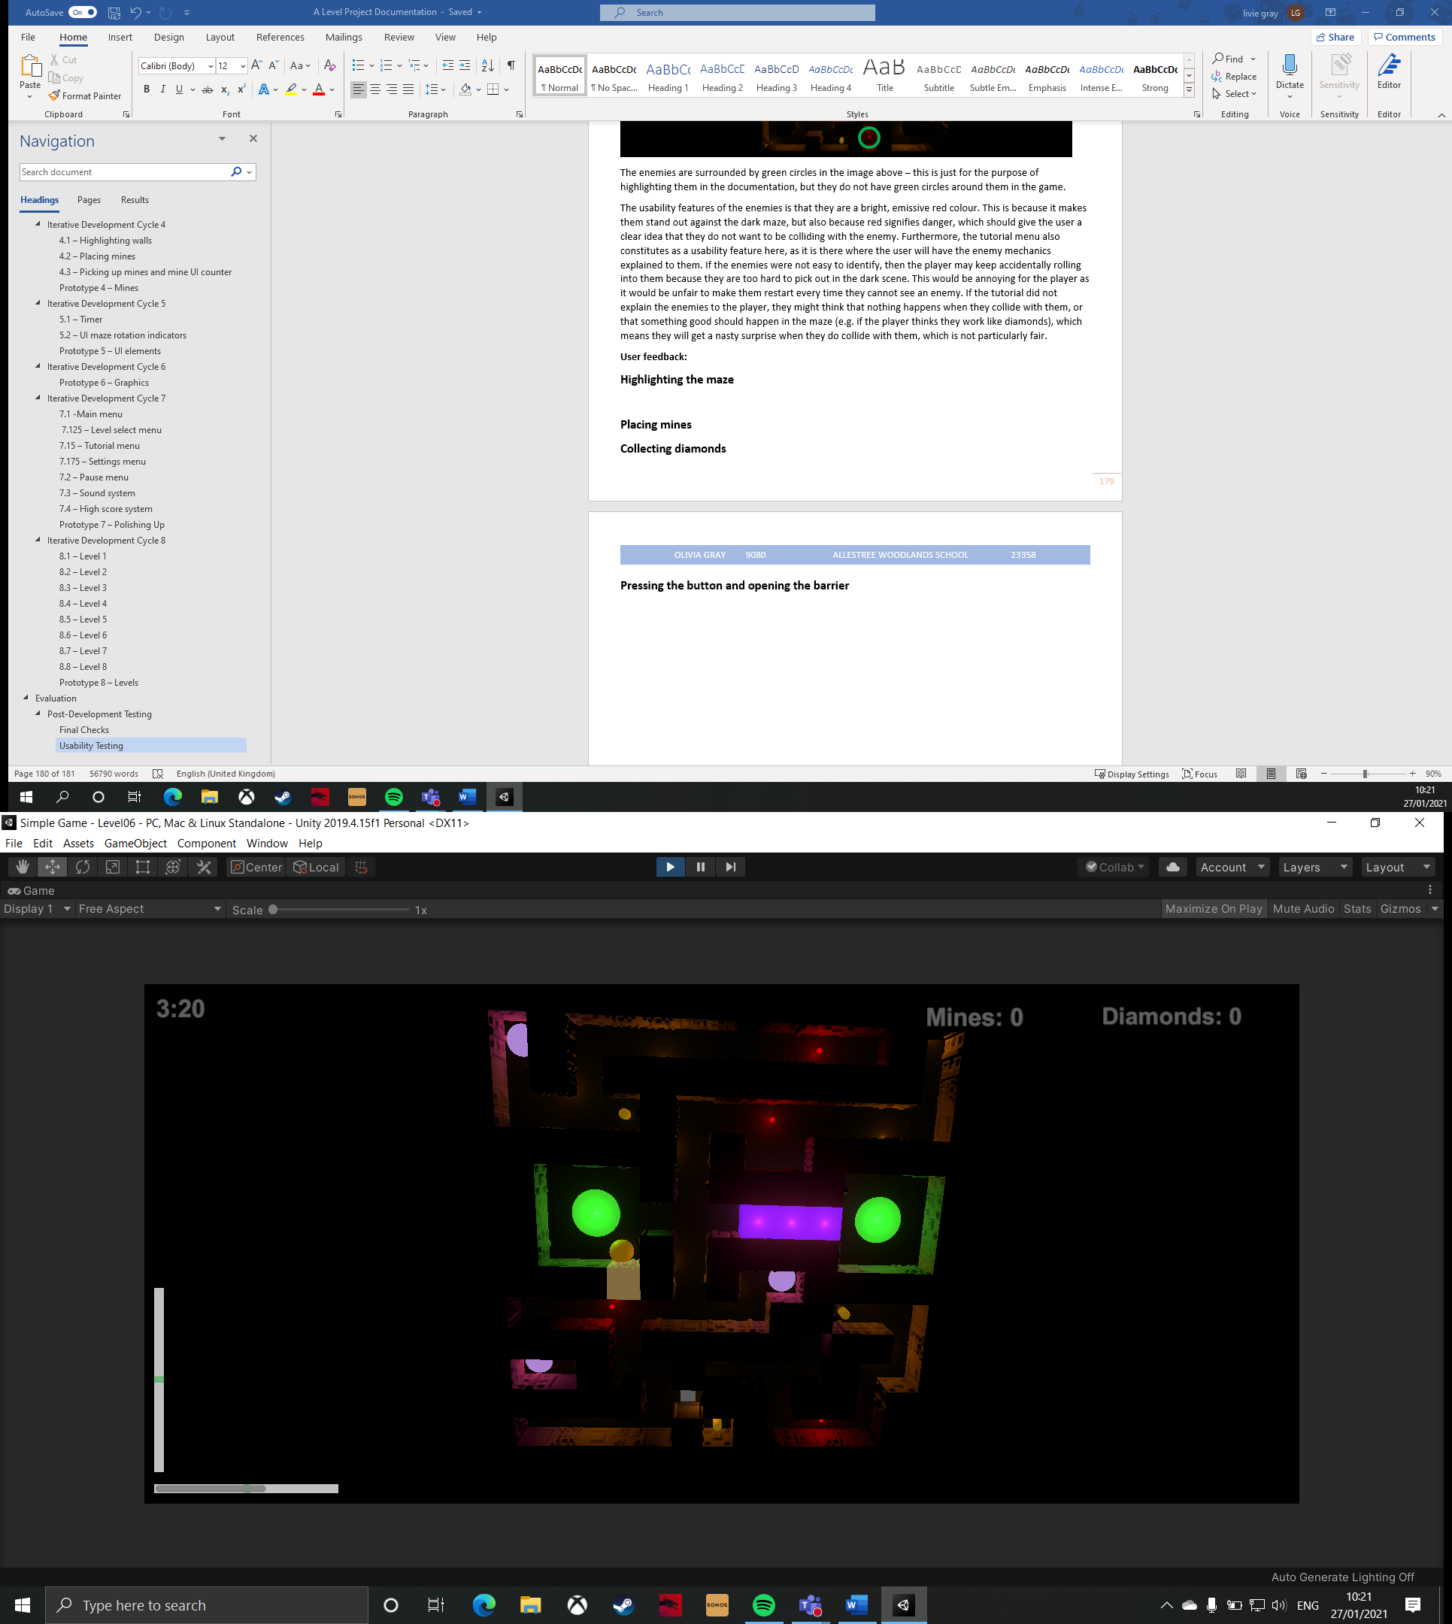

This feature should be easy to use because of the emissive material that a wall becomes when it is highlighted and because of the tutorial explanation. This should make it easier to use because the tutorial will tell the player what controls to use to highlight the wall, regardless of whether they are using a gamepad or keyboard, and the emissive material should make it very clear to the player which wall they are highlighting as it will stand out against the dark backdrop. If this feature was not particularly easy to use, the user would struggle completing level 5 onwards as these later levels require the use of mines to get through the maze. This could be frustrating for the player as they are limited to three mines per level, so if they accidentally placed a mine in the wrong place, because it was not clear which wall was being highlighted, they have wasted a mine and may have to restart the level, which would be bad, as the player needs to feel like they are learning the game and not repeatedly making stupid mistakes.

**Videos:**

* Asking the user to highlight the wall and place a mine

**User feedback:** ‘Left shift is a good choice of input for highlighting the walls, because it is very easy to reach and is commonly used in other games. The colour for a highlighted wall is very bright which means that it would be very hard to confuse it with a diamond or enemy. However, when the ball is in a corner, the highlighted wall keeps flipping between the two adjacent walls, which makes it hard to accurately place a mine in these scenarios. Other than that, really good.’

**Usability rating out of 10:** 8

**Placing mines**

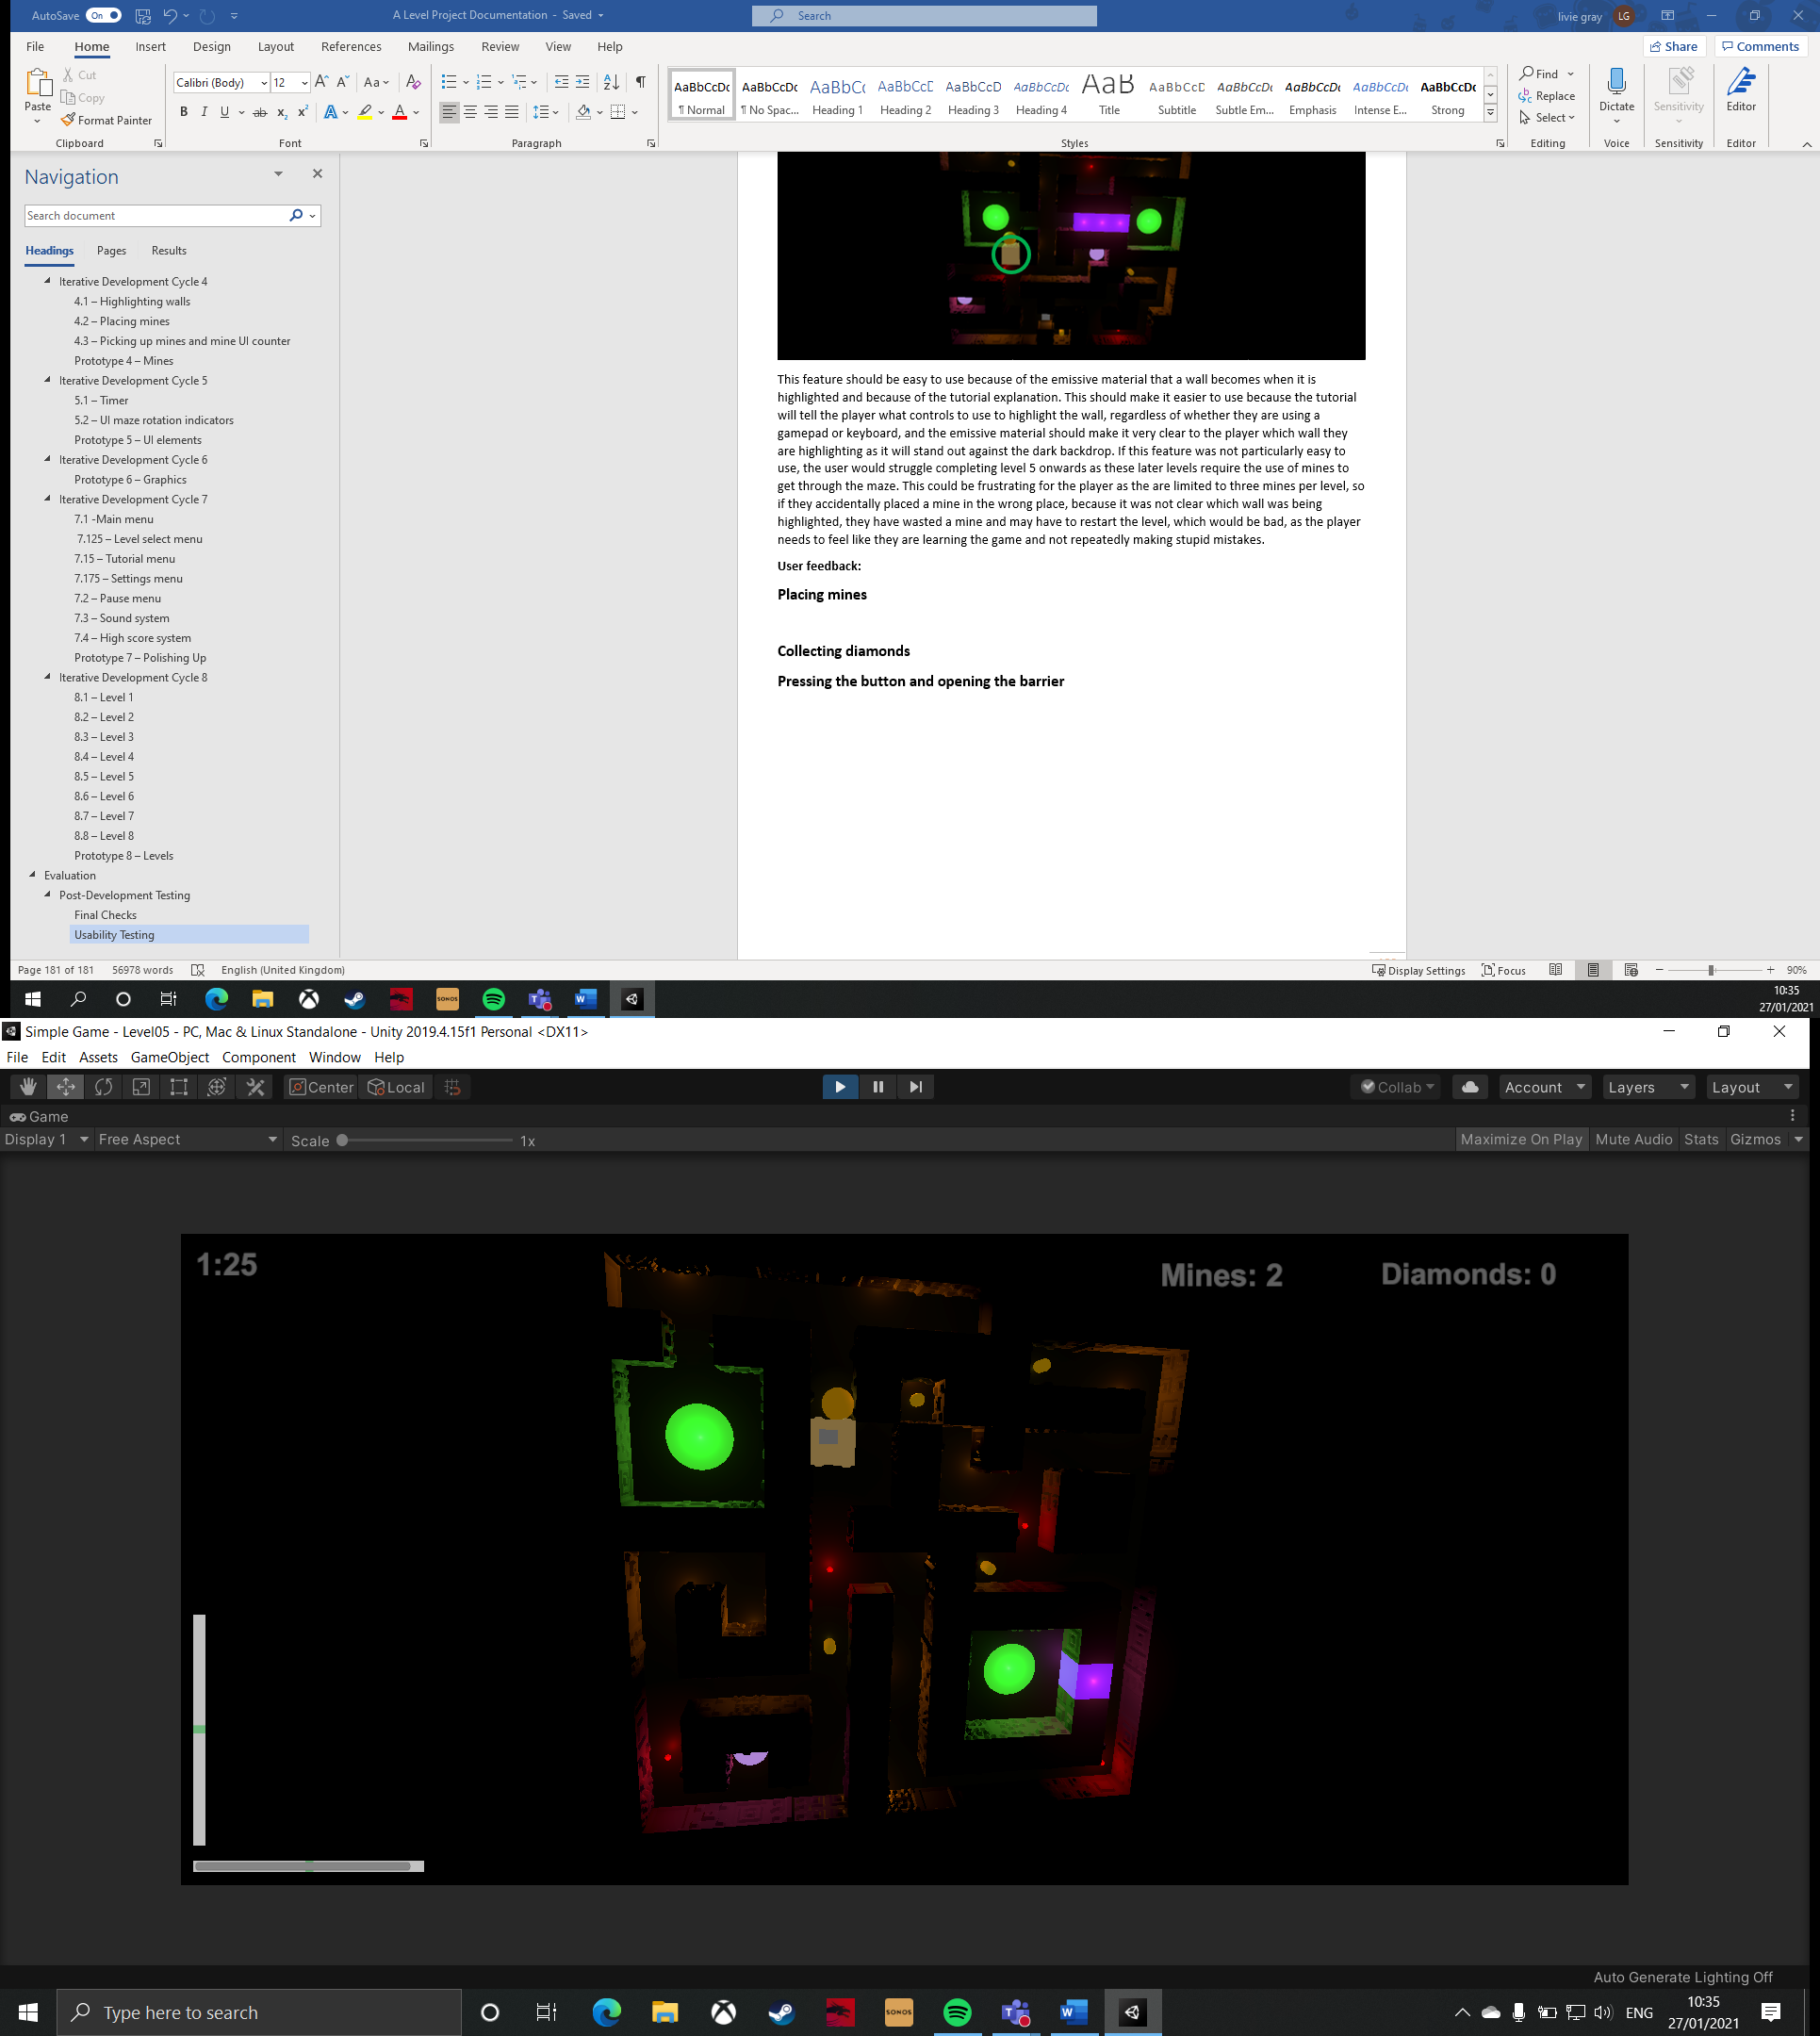

This feature is made more usable by the tutorial menu, its bright colour, the UI counter, and the sound effect and particle explosion that are created when the mine is detonated. This is designed to make it more usable as, while the tutorial tells the player what inputs to give when they want to place a mine, the emissive material helps the player to know when a mine has been placed. The mine counter also gives the player some indication of when they have placed a mine, but more importantly the player can see how mines they have left so that they can plan out their route through the maze. Lastly, the sound effect and particle explosion signify when the mine has been detonated. Without these usability features, the user would have to rely on slight visual cues to show when the mine has been placed or detonated, which might not be the easiest when they are also concentrating on other puzzles in the maze, such as if they need to place a mine in an area where an enemy patrols. This would be bad as it would probably cause the player to lose several times, which would be annoying.

**Videos:**

* Asking the user to highlight the wall and place a mine

**User feedback:** ‘Due to the emissive colour of the mine, it was easy to identify it. Furthermore, it was clear when the mine detonated because of the particle effect and sound effect. This all makes it easy to use because there are obvious visual and auditory cues that help me understand when a wall has been destroyed.’

**Usability rating out of 10:** 10

**Collecting diamonds**

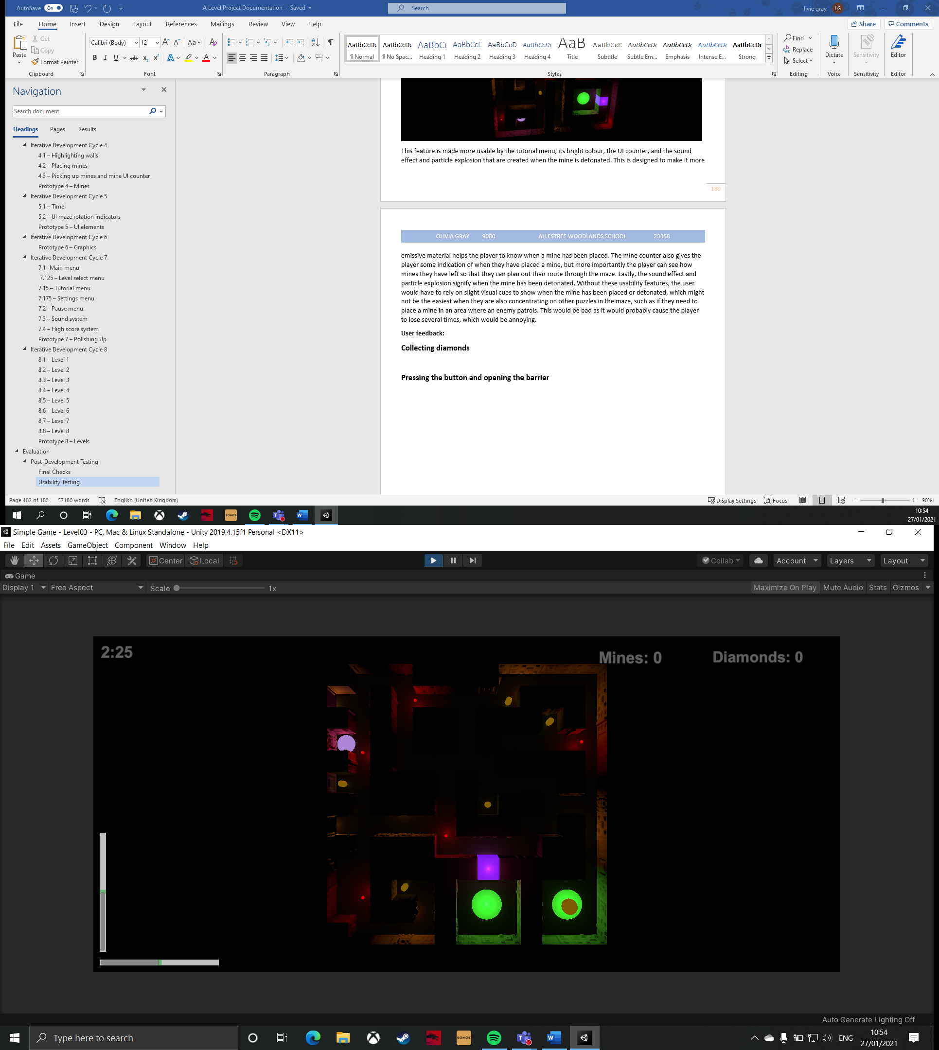

The diamonds are made easy to use by having them as a bright, emissive material, a diamonds counter on the UI, and by explaining their purpose in the tutorial. This should make this feature more usable by making the diamonds easy to identify, which is important given that the scene itself is quite dark. Furthermore, the diamond counter also helps the player remember how many diamonds they have collected in the level. This is important as the diamonds are a crucial way of boosting the score in each level. Without these usability features, it may not be very clear to the player why they should collect the diamonds, or even where in the maze they are. Therefore, the user would only reasonably be expected to collect some of the diamonds, and only learn where the diamonds are after several tries of the level, which is not the intended purpose of the diamonds.

**Videos:**

* Asking the user to pick up a diamond

**User feedback:** ‘The diamonds are very bright which helps with the clarity of the level. It is clear what there function is because of how they are explained in the tutorial – I know that I need to be collecting diamonds for the sake of my score. The diamond counter helps because it informs my decision over whether to roll over the exit now, or attempt to get more diamonds before I finish the level. The diamond counter is in a good position on the screen, so it does not interfere with the level, but I know it is available when I need it.’

**Usability rating out of 10:** 10

**Pressing the button and opening the barrier**

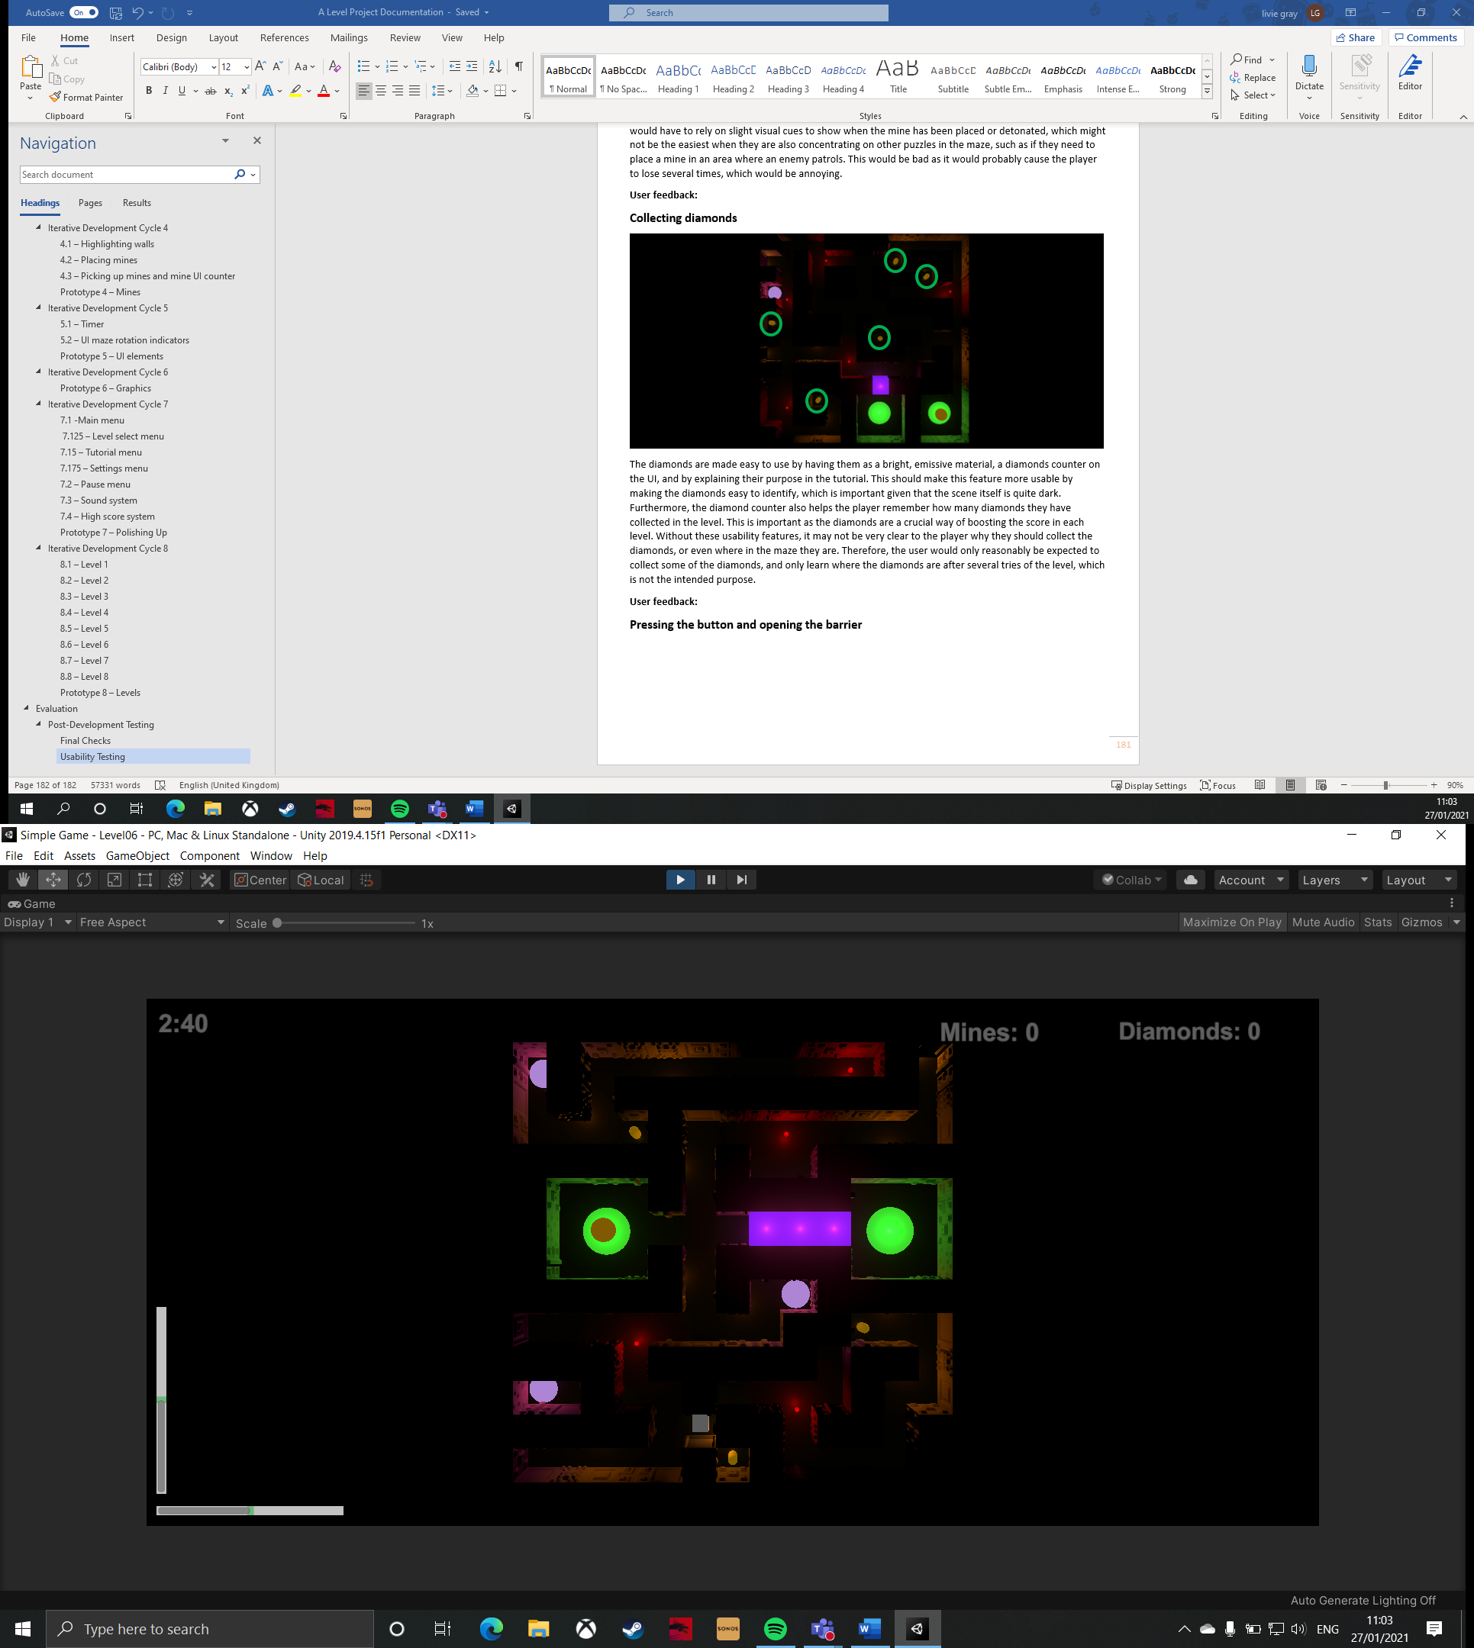

The usability features of the buttons and barriers are that they are bright, emissive colours, but also that the buttons and barriers are the same colour. This is important because it helps the user identify that the buttons link up to the barriers. Furthermore, the feature is explained in the tutorial, which should help the player understand what the purpose of the objects is, as it may not be clear what a random purple circle is doing in the maze, if they do not read the tutorial. Without these usability features, the player may not see the buttons or they might not understand what they are for, so the usability features should help to solve this issue.

**Videos:**

* Asking the user to press the button

**User feedback:** ‘The purple colour of the button and barrier are a good contrast to everything else in the maze, but the fact that the button and the barrier are the same colour shows me that they are connected to each other. This makes it easy to use because it reminds what to do even if I have forgotten the tutorial. Furthermore, the barrier disappears instantly when the ball rolls over the button, which means I get immediate feedback from the game. This is quite useful in other levels where the ball skims over the button when I am in a rush to get past enemies.’

**Usability rating out of 10:** 10

## **Evaluating the Solution**

Throughout the development of this project, I have ensured that each new feature contributes to fulfilling one or two of the client’s success criteria and essential features. This is important as it has resulted in the finished product meeting all of the client’s specification, which means that it should complete its purpose on the LearnFuture website. If this was not the case, then the client would be justified in not paying me for my work, as I would have violated the terms of our agreement.

The only success criteria that is not met as fully as I would have liked is ‘new puzzle elements introduced as the game progresses’, as, now that the game is assembled, I realise that only adding the mines in level 5 means that the user is not constantly adjusting to new features. This may not necessarily be a bad thing, however, as it is possible that I only feel this way because of how much time I have spent testing the solution and playing the levels. This would mean that, for an average user, the mines may provide enough of a new challenge that they would not want any more new features to be introduced in the eight levels of the game. This is important as the solution is designed to encourage the target audience to explore a career in archaeology, so the game should not be so impossibly hard that the player gives up before they have really had time to play the whole game. If the game were slightly longer (perhaps hitting the upper bound of ten levels), I could have added a different new feature, such as holes in the maze that the ball could fall through, or different elevations, where the ball would not be able to roll up slopes, so would have to find a different way through the maze.

Overall, the game feels good to play, with responsive controls, which is reinforced by my user’s feedback in the ‘Usability Testing’ section. Taking into account their feedback, some UI features needed slightly readjusting so they are not just peripheral features, and the pause menu buttons needed to give more immediate feedback. These features have already been fixed (by readjusting the sliders and reducing the time for the co-routine to start in the level loader), so the solution is ready to be presented to the client in this sense. This is important because the game needs to be easy to play and understand for the user, as they are not expected to spend hours playing the game, and figuring out all the nuances of the program. This means that the combination of different usability features should, and do, provide a good enough set of information for the user to play the game without constantly, re-checking the tutorial. If this was not the case, the game would most likely be an annoyance, particularly because each level must be completed within a time limit, so the user would not want to waste their time going back-and-forth between the levels and the tutorial.

However, the user did point out a limitation to the program in the ‘Usability Testing’ section, which was that highlighting a wall that is in a corner can be tricky to do accurately, as the program will constantly flip between either of the two adjacent walls as the ball rolls slightly, making it difficult to place mines in corners. This is bad because it will very quickly become frustrating if the user finds that they cannot complete a level because a mine was wasted in one of these instances. This would probably cause them to stop playing the game, because it is not user-friendly. To fix this issue, the program could use a timer to limit how many times the program finds the new closest wall every second. This would give the user a buffer where they can place the mine without it switching to the adjacent wall. The issue with this fix is that it would take away from some of the novelty of highlighting walls. This is because it is quite fun to roll around the maze with your finger on ‘left shift’ or ‘LB’ and watching the walls as they are highlighted and un-highlighted. This would be bad because, if the user chose to do this, it would make the highlighting walls feature seem very clunky, disjointed, and responsive, or it may not highlight the correct wall when they initially press ‘left shift’, as it would not have yet reached the next run-through of the for statement. It may be possible to use a sphere around the ball to collect how many walls are ‘x’ close to the ball, and if there are two, then it starts buffering the for statement. However, this could run into the same problem as specified above. Therefore, I believe that the current solution is decent because the user is never really expected to place mines in corners, as there are no levels where diamonds or buttons are blocked behind walls which are in corners. This means that there will always be another route to access the same object, so the user will never be forced into a corner. However, if there were objects blocked by walls in corners, it may have been necessary to consider the specified solutions, or maybe move the objects and redesign the level a bit, which would be quite time-consuming.

Furthermore, where I have been given leeway by the client (such as how the enemies move around the maze), I have thoroughly tested the feature so that it works as I intend it to. This is important because the client needs to be impressed with the initiative I have taken, because I should be presenting them with a product which is likely to attract users, not repel them. For example, if the enemies were stationary, this would not make for especially exciting puzzles in the levels, as the user would have no problem avoiding static objects. Therefore, whilst the client only specified that they wanted enemies in the game, I elected to give these enemies patrols in each level, which the user must adjust to each time. If I had not properly tested these mechanics, the game I present to the client could be a buggy mess, which would not give the client a good impression of the game, even if the mechanics I implemented were a good addition to the game. This would be bad because the client would be reluctant to use my game on the LearnFuture website until it is in a more polished state.

In addition to the point about the development of the enemies, the enemies were the key part of the solution where I differed from the initial design of the game. In the design phase, I had conceptualised enemies that followed a set route between two points. This seemed like a good idea at the time, and it may have actually worked alright in the finished product, but I believe that the current implementation of their pathfinding is far more comprehensive and really encourages the player to think about their actions in the level. This is important because the enemies are supposed to be an important puzzle element in the game, to help it fulfil the client’s success criteria. If I had not updated the enemies’ pathfinding algorithm, the enemies would have only travelled in straight lines between two nodes, which would have been too easy to learn. The way to make them a greater challenge would have been adding more, but I realised as I implemented the original enemies into the first level, that this would not have been an effective puzzle; instead, the level became way too difficult and would not have encouraged the player to plan, only act on instinct to ensure the ball did not collide with the enemy. Therefore, the current solution is definitely a large improvement that was worth the time taken to create it, as it means that the enemies meet the client’s success criteria more effectively.

In order to maintain the program in the future, the client will be able to do this without my input, unless they want to create a whole new feature. This is because the whole game, being made in OOP, is a collection of objects, so all that is needed to create a new level is pasting the object prefabs into a new scene and correctly setting up the variables in the inspector. This should be easy to do as all of the objects and variable have sensible names, so the client should be able to easily figure out what needs to be attached to what in the scene. If the program was not set up this way, the client would probably have to hire a specialist to create new levels, because they would have to rely on scripting to create objects in the scene at specific positions, which is quite long-winded. This would not be an ideal solution because the program was built in the Unity Engine, so it would make sense to utilise the Unity editor when it is there.

In addition to this, if the client wanted to add new features into the game, it would be easiest for me to do this given I created the software, but it would also be possible for the client to hire a different developer. This is because the code is commented all throughout the software, so each function is explained clearly. This is important for readability so others can understand what the program is doing in a given method. If the scripts were not commented, other developers may not be able to understand what my code does, because each developer will have a different solution to the same problem, so they need to know how I’ve created each feature so they can maintain it, or build on it.

# **Appendix A – Bibliography**

|  |  |
| --- | --- |
| **Use of external resource** | **URL** |
| Brackey’s video tutorial provided information to build the fade-to-black transition in the game. | [How to make AWESOME Scene Transitions in Unity! - YouTube](https://www.youtube.com/watch?v=CE9VOZivb3I&t=897s) |
| Brackey’s video tutorial helped make the camera shake feature when the ball collides with a wall. | [CAMERA SHAKE in Unity - YouTube](https://www.youtube.com/watch?v=9A9yj8KnM8c) |
| Using built-in Unity functions for the menus. | * [Unity - Scripting API: Application.Quit (unity3d.com)](https://docs.unity3d.com/ScriptReference/Application.Quit.html) * [Unity - Scripting API: QualitySettings.SetQualityLevel (unity3d.com)](https://docs.unity3d.com/ScriptReference/QualitySettings.SetQualityLevel.html) * [Unity - Manual: Quality (unity3d.com)](https://docs.unity3d.com/Manual/class-QualitySettings.html#:~:text=Unity%20allows%20you%20to%20set%20the%20level%20of,tends%20to%20have%20a%20detrimental%20effect%20on%20gameplay.) * [Unity - Scripting API: Screen.fullScreen (unity3d.com)](https://docs.unity3d.com/ScriptReference/Screen-fullScreen.html) * [Unity - Scripting API: AudioMixer (unity3d.com)](https://docs.unity3d.com/ScriptReference/Audio.AudioMixer.html) |
| Using Unity documentation to build the collision sound effect. | [Unity - Scripting API: AudioSource (unity3d.com)](https://docs.unity3d.com/ScriptReference/AudioSource.html) |
| Documentation helped me understand how to format a timer in the game’s UI. | [String.Format Method (System) | Microsoft Docs](https://docs.microsoft.com/en-us/dotnet/api/system.string.format?view=net-5.0) |
| PlayerPrefs were used to persistently store data for the application. | [Unity - Scripting API: PlayerPrefs (unity3d.com)](https://docs.unity3d.com/2020.2/Documentation/ScriptReference/PlayerPrefs.html#:~:text=%60PlayerPrefs%60%20is%20a%20class%20that%20stores%20Player%20preferences,on%20which%20operating%20system%20the%20application%20runs%20on.) |
| The Unity Documentation helped to create the enemies’ pathfinding. | [Unity - Scripting API: Vector3.MoveTowards (unity3d.com)](https://docs.unity3d.com/ScriptReference/Vector3.MoveTowards.html) |
| The Unity Documentation provided the information needed to make the soundtrack persistent through all scenes. | [Unity - Scripting API: Object.DontDestroyOnLoad (unity3d.com)](https://docs.unity3d.com/2017.3/Documentation/ScriptReference/Object.DontDestroyOnLoad.html) |

# **Appendix B – Code Listings**

The code has been listed in alphabetical order.

**BallThud**

public class BallThud : MonoBehaviour

{

public AudioSource audioSource;

public AudioClip[] thuds; //An array that holds four slightly different thud sound effects

public void PlayThud(float multiplier) //Takes a parameter passed from the ball script that represents the force that the ball hits a surface

{

audioSource.volume = 0.1f * multiplier; //Sets the volume of the thud in proportion to the force that the ball hits a wall

audioSource.PlayOneShot(thuds[Random.Range(0, thuds.Length - 1)]); //Plays one of four audio samples, that is chosen randomly

}

}

**Barrier**

public class Barrier : MonoBehaviour

{

void Start()

{

transform.position = new Vector3(transform.position.x, 1 , transform.position.z); //Sets the initial position so that it is definitely blocking the player's path

}

public void OpenBarrier()

{

Destroy(gameObject); //Deletes itself and all components attached to it

}

}

**CameraShake**

public class CameraShake : MonoBehaviour

{

public IEnumerator Shake (float magnitude)

{

Vector3 initialPos = transform.localPosition; //Used as a temporary variable so the camera cam return to its original position

float timeLeft = 0.1f;

while (timeLeft >= 0) //Sets a time limit on how long the shake will occur for

{

float x = Random.Range(-1f, 1f) * magnitude;

float y = Random.Range(-1f, 1f) * magnitude; //These three lines all give a random position to change the camera to, which is multiplied by the shake's size

float z = Random.Range(-1f, 1f) * magnitude;

transform.localPosition = new Vector3(x, y, z); //Tells the camerra to set its new position as the values given above

timeLeft -= Time.deltaTime; //Increments timePassed by the time that has elapsed since the last frame. This is a way of creating a timer

yield return null;

}

transform.localPosition = initialPos; //Resets the position of the camera when the shake is done

}

}

**CountdownTimer**

public class CountdownTimer : MonoBehaviour

{

public Text text;

public Text finalTimeText;

public float startTime;

private bool endGame = false;

public LevelLoader levelLoader;

public FinalScore finalScore;

private float timeLeft;

private float finalTimeInSeconds;

private string timeText;

void Update()

{

timeLeft = startTime - Time.timeSinceLevelLoad; //Unity is automatically logging the time since the scene was loaded. This works as there is no delay before the player can start controlling the maze

int minutes = Mathf.FloorToInt(timeLeft / 60f); //This is calculating how many minutes are left in 'timeLeft'

int seconds = Mathf.FloorToInt(timeLeft - minutes * 60f); //This is calculating how many seconds are left in 'timeLeft'

timeText = string.Format("{0:0}:{1:00}", minutes, seconds); //Defines the format of the text - I am telling it that I want it to show minutes:seconds

if (endGame == false) //Whilst the user has not reached the exit

{

text.text = timeText; //Updates the timer, which is in the user's UI

finalTimeText.enabled = false; //This is used to show the player when time is up, therefore it is set to false whilst the player is still 'playing' the level

finalTimeInSeconds = timeLeft; //Collects the remaining time into this variable

}

if (timeLeft <= 0) //When the player has ran out of time

{

text.text = "0:00"; //Easy way of stopping the timer going negative

finalTimeText.enabled = true; //Overwrites the opposite above

finalTimeText.text = "YOU RAN OUT OF TIME"; //Displays this in large writing on the UI

levelLoader.ReloadLevel(); //Restarts the level

endGame = true; //Stops the first if statement from running

}

}

public void ShowTimeLeftOnWin() //Called from the exit script

{

endGame = true; //Sets the game to ended so the timer stops running and a final time can be collated

finalScore.GetTimeLeft(finalTimeInSeconds); //Sends the final time to the final score script so a score can be calculated

}

}

**DestroyExplosionSoundEffect**

public class DestroyExplosionSoundEffect : MonoBehaviour

{

private float timeTilDestroy = 3f;

void Update()

{

if(timeTilDestroy <= 0)

{

Destroy(gameObject); //Destroys the mine explosion sound effect after three seconds

}

else

{

timeTilDestroy -= Time.deltaTime;

}

}

}

**Enemy**

public class Enemy : MonoBehaviour

{

public GameObject[] enemyPoints; //This is an array of the invisible markers in the maze

private int index; //Index acts as a variable to hold the destination marker

public float speed;

void Start()

{

index = 1; //Tells the enemy to start moving to the next marker

transform.position = enemyPoints[0].transform.position; //Sets the initial position of the enemy when the scene is intialised

}

void Update()

{

Move();

}

void Move()

{

if (transform.position != enemyPoints[index].transform.position) //If the enemy is not at the destination...

{

transform.position = Vector3.MoveTowards(transform.position, enemyPoints[index].transform.position, speed * Time.deltaTime); //...move towards it

}

if (transform.position == enemyPoints[index].transform.position) //However, if the enemy is at the destination...

{

if (index < enemyPoints.Length - 1) //The destination changes to the next invisible marker

{

index++;

}

else

{

index = 0; //If the enemy has reached the final object in the enemyPoints array, then it needs to be reset back to the first object so the enemy travels back to that and starts a new cycle

}

}

}

}

**Exit**

public class Exit : MonoBehaviour

{

private bool winGame = false;

public LevelLoader levelLoader;

public CountdownTimer timer;

public PlayerBall player;

private int diamondsAmountAtEnd;

public FinalScore finalScore;

private int score;

void Update()

{

if (winGame == true)

{

timer.ShowTimeLeftOnWin(); //Tells the timer to give its final time to the score script

finalScore.GetDiamondAmount(diamondsAmountAtEnd); //Gives the diamond amount to the score script

finalScore.TotalScore(); //Tells the score script to calculate the final score

finalScore.CheckForEndOfGame(); //Tells the score script that it is the end of the game

score = finalScore.finalScore; //Recollects what the final score is from the score script that has just calculated it

int sceneNumber = SceneManager.GetActiveScene().buildIndex; //Used to recognise what the current scene index is for the following switch statement

switch (sceneNumber)

{

case 1:

PlayerPrefs.SetInt("Level01", 1); //Using 1 to represent a completed level

int previousScore1 = PlayerPrefs.GetInt("Level01Score"); //Gets the score already held in PlayerPrafs

if (previousScore1 <= score) //And compares it with the new score

{

PlayerPrefs.SetInt("Level01Score", score); //If the new score is higher, then the highscore is updated

}

levelLoader.LoadNextLevel(); //Loads the next level

break;

case 2:

PlayerPrefs.SetInt("Level02", 1); //This repeats for all levels

int previousScore2 = PlayerPrefs.GetInt("Level02Score");

if (previousScore2 <= score)

{

PlayerPrefs.SetInt("Level02Score", score);

}

levelLoader.LoadNextLevel();

break;

case 3:

PlayerPrefs.SetInt("Level03", 1);

int previousScore3 = PlayerPrefs.GetInt("Level03Score");

if (previousScore3 <= score)

{

PlayerPrefs.SetInt("Level03Score", score);

}

levelLoader.LoadNextLevel();

break;

case 4:

PlayerPrefs.SetInt("Level04", 1);

int previousScore4 = PlayerPrefs.GetInt("Level04Score");

if (previousScore4 <= score)

{

PlayerPrefs.SetInt("Level04Score", score);

}

levelLoader.LoadNextLevel();

break;

case 5:

PlayerPrefs.SetInt("Level05", 1);

int previousScore5 = PlayerPrefs.GetInt("Level05Score");

if (previousScore5 <= score)

{

PlayerPrefs.SetInt("Level05Score", score);

}

levelLoader.LoadNextLevel();

break;

case 6:

PlayerPrefs.SetInt("Level06", 1);

int previousScore6 = PlayerPrefs.GetInt("Level06Score");

if (previousScore6 <= score)

{

PlayerPrefs.SetInt("Level06Score", score);

}

levelLoader.LoadNextLevel();

break;

case 7:

PlayerPrefs.SetInt("Level07", 1);

int previousScore7 = PlayerPrefs.GetInt("Level07Score");

if (previousScore7 <= score)

{

PlayerPrefs.SetInt("Level07Score", score);

}

levelLoader.LoadNextLevel();

break;

case 8:

PlayerPrefs.SetInt("Level08", 1);

int previousScore8 = PlayerPrefs.GetInt("Level08Score");

if (previousScore8 <= score)

{

PlayerPrefs.SetInt("Level08Score", score);

}

levelLoader.LoadMainMenu();

break;

}

}

}

void OnTriggerEnter(Collider other) //Called when an external object collides with the exit object

{

if (other.gameObject.tag == "Player") //Checks that the collision has occurred between the exit and the ball

{

winGame = true;

diamondsAmountAtEnd = player.diamondAmount; //Collects the diamonds amount from the ball script

}

}

}

**FinalScore**

public class FinalScore : MonoBehaviour

{

private float timeLeftSeconds;

private float diamondsCollected;

private float diamondMultiplier = 50f;

public int finalScore;

public Text finalScoreText;

private bool endGame = false;

void Update()

{

if (endGame == false)

{

finalScoreText.enabled = false; //This prevents any score being shown before the user has reached the exit

}

else

{

finalScoreText.enabled = true; //When the user has reached the exit, the score text will be shown and the score variable will be updated so it displays the correct score

}

}

public void GetTimeLeft(float time) //Collects the time that the timer was on when the user reached the exit

{

timeLeftSeconds = time; //And stores it in this variable so it can be used easily in this script

}

public void GetDiamondAmount(int diamonds) //Collects the amount of diamonds the user had when they reached the exit

{

diamondsCollected = diamonds; //And stores it in this variable so it can be used easily in this script

}

public void TotalScore()

{

float score = timeLeftSeconds + (diamondsCollected * diamondMultiplier); //Calculates a final score based on time remaining and diamonds collected

finalScore = Mathf.RoundToInt(score); //Prevents the final score being a float

finalScoreText.text = ("SCORE: " + finalScore.ToString()); //Updates the final score text so the user can see what they scored on that level

}

public void CheckForEndOfGame() //Causes an update in this script that tells it the user has reached the exit so it knows when to display the final score text

{

endGame = true;

}

}

**FloorTilt**

public class FloorTilt : MonoBehaviour

{

Rigidbody rb;

public float maxTilt;

public float minTilt;

public float speed;

public Slider xSlider;

public Slider zSlider;

private float rotXPercent;

private float rotZPercent;

void Start()

{

rb = GetComponent<Rigidbody>();

}

void Update()

{

Tilt();

FillAxes();

}

void Tilt() //This function controls the rotation of the maze, depending on player input. It is called every frame in the Update() function.

{

if ((Input.GetAxis("Horizontal") > 0.1 || Input.GetAxis("LeftJoyStickHort") > 0.2) && transform.rotation.x <= maxTilt) //0.1 specifies whether 'a' or 'd' has been pressed according to the Unity Engine input settings, and 0.2 acts as a dead zone for the joysticks so they are not too sensitive. When the player presses 'd' or pushes the left joystick to the right, and the maze rotation is not at its boundary:

{

transform.Rotate(Vector3.right * speed * Time.deltaTime); //The maze will rotate in the positive x-direction (to the right). This uses the Unity Function 'rotate()' which updates the object's rotation in a specified direction and with a specified speed, which is moderated by Time.deltaTime

}

if ((Input.GetAxis("Horizontal") < -0.1 || Input.GetAxis("LeftJoyStickHort") < -0.2) && transform.rotation.x >= minTilt) //When the player presses 'a' or pushes the left joystick to the left, and the maze rotation is not at its boundary:

{

transform.Rotate(Vector3.left * speed * Time.deltaTime); //The maze will rotate in the negative x-direction (to the left).

}

if ((Input.GetAxis("Vertical") > 0.1 || Input.GetAxisRaw("RightJoyStickVert") < -0.2) && transform.rotation.z <= maxTilt) //When the player presses 'w' or pushes the right joystick awawy from them, and the maze rotation is not at its boundary:

{

transform.Rotate(Vector3.forward * speed * Time.deltaTime); //The maze will rotate in the positive z-direction (away from the player).

}

if ((Input.GetAxis("Vertical") < -0.1 || Input.GetAxis("RightJoyStickVert") > 0.2) && transform.rotation.z >= minTilt) //When the player presses 's' or pushes the right joystick towards them, and the maze rotation is not at its boundary:

{

transform.Rotate(Vector3.back * speed * Time.deltaTime); //The maze will rotate in the negative z-direction (towards the player).

}

}

void FillAxes() //This method is called every frame in the Update() method

{

float xBound = 11.5f; //These values come from the rounded rotation values of the maze when it is at its boundaries

float zBound = 11.5f;

Quaternion rot = transform.rotation; //Collects the maze's rotation values and sticks them in 'rot'

rotXPercent = rot.x * 115 / xBound * 100; //Works out the percentage of the maze's current rotation in the x-axis out of its potential rotation

xSlider.value = rotXPercent; //Sets the UI slider (which has its inputs removed) filled percentage equal to the percentage to calculated

rotZPercent = rot.z * 115 / zBound * 100; //This is repeated for the data in the z-axis

zSlider.value = rotZPercent;

}

}

**LevelLoader**

public class LevelLoader : MonoBehaviour

{

public Animator transition;

public float delayTilLoad = 1f;

public void ReloadLevel()

{

StartCoroutine(LoadLevel(SceneManager.GetActiveScene().buildIndex)); //Calls a coroutine that starts the scene transition and reloads the scene

}

public void LoadNextLevel()

{

StartCoroutine(LoadLevel(SceneManager.GetActiveScene().buildIndex + 1)); //calls a coroutine that starts a scene transition and loads the scene with the next build index.

}

public void LoadMainMenu()

{

StartCoroutine(LoadLevel(0));

}

IEnumerator LoadLevel(int levelIndex) //This is a co-routine

{

yield return new WaitForSeconds(delayTilLoad); //Creates a delay before the scene transition begins

transition.SetTrigger("Start"); //This begins the scene transition animation (fade to black)

yield return new WaitForSeconds(delayTilLoad); //This delay is needed so that the scene transition has a chance to play before the next scene is loaded

SceneManager.LoadScene(levelIndex); //Loads the next scene according to the build settings

}

}**LevelSelectMenu**

public class LevelSelectMenu : MonoBehaviour

{

public Image level01Tick;

public Image level02Tick;

public Image level03Tick;

public Image level04Tick;

public Image level05Tick;

public Image level06Tick;

public Image level07Tick;

public Image level08Tick;

public Text level01Score;

public Text level02Score;

public Text level03Score;

public Text level04Score;

public Text level05Score;

public Text level06Score;

public Text level07Score;

public Text level08Score;

void Start()

{

if ((PlayerPrefs.GetInt("Level01")) == 1) //As PlayerPrefs does not use booleans, I have used integers as a form of binary boolean, where 1 represents true (i.e. the level has been completed)

{

level01Tick.enabled = true; //The tick shows the level has been completed

level01Score.text = (PlayerPrefs.GetInt("Level01Score")).ToString(); //This displays the highest score the player has achieved on the level

}

else

{

level01Tick.enabled = false; //Does not show a tick if the level has not been completed

}

if ((PlayerPrefs.GetInt("Level02")) == 1) //This is the same for all levels on the level select menu

{

level02Tick.enabled = true;

level02Score.text = (PlayerPrefs.GetInt("Level02Score")).ToString();

}

else

{

level02Tick.enabled = false;

}

if ((PlayerPrefs.GetInt("Level03")) == 1)

{

level03Tick.enabled = true;

level03Score.text = (PlayerPrefs.GetInt("Level03Score")).ToString();

}

else

{

level03Tick.enabled = false;

}

if ((PlayerPrefs.GetInt("Level04")) == 1)

{

level04Tick.enabled = true;

level04Score.text = (PlayerPrefs.GetInt("Level04Score")).ToString();

}

else

{

level04Tick.enabled = false;

}

if ((PlayerPrefs.GetInt("Level05")) == 1)

{

level05Tick.enabled = true;

level05Score.text = (PlayerPrefs.GetInt("Level05Score")).ToString();

}

else

{

level05Tick.enabled = false;

}

if ((PlayerPrefs.GetInt("Level06")) == 1)

{

level06Tick.enabled = true;

level06Score.text = (PlayerPrefs.GetInt("Level06Score")).ToString();

}

else

{

level06Tick.enabled = false;

}

if ((PlayerPrefs.GetInt("Level07")) == 1)

{

level07Tick.enabled = true;

level07Score.text = (PlayerPrefs.GetInt("Level07Score")).ToString();

}

else

{

level07Tick.enabled = false;

}

if ((PlayerPrefs.GetInt("Level08")) == 1)

{

level08Tick.enabled = true;

level08Score.text = (PlayerPrefs.GetInt("Level08Score")).ToString();

}

else

{

level08Tick.enabled = false;

}

}

public void LoadLevel01() //When the player presses the '1' button, level 1 will be loaded.

{

SceneManager.LoadScene(1);

}

public void LoadLevel02() //This is the same for all other numbered buttons on the level select menu

{

SceneManager.LoadScene(2);

}

public void LoadLevel03()

{

SceneManager.LoadScene(3);

}

public void LoadLevel04()

{

SceneManager.LoadScene(4);

}

public void LoadLevel05()

{

SceneManager.LoadScene(5);

}

public void LoadLevel06()

{

SceneManager.LoadScene(6);

}

public void LoadLevel07()

{

SceneManager.LoadScene(7);

}

public void LoadLevel08()

{

SceneManager.LoadScene(8);

}

}

**MainMenu**

public class MainMenu : MonoBehaviour

{

public void QuitGame() //This function is called when the user presses the 'quit' button

{

Application.Quit(); //Closes down the program

}

}

**Mine**

public class Mine : MonoBehaviour

{

public float timeToDetonation = 3f;

public ParticleSystem mineExplosion;

public PlayerBall destroyWall;

public float explosionRadius = 0.00001f;

public GameObject explosionSound;

private bool canExplode;

void Start()

{

canExplode = true; //This means that the mine will destroy walls, but is part of a function that stops it repeatedly exploding

}

void Update()

{

if (timeToDetonation <= 0f) //Explodes after the mine is in the scene for three seconds

{

if (canExplode)

{

Explode();

canExplode = false; //Prevents mine exploding several times

}

}

else

{

timeToDetonation -= Time.deltaTime; //Part of the countdown

}

}

void Explode()

{

Collider[] wallsToExplode = Physics.OverlapSphere(transform.position, 0.1f); //explosionRadius destroys more than one at 0.00001f, but if manually set like is then does only destroy one Creates a sphere around the mine object that collects all colliders inside it and stores it in this variable

foreach (Collider wall in wallsToExplode) //Iterates through all colliders in the array created above

{

WallDestroy wallDestroy = wall.GetComponent<WallDestroy>(); //Sets the WallDestroy class to this variable

if (wallDestroy != null)

{

wallDestroy.DestroyWall(); //Calls a method that destroys the object it is attached to

}

}

Instantiate(mineExplosion, transform.position, Quaternion.identity); //Creates a particle explosion effect; this is destroyed a few seconds later

Instantiate(explosionSound, transform.position, Quaternion.identity); //Plays an explosion sound effect; this is also destroyed in a bit

Destroy(gameObject); //Finally, the mine itself is destroyed

}

}

**Particle**

public class Particle : MonoBehaviour

{

public float timeTilDestroy = 1.5f;

void Update()

{

if (timeTilDestroy <= 0)

{

Destroy(gameObject); //Destroys particle explosion effect after a second and a half

}

else

{

timeTilDestroy -= Time.deltaTime;

}

}

}

**PauseMenu**

public class PauseMenu : MonoBehaviour

{

public static bool isGamePaused = false;

public GameObject pauseMenuUI;

public LevelLoader levelLoader;

void Update()

{

if (Input.GetKeyDown(KeyCode.Escape)) //Checks if 'escape' has been pressed

{

if(isGamePaused) //Used to toggle the pause menu on and off

{

Resume();

}

else

{

Pause();

}

}

}

public void Resume()

{

pauseMenuUI.SetActive(false); //Disables the pause menu panel so it is invisible

Time.timeScale = 1f; //Resumes the game

isGamePaused = false;

}

void Pause()

{

pauseMenuUI.SetActive(true); //Enables the pause menu panel so the user can see it

Time.timeScale = 0f; //Stops the game from progressing further so it is effectively 'paused'

isGamePaused = true;

}

public void RestartLevel()

{

Time.timeScale = 1f; //This is necessary so that the level loader can start the scene transition. Otherwise, it would restart the level, but there would be no transition

levelLoader.ReloadLevel(); //Calls the function in the level loader that calls the coroutine to load a level with a scene transition

}

public void LoadMenu()

{

Time.timeScale = 1f; //This is also necessary so that the scene transition works

levelLoader.LoadMainMenu(); //Calls the function in levelLoader that sets the target build index to 0, as this is what the main menu is stored as

}

public void QuitGame()

{

Application.Quit(); //Shuts the game down

}

}

**PlayerBall**

public class PlayerBall : MonoBehaviour

{

public Rigidbody rb;

public LevelLoader levelLoader;

public ParticleSystem deathParticles;

public Barrier barrier1;

public Barrier barrier2;

public Barrier barrier3;

private bool canMakeNoise;

public BallThud ballThud;

public CameraShake cameraShake;

public float cameraShakeMagnitude;

private bool gameOver = false;

public Text diamondNo;

public int diamondAmount;

public GameObject[] blocks;

public float highlightRange;

private GameObject closestBlock;

public Material originalBlock;

public Material highlightedBlock;

private float distanceToClosestBlock=100;

private bool canPlaceMine = false;

private float timeSinceMinePlaced = 0;

public float timeBetweenMines = 5;

public GameObject mine;

public GameObject floor;

public Text minesText;

private int minesAmount = 0;

void Start()

{

rb = GetComponent<Rigidbody>();

diamondAmount = 0;

}

void Update()

{

if (Time.timeSinceLevelLoad < 1)

{

canMakeNoise = false;

}

else

{

canMakeNoise = true;

}

FindClosestBlock(); //This is called every frame so that the program always knows what the closest wall to the ball is

if (distanceToClosestBlock <= highlightRange) //Stops the user being able to highlight walls that are too far away from it - the ball needs to be almost touching a wall to highlight it

{

if (Input.GetKey(KeyCode.LeftShift) || Input.GetButton("LBButton") && closestBlock != null) //Takes keyboard and gamepad inputs; the last statement checks that there is a wall in range of the ball, so it does not throw errors if there is not

{

HighlightClosestBlock();

canPlaceMine = true; //Means that the player can only place a mine whilst a wall is being highlighted, this is to prevent any accidental mine placements

}

else

{

canPlaceMine = false;

}

}

else

{

for (int i = 0; i < blocks.Length; i++) //Iterates through all walls in the maze (except ones surrounding the exit as the user should not be able to destroy them ones)

{

if (blocks[i] != null)

{

blocks[i].GetComponent<Renderer>().material = originalBlock; //Sets the original material on all walls. The closest block will be overwritten when the user presses the right key

}

}

}

if (timeSinceMinePlaced >= timeBetweenMines) //Stops the user being able to place mines in quick succession, also stops it from setting several mines in one click

{

if (canPlaceMine && minesAmount > 0 && (Input.GetKeyDown(KeyCode.Space) || Input.GetButton("RBButton"))) //Checks that the user at least one mine to use and that they have given the corresponding input

{

PlaceMine(); //Calls the function below

timeSinceMinePlaced = 0f; //Resets the time since a mine has been placed so the timer above is reset

}

}

else

{

timeSinceMinePlaced += Time.deltaTime; //Part of the timer

}

if (gameOver == true)

{

GameOverSequence(); //Calls function that handles ending the game

}

minesText.text = "Mines: " + minesAmount; //Updates the UI text element every frame so that it will recognise when minesAmount has been changed (when a mine is placed or picked up)

}

void OnTriggerEnter(Collider other)

{

if (other.gameObject.tag == "Enemy") //Checks that the ball has collided with an object with the enemy tag

{

gameOver = true; //Allows the game over sequence to be called from the update function

}

if (other.gameObject.tag == "Diamond") //Checks whether the ball object has collided with a diamond object

{

CollectDiamond(other); //Calls this method (see below)

}

if (other.gameObject.tag == "Button") //Checks whether the ball has collided with a button

{

if (barrier1 != null) //Ensures that an object has been assigned to this value so that it does not throw an error

{

barrier1.OpenBarrier(); //Calls open barrier which destroys the barrier object

}

}

if (other.gameObject.tag == "Button2")

{

if (barrier2 != null)

{

barrier2.OpenBarrier();

}

}

if (other.gameObject.tag == "Button3")

{

if (barrier3 != null)

{

barrier3.OpenBarrier();

}

}

if (other.gameObject.tag == "Mine") //Checks whether the ball has collided with a 'mine pick-up' object

{

Destroy(other.gameObject); //Destroys the mine pick-up object

minesAmount += 3; //Increases the amount of mines available to the user

}

}

void OnCollisionEnter(Collision other) //This method is needed as the ball should not be able to go through the wall as the walls' colliders are not triggers

{

if(other.gameObject.tag == "Wall") //Checks whether the ball has collided with a wall

{

if (canMakeNoise == true)

{

float multiplier = other.relativeVelocity.magnitude; //Works out avolume multiplier value based on the force that the ball hits the wall

ballThud.PlayThud(multiplier); //Calls the method that plays the sound effect

StartCoroutine(cameraShake.Shake(cameraShakeMagnitude)); //Calls a coroutine in the CameraShake script that causes the camera to shudder

}

}

}

void CollectDiamond(Collider other) //Takes the diamond that has been collided with as a parameter so it can be easily destroyed

{

Destroy(other.gameObject); //Destroys the diamond and all components attached to it

diamondAmount++; //Add one to diamond counter

diamondNo.text = ("Diamonds: " + diamondAmount.ToString()); //Updates the text in the diamondNo UI element

}

void FindClosestBlock()

{

closestBlock = null;

distanceToClosestBlock = 100; //Sets the value ridiculously large so that every wall in the maze will be closer, so it can check every wall for its relative distance to the ball; reset every frame

for (int i = 0; i < blocks.Length; i++) //Iterates through all walls in the maze, which are stored in an array called blocks

{

if (blocks[i] != null) //Stops errors being produced in levels where the user cannot highlight any walls

{

float distance = Vector3.Distance(transform.position, blocks[i].transform.position); //Finds the relative distance between the ball and wall

if (distance < distanceToClosestBlock)

{

closestBlock = blocks[i]; //Sets the so-far nearest wall in this variable

distanceToClosestBlock = distance; //Overwrites the distance so that it is the distance between the new closest block and the ball, so the program will know if another, closer wall has been found

}

}

}

}

void HighlightClosestBlock()

{

for (int i = 0; i < blocks.Length; i++)

{

if (blocks[i] != null)

{

blocks[i].GetComponent<Renderer>().material = originalBlock; //Sets all walls to the original material (which is not emissive)

}

}

closestBlock.GetComponent<Renderer>().material = highlightedBlock; //Overwrites the closest wall to set its material to a bright, emissive one

}

void PlaceMine()

{

Vector3 minePos = new Vector3(closestBlock.transform.position.x, closestBlock.transform.position.y + 0.59f, closestBlock.transform.position.z); //Creates a variable that is positioned just on top of the closest wall

Quaternion mineRot = new Quaternion(0f, 0f, 0f, 0f); //Sets ot so there will be no rotation on the mine.

GameObject mineSet = Instantiate(mine, minePos, mineRot); //Creates a mine in the maze, this starts a countdown timer before it explodes. This is handled in the mine script

mineSet.transform.SetParent(floor.transform); //This means that the maze can still be rotated while the mine has not yet exploded

mineSet.transform.rotation = new Quaternion(0f, 0f, 0f, 0f);

minesAmount--; //Reduces the amount of mines the user has by one so they cannot place an infinite amount in the maze

}

void GameOverSequence()

{

Vector3 pos = new Vector3(transform.position.x, transform.position.y + 1.0f, transform.position.z); //Gets and alters the variable containing the position of the ball

Instantiate(deathParticles, pos, Quaternion.identity); //Creates particle explosion that signifies the ball has touched the enemy

levelLoader.ReloadLevel(); //Uses the level loader to restart the level

gameOver = false; //Stops this method being called repeatedly

Destroy(gameObject); //Finally destroys the ball so that the end of the level is fully dealt with before it is deleted

}

}

**SettingsMenu**

public class SettingsMenu : MonoBehaviour

{

public AudioMixer audioMixer; //This is the channel that all sound comes through to be outputted

public void SetVolume(float vol) //Takes a value between -80 and 0 (with 0 being the maximum volume) that has been set by the player using a slider

{

audioMixer.SetFloat("vol", vol); //Sets the volume of all audio in the master channel to the value from the slider

}

public void SetGraphics(int graphicsDropdownIndex) //Takes the index that has been selected by the player in the graphics dropdown tab

{

QualitySettings.SetQualityLevel(graphicsDropdownIndex); //Uses Unity's build settings to set a graphics quality setting based on the previous index

}

public void SetFullscreen (bool fullscreen) //Gets a boolean from a toggle

{

Screen.fullScreen = fullscreen; //Sets fullscreen to true of false accordingly

}

}

**SoundSystem**

public class SoundSystem : MonoBehaviour

{

private SoundSystem soundSystem = null;

private new AudioSource audio;

private void Awake() //Called before the scene is even initialised

{

if (soundSystem == null) //Checks whether there is already a value given to the soundSystem variable

{

soundSystem = this; //If not, I set the current instance of the soundtrack as the value of soundSystem

DontDestroyOnLoad(gameObject); //Then, tell it not to be destroyed as new scenes are loaded

}

else if (soundSystem == this) //This line checks whether soundSystem has a value

{

Destroy(gameObject); //If it does already, then it needs to destroy the new one

}

}

void Start()

{

audio = GetComponent<AudioSource>(); //Gets an audiosource component attached to the soundSystem object

audio.Play(); //Plays the pre-set sound track audio through this audio source

}

}

**WallDestroy**

public class WallDestroy : MonoBehaviour

{

public void DestroyWall()

{

Destroy(gameObject);

}

}